Using Planck’s law for radiation intensity
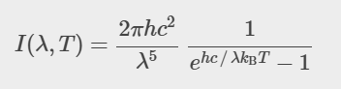
- Write how the formula changes for Wien’s approximation
- Compare the results of said approximation for values of wavelengths between
- 1x10⁻⁶ and 1.5x10⁻⁶
- 2x10⁻⁶ and 2.5x10⁻⁶
- 3x10⁻⁶ and 3.5x10⁻⁶
and analyze for which interval(s) this approximation works more similar to Planck’s law.
(h= 6.626x10⁻³⁴, c= 3x10⁸, k_{B}= 1.38x10⁻²³, T= 6000 K)

