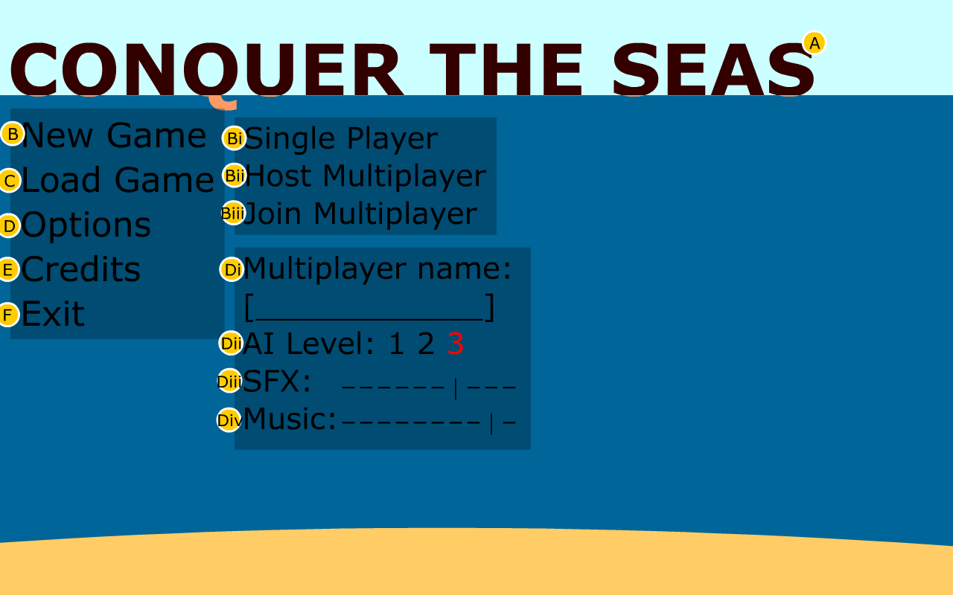
3.1.1 Main Menu
A. Logo: the games logo
B. New Game: Pops up submenu for game type (Bi, Bii, Biii)
Bi. Single Player: starts single player game
Bii. Host Multiplayer: starts a new server and puts you in the multiplayer lobby
Biii. Join Multiplayer: searches for a game on your network. Once selected, moves you to the multiplayer lobby.
C. Load Game: Pops up a dialogue box for selecting a save file
D. Options: Pops up submenu for setting options (Di, Dii, Diii, Div)
Di. Multiplayer Name: Text box to enter handle
Dii. AI Level: Difficult level of the AI (higher number is more difficult)
Diii. SFX: Volume of game noises that are not music (1-10 scale)
Div. Music: Volume of in game music (1-10 scale)
E. Credits: Displays our credits
F. Exit Game: Quits game and cleans up

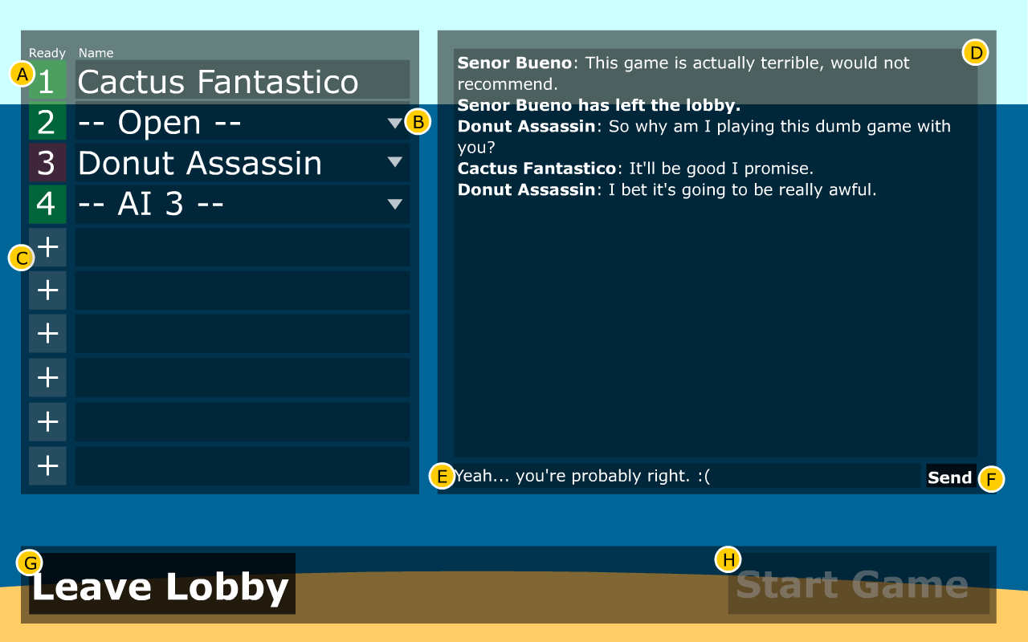

3.1.2 Multiplayer Lobby
A. Player number and readiness indicator (green is ready, red is not)
B. Drop down menu to select player type (choice between AI with difficulty level, open to allow another player to join, and close). If a player has joined, his handle is displayed in this field.
C. Add a player: creates another slot with the drop down menu in B
D. Chat area: displays messages sent by the players and notifies users when players join/leave
E. Text entry field: displays text to be sent to the other players
F. Send button: when clicked sends text from the text entry field (enter will work if one does not want to click)
G. Leave Lobby: puts player back to the main menu
H. Start Game: starts game immediately, only the player who hosted the game can click this

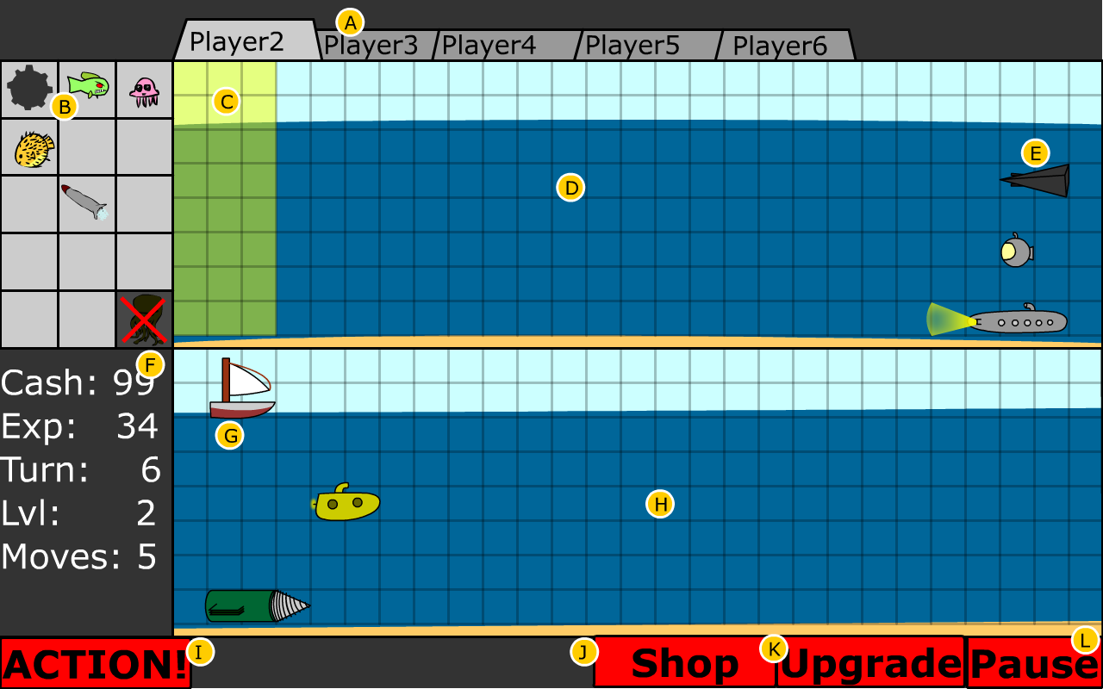

3.1.3 In Game UI
A. Enemy Tabs: clicking one of these displays that opponent's ocean in D. The light colored larger tab indicates the currently selected opponent. Instead of Player2, it will display that opponent's handle.
B. Offensive Unit Area: a graphical display of the units the player can send at their opponent
C. Deployable Space: the area in which the player can deploy their offensive units
D. Opponent's Ocean: a display of the currently selected opponent's ocean
E. Opponent's Defensive Units: shows the current state of the opponent's defensive units. This will allow players to know if the opponent's vessels are injured and how they are upgraded.
F. Stats: displays all the values relevant to the current turn: how much money the player has, how much experience the player has, what turn it is, what level the player has reached, and how many moves that player has left in their turn.
G. Player's Defensive Units: the player can select these to order them to move or shoot as desired
H. Player's Ocean: displays the current status of the player's ocean, so that they can plan their moves accordingly.
I. Action! Button: submits player's move to the server. Once all players have submitted their moves, the server returns the results to each player. Then, each player can make their next move.
J. Shop Button: brings player to the shop screen
K. Upgrade Button: brings player to the upgrade screen
L. Pause Button: brings player to the pause menu
M. Timer: shows the amount of time remaining before the player's turn is automatically sent to the server.
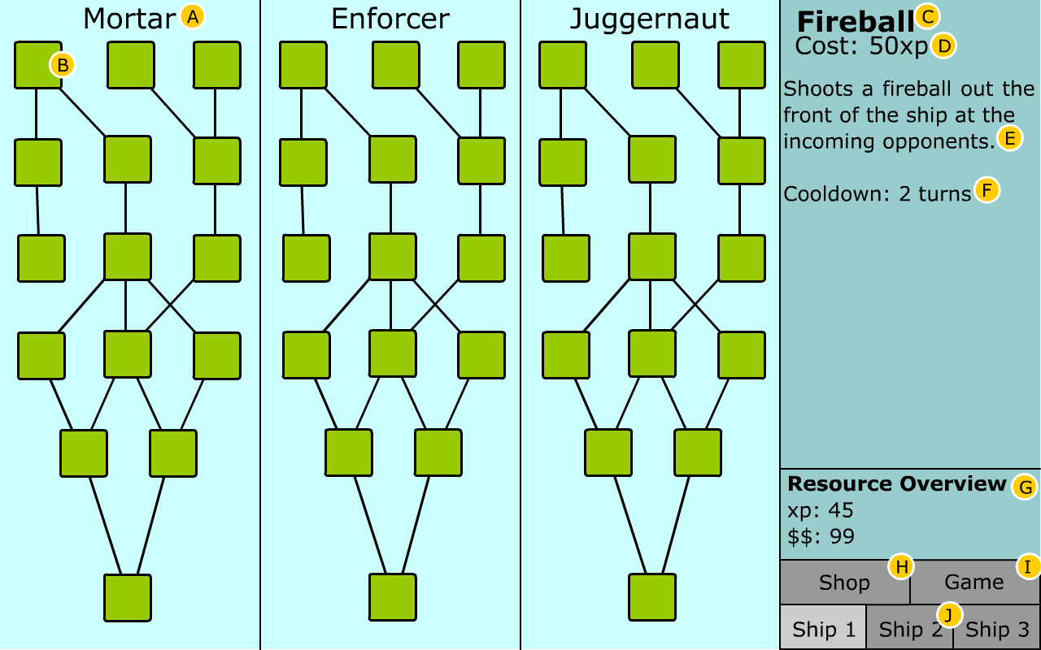

3.1.4 Upgrades Menu: menu for upgrading the player's defensive units
A. Tech Tree Title: each of the three tech trees operate independently of one another and are unique to each of the three ships
B. Tech: each of these squares represents a technology that can be upgrade. These squares will contain an unique icon for each tech upgrade. Any technology with a line extending to one above it depends on the one above it. That is, you must have the one above it to be able to purchase it. Some may have level requirements and some may not be able to combine with others. Click on a tech purchases it.
C. Tech Title: the title of the currently displayed technology (the displayed technology will be whichever the mouse hovers over)
D. Cost: the cost of the upgrade in experience
E. Description: a short explanation of what this upgrade allows the ship to do
F. Cooldown: the number of turns (or moves) a player must wait before using this technology again. Some technology will grant a passive bonus which will not have a cooldown.
G. Resource Overview: displays the users experience and money
H. Shop Button: moves player to the shop menu
I. Game Button: exits the upgrade menu and returns the game
J. Ship Tab: switches between the ships to select which one to upgrade. Current ship indicated by lighter box.

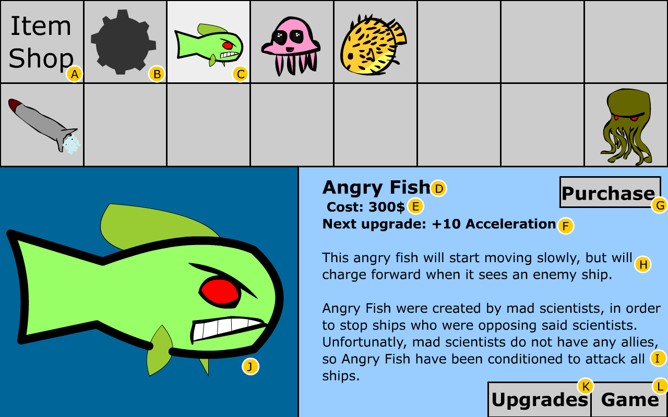

3.1.5 Shop Menu: menu for purchasing and upgrading the players offensive units
A. Place Holder Square: tells user they are in shop since there will only be 15 items
B. Unselected Item: it should be noted that the empty squares will contain unique pictures of items the user can purchase and upgrade
C. Selected Item: the item currently displayed in the lower half of the screen. To change which is the selected item simply click on an unselected item.
D. Item Name
E. Item Cost: will be in money only for items and their upgrades
F. Next Upgrade: description of what purchasing the next level will of this item will alter. At the start of the game, most items will simply be deployable on their first purchase (players will not start with all items).
G. Purchase Button: when clicked, the item/upgrade is purchased and the players arsenal is upgraded accordingly
H. Item Description: description of how the offensive unit works
I. Flavor text: comedic description of the item
J. Large icon of currently selected item or upgrade.
K. Upgrades Button: moves to upgrades menu
L. Game Button: close the shop menu and returns the player to the game

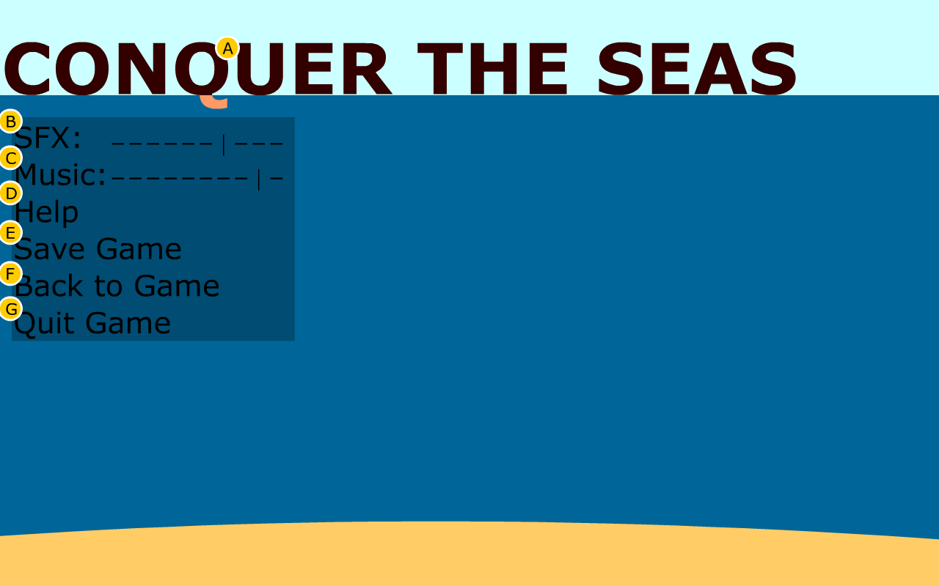
3.1.6 In Game Paused Menu
A. Logo: the games logo
B. SFX: Volume of game noises that are not music (1-10 scale)
C. Music: Volume of in game music (1-10 scale)
D. Help: pops up help files (possibly instructional video)
E. Save Game: pops up a dialogue box allowing the player to create a save file for their game
F. Back to Game: returns the player to their current game
G. Quit Game: quits the current game and returns the user to the main menu

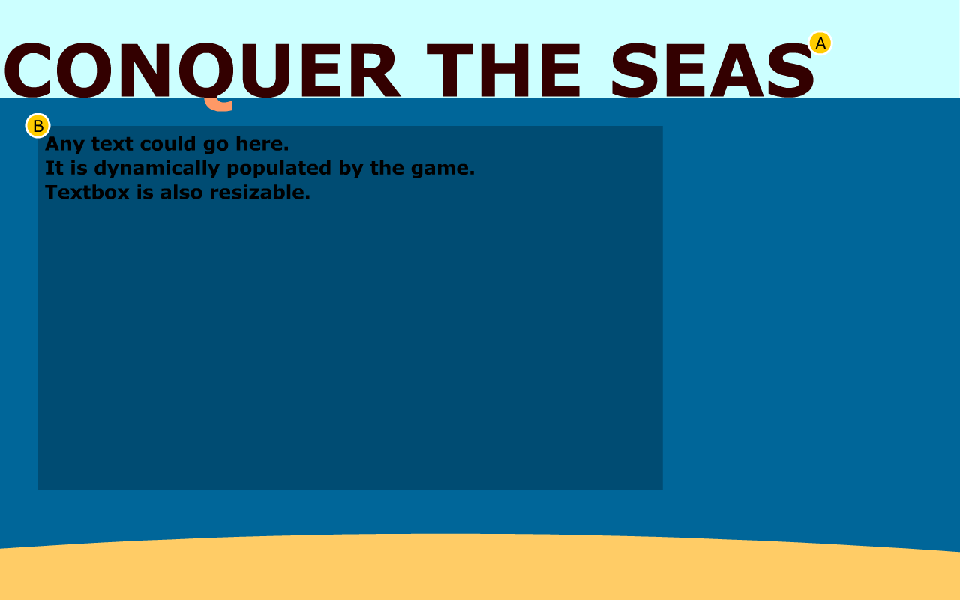
3.2 Client-Server Concept Model
3.2.1 Client-Server Concept Model Diagram
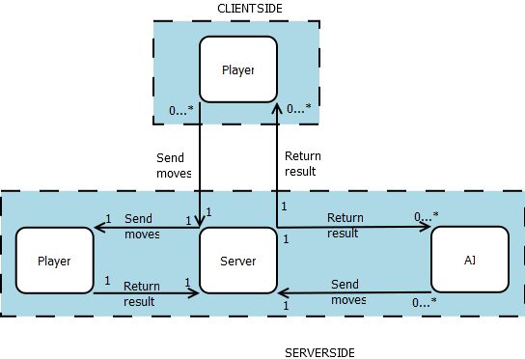
3.2.2 Client-Server Concept Model Explanation
This project has two main components: Clients and the Server. The Server exists on one machine only. Its task is to do all game computations. Clients are the individual instances of the game - one for each player. The Client relays information to the Server, which performs calculations and sends information back to the Client. The Player makes decisions and actions, inputs these into the Client, which then sends this information to the Server. This means there are two types of interactions: Player-Client where the user is inputting commands to the game, and Client-Server, where the local game is sending or receiving information from the host Server.
Once a player chooses to host a multiplayer game he becomes the Server for that game. His computer, the Server, will receive one turn from each of the client players (who joined the game by selecting join multiplayer game), the local player, and calculate turns for each of the AI players. Once it receives turns from each of these sources, it determines the outcome of each move in the turn and returns the results to all the players, including the local player and AI players. Each player than sees the results of the previous turn and plans their next set of turns accordingly.

3.3 Use Cases

3.3.1 Launching and Interacting with the Game
Use Case Name: Playing the Game
Iteration: Finished
Summary: How a player launches, starts, and quits the game.
Basic Course of Events:
1. The player launches the game by double clicking on the Conquer the Seas executable.
2. (optional) The player opens the options menu and tweaks the settings to their liking.
3. The player joins a multiplayer game.
4. The player plays the game (see 3.3.3 Taking a Turn).
5. The player wins the game.
6. The player returns to the main menu.
7. The player quits the game.
Alternative Paths:
1a. The player could launch the game from a command prompt by entering “python conquertheseas.py.”
3a. The player joins a single player game.
3b. The player hosts a multiplayer game (see 3.3.2 Managing the Multiplayer Lobby).
5a. The player loses the game.
7a. The player chooses to play another game which returns him to step 3.
Exception Paths: If Python is not installed on the computer, the executable will do nothing, ideally the player will have enough sense to check the README file, realize the issue, and follow the steps to remedy it.
Extension Paths: None
Triggers: The player has decided he would like to play the game.
Assumptions: The game is installed on the computer on which the player intends to play.
Preconditions: Python 2.7 is also installed on the computer on which the player intends to play.
Postconditions: A clean exit leaving nothing new on the computer with the possible exception of a save file.

3.3.2 Managing the Multiplayer Lobby
Use Case Name: Managing the Multiplayer Lobby
Iteration: Finished
Summary: How a player controls the multiplayer game lobby; including adding/removing AI/human players and launching the game.
Basic Course of Events:
1. Multiplayer lobby screen pops up.
2. Player can increase number of players by clicking on the plus icon.
3. Player selects player type for each of the slots from the following options: AI (with difficulty level), Open (to allow another human player to connect), or Close to remove the added slot.
4. Other human players join.
5. (optional) Players communicate through the chat and discuss whether to alter the AI difficulty or number of players.
6. Other players set themselves to ready.
7. Player selects start game and the game begins.
Alternative Paths:
6a. The host player does not want one of the recently joined players to be in the game and selects Kick from the drop down menu to remove this player from the game.
7a. Player starts the game before the other players are all set to ready and is met with a warning message from which the player can decide to start anyway or cancel and wait for readiness.
7b. Player cancels the game and is returned to the main menu.
Exception Paths: The player is not connected to any sort of network and upon selecting host multiplayer game is presented with an error informing him of this.
Extension Paths: None
Triggers: Player selected host multiplayer game.
Assumptions: None
Preconditions: The player must have an internet connection.
Postconditions: Game has begun, or the player is returned to the main menu.

3.3.3 Taking a Turn
Use Case Name: Taking a Turn
Iteration: Finished
Summary: How a player plans and submits a single turn in the game.
Basic Course of Events:
1. The player preforms any combination of the following actions in any order:
- Player selects his units and distributes his limited moves among them.
- Player selects offensive units and places them in the enemy's deployable space.
- Player clicks “Upgrade” button bringing up the upgrades page where upgrades are viewed and/or purchased, then the player returns to the Game screen.
- Player clicks “Shop” button bring up the shop page where items (or their upgrades) are view and/or purchased, then the player returns to the Game screen.
2. Player clicks “ACTION!” button to submit his turn to the server.
3. Player waits to receive the results of his turn and then starts at step 1 to begin his next turn.
Alternative Paths:
In step 3, the game could have reached an end state once the results are returned. This would lead to a Game Over or Victory screen, if all of the player's defensive units were destroyed or if all of the enemy players' defensive units were destroyed, respectively.
Exception Paths: None
Extension Paths: None
Triggers: Player is in an unfinished game.
Assumptions: The game has not ended yet and the server returned a valid result.
Preconditions: Player receives the previous turn's result from the server.
Postconditions: The server calculates the result of the turn and returns this result to all the players.

