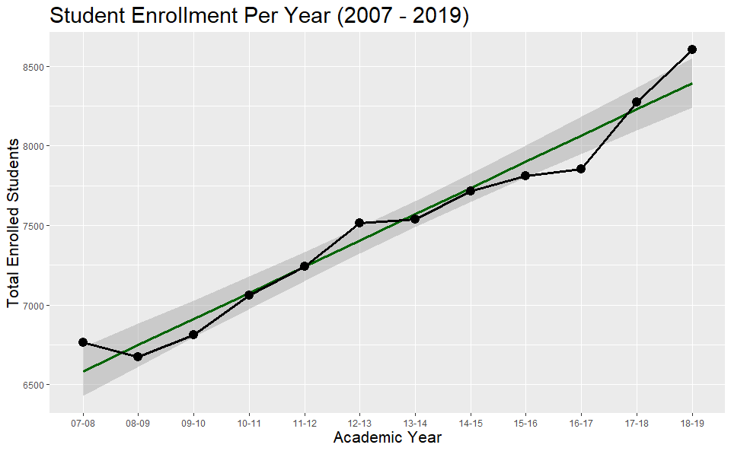

The beneficiaries of the data would be the University and its research/administration. They can notice that the trend of enrolled students has been on a constant increase since 2009-2010 and has especially been true since Dr. Kesselman took over. They should be able to easily understand the graph based on its axis and title.

I modified the data by cleaning up the years to be in yy-yy format rather than YYYY-YYYY format. It makes it look cleaner but also some of the data was delivered with different formats which looked sloppy. For instance, one was delivered as 2010-11 and others were written like 2007-2008. I also added a line to show the regression line using the geom_smooth function. I make the bullets and lines a bit thicker and added some color to the regression line to differentiate it from the data lines.