**Code**

import numpy as np

import matplotlib.pyplot as plt

from matplotlib import style

from matplotlib.backends.backend_pdf import PdfPages

style.use("ggplot")

filename = "provided/abalone.data.txt"

# x and y coordinates, whitespace-separated

X = np.loadtxt(filename, delimiter=',', usecols=(2, 4))

class Abalone_Data(object):

    def __init__(self, data):

        self.data_diameter = data[:, 0]

        self.data_weight = data[:, 1]

class Abalone(Abalone_Data):

    def __init__(self, abalone_data, a, b):

        self.data = Abalone_Data(abalone_data)

        self.a = a

        self.b = b

        self.mansonmodel = self.model(self.data.data_diameter, a, b)

        self.ssr = self.SSR(self.mansonmodel, self.data.data_weight)

        self.ssr_str = r'SSR = ' + str(self.ssr)

        self.plot = self.generate_plot()

    def SSR(self, y_observed, y_predicted):

        ssr = np.sum((y_observed - y_predicted)**2)

        return ssr

    def model(self, x, a, b):

        manson_model = a * x ** b  # model = 5.1 * X[:,0] ** 2

        return manson_model

    def generate_plot(self):

        plt.clf()

        plot = plt.scatter(X[:, 0], X[:, 1], marker='o', s=150, alpha=0.5, label='Observed')

        plot = plt.scatter(X[:, 0], self.mansonmodel, marker='.', color='black',

                    label=r'Model: W=' + str(self.a) + r'D$^{' + str(self.b) + r'}$')

        plot = plt.text(0.05, 2.2, self.ssr_str)

        plot = plt.xlabel('D')

        plot = plt.ylabel('W')

        plot = plt.legend()

        return plot

    def save_plot(self, fileprefix):

        self.plot.get_figure().savefig("%s.png" % fileprefix)

abalone_dataset_first = Abalone(X, 5.1, 5.0)

abalone_dataset_first.save_plot("first")

abalone_dataset_second = Abalone(X, 5.1, 2.2)

abalone_dataset_second.save_plot("second")

abalone_dataset_third = Abalone(X, 5.1, 2.15)

abalone_dataset_third.save_plot("third")

#print(abalone_dataset_first.ssr_str)

#print(abalone_dataset_first.plot)

**Results**

The first plot uses the given 5.1 and 5.0 with an SSR of 3007 which is majorly off

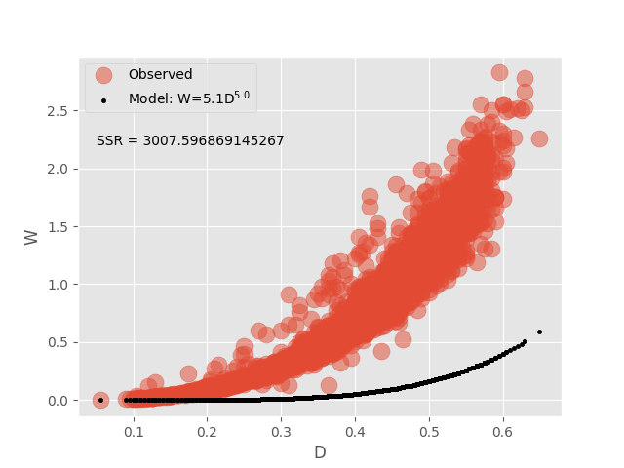

The second plot uses a of 5.1 and b of 2.2 has a much better ssr of 153 which his closer

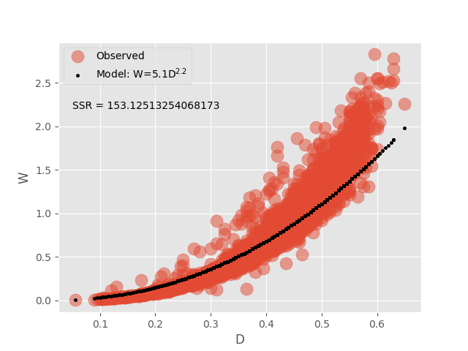

The final plot has an A value of 5.1 and B value of 2.15 which returned 133 SSR which is a better fit

