Name: Wong Cho Hei

SID: 1155109484

The Linux system I am using is ubuntu 20.04 LTS 64bit under VMWare Workstation.

The windows build I am using is Windows 10 build 19042.

The library included in the programme are:

1. [tinycthread.h](https://github.com/tinycthread/tinycthread) (merely modified)
2. [tinycthread_pool.h](https://github.com/enbandari/tinycthreadpool) (slightly modified)

Since the headers are modified, please do not download the original files, and replace them for the project.

CPU and Memory specifications

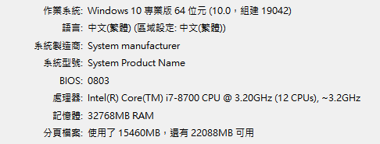

1. Compare the achievable throughput, loss, and CPU utilization in Linux and Windows platforms.

In Linux, the server programme alone takes around 50% of the CPU usage.

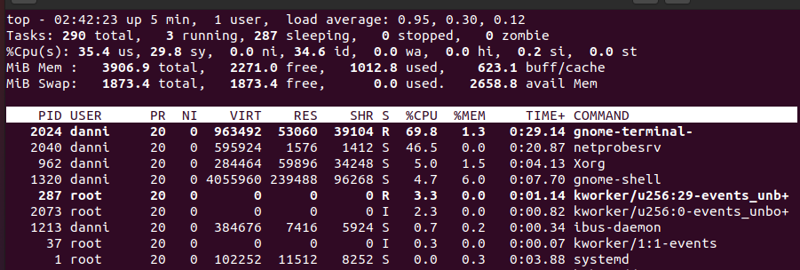The client under linux environment can go up to around 3 Gbps bidirectionally while taking 73% of the CPU usage and around 4MB ram. But for some reason, one client programme under window can only go for 12 Mbps while taking 11% of my cpu usage and around 8 MB ram.

However, if I test the server programme under Windows environment, the server takes 15% of my cpu usage. If a linux client try to connect to the server at this moment, it will be able to speed up to around 2Gbps while only taking 40% of the CPU usage. And the windows client behaves the same.

1. Compare the achievable throughput versus the number of client sessions, under both TCP and UDP.

Windows both TCP & UDP (4 clients): Around 50 Mbps

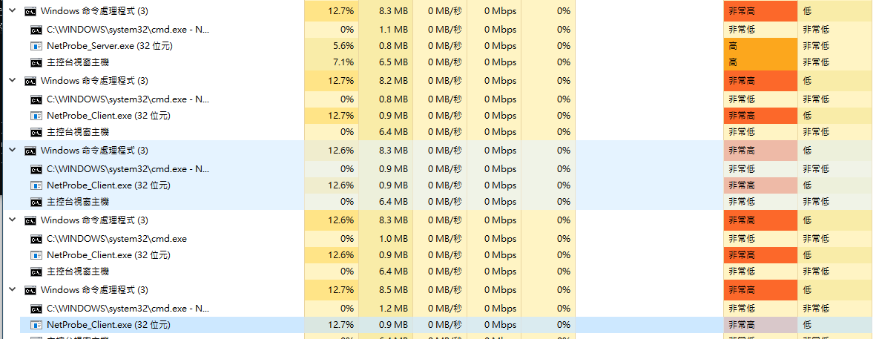

Ubuntu both TCP & UDP (3 clients): Around 10Gbps

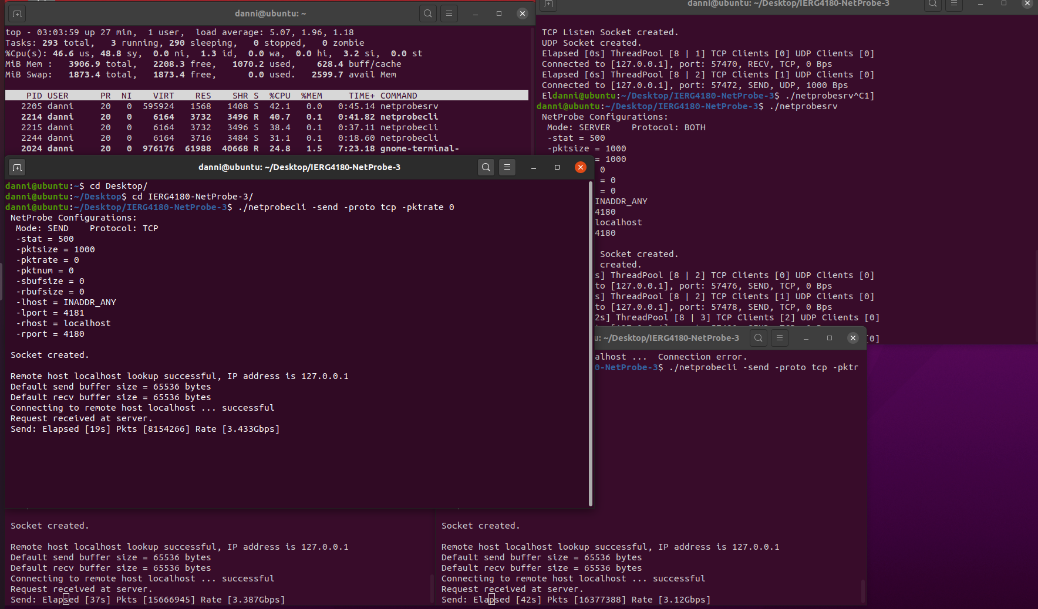

1. Explore the response time versus various system parameters.

The more client connected to the server, the higher the jitter and deliver time is (although the difference is tiny and merely a change compared to single thread programme).