The Millionaire of Three Kingdoms
-First Draft-

By Chun-Ming Lum
Mentor: Professor Stamos Ioannis

Game Overview

The basic ideas of the Millionaire of Three Kingdoms are imported from the Monopoly and a Chinese game called “Fu Jia Tian Xia” (富甲天下). Like the Monopoly, the game world will be on a game board. However, the setting and background of the game will be during the Three Kingdoms Period in China. Players will be choosing some popular characters at that period to play the game. The objectives of the game will be to occupy all the lands and conquer the “world,” or to eliminate all opponents. On the other hand, the losing condition of the game is when the human player is eliminated, or when all lands are occupied by one of the opponents.
Each player will throw 2 dice to decide how many spaces to move forward. When step onto a land without owner, the player will be prompt whether to buy the land. If step onto the player’s own land, player can choose to upgrade the land to village, from village to town, from town to city, and from city to castle. The size of the land will determine the capacity of the population, and population will determine the capacity of the military (soldiers), the fee of the toll, and the tax you will be collecting each month (every 30 turns). When step onto other’s land, the player will be prompt whether to pay the toll, to fight, or to attack. Paying the toll will prevent a war. Fighting will trigger a war, if the player win, he/she will not need to pay the toll, but if loss, he/she will need to pay double the fee. Attacking will fight offensively, the player will occupy the land if he/she wins, but will need to pay double if loss. On the other hand, if the player is attack by an opponent, he/she can choose to either to defend or abandon the land. All wars will be simulated randomly by the computer. If the player doesn’t have enough money to pay the toll when step onto other’s land, he/she will be forced to either fight or attack. Losing the war will be eliminated from the game.
There are also some places cannot be purchased or occupied, those places are Market, Casino, Bank, and Playground. Market is a place to hire (buy) soldiers who fight for money. Casino is a place where players can gamble. Bank is a place where players can save money for interest. Playground is a place where players can pay to play mini games, winning some mini games will earn some random bonus.
Besides having soldiers in each land to defend the lands, each player can also have soldiers with him/her traveling the world. This is how you can afford fight or attack opponents’ lands.

Characters

曹操Cao Cao | 
刘备Liu Bei | 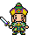
孙权Sun Quan | 
诸葛亮Zhuge Liang | 
关羽Guan Yu | 
张飞Zhang Fei | 
赵云Zhao Yun | 
呂布Lu Bu | 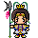
貂蝉Diao Chan | 
夏侯惇Xiahou Dun | 

Lands/Places

Jing Zhou/Chi Bi
Buyable lands/lands that can be occupied
- 樊城Fan Cheng
- 襄阳Xiang Yang
- 麦城Mai Cheng
- 临沮Lin Ju
- 当阳Dang Yang
- 夷陵Yi Ling
- 西陵Xi Ling
- 竟陵Jing Ling
- 江陵Jiang Ling
- 公安Gong an/X Ling
- 武陵Wu Ling
- 汉寿Han Shou
- 沔阳Mian Yang
- 江夏Jiang Xia
- 黄州Huang Zhou
- 武昌Wu Chang
- 蕲春Qi Chun
- 彭泽Peng Ze
- 建昌Jian Chang
- 九江 Jiu Jiang
- 南昌 Nan Chang
- 巴陵Ba Ling
- 长沙Chang Sha

Market
- A place to hire soldiers who fight for money. Price varied from time to time

Casino
- A place to gamble to win/loss gold

Bank
- A place to save money to earn interest. Interest rate varied from time to time

Playground
- A place to play mini game, winning the mini game will earn a random bonus

Artificial Intelligence

Computer Player
//the computer player’s turn, throw dice and move the character piece
if (map->space == LAND)
{ //the land is buyable
if ((land->owner == “”) && (character->gold >= land->price))
{ //land has no owner, and has enough gold to buy
//buy the land
}
else if (land->owner == character->name)
{ //land is own by himself/herself, upgrade the land
//upgrade the land
if (land->level < land->maxLevel)
{ //not the highest level yet
land->level ++;
}
}
else
{ //land is not own by himself/herself
//prompt whether to pay toll, fight, or attack
if (land->soldiers < character->soldiers)
{ //there are less soldiers in the land than the computer player
//attack to occupy
}
else if (character->soldiers > 1000)
{ //the computer player has more than 1000 soldiers
//fight
}
else
{ //the computer player has little soldiers
if (character->gold > land->toll)
{ //the computer player has enough gold to pay the toll
//pay toll
}
else
{ //not enough gold to pay
//fight
}
}
}
}
else
{ //the land is not buyable
if (map->space == MARKET)
{ //market
//depends on how many soldiers the computer player is carrying and how much //gold he/she has. Amount will be random, but if there are a lot of gold he/she is
//carrying then hires more, else less
}
else if (map->space == CASINO)
{ //casino
if (character->gold > 500)
{ //has more than 500 gold
//play the casino
}
else
{ //less than 500 gold
//walk out of casino
}
}
else if (map->space == BANK)
{ //bank
if (character->gold > 1000)
{ //has more than 1000 gold
//random
}
else
{
//walk out of the bank
}
}
else if (map->space == PLAYGROUND)
{ //playground
if (character->gold > playground->fee)
{ //has enough gold
//random
}
else
{ //not enough gold
//walk out of the playground
}
}
}

War Simulation
- Regular war
//at most 1000 soldiers of each side will be participating in a war
for (int i=0; i<10; i++)
{ //loop for 10 times
//randomly subtract some soldiers from both sides
//subtract soldiers in the range of 0 to 100 in each loop
}

//end of war

if (offensive->soldiers > defensive->soldiers)
{ //offensive side wins
//survived soldiers = offensive->soldiers
//don’t need to pay toll
}
else
{ //defensive side wins
//survived soldiers = defensive->soldiers
//offensive side needs to pay double the toll
}

- Attack (attempt to occupy)
//unlimited number of soldiers can be participating in an offensive war, but defender of the //land has advantage
for (int i=0; i<10; i++)
{ //loop for 10 times
//randomly subtract some soldiers from both sides
//subtract soldiers of the defensive side from 0 to 100 in each loop
//subtract soldiers of the offensive side from 50 to 200 in each loop

count ++; //increment count
}

//end of war

if (offensive->soldiers > defensive->soldiers)
{ //offensive side wins
//survived soldiers = offensive->soldiers
//offensive side occupies the city
}
else
{ //defensive side wins
//survived soldiers = defensive->soldiers
//offensive side needs to pay double the toll
}

Interface
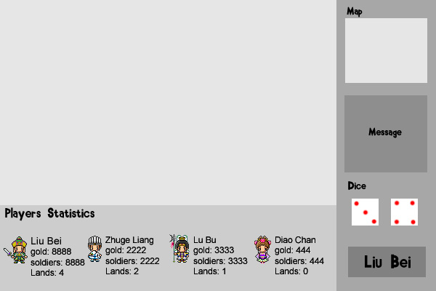
The bottom of the screen displays players’ statistics
The two dice decide how many spaces to move
This area displays messages and communicates with the players
This area displays the entire map
This area displays the part of the map where the current player is at

This shows whose turn it is

Plan
September to October – Building level editor, designing graphics/tiles, coding
November to December – Coding game play and artificial intelligent
December – Design maps, testing

