Daniel Gelan
Sheger City, Koye Feche
Oromia
Danielgelandu1@gmail.com
(+251)-994989535
Date: ____ __, 2025

To: ______________________,
I am excited to apply for the Senior Enterprise Application Developer role at Oromia Bank With extensive experience as a Full Stack Developer, SAP ABAP Developer, and SAP BASIS Administrator, I have a proven track record of designing, implementing, and supporting robust enterprise systems that drive operational efficiency and business success. My technical expertise and passion for delivering innovative solutions align closely with ________ commitment go “________________”.
As a Full Stack Developer, I led the development of an COOP-Robust Currency Exchange Management System, where I built backend logic for real-time currency rate tracking and transaction processing using ASP.NET MVC and SQL Server. I also designed responsive frontend interfaces with Tailwind CSS and Bootstrap 5, enabling intuitive dashboards for transaction monitoring and financial reporting. This system streamlined currency exchange operations and mitigated financial risks for the organization.
In my personal project, BITA ERP, I developed specialized modules for Material Management, Procurement, and User Management, leveraging both ASP.NET MVC and ASP.NET Core for cross-platform compatibility. I optimized the SQL Server database schema to ensure seamless integration and performance, showcasing my ability to deliver scalable, user-focused solutions from concept to launch.
During my tenure supporting a SAP ERP implementation, I transitioned from providing technical support to becoming a SAP ABAP Developer and SAP BASIS Administrator. I developed custom ABAP programs to enhance module functionality and performed critical BASIS tasks, including system monitoring, performance tuning, and database management. These efforts ensured system stability and supported business process optimization across the organization.
My technical skills in ASP.NET MVC, ASP.NET Core, SQL Server, SAP ABAP, and SAP BASIS, combined with my ability to collaborate across teams and deliver high-quality solutions, make me a strong candidate for this role. I am eager to contribute my expertise to [Company Name] and drive impactful technological advancements.
I would welcome the opportunity to discuss how my skills and experiences align with your needs. Thank you for considering my application. I look forward to the possibility of contributing to Dashen Banks's success and can be reached at +251-994-989-535 or Daniel Gelan to schedule a conversation.

Sincerely,
Daniel Gelan



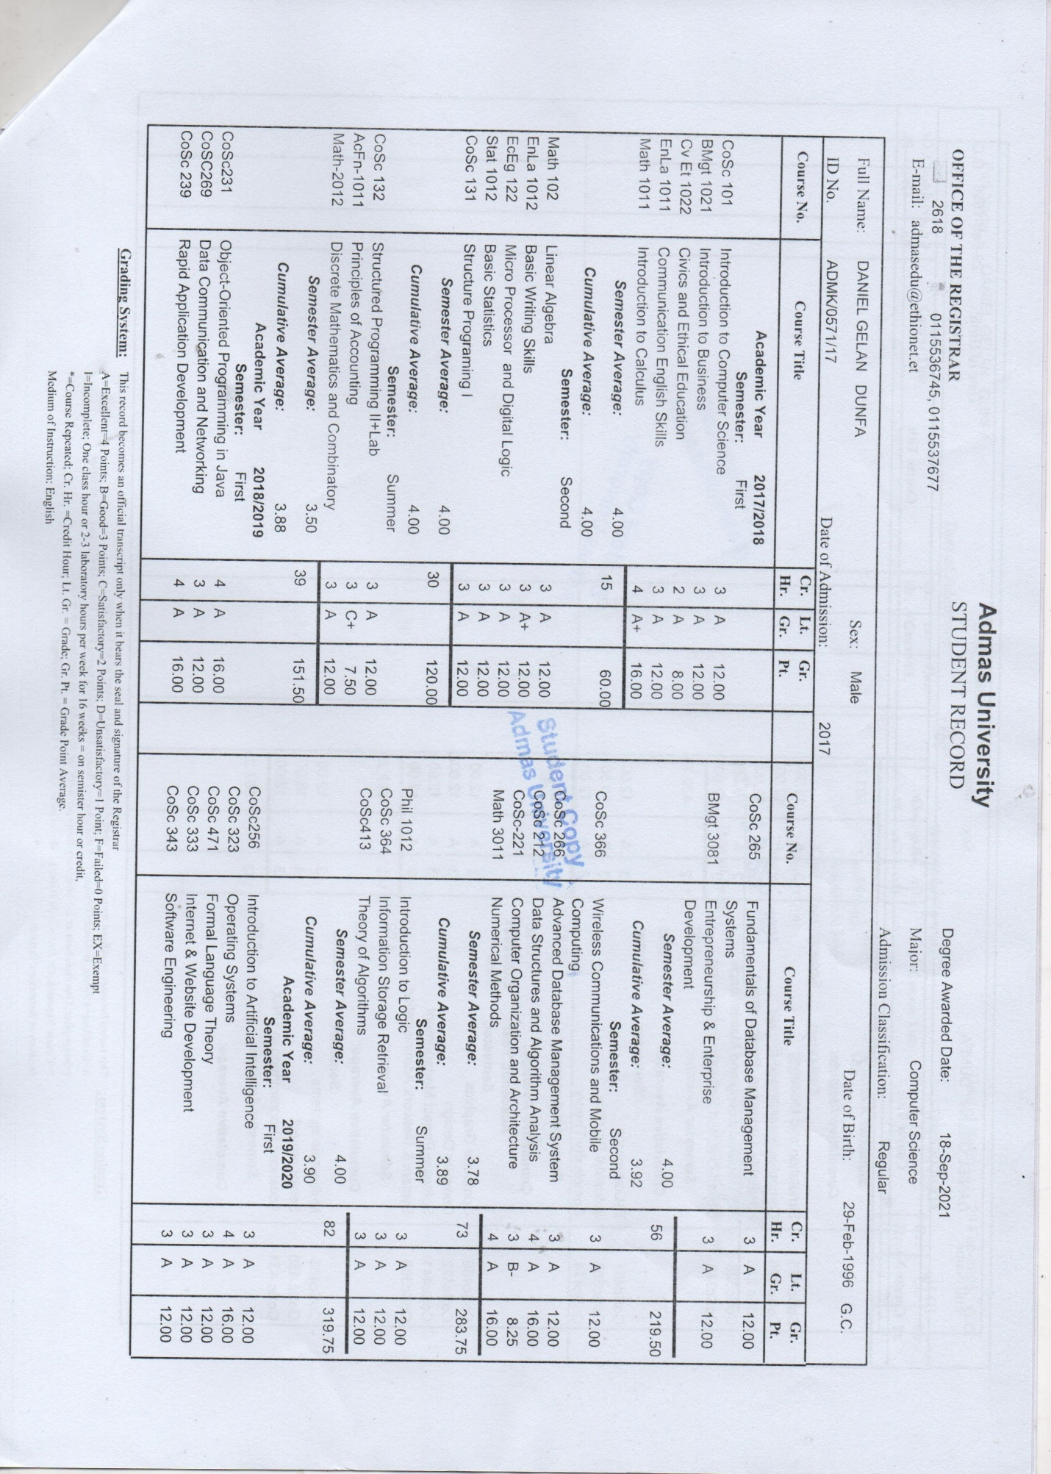
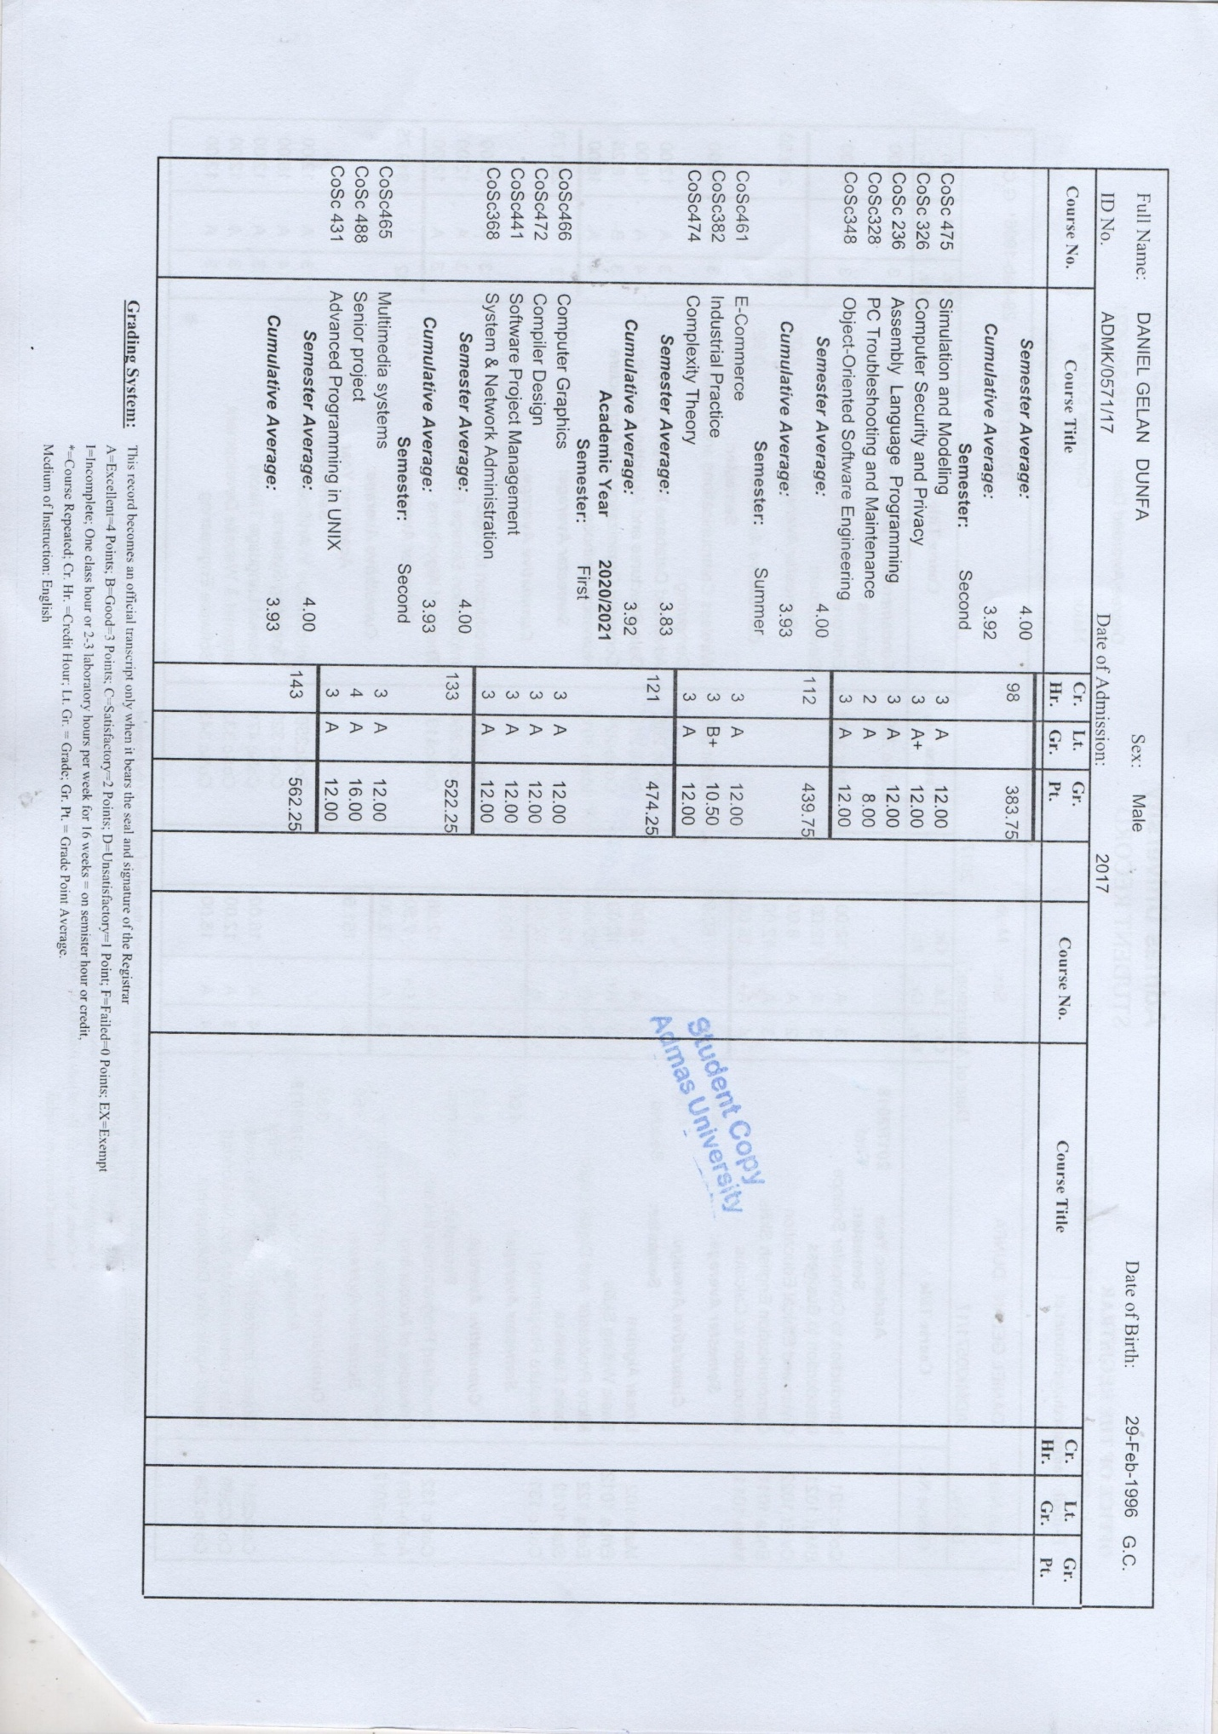

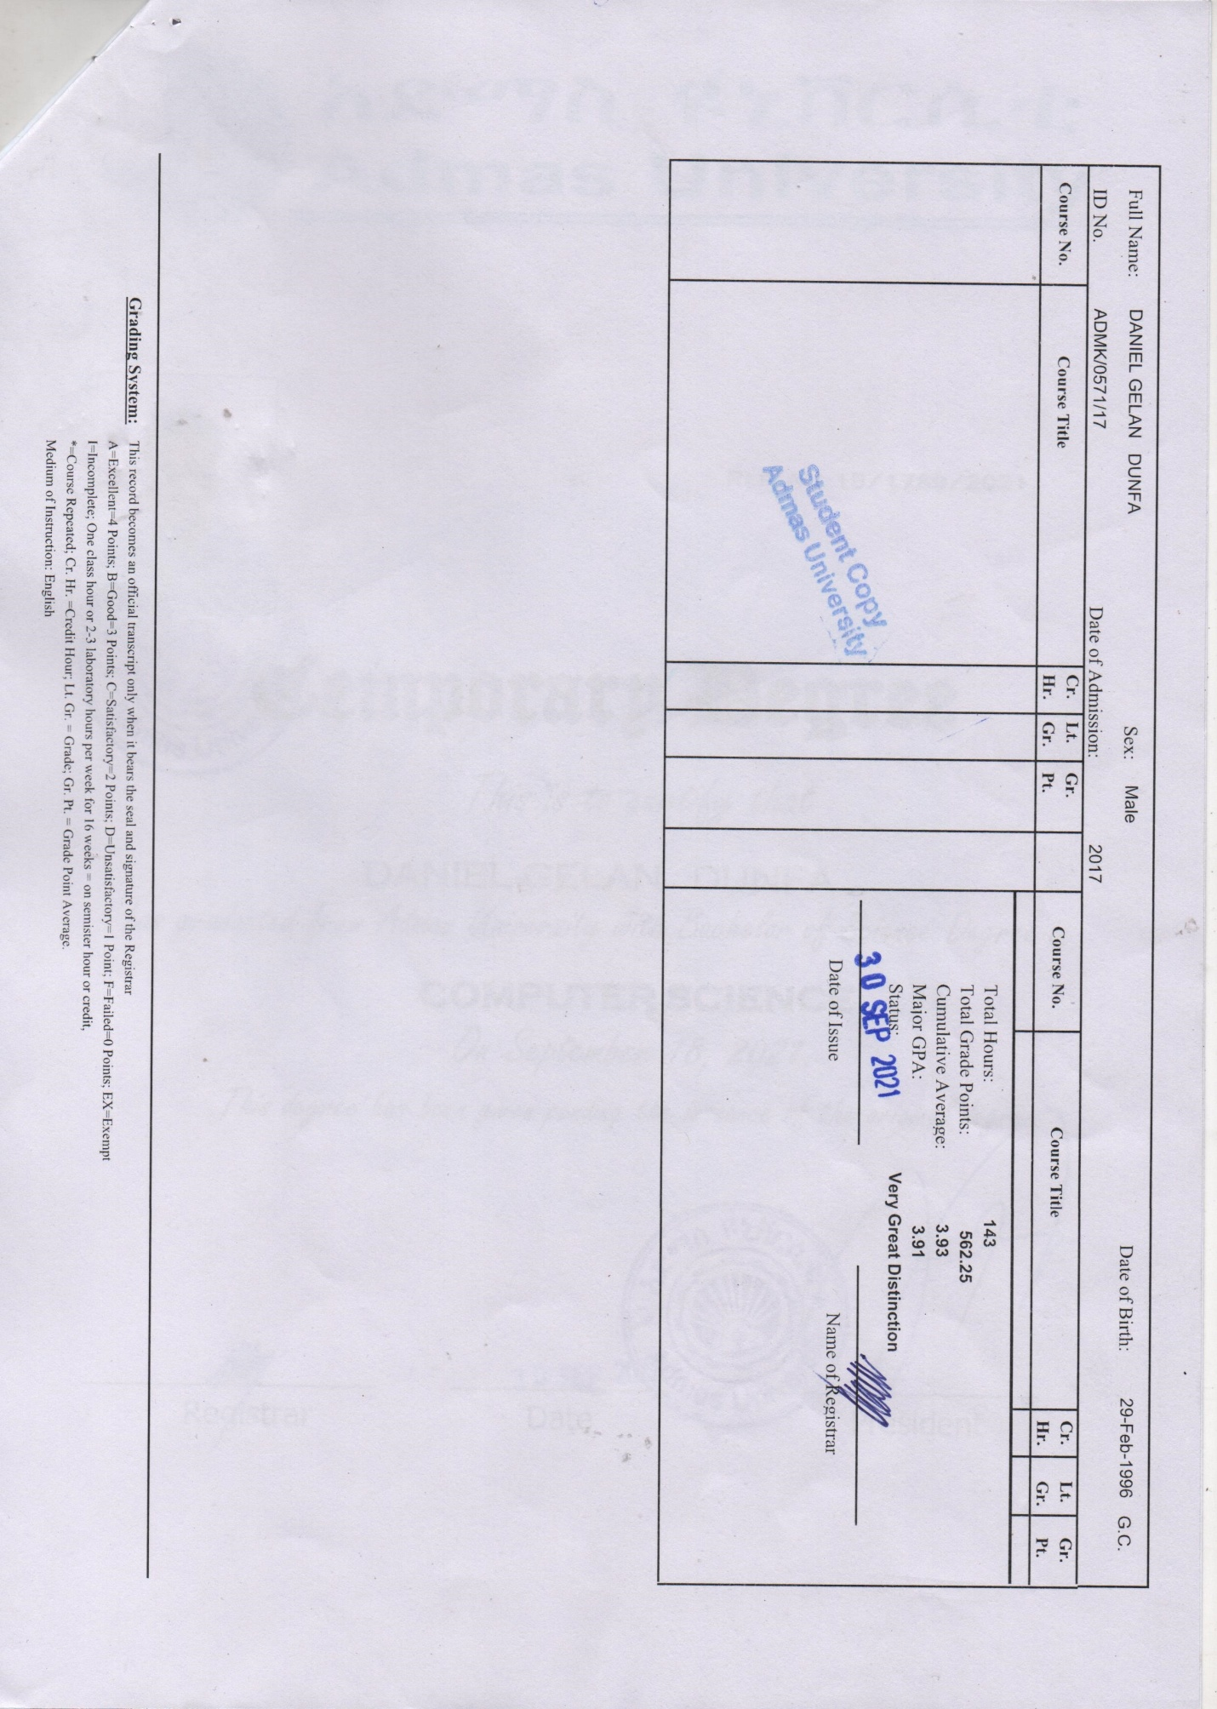

PROFESSIONAL SUMMARY

Full Stack Software Developer

Experienced Full Stack Software Developer with 3 years and 6 months of professional experience. Developed and deployed multiple enterprise-level systems, including a Risk Management System, Share Management System, Outsourcing Management System, and Audit Management System. These systems streamlined business operations, enhanced regulatory compliance, and improved overall organizational efficiency. Strengthened compliance integrity by enabling real-time cross- referencing of customer data with international sanction lists, reinforcing trust with key stakeholders.

WORK EXPERIENCE

28/02/2022 – CURRENT Addis Ababa, Ethiopia
FULL STACK SOFTWARE DEVELOPER COOPERATIVE BANK OF OROMIA

- Administered SAP ERP Applications: Administered and maintained SAP ERP modules, ensuring their operational integrity and reliability as part of a collaborative team effort.
- Contributed to Internal Software Solutions: Played a key role in the development, implementation, and maintenance of internal software systems and automations to enhance operational efficiency and productivity.
- Supported User Training and Support: Provided assistance in user support and training for internal software systems and automations, ensuring optimal utilization by company personnel.
- Identified Process Improvement Opportunities: Proactively identified opportunities for process enhancement and automation, collaborating with stakeholders to implement improvements and optimize existing systems.
- Assisted in Documentation and Reporting: Assisted in maintaining documentation for internal software systems and automations, including user guides and technical specifications. Provided support in generating reports to track system performance and usage metrics.

LANGUAGE SKILLS
Mother tongue(s): AFAAN OROMOO

Other language(s):
 | UNDERSTANDING |  | SPEAKING |  | WRITING
 | Listening | Reading | Spoken  production | Spoken  interaction
ENGLISH | C2 | C2 | C2 | C2 | C2
AMHARIC | C2 | C2 | C2 | C2 | C2
Levels: A1 and A2: Basic user; B1 and B2: Independent user; C1 and C2: Proficient user

PROJECTS
01/03/2022 – CURRENT
SAP ERP IMPLEMENTATION
Contributed to the implementation and post-implementation support of SAP ERP, transitioning to specialized roles in SAP ABAP development and SAP BASIS administration.
- Role: Technical Support, SAP ABAP Developer, SAP BASIS Administrator
- Technologies Used: SAP ERP, SAP ABAP, SAP BASIS, SQL
Key Contributions:
- Provided technical support during SAP ERP implementation, ensuring smooth deployment, system configuration, and user training.
- Developed custom ABAP programs and reports to enhance SAP module functionality, optimizing business processes post-implementation.
- Managed SAP BASIS administration tasks, including system monitoring, performance tuning, user administration, and database maintenance.
- Collaborated with cross-functional teams to troubleshoot issues, apply patches, and ensure system stability and security.
- Designed and optimized database interactions to support SAP ERP performance and scalability.

13/03/2024 – CURRENT
Automated Audit System
Automated system to streamline company auditing. Facilitates audit creation, response management, and budget year report generation.
  - Role: Lead Developer
  - Technologies Used: Java, Spring Boot, PostgreSQL, TypeScript, Angular
Key Contributions:
- Designed and developed backend processes for audit creation and response management.
- Implemented frontend interfaces for user interaction.
- Integrated report generation for audit findings and budget year projections.

01/02/2024 – 01/06/2024
Risk Management System
Automated system to streamline company risk management processes, including risk identification, assessment, mitigation tracking, and report generation.
- Role: Full Stack Developer
- Technologies Used: ASP.NET MVC, SQL Server, Tailwind CSS, Bootstrap 5
Key Contributions:
- Developed backend logic for capturing and managing risk data, including classification and mitigation workflows.
- Built responsive frontend interfaces for efficient risk entry, tracking, and dashboard visualization.
- Implemented report generation features for comprehensive risk summaries and mitigation progress tracking.

23/10/2024 – CURRENT
Share Management System
System developed to manage company share distribution, ownership records, transactions, and reporting. Streamlined share allocation, tracking, and audit compliance.
- Role: Full Stack Developer
- Technologies Used: ASP.NET MVC, SQL Server, Tailwind CSS, Bootstrap 5
Key Contributions:
- Designed and implemented backend modules for share issuance, transfer, and ownership history tracking.
- Created responsive frontend components for real-time share data visualization and transaction entry.
- Integrated reporting tools for generating shareholder statements and transaction audit logs.
23/03/2025 – CURRENT
Outsourcing Management System

System developed to manage outsourcing operations, including vendor registration, contract management, task assignments, and performance tracking. Improved coordination, transparency, and operational efficiency.
- Role: Full Stack Developer
- Technologies Used: React.js, Next.js and SQL Server
Key Contributions:
- Developed frontend interfaces for vendor onboarding, contract workflows, and task monitoring.
- Implemented dynamic pages and API integrations using Next.js for seamless navigation and data flow.
- Enabled role-based access and dashboards for managing outsourcing KPIs and vendor performance
01/10/2024 – 01/12/2024
COOP-Robust Currency Exchange Management System (Core System for the Company)

Automated system to streamline currency exchange operations, including rate tracking, transaction processing, risk management, and financial reporting.
- Role: Lead Developer
- Technologies Used: ASP.NET MVC, SQL Server, Tailwind CSS, Bootstrap 5 Key Contributions:
- Developed backend logic for real-time currency rate retrieval, transaction processing, and exchange risk analysis using object-oriented principles.
- Designed responsive frontend interfaces for seamless transaction entry, rate monitoring, and dashboard visualization.
- Implemented secure financial reporting features to generate detailed summaries of exchange transactions and risk exposure.

23/02/2025 – CURRENT
BITA ERP (Personal Project Ready for Market ERP System)

Enterprise Resource Planning system with specialized modules for streamlined business operations, focusing on material management, procurement, and user management, built with cross-platform compatibility.
- Role: Full Stack Developer
- Technologies Used: ASP.NET MVC, ASP.NET Core, SQL Server, Tailwind CSS, Bootstrap 5
Key Contributions:
- Developed Material Management module for inventory tracking, stock optimization, and material requisition workflows using object-oriented design.
- Built Procurement module to automate purchase orders, vendor management, and cost tracking with seamless integration to material management.
- Implemented User Management module for role-based access control, authentication, and user activity monitoring.
- Designed and optimized relational database schema in SQL Server to support cross-platform functionality between ASP.NET MVC and ASP.NET Core.
- Created responsive, cross-platform compatible frontend interfaces using Tailwind CSS and Bootstrap 5 for intuitive user interaction across modules.

