Часть 1. PL/pgSQL. Обзор и конструкции языка.

Функция book_name:

1 CREATE OR REPLACE FUNCTION book_name(p_book_id INTEGER, p_title TEXT)
2 RETURNS TEXT
3 LANGUAGE plpgsql
4 STABLE
5 AS $$
6 DECLARE
7 full_name TEXT;
8 max_len CONSTANT INTEGER := 45;
9 cutoff_pos INTEGER;
10 BEGIN
11 SELECT p_title || ' — ' || STRING_AGG(
12 author_name(a.last_name, a.first_name, a.middle_name),
13 ', '
14 ORDER BY au.seq_num
15 )
16 INTO full_name
17 FROM authorship au
18 JOIN authors a ON au.author_id = a.author_id
19 WHERE au.book_id = p_book_id;
20
21 IF full_name IS NULL THEN
22 full_name := p_title;
23 END IF;
24
25 IF LENGTH(full_name) <= max_len THEN
26 RETURN full_name;
27 END IF;
28
29 cutoff_pos := 42;
30
31 cutoff_pos := GREATEST(
32 POSITION(' ' IN REVERSE(LEFT(full_name, cutoff_pos))),
33 1
34 );
35
36 IF cutoff_pos > 1 THEN
37 cutoff_pos := 42 - cutoff_pos + 1;
38 RETURN RTRIM(LEFT(full_name, cutoff_pos)) || '...';
39 ELSE
40 RETURN LEFT(full_name, 42) || '...';
41 END IF;
42 END;
43 $$;

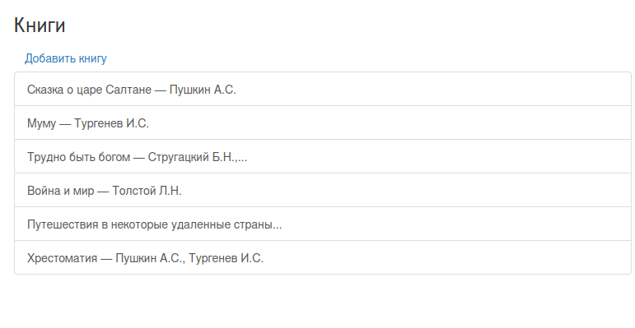
Рис. 1 – Пример работы.

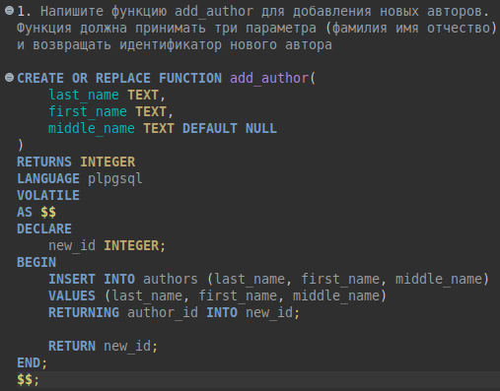
Рис. 2 – Функция add_author.

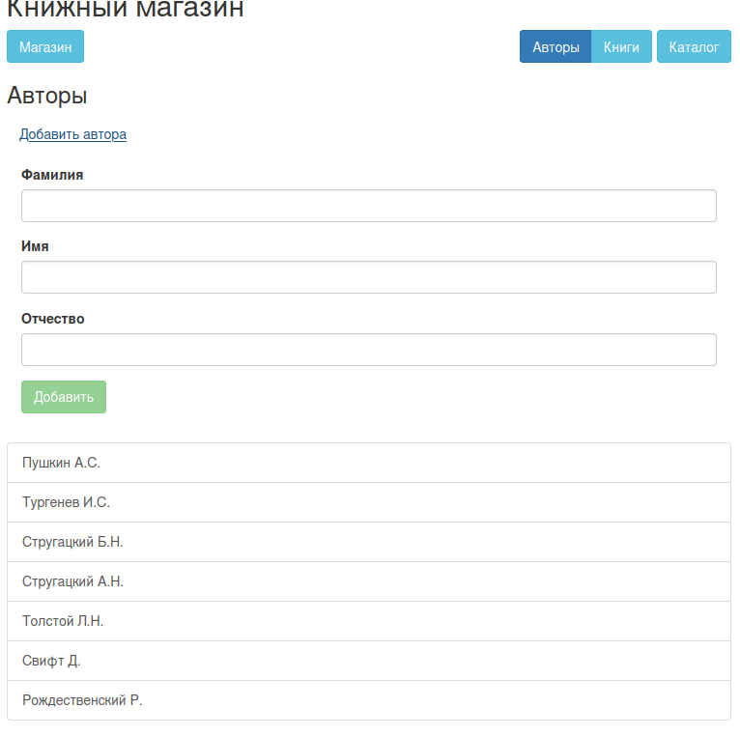
Рис. 3 – Пример работы.

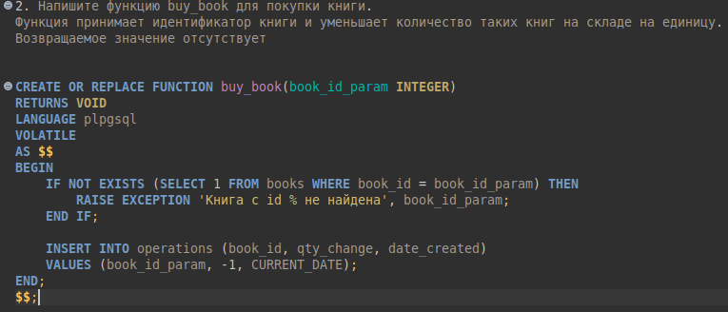
Рис. 4 – Функция buy_book.

