Часть 1. PL/pgSQL. Курсоры

1 CREATE OR REPLACE FUNCTION book_name(p_book_id INTEGER, p_title TEXT)
2 RETURNS TEXT
3 LANGUAGE plpgsql
4 STABLE
5 AS $func$
6 DECLARE
7 full_name TEXT;
8 authors TEXT[];
9 first_two TEXT;
10 cnt INT;
11 max_len CONSTANT INTEGER := 45;
12 cutoff_pos INTEGER;
13 BEGIN
14
15 SELECT ARRAY_AGG(
16 author_name(a.last_name, a.first_name, a.middle_name)
17 ORDER BY au.seq_num)
18 INTO authors
19 FROM authorship au
20 JOIN authors a ON a.author_id = au.author_id
21 WHERE au.book_id = p_book_id;
22
23 IF authors IS NULL THEN
24 full_name := p_title;
25 ELSE
26 cnt := array_length(authors, 1);
27
28 IF cnt = 1 THEN
29 full_name := p_title || ' — ' || authors[1];
30 ELSIF cnt = 2 THEN
31 full_name := p_title || ' — ' || authors[1] || ', ' || authors[2];
32 ELSE
33 first_two := authors[1] || ', ' || authors[2] || ' и др.';
34 full_name := p_title || ' — ' || first_two;
35 END IF;
36 END IF;
37
38
39 IF LENGTH(full_name) <= max_len THEN
40 RETURN full_name;
41 END IF;
42
43 cutoff_pos := max_len - 3;
44
45 cutoff_pos := GREATEST(
46 POSITION(' ' IN REVERSE(LEFT(full_name, cutoff_pos))),
47 1
48 );
49
50 IF cutoff_pos > 1 THEN
51 cutoff_pos := (max_len - 3) - cutoff_pos + 1;
52 RETURN RTRIM(LEFT(full_name, cutoff_pos)) || '...';
53 ELSE
54 RETURN LEFT(full_name, 42) || '...';
55 END IF;
56 END;
57 $func$;

1 CREATE OR REPLACE FUNCTION book_name_sql(p_book_id int, p_title text)
2 RETURNS text
3 LANGUAGE sql
4 BEGIN ATOMIC
5 WITH a AS (
6 SELECT ARRAY_AGG(
7 author_name(a.last_name, a.first_name, a.middle_name)
8 ORDER BY au.seq_num
9 ) AS authors
10 FROM authorship au
11 JOIN authors a ON a.author_id = au.author_id
12 WHERE au.book_id = p_book_id
13 )
14 SELECT CASE
15 WHEN authors IS NULL THEN p_title
16 WHEN array_length(authors, 1) = 1 THEN p_title || ' — ' || authors[1]
17 WHEN array_length(authors, 1) = 2 THEN p_title || ' — ' || authors[1] || ', ' || authors[2]
18 ELSE p_title || ' — ' || authors[1] || ', ' || authors[2] || ' и др.'
19 END
20 FROM a;
21 END;

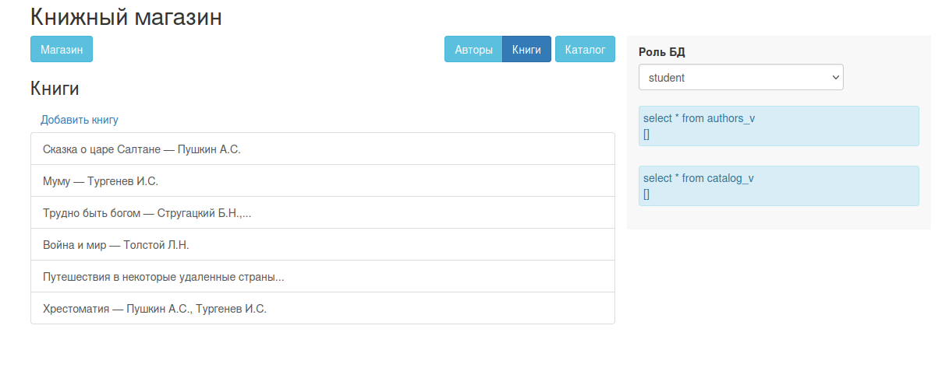

Часть 2. PL/pgSQL. Динамические команды.

1 CREATE OR REPLACE FUNCTION get_catalog(
2 author_name_param TEXT DEFAULT NULL,
3 book_title_param TEXT DEFAULT NULL,
4 in_stock_param BOOLEAN DEFAULT NULL
5 )
6 RETURNS TABLE (
7 book_id INTEGER,
8 display_name TEXT,
9 onhand_qty INTEGER
10 )
11 LANGUAGE plpgsql
12 STABLE
13 AS $func$
14 DECLARE
15 sql TEXT := '
16 SELECT book_id, display_name, onhand_qty
17 FROM catalog_v
18 WHERE TRUE';
19 BEGIN
20 IF author_name_param IS NOT NULL AND author_name_param <> '' THEN
21 sql := sql || format(
22 ' AND full_authors_long ILIKE %L',
23 '%' || author_name_param || '%'
24 );
25 END IF;
26
27 IF book_title_param IS NOT NULL AND book_title_param <> '' THEN
28 sql := sql || format(
29 ' AND title ILIKE %L',
30 '%' || book_title_param || '%'
31 );
32 END IF;
33
34 IF in_stock_param IS NOT NULL THEN
35 IF in_stock_param THEN
36 sql := sql || ' AND onhand_qty > 0';
37 ELSE
38 sql := sql || ' AND onhand_qty = 0';
39 END IF;
40 END IF;
41
42 RETURN QUERY EXECUTE sql;
43 END;
44 $func$;

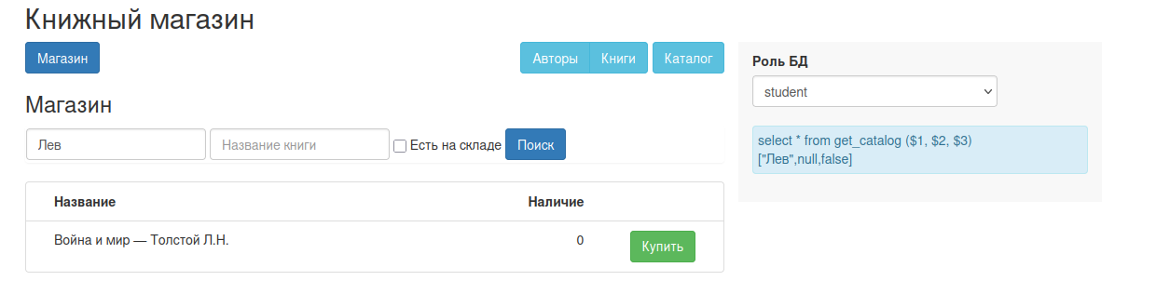

Часть 3. PL/pgSQL. Массивы.

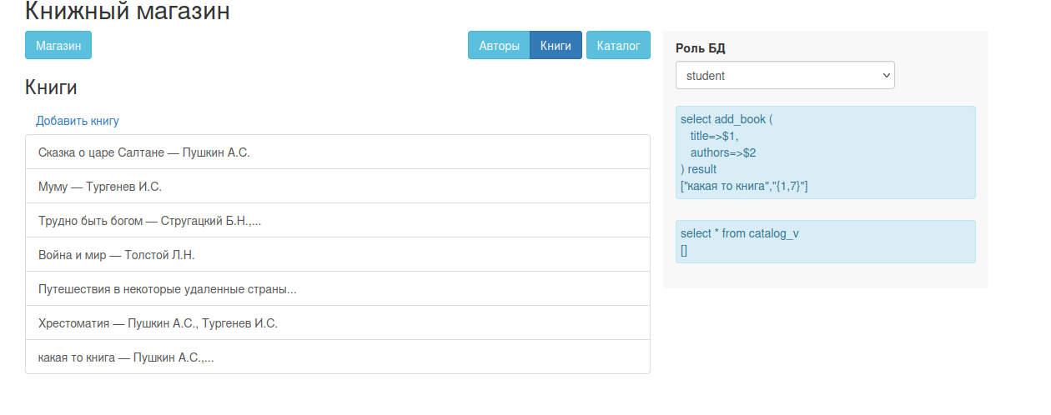

1 CREATE OR REPLACE FUNCTION add_book(
2 title text,
3 authors integer[]
4 )
5 RETURNS integer
6 LANGUAGE plpgsql
7 AS $func$
8 DECLARE
9 new_book_id integer;
10 i integer;
11 BEGIN
12 INSERT INTO books(title)
13 VALUES (title)
14 RETURNING book_id INTO new_book_id;
15
16 IF authors IS NOT NULL THEN
17 FOR i IN 1 .. array_length(authors, 1) LOOP
18 INSERT INTO authorship(book_id, author_id, seq_num)
19 VALUES (new_book_id, authors[i], i);
20 END LOOP;
21 END IF;
22
23 RETURN new_book_id;
24 END;
25 $func$;

