Solution for Problem 1

- Determine if the code is a Hamming code.
To check a linear block code whether it is a Hamming code or not, it must satisfy the following rules:
m = n−k = 7−4 = 3
k = 2m−m−1 = 23−3−1 = 4
n = 2m−1 = 23−1 = 7

Hence the (7,4) linear block code is a Hamming code.

- Determine the code rate of this linear block code.
Code rate is k/n for every k bits of useful information, the coder generates a total of n bits of data, of which n-k are redundant.
Therefore, the code rate is 4/7

- Calculate the resulting bitrate after applying the linear block code.
Resulting bitrate a.k.a Gross bitrate * k/n = Net bitrate = 4kbps * 7/4 = 7kbps

- Find the parity check matrix, H of the code.

The parity check matrix can be found as follows:

G = [I_{k} : P]

H = [P^{T} : I_{n-k}]

P = $\left[\begin{aligned}\begin{matrix}1 \\ 0\end{matrix} \begin{matrix}1 \\ 1\end{matrix} \begin{matrix}0 \\ 1\end{matrix} \\ \begin{matrix}1 \\ 1\end{matrix} \begin{matrix}1 \\ 0\end{matrix} \begin{matrix}1 \\ 1\end{matrix}\end{aligned}\right]$ P^{T} = $\left[\begin{matrix}1 \\ 1 \\ 0\end{matrix} \begin{matrix}0 \\ 1 \\ 1\end{matrix} \begin{matrix}1 \\ 1 \\ 1\end{matrix} \begin{matrix}1 \\ 0 \\ 1\end{matrix}\right]$

H = $\left[\begin{matrix}1 \\ 1 \\ 0\end{matrix} \begin{matrix}0 \\ 1 \\ 1\end{matrix} \begin{matrix}1 \\ 1 \\ 1\end{matrix} \begin{matrix}1 \\ 0 \\ 1\end{matrix} \begin{matrix}1 \\ 0 \\ 0\end{matrix} \begin{matrix}0 \\ 1 \\ 0\end{matrix} \begin{matrix}0 \\ 0 \\ 1\end{matrix}\right]$

- Construct the encoding table for the linear block code.
The encoding table for (7,4) linear block code is
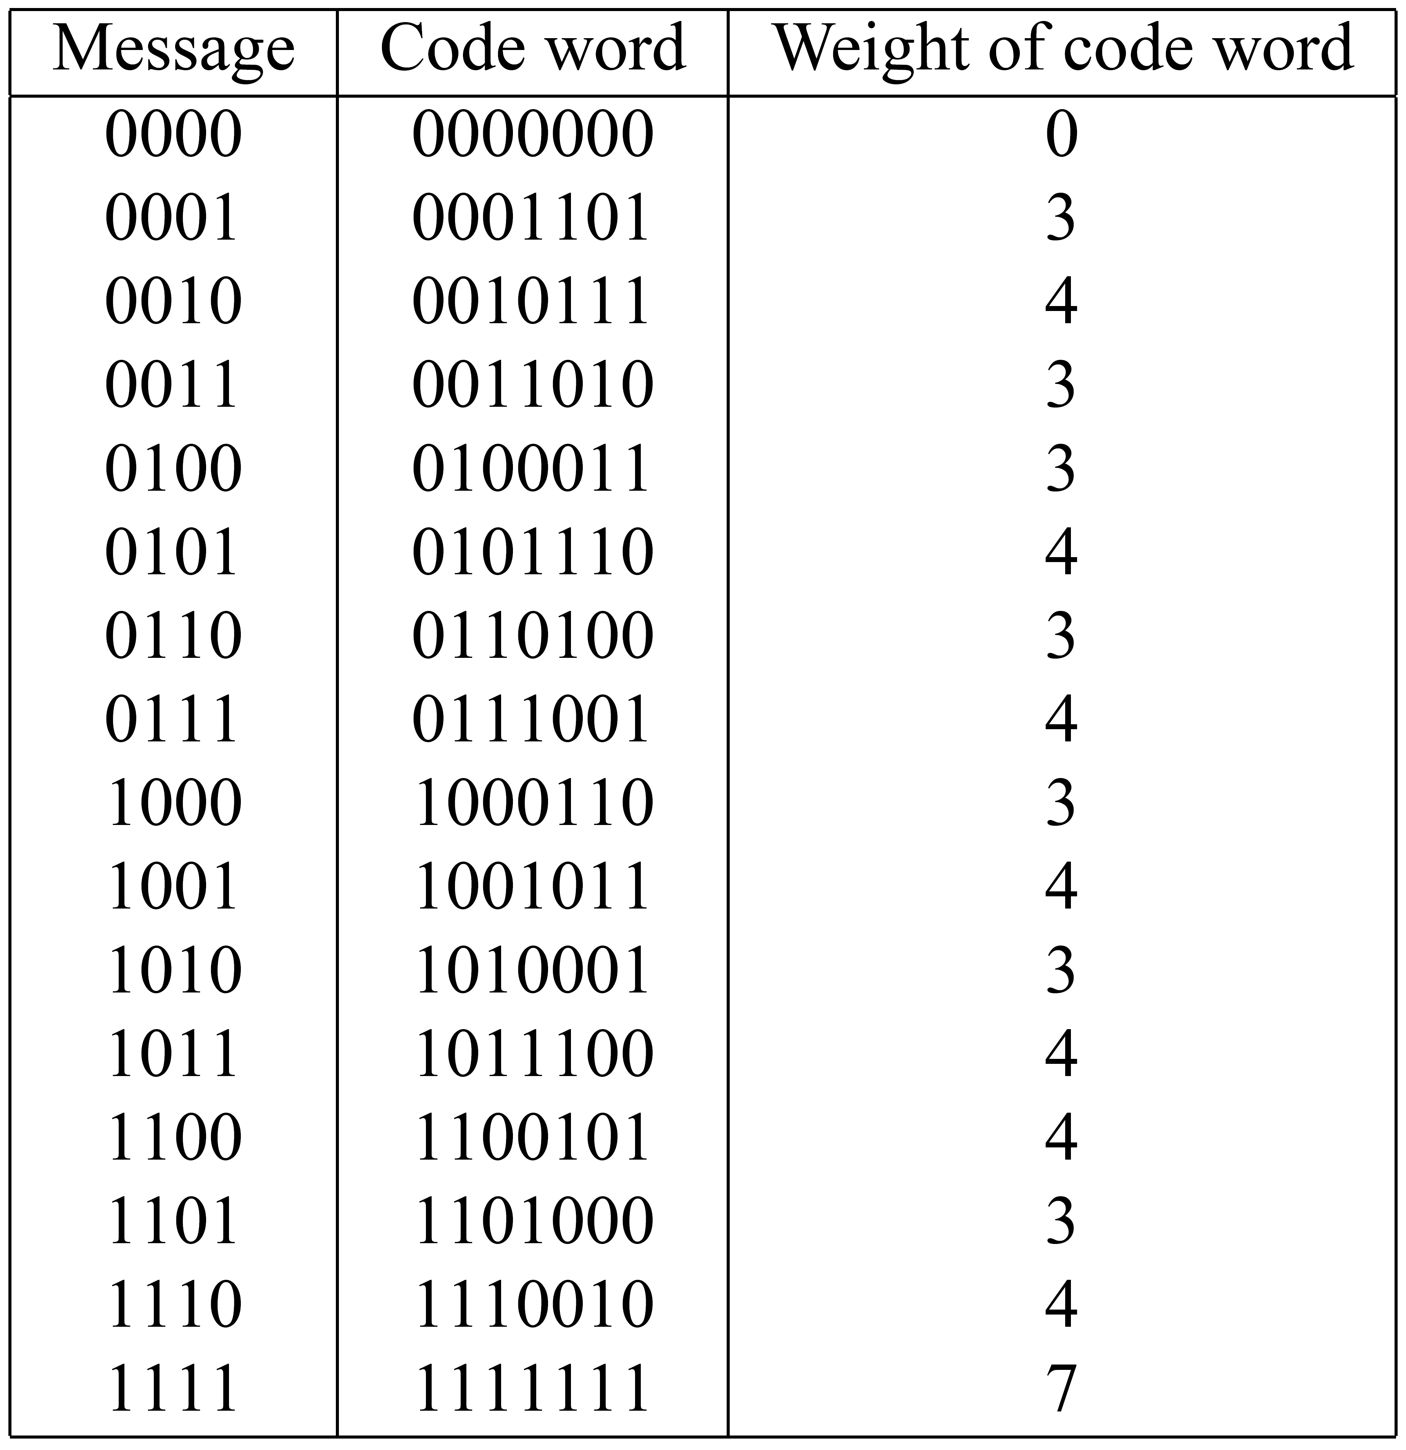

- Determine the error correcting capabilities of this code i.e. what is the minimum distance, how many errors can the code detect, how many errors can the code correct?
_{dmin} = 3
e = d_{min} – 1 =2
t <= ½ (d_{min} – 1) <= 1

Hence the (7,4) linear block code can detect 2 bit errors and correct 1 bit error in 7 bit output codeword

- Construct the decoding table for the linear block code.
Step 1: Find the transpose of the parity check matrix, H^{T}
H = $\left[\begin{matrix}1 \\ 1 \\ 0\end{matrix} \begin{matrix}0 \\ 1 \\ 1\end{matrix} \begin{matrix}1 \\ 1 \\ 1\end{matrix} \begin{matrix}1 \\ 0 \\ 1\end{matrix} \begin{matrix}1 \\ 0 \\ 0\end{matrix} \begin{matrix}0 \\ 1 \\ 0\end{matrix} \begin{matrix}0 \\ 0 \\ 1\end{matrix}\right]$ H^{T} = $\left[\begin{aligned}\begin{matrix}1 & 1 & 0\end{matrix} \\ \begin{matrix}0 & 1 & 1\end{matrix} \\ \begin{matrix}1 & 1 & 1\end{matrix} \\ \begin{matrix}1 & 0 & 1\end{matrix} \\ \begin{matrix}1 & 0 & 0\end{matrix} \\ \begin{matrix}0 & 1 & 0\end{matrix} \\ \begin{matrix}0 & 0 & 1\end{matrix}\end{aligned}\right]$

Step 2: Use the following formula to construct the decoding table
s = e H^{T}

- Decode the following received words: 1101011. Show how the code can correct this error.

s = r H^{T} = $\left[1101011\right]$ $\left[\begin{aligned}\begin{matrix}1 & 1 & 0\end{matrix} \\ \begin{matrix}0 & 1 & 1\end{matrix} \\ \begin{matrix}1 & 1 & 1\end{matrix} \\ \begin{matrix}1 & 0 & 1\end{matrix} \\ \begin{matrix}1 & 0 & 0\end{matrix} \\ \begin{matrix}0 & 1 & 0\end{matrix} \\ \begin{matrix}0 & 0 & 1\end{matrix}\end{aligned}\right]$ = $\left[011\right]$

From the decoding table, this syndrome corresponds to error pattern e=[0100000]. Hence the correctable codeword is:

y = r + e
= [1101011] + [0100000]
= [1001011]

Solution for Problem 2

- Determine the minimum bit rate of this system if the signal is quantised to 4 bits code per sample.

Given that the signal is quantised to 4 bits code per sample.
Bandwidth of each signal = 5000 Hz
Hence, Nyquist rate = 2 x 5000 Hz = 10,000 Hz for each signal
For 4 analogue signals, the sampling rate is 4 x 10,000 Hz = 40,000 samples/sec
Therefore, the minimum bit rate = 40,000 x 4 = 160,000 bps = 160 kbps

- If signal is to be modulated to a 16 multilevel signal for transmission over an AWGN channel, calculate the required bandwidth and the transmission power in dB.
To calculate the required bandwidth and the transmission power in dB:
Step 1: Calculate the required bandwidth to transmit the 16 multilevel signal
From (b), the 16 multilevel signal is 160,000 bps, hence the channel capacity
C = 2B * log₂16 （nyquist bandwidth equation）
（RB = FS * NB）
160 kbps = 2B * log₂16
B = (160 kbps/2) / log₂ 16 = 20,000 Hz
Step 2: Calculate the required SNR in dB
C = B log₂ (1 + SNR)
160kbps = 20kHz log₂ (1 + SNR)
SNR = 2^{C/B} – 1 =2^{(160kbps/20,000)} – 1 = 255
Therefore, the required transmission power in dB required is:
SNR_dB = 10 log₁₀ SNR = 24 dB

- If the transmission power dropped 5dB, explain the possible problem? Propose a remedy for this problem and explain your remedy.
If the transmission power dropped from 10dB from 24 dB to 19 dB (5 dB), the channel capacity dropped to 94,140 bps, which is far less than the required 160,000bps by the system.
SNR_dB = 24 dB – 5 dB = 19 dB
19 = 10 log₁₀ SNR dB, SNR = 79
Calculate new channel capacity as the result of the transmission power drop:
C = B log₂ (1 + SNR) = 20,000 * log₂ (1 + 79) = 126,594 bps
Let’s discuss the possible problem and remedy.

Solution for Problem 3

Step 1: Calculate all relevant probabilities:

P(x₁, y₁) = P(x₁) * P(y₁|x₁) = 1/3 * 2/3 = 2/9
P(x₁, y₂) = P(x₁) * P(y₂|x₁) = 1/3 * 1/3 = 1/9
P(x₂, y₁) = P(x₂) * P(y₁|x₂) = 2/3 * 1/10 = 1/15
P(x₂, y₂) = P(x₂) * P(y₂|x₂) = 2/3 * 9/10 = 3/5
P(y₁) = P(x₁)*P(y₁|x₁) + P(x₂)*P(y₁|x₂) = 2/3 * 1/3 + 1/10 * 2/3 = 13/45
- Alternatively P(y₁) = P(x₁,y₁) + P(x₂,y₁) = 2/9 + 1/15 = 13/45
P(y₂) = 1 – P(y₁) = 32/45
P(x₁|y₁) = P(x₁, y₁) / P_{y} (y₁) = 10/13
P(x₂|y₁) = P(x₂, y₁) / P_{y} (y₁) = 3/13
P(x₁|y₂) = P(x₁, y₂) / P_{y} (y₂) = 5/32
P(x₂|y₂) = P(x₂, y₂) / P_{y} (y₂) = 27/32
Step 2: Determine H(x)
H(x) = $\sum_{i}{P(xi)\log{\frac{1}{P(xi)}}}$ = P(x₁)$\log{\frac{1}{P(x1)}}$ + P(x₂)$\log{\frac{1}{P(x2)}}$ = 1/3*1.58 +2/3*0.58=0.53+0.39=0.92
Step 3: Determine H(x|y)
H(x|y) = $\sum_{i}{\sum_{j}{P(xi,yj)\log{\frac{1}{P(xi|yj)}}}}$
= 0.22*0.38+0.11*2.68+0.07*2.11+0.6+*0.25=0.08+0.29+0.14+0.15=0.66
Step 4: H(y)
H(y) = $\sum_{i}{P(yi)\log{\frac{1}{P(yi)}}}$ = P(y₁)$\log{\frac{1}{P(y1)}}$ + P(y₂)$\log{\frac{1}{P(y2)}}$
= 13/45*1.79 +32/45*0.49=0.52+0.35=0.87
Step 5: H(y|x)
H(y|x) = $\sum_{i}{\sum_{j}{P(yi,xj)\log{\frac{1}{P(yi|xj)}}}}$
= 0.22*0.58+0.11*1.58+0.07*3.32+0.6*0.15=0.13+0.18+0.22+0.09=0.67
Step 6: I(x;y)
I(x;y) = H(x) - H(x|y) = 0.92-0.66=0.25
C = max I(x;y)

Solution for Problem 4

- Marginal distribution for X

$P(x_{i})=\sum_{i}{p\left(x_{i}, y_{j}\right)=}(\frac{1}{2},\frac{1}{4},\frac{1}{8}, \frac{1}{8})$

- Marginal entropy of X

$H(X)=-\sum_{i}{p\left(x_{i}\right)\log_{2}p\left(x_{i}\right)=}-(-\frac{1}{2}-\frac{1}{2}-\frac{3}{8}-\frac{3}{8})$ = 1.75 bits

- Marginal distribution for Y

$P(y_{j})=\sum_{j}{p\left(x_{i}, y_{j}\right)=}(\frac{1}{4},\frac{15}{32}, \frac{9}{32})$

- Marginal entropy of Y

$H(Y)=-\sum_{j}{p\left(y_{j}\right)\log_{2}p\left(y_{j}\right)=}-(-\frac{1}{2}-\frac{62}{121}-\frac{35}{68})$= 1.53 bits

- Joint Entropy

$H(X,Y)=-\sum_{i}{\sum_{j}{p\left(x_{i},y_{j}\right)\log_{2}p\left(x_{i},y_{j}\right)=\left(\frac{1}{4}\right)+\left(\frac{3}{8}\right)+\left(2\right)\left(\frac{5}{32}\right)+\left(\frac{24}{53}\right)+\left(\frac{35}{68}\right)+\left(3\right)\left(\frac{81}{253}\right)}}$=
= 2.87 bits

- Mutual information

I(X; Y ) = H(X) + H(Y ) − H(X, Y ) = 1.75 + 1.53 – 2.54 = 0.41 bits

$$I\left(X;Y\right)= H\left(X\right)+H\left(Y\right)-H(X,Y)$$
The way of calculating I(X;Y)

