Running with non-optimized algorithm, please notice that I use 2 separate kernels to do this task:

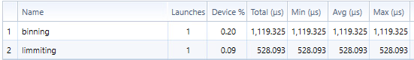

Total time non optimize is 1647 ms.

There is a bug that made all the test run the fast version fail on lab machine.