**Activity-**The categorization of behavior into one or more actions is termed as an activity. In other words, it can be said that an activity is a network of nodes that are connected by edges. The edges depict the flow of execution. It may contain action nodes, control nodes, or object nodes.

The control flow of activity is represented by control nodes and object nodes that illustrates the objects used within an activity. The activities are initiated at the initial node and are terminated at the final node.

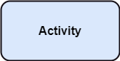

**Activity partition /swimlane**

The swimlane is used to cluster all the related activities in one column or one row. It can be either vertical or horizontal. It used to add modularity to the activity diagram. It is not necessary to incorporate swimlane in the activity diagram. But it is used to add more transparency to the activity diagram.

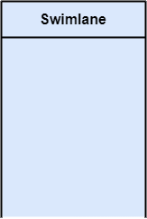

**Forks**

Forks and join nodes generate the concurrent flow inside the activity. A fork node consists of one inward edge and several outward edges. It is the same as that of various decision parameters. Whenever a data is received at an inward edge, it gets copied and split crossways various outward edges. It split a single inward flow into multiple parallel flows.

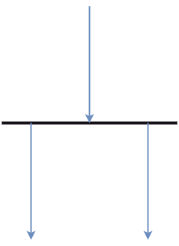

**Join Nodes**

Join nodes are the opposite of fork nodes. A Logical AND operation is performed on all of the inward edges as it synchronizes the flow of input across one single output (outward) edge.

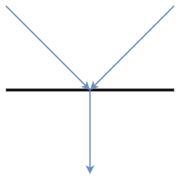

**Pins**

It is a small rectangle, which is attached to the action rectangle. It clears out all the messy and complicated thing to manage the execution flow of activities. It is an object node that precisely represents one input to or output from the action.

Notation of an Activity diagram

Activity diagram constitutes following notations:

**Initial State:** It depicts the initial stage or beginning of the set of actions.

**Final State:** It is the stage where all the control flows and object flows end.

**Decision Box:** It makes sure that the control flow or object flow will follow only one path.

**Action Box:** It represents the set of actions that are to be performed.

