姓名:李展緯 學號:40747044s

演算法hw3 handwritten

1.

(1)

Write down the state transition(recursive relation), and tabulate(draw a table) with the givenitems by using the transition you wrote.Please label the meaning of the column and the row in your table.

|  |  |  |  |  |  |  |
| --- | --- | --- | --- | --- | --- | --- |
| i\w | 1 | 2 | 3 | 4 | 5 | 6 |
| 1 | 0 | 4 | 4 | 4 | 4 | 4 |
| 2 | 0 | 4 | 4 | 4 | 6 | 6 |
| 3 | 2 | 4 | 6 | 6 | 6 | 8 |
| 4 | 2 | 4 | 6 | 6 | 6 | 8 |

橫列:容量為w 的袋子所能裝的物品最高價值

直行:編號為i 的物品

V(i,w) = max( v[ i-1, w ], v[ i-1,w-w(i) ] + v(i) )

(2)

dp( i , j ) = p(i) + (sum( i+1,j ) – dp(i+1 , j ))

dp( i , j ) = p(j) + (sum( i,j-1 ) – dp(i , j-1 ))

上述兩種情況中，因為對手一定拿最多的那一堆，因此用i~j的總和

P1,….P6 = 2,8,3,7,5,3

dp( i,j ) =

{

dp(i,j) = p(i) if i = j

dp(i,j).first = dp(j,j).first + a(i,j+1).second , dp(i,j).second = dp(i,j+1).first

if dp(i,j) dp(j,j).first + a(i-1,j).second > dp(i,i) dp(j,j).first + a(i-1,j).second

dp(i,j).first = dp(i,i).first + a(i-1,j).second, dp(i,j).second = dp(i-1,j).first

if dp(i,j) dp(j,j).first + a(i-1,j).second < dp(i,i) dp(j,j).first + a(i-1,j).second

}

dp(I,j).first 為在pi~pj中先手可拿到的數量

dp(I,j).first 為在pi~pj中後手可拿到的數量

|  |  |  |  |  |  |  |
| --- | --- | --- | --- | --- | --- | --- |
| i\j | 2 | 8 | 3 | 7 | 5 | 3 |
| 2 | (2,0) | (0,0) | (0,0) | (0,0) | (0,0) | (0,0) |
| 8 | (8,2) | (8,0) | (0,0) | (0,0) | (0,0) | (0,0) |
| 3 | (5,8) | (8,3) | (3,0) | (0,0) | (0,0) | (0,0) |
| 7 | (15,5) | (11,7) | (7,3) | (7,0) | (0,0) | (0,0) |
| 5 | (10,15) | (15,8) | (8,7) | (7,5) | (5,0) | (0,0) |
| 3 | (18,10) | (16,10) | (10,8) | (10,5) | (5,3) | (3,0) |

2.

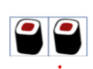(1)

dp(1) = 1

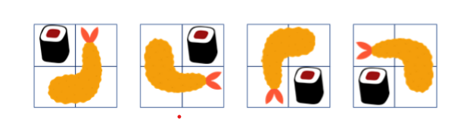dp(3) = 11

8種組合

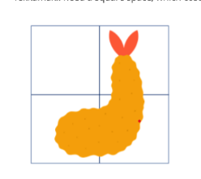

2種組合



1種組合

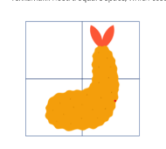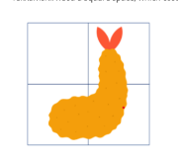(2)

No

當 dp = 3時，此方程式不成立，因為有情況未被包含進去 如:

(3)dp(4) = dp(1) + dp(3)+dp(3)+dp(1)+dp(2)+dp(2)

(4)dp(5) = dp(4) + dp(1) + dp(1) + dp(4)

dp(5) = dp(4) + dp(1) + dp(1) + dp(4) = 2(dp(4) + dp(1)) = 2(dp(1)+dp(2)+ dp(3)+ dp(4))

dp(n) = 2( dp(n-1),….dp(1) )

3.

(1) 因為有M格，而每格只有1或0兩種選擇，因此為2M

(2)2M-1 ~ 0

(3)if(P&S != 0) 則可知道上下兩行必有相鄰的西瓜

(4)