Sample of Paper Publication for IJ3C
??
Gwo-Jen Hwang^{1*}, Author Name², Author Name³, Author Name¹

ABSTRACT
With the advancement and popularity of mobile and wireless communication technologies, computer-supported learning activities can be conducted without being limited by time and space. Researchers have called such an anywhere and anytime learning approach "ubiquitous learning." In a ubiquitous contextual learning activity, students are situated in an environment that combines real-world and digital-world learning resources. Although such a learning approach is innovative and interesting, researches have pointed out the problem of lacking proper learning mechanisms that can guide or assist the students to learn collaboratively in such complicated learning contexts. To cope with this problem, in this study, a collaborative learning system is developed based on a knowledge engineering approach to supporting collaborative ubiquitous learning activities. Anexperiment conducted in an elementary school Natural Science course has shown the effectiveness of this system.
Keywords: e-learning, collaborative learning, knowledge acquisition, ubiquitous learning
I. INTRODUCTION
Researchers have indicated that schools are communities of practice with their own formal and informal codes of behavior, but this traditional learning cannot be regarded as situated since the curricular content is not used by the school community itself[1-4]; moreover,students find it difficult to apply learned knowledge after school because learning takes place within the culture of school life instead of the culture in which the domain knowledge is used [5]. Students prefer “authentic activities” in which they can work with problems from the real world. In addition to learning in an authentic scenario, researchers have also indicated the importance of enabling students to access educational information flexibly, calmly and seamlessly. In order to situate students in an authentic learning environment, which refers to direct experiences that take place within the context of practice, it is important to place the students in a series of designed lessons that combine both real and virtual learning environments [6].
Paper submitted 08/15/11; revised 11/15/11; accepted 12/30/11.
*Corresponding Author: Gwo-Jen Hwang (E-mail:gjhwang.academic@gmail.com).
¹Graduate Institute of Digital Learning and Education, National Taiwan University of Science and Technology, 43, Sec.4, Keelung Rd., Taipei, 106, Taiwan
²Department of Computer Science and Information Management, Soochow University, Taipei, Taiwan
³Department of Information and Learning Technology, National University of Tainan, 33, Sec. 2, Shulin St., Tainan city 70005, Taiwan

In the past decade, various studies have been conducted to situate students in authentic environment with learning supports from the digital systems via mobile and wireless communication technologies. For example, Chen, Kao, and Sheu (2003) presented an in-file learning activity about bird watching using mobile devices [7]. Ogata and Yano (2004) demonstrated a language learning system that is able to guide the students to practice Japanese based on the real-world contexts surrounding the students [8]. Hwang and Change (2011) conducted an elementary school social science learning activity in a temple with mobile devices [4]. With the help of these new technologies, individual students are able to learn in real situations with learning supports or instructions from the computer system using the mobile devices to access the digital content via wireless communications.
Furthermore, by applying the sensing devices, such as RFID (Radio Frequency Identification) or QR (Quick Response) codes, the learning system can detect and record the learning behaviors of the students in both the real world, and hence learning guidance can be provided accordingly. Such a new technology-enhanced learning model has been called context-aware ubiquitous learning (u-learning) or ubiquitous contextual learning [9]. It not only supports learners with an alternative way of dealing with problems in the real world, but also enables the learning system to more actively interact with the learners [9-12].That is, a context-aware u-learning environment is able to offer more adaptive supports to the learners by taking into account their learning behaviors and contexts in both the cyber world and the real world; moreover, the learning system can actively provide personalized supports or hints to the learners in the right way, in the right place, and at the right time, based on the personal and environmental contexts in the real world, as well as the profile and learning portfolio of the learner[13-16].
However, without proper learning support, students might feel confused in such an “active”, “authentic”, “constructive” and “collaborative” learning environment. Among various technologies, computer-oriented Mindtools have been recognized as being an effective way for training the “meaningful learning” and “critical thinking” abilities of students. Jonassen (1999) further indicated that, the creation of the knowledge bases of expert systems is the part of the activity that engages critical thinking [17]; that is, students are likely to interpret and organize their personal knowledgewhile participating in the knowledge acquisition process, which has been called knowledge engineering. Therefore, it has become an important issue to develop Mindtools using the knowledge engineering approach.Researchers also indicated that the critical bottleneck of building expert systems is to obtain the knowledge of the special domain from the domain experts, which is called knowledge acquisition; The most widely used knowledge acquisition technology is the grid-based approach [18-20].
In the past decades, several models have been proposed to generate more meaningful rules based on the grid-oriented approaches, such as the EMCUD method, which can generate embedded meanings from a grid-based knowledge representation format by defining the impacts of the constructs on each element [21-22].Chu and Hwang (2008) proposed a Delphi-based approach to eliciting knowledge from multiple experts with a grid-based approach originated from the method proposed by Kelly(1955), and applied it to a medical category [23-24]. It can be seen that researchers not only consider gathering individuals’ knowledge, but also concentrate on reaching the common consensus of a group. More precisely, it is aimed to offer chances to group members to refer to other members’ knowledge and enhance or share one’s own knowledge.
II. BACKGROUNDAND MOTIVATION
Lave (1991) indicated that schools are communities of practice with their own formal and informal codes of behavior [3], but this traditional learning cannot be regarded as being situated since the curricular content is not used by the school community itself. Students find it difficult to apply learned knowledge after school because learning takes place within the culture of school life instead of within the culture in which the domain knowledge is used [5]. Students prefer “authentic activities” in which they can work with problems from the real world.
Young (1993) indicated that there are four critical tasks involved in instructional design for situated learning [24]: (1) Selecting the situations that will afford the acquisition of knowledge that the teacher wishes each student to acquire [26]; (2) Providing necessary “scaffolding” for novices to operate within the complex realistic context, while still permitting experts to work within the same situation [27]; (3) Giving support that enables teachers to track progress, assess information, interact knowledgeably and collaboratively with individual students or cooperating groups of students, and prepare situated learning activities to assist the students in improving their ability to utilize skills or knowledge [28]; (4) Defining the role and nature of assessment and what it means to "assess" situated learning [29].
35
In addition to learning in an authentic scenario, researchers have also indicated the importance of enabling students to access educational information flexibly, calmly and seamlessly. In order to situate students in an authentic learning environment, which refers to direct experiences that take place within the context of practice, it is important to place the students in a series of designed lessons that combine both real and virtual learning environments [6]. Hwang et al. (2008) further defined the term “context-aware ubiquitous learning” [9]. In such a learning environment, the learner’s situation or the situation of the real-world environment in which the learner is located can be sensed, implying that the system is able to conduct the learning activities in the real world. That is, a context-aware u-learning environment is able to offer more adaptive supports to the learners by taking into account their learning behaviors and contexts in both the cyber world and the real world; moreover, the learning system can actively provide personalized supports or hints to the learners in the right way, in the right place, and at the right time, based on the personal and environmental contexts in the real world, as well as the profile and learning portfolio of the learner. Jonassen (1999) indicated that “meaningful learning” consists of several characteristics [17]:
35
35
- Active: learners interact with an environment and manipulate the objects in that environment.
- Constructive: learners integrate new experiences with their prior knowledge for constructing their own explanations of the target objects.
- Authentic: learning tasks are situated in some meaningful real-world learning missions or simulated in some case-based or problem-based learning environments.
- Cooperative/collaborative: learners are arranged to work in a way that involves social negotiation and knowledge sharing
However, without proper learning support, students might feel confused in such an “active”, “authentic”, “constructive” and “cooperative/collaborative” learning environment. Among various technologies, computer-oriented Mindtools have been recognized as being an effective way for training the “meaningful learning” and “critical thinking” abilities of students. Jonassen (1999) further indicated that the creation of the knowledge bases of expert systems is the part of the activity that engages critical thinking [17]; that is, students are likely to interpret and organize their personal knowledgewhile participating in the knowledge acquisition process. Therefore, it has become an important issue to develop Mindtools using a knowledge acquisition approach.
Among the existing knowledge acquisition methods, the repertory grid method proposed by Kelly (1955) has been recognized as being the most widely used [18-20, 24]. A single repertory grid is represented as a matrix whose columns have element labels and whose rows have construct labels. An element might represent a decision to be made, an object to be classified or a goal to be achieved, while a construct consists of a trait and the opposite of that trait; therefore, a grid represents a class of objects, or individuals, and the value assigned to an element-construct pair value reflects the linking relationship of the element and the construct. In recent years, the repertory grid method has been used as a tool for teachers in designing learning content and for students in reorganizing their knowledge. For example, Shih et al. (2011) developed a context-aware u-learning environment for learning about campus vegetation in elementary schools based on employing the repertory grid method to design the learning content [30]; Chu et al. (2008) employed the repertory grid method to assist teachers in defining metadata of e-libraries to meet the need of training students’ observation and classification skills [31]. Chu, Hwang, and Tsai (2010) further developed a repertory grid-oriented Mindtool to assist students to learn in a nature science course of an elementary school [13].
In addition to serving as a personal knowledge construction tool, repertory grid-oriented techniques have been employed to gather opinions from multiple experts, and consideration has been given to how to generalize those suggestions to one meaningful and completed outcome [23][32]. For example, Alexander et al. (2008) introduced a different form of repository grid, called a “Reflection Grid”, as a collaboration tool, which was applied to a Management Sciences study to assist research teams in probing some issues and sharing their findings [33]. The study of Chu and Hwang (2008) further showed that repertory grids can not only be used to successfully gather opinions from individuals, but can also help group members to concentrate on reaching a common consensus [23]. That is, repertory grids could be an effective Mindtool for conducting collaborative working or learning. Therefore, in this paper, a repertory grid-oriented Mindtool for collaborative u-learning is proposed. Moreover, a collaborative learning activity has been conducted for a natural science course of an elementary school to investigate the effectiveness of this innovative approach.
III. GRID-ORIENTED SYSTEMFOR COLLABORATIVEU-LEARNING
In the collaborative u-learning activity, the students need to determine the constructs for describing and classifying the target elements by themselves. Moreover, they need to fill in each <construct, element> relationship with a description instead of a rating. The teachers need to provide the objective repertory grid, which will be served as the scaffolding for the students, as shown in Table 1 [34].
36
Table 1. Illustrative example of an objective grid given by the teacher
 | Pachlioptaaristolochiaeinterpositus | male Papiliomemnonheronus | Idea leuconoe
Forewings’ Color | Deep brown | Deep blue | White with black spots  ??
Hindwings’ Color | Black embellished red and white spots | Shining blue | White with black spots
Having tails on hindwings | Yes | No | No
Having cell on Forewings | Yes, one | Yes, one | Yes, one
Having cell on hindwings | Yes, one | Yes, one | Yes, more than one
How many pairs of legs? | 3 | 3 | 2
Obvious different pattern between forewings and hindwings | Yes, red and white spots on hindwings | Yes,wavy edge and a row of big black spots on hindwings | No

The collaborative u-learning activity consists of three phases (as shown in Figure 1):
- In the first phase, the students are guided to observe the learning objectives in the authentic environment. They compose new knowledge via building the grid to describe the attributes of the learning objects and the relationships among them. Students are allowed to interact with their peers in this phase. After the students complete their own grid, the teacher integrates the grids developed by individual students and grades the importance degree for each construct.
- In the second phase, the students are allowed to refer to the integrated grid, and modify their own grid in computer classroom. That is, students are allowed to incorporate new ideas (constructs) by discussing with their peers and visiting the integrated knowledge grid.
- In the third phase, the students will be asked to observe the learning objectives in the authentic environment again, to modify their own grid.
Based on the innovative approach, the PCUL (System for Collaborative U-Learning) system has been developed to assist the students in identifying and classifying learning objects observed in the real world. By following the instruction displayed on the PDA, the student can find the exact location of the target butterfly, and start to observe its characteristics of it.
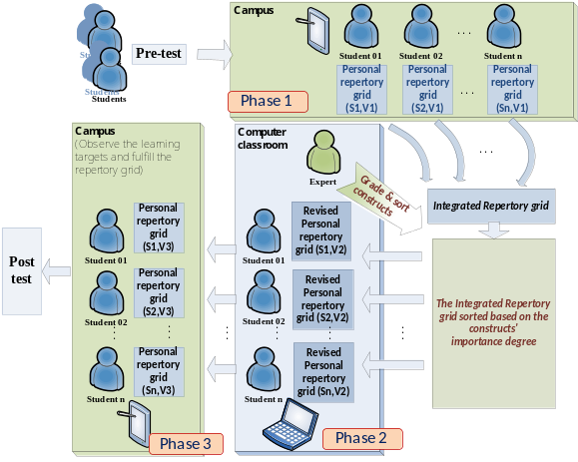
Figure 1. The three phases of the collaborative u-learning activity
After finishing the observation of the butterfly, the student will be guided by PCUL to find another target butterfly in the butterfly ecology garden and compare the two. Meanwhile, the student is asked to find a construct for distinguishing the butterflies and write it on the PDA. If the student fails to determine the construct, some observation guidance will be given by PCUL (as shown in Figure 2).

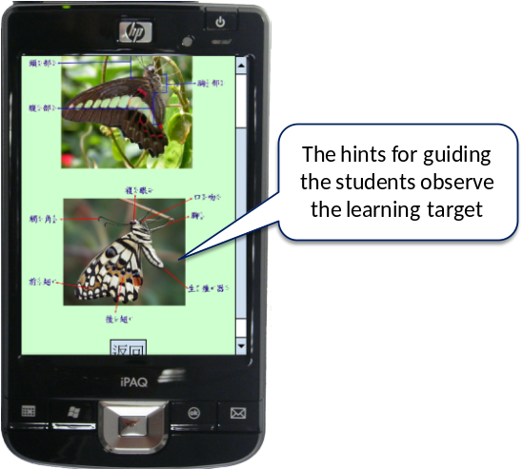

Figure 2. Illustrative example of guiding the students to observe the butterflies
While observing butterflies in the ecology garden, the students are guided by PCUL based on their on-going grids. As shown in Figure 3, PCUL will assist the students to give a construct by using that to distinguish the two objects. Once the student define the construct, they will be asked to complete their grids by observing the learning objects with empty <learning object, construct> value.
??

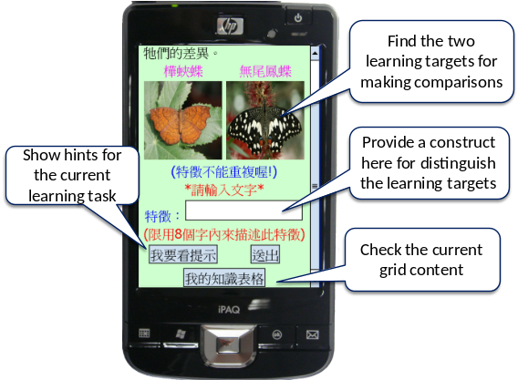
Figure 3. Illustrative example of guiding the students to observe the butterflies and defining a construct
After defining all the constructs, the students are asked to complete the learning results in their grid (as shown in Figure 4).

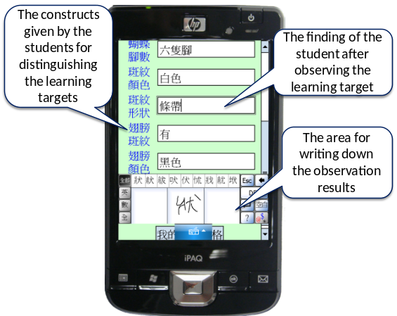
Figure 4. Illustrative example of guiding the student to record the observation results
In the second phase, the students are asked to refer to the integrated grid and modify their own grids in the computer room. To offer high quality reference materials, the experts are asked to grade the grids and the constructs developed by the students before starting the knowledge-sharing activity. In addition, all of the constructs provided by the students are sorted by the experts from the most important to the least important. When the students log in PCUL in computer room, an interface is provided to show the grids developed by individual students in the first phase, as shown in Figure 5. In this interface, all of the grids are displayed with a grade from five stars (excellent) to zero star (poor). After referring to the graded grids, the students are allowed to modify their own grids.
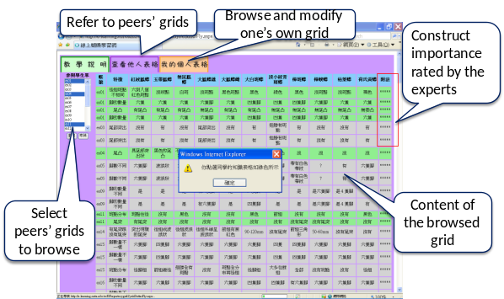
Figure 5. Interface of PCUL for browsing the grids developed by individual students
IV. EXPERIMENTAND ANALYSIS
To evaluate the effectiveness of the PCUL system, an experiment was conducted on the “Butterfly and Ecology” unit of the natural science course of an elementary school in Taiwan. The objective of this course was to help the students realize the living styles as well as identify and differentiate the appearances the butterflies. The authentic learning environment is a “Butterfly and Ecology” garden in an elementary school. The butterfly ecology garden consisted of 11 ecology areas according to the specific host plant; moreover, each area has an instructional sign to introduce the butterflies in that area. Note that each species of butterfly requires special host plants as their foods; therefore, in each ecology area, the students are able to observe the ecology of the butterflies that have special relevance to the host plants of that area. The participants of this study were 41 fifth-grade students taught by the same teacher in the third elementary school. After receiving the fundamental plant knowledge in a natural science course, the participants were divided into a control group (n = 20) and an experimental group (n = 21).
A pre-test was conducted to ensure that both groups of students had the equivalent basic knowledge required for learning the subject unit. The mean and standard deviation of the pre-test were 74.9 and 7.15 for the control group, and 78.10 and 9.95 for the experimental group with t = -1.18 and p > .05, implying that the two groups of students had equivalent abilities in learning the subject unit.
The test items of the post-test aimed to evaluate the knowledge for recognizing and comparing butterflies based on their characteristics, which is the objective of the subject unit. The post-test scores were used as an indicator for representing the learning achievements of the students. From the t-test results of the post-test, it is found that the students in the experimental group had significantly better achievements than those in the control group (t=3.58, p<.001). This result implies that the innovative approach is helpful to students in improving their learning achievements in terms of the identifying and differentiating butterflies.
??
This study further investigated the improvements of the students’ in-field differentiating ability by evaluating the grids developed during the learning process. Researchers have indicated that the quality of the differentiating ability represented in a grid highly depends on two factors: first, the constructs (i.e., characteristics) used for identifying and classifying the elements (i.e., butterflies); second, the ratings given to describe the relationships between the constructs and the elements [23-26].
In this study, the learning activity for the students in the experimental group consisted of three phases. In the first phase, the students were guided to observe the learning objects in the butterfly garden and to develop their own grids. In the second phase, the students were asked to share their grids with others. In the third phase, the students were asked to observe the learning objects in the butterfly garden again, and modify their grids according to their observations, as shown in Figure 6.
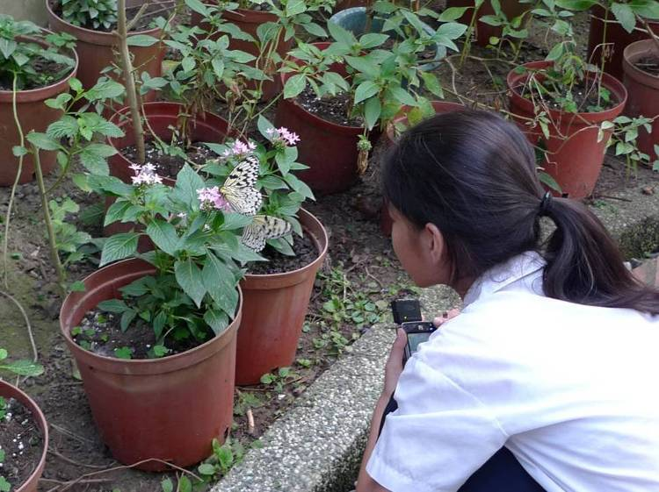
38
Figure 6. A student is observing the ecology of butterflies to complete her grid
The grids developed in each phase were evaluated by two experienced teachers based on the suitability of selecting the constructs for classifying the butterflies and the correctness of the ratings for describing the <butterfly, characteristic> relationships. By applying the Pearson correlation analysis, it was found that the scores given by the two experts were highly consistent, with a correlation coefficient of 0.81 (p < .01).
The paired-samples t-test result for the scores of the grids developed by the students in the first and third phases is shown in Table 2, indicating statistically significant improvements in field differentiating ability after participating in the collaborative u-learning activity.
Table 2. Paired-samples t-test of the scores of the grids developed in the first and third phases
 | Mean | N | SD | M.D. | t
The grid scores in the first phase | 28.50 | 21 | 14.73 | -48.12 | -9.81***
The grid scores in the third phase | 76.62 | 21 | 28.14
***p < .001; M.D.: Mean difference
V. CONCLUSIONS
In this paper, a knowledge engineering approach is proposed for developing PCUL (Mindtool for Collaborative U-Learning) for collaborative u-learning activities. From the experiment results, it was found that PCUL is helpful to the students in improving their in-field differentiating ability after participating in the collaborative u-learning activity.
Norman (1993) distinguished the thinking aspects into two forms; that is, “experiential thinking” and “reflective thinking” [35]. Experiential thinking means making decisions or learning according to one’s own experiences; reflective thinking, on the other hand, requires deliberation. Norman contended that reflective thinking occurs when students construct new knowledge by adding new representations, modifying old ones, and comparing the two. In this study, PCUL will guide the students to observe the target objects in the real-world learning environment and develop their own repertory grids; that is, the students need to organize their knowledge via “experiential thinking”. In the second phase, the students are guided to share their repertory grids with others and revise the repertory grids after making further observations; that is, they are asked to do reflective thinking.
The experiment results show that the innovative approach is helpful to the students in improving their knowledge structure as well as their learning achievements in comparison with the “pure” u-learning approach that guides and provides hints to the students for observing target objects in the real world without the aid of Mindtools. That is, the knowledge sharing mechanism that supports the students to collaborate in fields enables the students to go through “experiential thinking” and “reflective thinking,” such that their knowledge can be re-organized after referring to the findings in fields and the knowledge structure shared by their peers. This finding complies with what has been reported by other researchers, that is, students improve significantly when they participate in learning socially, and interact in face-to-face collaborative learning activities [27, 36], particularly, when using hand-held devices to learn [37-38].
Although PCUL seems to be effective and promising, there are some limitations to the current approach. As the repertory grid method is suitable for representing classification knowledge, such as the identification of plants, animals or diseases, it can only be applied to courses that are relevant to the classification of knowledge, such as medical treatment, natural science or chemistry [13]. To develop effective Mindtools for other courses that are not related to the classification of knowledge, such as mathematics or experiment procedures, one might need to find more suitable approaches.
??
Furthermore, although PCUL is helpful to the students, the teaching burden for the teachers in developing the objective repertory grids cannot be neglected; therefore, in the future, it is important to provide a system to assist the teachers to develop objective repertory grids with an easy-to-follow procedure. Currently, we plan to conduct a series of experiments to analyze the correlation between the learning achievements of the students and their grid outcomes. We also plan to compare the knowledge structures, observation ability and differentiating ability of individual students in different collaborative learning stages.
ACKNOWLEDGMENTS
This study is supported in part by the National Science Council of the Republic of China under contract numbers NSC 99-2511-S-031 -002 -MY2 and NSC 99-2631-S-011 -002.
REFERENCES
- C. K.Chiou, Judy C. R. Tseng, G. J. Hwang, andS. Heller, “An adaptive navigation support system for conducting context-aware ubiquitous learning in museums,” Computers & Education, vol. 55, no. 2, pp. 834-845, Sept. 2010.
39
- H. C. Chu, G. J. Hwang, C. C. Tsai, and Judy C. R.Tseng, “A two-tier test approach to developing location-aware mobile learning systems for natural science courses,” Computers & Education, vol. 55, no. 4, pp. 1618-1627, Dec. 2010.
- J. Lave, “Situating Learning in Communities of Practice,”in Perspectives on Socially Shared Cognition. L. B. Resnick., J. M. Levine., & S. D. Teasley, Eds. Washington, DC: American Psychological Association, 1991, pp. 63-82.
- G. J. Hwang, andH. F. Chang, “A formative assessment-based mobile learning approach to improving the learning attitudes and achievements of students,” Computers & Education, vol. 56, no. 1, pp. 1023-1031, May 2011.
- J. S. Brown, A. Collins, and P.Duguid, “Situated Cognition and the Culture of Learning,” Educational Researcher,vol. 18, no. 1, pp. 32-42, Jan. 1989.
- M. Minami, H. Morikawa, and T. Aoyama, “The design of naming-based service composition system for ubiquitous computing applications,”in proceedings of the 2004 Symposium on Applications and the Internet-Workshops (SAINT 2004 Workshops), Washington, DC: IEEE Computer Society Press, 2004, pp. 304-312.
- Y. S. Chen, T. C. Kao, andJ. P. Sheu, “A mobile learning system for scaffolding bird watching learning,” Journal of Computer Assisted Learning, vol. 19, pp. 347-359, Apr. 2003.
- H. Ogata, andY. Yano, “Context-Aware Support for Computer-Supported Ubiquitous Learning,” in proceedings of the 2nd IEEE International Workshop on Wireless and Mobile Technologies in Education (WMTE'04), JungLi, Taiwan: IEEE Computer Society, 2004, pp. 27-34.
- G. J. Hwang, C. C. Tsai, and S. J. H. Yang, “Criteria, Strategies and Research Issues of Context-Aware Ubiquitous Learning,” Educational Technology & Society, vol. 11, no. 2, pp. 81-91, 2008.
- G. J. Hwang, F. R. Kuo,P. Y. Yin,and K. H. Chuang, “A Heuristic Algorithm for planning personalized learning paths for context-aware ubiquitous learning,” Computers & Education, vol. 54, no. 2, pp. 404-415, Feb. 2010.
- G. J. Hwang, T. C. Yang, C. C. Tsai, and Stephen J. H. Yang, “A context-aware ubiquitous learning environment for conducting complex experimental procedures,” Computers & Education,vol. 53, pp. 402-413, Sept. 2009.
- S. J. H. Yang, T. Okamoto, and S. S. Tseng, “A Matter of Context-Aware Ubiquitous Learning,” Journal of Educational Technology and Society,vol. 11, no. 2, pp. 1-2, 2008.
- H. C. Chu, G. J. Hwang, and C. C. Tsai, “A knowledge engineering approach to developing Mindtools for context-aware ubiquitous learning,”Computers & Education, vol. 54, no. 1, pp. 289-297, Jan. 2010.
- H. C. Chu, G. J. Hwang, and Judy C. R. Tseng, “An innovative approach for developing and employing electronic libraries to support context-aware ubiquitous learning,” The Electronic Library, vol. 28, no. 6, pp. 873-890, 2010.
- P. H. Hung, Y. F. Lin, and G. J. Hwang, “Formative assessment design for PDA integrated ecology observation,” Educational Technology & Society, vol. 13, no. 3, pp. 33-42, Jul. 2010.
- J. L. Shih, C. W. Chuang, and G. J. Hwang, “An inquiry-based mobile learning approach to enhancing social science learning effectiveness,” Educational Technology & Society, vol. 13, no. 4, pp. 50-62, 2010.

- D. H. Jonassen, Computers as mindtools for schools, engaging critical thinking, Englewood Cliffs, NJ: Prentice-Hall, 1999.
40
- H. M. Edwards, S. McDonald, and S. M. Young, “The repertory grid technique: Its place in empirical software engineering research,” Information and Software Technology, vol. 51, pp. 785-798, 2009.
- G. J. Hwang, B. M. T. Lin, H. H. Tseng, and T. L. Lin, “On the Development of a Computer-Assisted Testing System with Genetic Test Sheet-Generating Approach,”IEEE Transactions on Systems, Man, and Cybernetics: Part C, vol. 35, no. 4, pp. 590-594, Nov. 2005.
- D. Jankowicz, The Easy Guide to Repertory Grids, University of Luton, UK: Wiley press, 2004.
- G. J. Hwang, and S. S. Tseng, “EMCUD: A knowledge acquisition method which captures embedded meanings under uncertainty,” International Journal of Man-Machine Studies, vol. 33, no. 4, pp. 431-451, Oct. 1990.
40
- G. H. Hwang, J. M. Chen, G. J. Hwang, and H. C. Chu,“A time scale-oriented approach for building medical expert systems,” Expert Systems with Applications, vol. 31, no. 2, pp. 299-308, Aug. 2006.
- H. C. Chu, and G. J. Hwang, “A Delphi-based approach to developing expert systems with the cooperation of multiple experts,” Expert Systems with Applications, vol. 34, pp. 2826-2840, May 2008.
- , Jan. 2009

Photo  (Electronic File) | Author 1 Biographies: 10 points, …. …. ….. …..

Author 2 Biographies, 10 points ….. ….. ……….. ……….

