**Assignment: See it, correct it, now make it**

**Website**

<https://danny1401.github.io/See-it_Correct-it_Make-It/>

or

<https://danny1401.github.io/See-it_Correct-it_Make-It/index.html>

**The Partner Group**

|  |  |  |
| --- | --- | --- |
| **Name** | **Student number** | **Additional info** |
| Danny Thinh Tran | s354409 |  |
| Kunwar Karan Singh | s235371 | PACT as an appendix on the last page |

**The barriers from the website “*University of Advancing Technology”***

* From what I can see in the design is that there seems to be no sort of borderlines or not spaces between the elements so it feels like it’s too much sometimes. We can’t really feel the flow of how the elements are connected, but rather the fact that the elements are pushing each other for more room and attention.

***Solution:*** *Open up for more room between the elements or change their positions to other places so it’s easier to take in all the information from the website.*

* 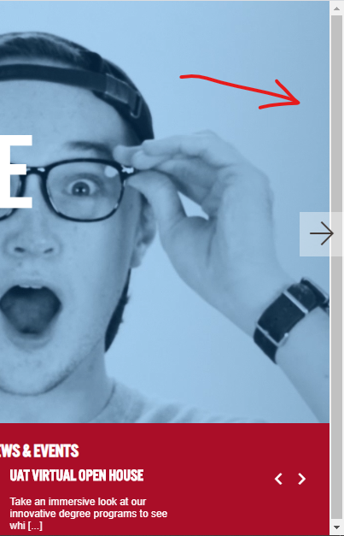There seems to be a misplaced scrollbar on the homepage which doesn’t have a purpose for anything on the site. Looking through the pages of the website from Google Chrome, it seems that the scrollbar only appears on the homepage, but I don’t know if it’s the same with the other browsers.

***Solution:*** *Remove the scrollbar.*

* 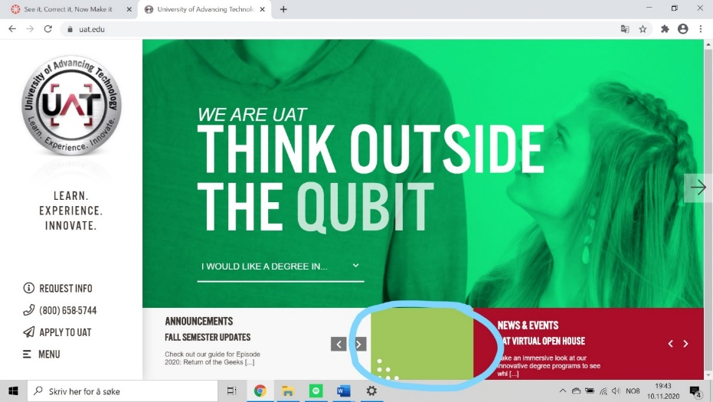The green box in the middle doesn’t seem to lack any purpose so it takes up some unnecessary space on the website. The color doesn’t seem to fit in that much either.

***Solution:*** *Remove the green box.*

* 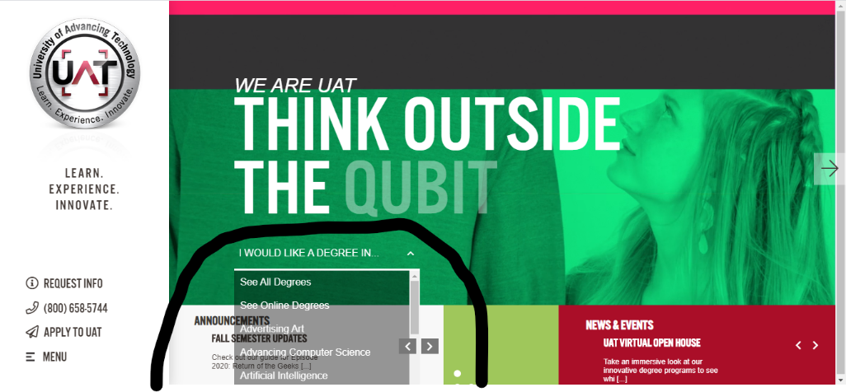There seems to be a little dropdown button in the moving image at the homepage. At first, I didn’t notice it because I thought it was a part of the video, but after looking through how it works, I realized that it would be better off if it was placed somewhere else.

The dropdown function seems to overlap under website too, since we can’t see the last option – Virtual Reality. The transparency doesn’t seem to fit in either with the design.

***Solution:*** *Change the whole idea of the dropdown to something that makes it easier to find the different degrees and place it under the page.*

* The boxes which shows announcements and news, should be placed somewhere else since they don’t really fit in with the moving image on top. Their functions don’t show a lot of information either since they just work as links to other pages with more stable information.

***Solution:*** *Place the boxes under the page with a cleaner way to look at the information. Since it’s just links, they would be better off as buttons.*

**PACT APPENDIX s235371 (Did not submit within 1. October)**

*Kunwar Karan Singh (s235371) did not submit the PACT assignment within 1. October, therefore his pact assignment is added as an appendix to this word document.*

Persona;

The person I have chosen is from option D. She is 65 years old, living in Siberia. I give her a fictional name, Sandra.

Scenario 1;

This person, let’s call her Sandra, wants to buy a present to her niece to Christmas. Her niece wants clothes to her birthday. Therefore, she goes to the web to try to find relevant information. After researching for a while, she finds [www.ellos.no](http://www.ellos.no). She has heard that this company has nice clothing for all ages, but she does struggle a bit navigating throughout. In the following list we will explore this further.

Barriers;

1. The menu items are not as intuitive to use for everyone. Especially if you aren’t that familiar with all types of website designs.

Solution: Add the menu items visible on the top part of the website. With buttons such as “Home” “Men” “Women” “Kids” etc.

2. It is quite difficult to find a phone number when you go through the “contact us” section. Some costumers might prefer calling to ask a questing, and therefore it should be more visible.

Solution: Place the phone number more visible in the contact us section.

3. The St. Tropez site within [ellos.no](http://ellos.no) has a lot of effect and animations. This can seem a bit confusing for many visitors.

Solution: Reduce the amount of effects and animation on those pages (to be specific; the St.Tropez window).

4. Within the site there are a lot of pop-up windows. These might be seen as confusing, and disturbing.

Solution; Use less Pop-up windows throughout the website.

5. When ordering online the “you might like” section takes up too much space and attention. It is not easy enough to instead navigate to the next step of the ordering process. I understand that this might be for marketing purposes (to sell more items), but it might leave a negative impact on some costumer’s overall satisfaction.

Solution; Reduce the size of the “you might like” section and make the “next step” buttons larger and more visible.

6. It is not so easy to find information about the different payment options on the site. You have to find a product you like, and then go through all of the sections, such as “membership”, “you might like”, etc. This could be challenging.

Solution; Add more information about the payment options at the bottom of the first page for example. Or leave a link to it.

7. The filter to find different styles of clothing is not that easy to use. I see this especially in the Adidas section for kid clothing.

Solution; Add a simpler form instead of the current solution. Maybe have a section with just the form, instead of a pop-up form.

8. The pictures on the home page are quite large and creates some confusing.

Solution; Make the pictures and text a bit smaller on the home page, so that it becomes easier to navigate.

9. When scrolling through the different products and clothes [ellos.no](http://ellos.no) has decided to use “endless” scrolling. So, it downloads more and more products as you scroll downwards. This might make it more difficult to find a product you previously liked when scrolling through.

Solution: Have individual pages when scrolling, such as page 1, page 2, e.g.

10. When buying clothes as a gift, or even for ourselves it could be difficult to imagine how large the clothes will be. [ellos.no](http://ellos.no) have a “review” function. But it would be nice to include a parameter to see how other people felt about the exact size. Like “how accurate was the size” too small or too large?

Solution; Add information on the individual clothe page of the size accuracy.

11. We live in very globalized world. Many people, regardless their age talk different languages. It would be nice to have the ability to change the language of the website. [ellos.no](http://ellos.no) doesn’t have this easily accessible.

Solution: Add a change language button on the home page. Preferably with flags.