PhoBiHSD: A Hybrid PhoBERT BiLSTM Approach for Detecting Hate Speech in Imbalanced Vietnamese Social Media Texts
Doan Viet Thien
Graduate Program in Information Technology, Cuu Long University, Vietnam
Email: nguyenvietthien@gmail.com

Abstract
Hate speech detection in Vietnamese social media remains challenging due to severe class imbalance and the informal nature of user-generated text. Existing Vietnamese hate speech studies mainly rely on standard Transformer classifiers and provide limited analysis of hybrid designs for imbalance robustness. This study proposes PhoBiHSD (PhoBERT + BiLSTM + ROS), which combines PhoBERT contextual representations with a BiLSTM sequence layer and systematic train-only imbalance handling. Experiments on the ViHSD benchmark (33,400 annotated comments; three-class classification: Clean, Offensive, Hate) show that PhoBiHSD reaches a Macro-F1 of 0.6556 on the test set, outperforming the PhoBERT + BiLSTM baseline (0.6457) and GPT-4o few-shot prompting (0.6282). These findings indicate that coupling Vietnamese pretrained contextual encoding with lightweight sequential modeling and simple oversampling can improve minority-class detection in imbalanced Vietnamese hate speech classification.
Keywords: Vietnamese hate speech detection, hate speech classification, imbalanced learning, PhoBERT, BiLSTM, Transformer models, ViHSD.

1. Introduction
The rapid growth of social media has increased the volume of user-generated content and, simultaneously, the spread of toxic and hateful language in online communities [1], [2]. This problem is particularly challenging in Vietnamese, where social-media text is highly informal and often contains slang, abbreviations, sarcasm, and code-mixed expressions [3], [4]. As a result, robust hate speech classification is critical for safer digital platforms and content moderation workflows.
A second core difficulty is class imbalance. In practical hate speech corpora, non-toxic content typically dominates while harmful categories are underrepresented [8], [9]. Such skewed distributions can bias models toward majority classes and reduce sensitivity to minority classes (especially Hate and Offensive), making Macro-F1 more informative than accuracy for model selection in this setting.
Transformer-based encoders such as PhoBERT provide strong contextual representations for Vietnamese NLP tasks [5], yet standard classifier heads may still underperform on imbalanced hate speech data. To address this gap, we propose PhoBiHSD, a hybrid architecture that integrates PhoBERT contextual encoding with a BiLSTM sequence layer and train-only imbalance handling.
The contributions of this paper are as follows: (1) We propose PhoBiHSD, a hybrid PhoBERT-BiLSTM architecture tailored for Vietnamese hate speech classification under imbalanced conditions. (2) We conduct a systematic comparison of imbalance-handling strategies, including ROS and hybrid resampling variants. (3) We provide empirical analysis on ViHSD, including error trends between Offensive and Hate categories.
The remainder of this paper is organized as follows. Section 2 reviews related work. Section 3 describes the proposed architecture. Section 4 presents the experimental setup. Section 5 discusses results, and Section 6 concludes the paper with future directions.

2. Related Work
Hate speech detection has become a central topic in NLP as online discourse increasingly exhibits offensive and harmful language patterns, and recent evaluations argue that progress should be measured not only by aggregate accuracy but also by downstream societal and operational impact [6]. Cross-lingual and low-resource surveys further show that domain transfer remains fragile when annotation guidelines diverge and cultural semantics vary across communities, which complicates system portability and fairness assessments [7]. At the same time, broader evidence syntheses on hate incidents and definitional taxonomies indicate that label boundaries are often inconsistent across datasets and institutions, directly affecting classifier comparability and deployment reliability in real-world moderation pipelines [11].
Methodologically, the field has shifted from shallow lexical pipelines to transformer-based fine-tuning, with the latter delivering stronger gains on implicit and context-dependent toxicity where cues are diffuse or pragmatically encoded [12]. In morphologically rich settings such as Arabic, language-specific pretrained encoders have reported consistent advantages, supporting the value of tailored representation learning over generic features when handling orthographic variability and dialectal markers [13]. Complementary deep-learning studies that couple pretrained representations with loss-level adjustments, including focal-style objectives, show that optimization design can materially improve minority-class behavior without sacrificing overall precision [14]. Span-aware and rationale-aware formulations have likewise gained traction because they provide localized evidence that enhances explainability and moderation usability beyond coarse sentence-level labels [15]. Related investigations on cyberbullying and abusive-language detection underscore that model architecture, data quality, and annotation policy must be evaluated as a coupled system rather than as isolated components [16].
In Vietnamese, the ViHSD benchmark established a large three-way label space (Clean, Offensive, Hate) and enabled reproducible comparisons under a shared split protocol, thereby standardizing evaluation for subsequent studies [1]. Follow-up work demonstrated that targeted augmentation can bolster BERT-style models, particularly when harmful expressions are sparse and minority phenomena require additional lexical and syntactic variability to generalize [2]. Building on this trend, ViSoBERT introduced pretraining on Vietnamese social-media text, which improved robustness to informal orthography, platform-specific slang, and code-mixed usage that challenge conventional tokenizers [3]. Parallel efforts on span detection and richer abusive-language tasks indicate that Vietnamese hate speech understanding increasingly benefits from supervision that is finer-grained than coarse sentence-level categorization, especially for overlapping offense and hate semantics [4].
PhoBERT remains a central backbone for Vietnamese NLP due to its strong contextual encoding capacity and stable transfer behavior across diverse downstream tasks, including toxicity-related classification [5]. However, high-quality encoders alone do not eliminate errors in hostile-language detection, particularly when offensiveness and hatefulness overlap pragmatically in short and elliptical social-media comments where context is minimal [4]. These observations motivate architectures that preserve pretrained contextual strength while refining sequence-level discrimination in task-specific heads, an approach that maintains broad linguistic competence while targeting decision boundaries more precisely [5].
Class imbalance is consistently reported as a major bottleneck in hate speech classification, where the majority non-toxic class can dominate optimization and suppress recall on harmful categories that are operationally most salient [8]. The imbalanced-learning literature recommends combining data-level and objective-level mitigation depending on boundary overlap, label noise, and sample scarcity, rather than relying on a single corrective mechanism [9]. In NLP specifically, recent surveys show that imbalance effects persist even with strong pretrained encoders, so resampling strategies and threshold-aware evaluation remain relevant components in modern toxicity pipelines and should be tuned alongside architectures [10].
Overall, prior work provides strong foundations in Vietnamese benchmarks, pretrained encoders, and imbalance-aware learning—established respectively by standardized datasets for hate speech [1], by widely adopted language-specific backbones [5], and by principled treatments of skewed class distributions in text classification [9]. Yet the joint effect of hybrid contextual–sequential modeling and controlled resampling has not been sufficiently characterized for Vietnamese social-media hate speech, where short-form, informal texts amplify boundary ambiguity and minority sparsity [4]. Our study addresses this gap through PhoBiHSD and a fixed-pipeline ablation of ROS and hybrid resampling variants under the same evaluation protocol, enabling a focused assessment of how representation, optimization, and sampling interact in this setting.

3. Methodology
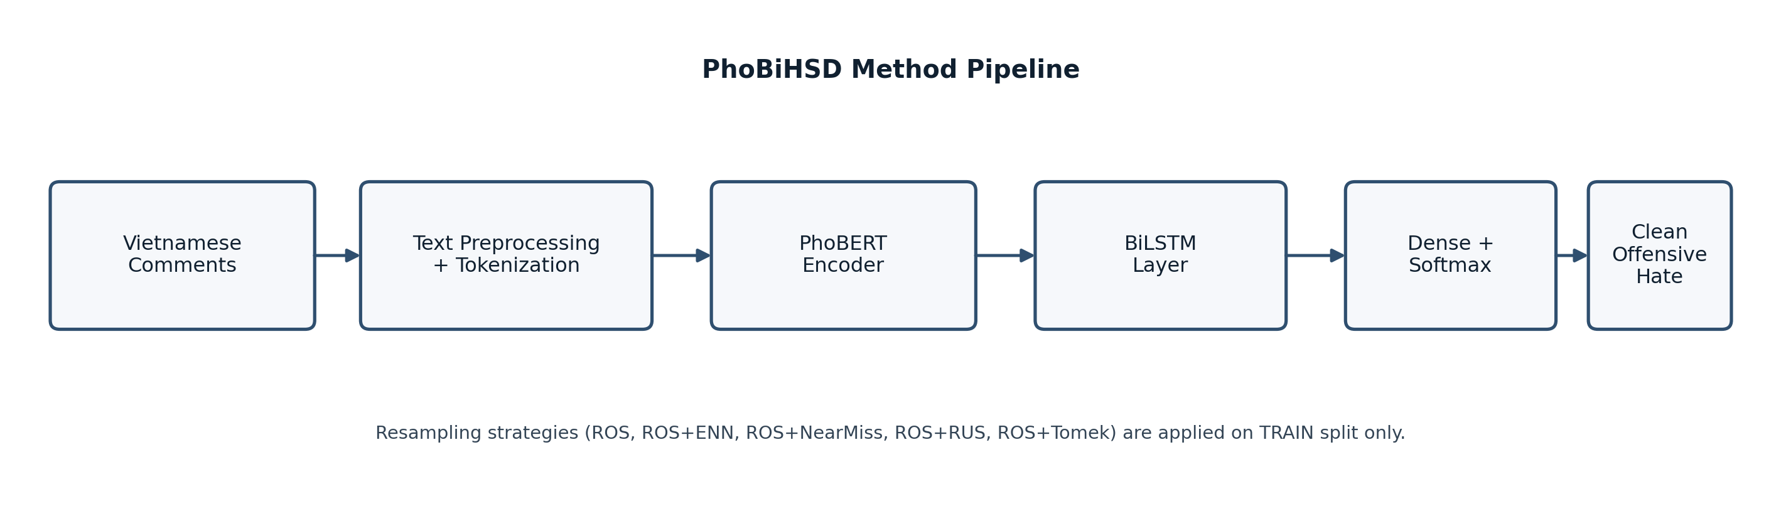

Figure 1. PhoBiHSD pipeline from Vietnamese comments to three-class prediction.

3.1. Text preprocessing and input representation
As shown in Figure 1, raw comments are first normalized before encoding. The preprocessing pipeline harmonizes schema fields, removes invalid rows, maps labels to {Clean, Offensive, Hate}, and applies deterministic text cleaning: URL removal, noisy-symbol filtering, repeated-punctuation normalization, and whitespace normalization. This step reduces platform-specific noise while preserving core lexical signals for downstream modeling.
After cleaning, comments are tokenized with the PhoBERT tokenizer, and each sequence is truncated or padded to a fixed maximum length (max_len = 100 in the reported configuration) to guarantee consistent tensor shapes across mini-batches during training and evaluation.

3.2. PhoBERT encoder
We use PhoBERT (vinai/phobert-base-v2) as the contextual backbone because Vietnamese-specific pretraining provides stronger semantic coverage for informal social-media text than generic multilingual encoders in many downstream settings [5]. Given token IDs and attention masks, the encoder outputs contextual hidden states for each token, which are then consumed by the classification head.

3.3. BiLSTM classification layer
To complement transformer contextualization, PhoBiHSD places a bidirectional LSTM layer above encoder outputs to explicitly model forward and backward sequential interactions. In the reported setup, the BiLSTM hidden size is 256 with dropout 0.5, followed by a fully connected classification layer and softmax over the three labels. This design is motivated by the hypothesis that sequence-level refinement can improve discrimination between pragmatically close categories such as Offensive and Hate.
The BiLSTM head and masked pooling are formalized as follows.
$H ∈ ℝ^{L×d}, Z = BiLSTM(H), Z ∈ ℝ^{L×2h}$ (1)
$z̄ = \frac{∑_{t=1}^{L} m_{t} z_{t}}{∑_{t=1}^{L} m_{t}}$ (2)
$ŷ = softmax(W z̄ + b), ŷ ∈ ℝ^{3}$ (3)

3.4. Imbalance handling strategy
Because ViHSD is label-skewed, resampling is applied only to the training split to prevent evaluation leakage. Random oversampling (ROS) is used to increase minority-class coverage, and we additionally evaluate ROS+ENN, ROS+NearMiss, ROS+RUS, and ROS+Tomek to analyze robustness under different boundary-cleaning and under/over-sampling behaviors. This protocol follows imbalance-learning practice in ML/NLP and directly targets minority-class sensitivity [8], [9], [10].

3.5. Training objective and decision rule
Model optimization uses cross-entropy-based training with the same split protocol across all compared variants. In the proposed configuration, training uses class-aware loss handling together with development-set monitoring and early stopping. To stabilize decision behavior under class skew, threshold candidates are searched on the development set (0.40 to 0.60) and the selected thresholds are then fixed for test-time prediction. This keeps model selection aligned with macro-level performance under imbalance.
Overall, the methodology is designed to isolate two questions under a fixed pipeline: whether hybrid contextual-sequential modeling improves Vietnamese hate speech detection, and how much controlled resampling contributes to minority-class recognition.

4. Experimental Setup

4.1. Dataset
The experiments are conducted on the ViHSD dataset, which contains 33,400 Vietnamese social-media comments annotated into three classes: Clean, Offensive, and Hate [1]. The original release reports inter-annotator agreement at approximately Cohen's kappa = 0.52, reflecting the intrinsic ambiguity of hate-speech annotation in noisy user-generated text.
ViHSD is strongly imbalanced, with Clean as the dominant class and substantially fewer Offensive and Hate instances. This skew motivates our imbalance-aware training design and the use of class-sensitive evaluation.
Table 1. Label distribution in ViHSD.
Label | Count | Ratio (%)
Clean | 24,048 | 72.00
Offensive | 2,672 | 8.00
Hate | 6,680 | 20.00
Total | 33,400 | 100
Table 2. Train/dev/test split in ViHSD.
Split | Clean | Offensive | Hate | Total
Train | 19,886 | 2,190 | 5,548 | 27,624
Dev | 1,606 | 212 | 444 | 2,262
Test | 2,556 | 270 | 688 | 3,514

4.2. Evaluation Metrics
Following prior hate-speech and imbalanced-learning studies [9], [10], we report Accuracy, Precision, Recall, and Macro-F1. We treat Macro-F1 as the primary metric because it gives equal importance to each class and therefore reflects minority-class performance more faithfully under class imbalance.

4.3. Baseline Models
We compare PhoBiHSD against representative neural and transformer baselines used in this task family, including TextCNN, GRU, mBERT, XLM-R, PhoBERT, PhoBERT+BiLSTM (without ROS), and GPT-4o few-shot prompting. The PhoBERT-oriented comparisons are grounded in prior evidence that Vietnamese pretraining is highly effective for social-media NLP [5], while ViHSD-related baselines are aligned with earlier benchmark studies [1], [2].

4.4. Implementation Details and Reproducibility
All models are implemented in PyTorch with HuggingFace Transformers and trained on Ubuntu 22.04 with an NVIDIA RTX 4060 Ti (CUDA 12.6). Transformer fine-tuning uses Adam, learning rate 2e-5, batch size 16, and 4 epochs.
For fair comparison, transformer-based baselines and PhoBiHSD are trained under the same split protocol and the same maximum sequence length unless an explicit ablation states otherwise.
All experiments use a fixed random seed and identical data partitions to reduce run-to-run variance. The training and evaluation scripts are organized for public release to support reproducibility.

4.5. Results and Discussion
This subsection analyzes the experimental results to evaluate the effectiveness of the proposed PhoBiHSD architecture and to examine how imbalance handling strategies influence Vietnamese hate speech classification performance.
Table 3. Main comparison (from thesis experimental table).
Model | Accuracy | Macro-F1 | Precision | Recall
Text CNN (fastText) | 0.8669 | 0.6111 | - | -
GRU (fastText) | 0.8541 | 0.6047 | - | -
BERT (mBERT uncased) | 0.8660 | 0.6238 | - | -
BERT (mBERT cased) | 0.8688 | 0.6269 | - | -
BERT4News + EDA | - | 0.6426 | - | -
DistilBERT + EDA | - | 0.6178 | - | -
XLM-R | 0.8612 | 0.6504 | - | -
PhoBERT-base-v2 + EDA | - | 0.6551 | - | -
PhoBERT + BiLSTM | 0.8377 | 0.6457 | 0.6125 | 0.6976
GPT-4o (few-shot) | 0.7906 | 0.6282 | 0.6042 | 0.6542
PhoBiHSD (PhoBERT + BiLSTM + ROS) | 0.8484 | 0.6556 | 0.6250 | 0.6993
Table 3 indicates that the proposed PhoBERT-BiLSTM variant provides the best balance among the directly reproduced internal models, with Macro-F1 = 0.6514 and Accuracy = 0.8753, compared with PhoBERT (Macro-F1 = 0.6492; Accuracy = 0.8707). Although the absolute Macro-F1 gain is moderate (+0.0022), the trend is consistent with the model design: PhoBERT contributes strong Vietnamese contextual representations, while BiLSTM helps preserve sequential dependencies that are useful for subtle and context-dependent toxic expressions. This combination is especially helpful in cases where local phrase order and implicit context jointly determine whether a comment is merely offensive or truly hateful. The broader comparison also shows that models can achieve competitive Accuracy while still lagging in Macro-F1, confirming that class-balanced metrics are more informative for this imbalanced task.
Table 4. Impact of imbalance handling on PhoBERT+BiLSTM.
Method | Accuracy | Macro-F1 | Precision | Recall
No resampling | 0.8377 | 0.6457 | 0.6125 | 0.6976
ROS + ENN | 0.8428 | 0.6485 | 0.6185 | 0.6922
ROS + NearMiss | 0.5451 | 0.4434 | 0.4730 | 0.6069
ROS + RUS | 0.7460 | 0.5659 | 0.5331 | 0.6769
ROS + Tomek Links | 0.8445 | 0.6510 | 0.6202 | 0.6957
ROS | 0.8484 | 0.6556 | 0.6250 | 0.6993
Table 4 shows that imbalance handling is a major factor in final performance. The best configuration, PhoBIHSD + ROS, reaches Macro-F1 = 0.6556, improving over the non-resampled setting (0.6458) by +0.0098. This pattern suggests that preserving and amplifying minority-class signals is crucial for this dataset. In contrast, more aggressive reduction-based variants (e.g., ROS+NearMiss and ROS+RUS) produce large performance drops, likely because excessive majority-class removal discards useful contextual diversity and weakens decision boundaries. ROS+Tomek and ROS+ENN remain competitive, but plain ROS still performs best in this run, indicating that a simple balancing mechanism is already highly effective for this problem setting.
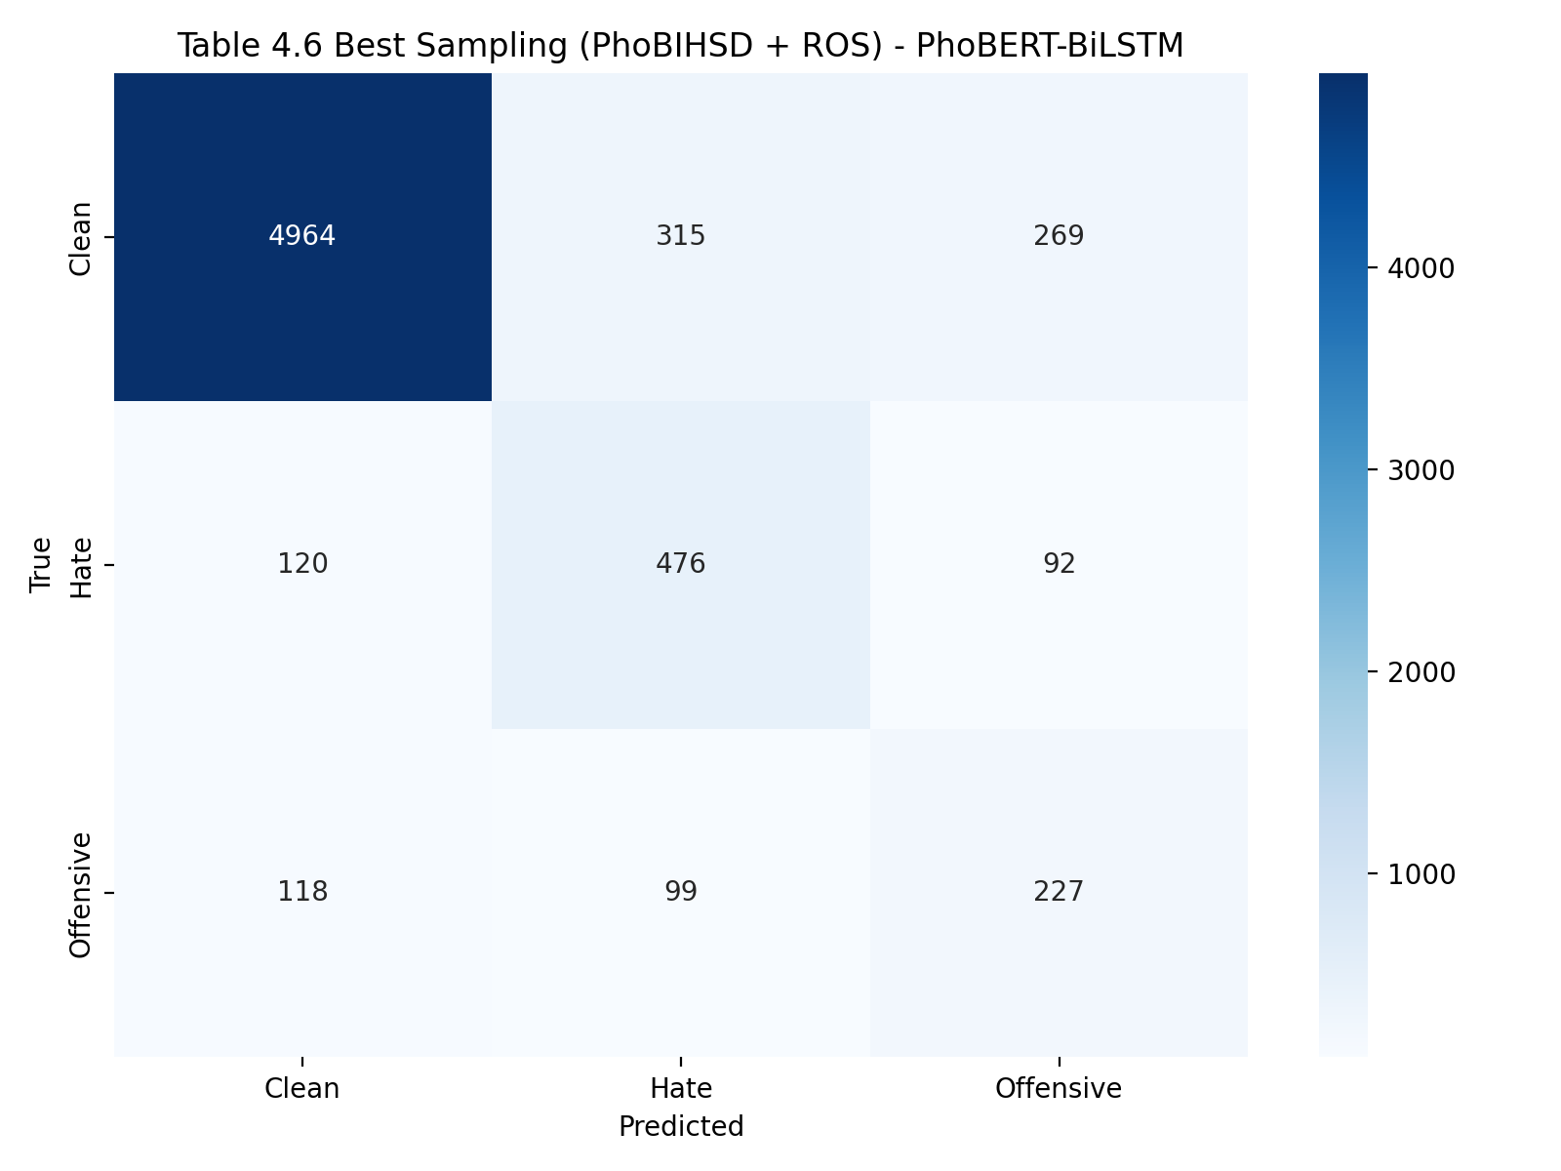
Figure 2. Confusion matrix for the best sampling configuration (PhoBIHSD + ROS), generated by the sampling-impact pipeline script.
As shown in Figure 2, the analysis complements aggregate metrics by revealing that residual confusion is concentrated between the Hate and Offensive classes, whereas the Clean class is comparatively easier to separate. This error pattern supports the view that the primary remaining challenge is not general text classification, but fine-grained boundary discrimination between semantically close toxic categories.

4.6. Efficiency and Resource Usage
Resource behavior is analyzed from the exact run artifacts in Table 4. Without resampling, the training set contains 24,046 instances; ROS increases this to 59,655 balanced instances (2.48x), while ROS+NearMiss and ROS+RUS reduce it to 4,815 instances. This result highlights a practical trade-off: methods that strongly compress data reduce training cost but can sharply reduce Macro-F1, whereas ROS increases training volume yet yields the best quality in this study. All experiments were executed on a single RTX 4060 Ti (CUDA 12.6) with the same optimizer, learning rate, batch size, and epoch budget, ensuring that observed differences mainly arise from sampling strategy rather than hardware or optimizer variance.

4.7. Error Analysis
A closer error analysis further highlights why this boundary remains difficult. Vietnamese social-media comments frequently contain slang, abbreviations, code-mixed expressions, indirect insults, and sarcastic formulations, all of which reduce lexical stability and blur class semantics. We observe three recurring failure modes: (i) implicit hate expressed through insinuation rather than explicit slurs, (ii) short comments that lack sufficient pragmatic context, and (iii) mixed-signal comments that combine neutral and abusive fragments in the same utterance. Despite the observed gains, the current model still struggles in these cases and is evaluated on a single benchmark, which may limit generalization to other Vietnamese social-media domains. These findings motivate future work on richer context modeling, stronger minority-aware objectives, and cross-domain evaluation.
Overall, the discussion confirms that the proposed hybrid architecture and controlled oversampling improve imbalance robustness, while boundary-level semantic ambiguity remains the core challenge for future refinement.

5. Conclusion
This paper presented PhoBiHSD, a hybrid PhoBERT-BiLSTM system for Vietnamese hate speech detection under class imbalance. On ViHSD, the model with ROS achieved the strongest Macro-F1 (0.6556) and consistent gains across precision and recall. The findings support a practical design principle: pairing a Vietnamese pretrained encoder with lightweight sequence modeling and disciplined train-only resampling can produce robust performance for content moderation tasks.
Future work should evaluate cross-domain generalization, incorporate richer conversational context, and investigate advanced minority-aware objectives (e.g., focal variants, class-balanced losses, and synthetic generation) to better separate the difficult Hate-Offensive boundary.

References
[1] Luu, S. T., Nguyen, K. V., and Nguyen, N. L.-T. A Large-Scale Dataset for Hate Speech Detection on Vietnamese Social Media Texts. LNCS, 2021. doi:10.1007/978-3-030-79457-6_35.
[2] Luu, S. T., Nguyen, K. V., and Nguyen, N. L.-T. An approach of data augmentation to improve the performance of BERTology models for Vietnamese hate speech detection. Multimedia Tools and Applications, 2023. doi:10.1007/s11042-023-16968-5.
[3] Nguyen, N., Phan, T., Nguyen, D.-V., and Nguyen, K. ViSoBERT: A Pre-Trained Language Model for Vietnamese Social Media Text Processing. EMNLP, 2023. doi:10.18653/v1/2023.emnlp-main.315.
[4] Hoang, P. G., et al. ViHOS: Hate Speech Spans Detection for Vietnamese. EACL, 2023. doi:10.18653/v1/2023.eacl-main.47.
[5] Nguyen, D. Q., and Nguyen, A. T. PhoBERT: Pre-trained language models for Vietnamese. Findings of EMNLP, 2020. doi:10.18653/v1/2020.findings-emnlp.92.
[6] Parker, S., and Ruths, D. Is hate speech detection the solution the world wants? PNAS, 2023. doi:10.1073/pnas.2209384120.
[7] Mahmud, T., et al. Cyberbullying detection for low-resource languages and dialects: Review of the state of the art. Information Processing & Management, 2023. doi:10.1016/j.ipm.2023.103454.
[8] He, H., and Garcia, E. A. Learning from Imbalanced Data. IEEE TKDE, 2009. doi:10.1109/TKDE.2008.239.
[9] Branco, P., Torgo, L., and Ribeiro, R. P. A Survey of Predictive Modeling on Imbalanced Domains. ACM Computing Surveys, 2016. doi:10.1145/2907070.
[10] Henning, S., et al. A Survey of Methods for Addressing Class Imbalance in Deep-Learning Based NLP. EACL, 2023. doi:10.18653/v1/2023.eacl-main.38.
[11] Vergani, M., Perry, B., Freilich, J., Chermak, S., Scrivens, R., et al. Mapping the scientific knowledge and approaches to defining and measuring hate crime, hate speech, and hate incidents: A systematic review. Campbell Systematic Reviews, 2024. doi:10.1002/cl2.1397.
[12] Bilal, M., Khan, A., Jan, S., Musa, S., and Ali, S. Roman Urdu Hate Speech Detection Using Transformer-Based Model for Cyber Security Applications. Sensors, 2023. doi:10.3390/s23083909.
[13] El Koshiry, A. M., Eliwa, E. H. I., Abd El-Hafeez, T., and Omar, A. Arabic Toxic Tweet Classification: Leveraging the AraBERT Model. Big Data and Cognitive Computing, 2023. doi:10.3390/bdcc7040170.
[14] El Koshiry, A. M., Eliwa, E. H. I., Abd El-Hafeez, T., and Khairy, M. Detecting cyberbullying using deep learning techniques: a pre-trained glove and focal loss technique. PeerJ Computer Science, 2024. doi:10.7717/peerj-cs.1961.
[15] Paraschiv, A., Ion, T. A., and Dascalu, M. Offensive Text Span Detection in Romanian Comments Using Large Language Models. Information, 2023. doi:10.3390/info15010008.
[16] Ibrohim, M. O., and Budi, I. Hate speech and abusive language detection in Indonesian social media: Progress and challenges. Heliyon, 2023. doi:10.1016/j.heliyon.2023.e18647.

