**EE4717/IM4717 Web Application Design - Project Report**

**Design project group number**: F37-DG15

**Team members**: Zhang Linghan (IM4717)

Zhang Guobin(EE4717)

**Project Title**: THE SHOEBOX (Online ecommerce portal selling sports shoes)

**Summary of Project**:

The objective is to build an online ecommerce portal selling sports shoes. The web application allows consumers to view and search for products filtered by their preference, add products to shopping cart and place orders. The products are listed with details including images, brand information and choices of styles, sizes etc.

**Table of Contents**

**1. Application Requirements and Specifications**

**2. Functional Requirements and Specifications**

**3. Design of the web application**

3.1 Site Map

3.2 Storyboard

3.3 Wireframe

*3.3.1 Home Page*

*3.3.2 Product List Page*

*3.3.3 Product Detail Page*

*3.3.4 Shopping Cart Page*

3.4 Database

3.5 Web application testing plan

**4. Implementation**

4.1 Coding of the web page template

4.2 Coding of the pages

4.3 Coding of the each function

**5. Testing of web application**

5.1 Functionality Testing

5.2 Usability testing

5.3 Interface testing

5.4 Compatibility testing

5.5 Performance testing

**6. Conclusion**

**Appendices**

Appendix : Source Codes

1. **Application Requirements and Specifications**

The application is an online ecommerce portal. The requirements are listed below. The application should:

1. Allow users to view list of products
2. Allow users to filter the products based their preferences.
3. Enable online purchase of products listed in the shop.
4. Provide contact information.
5. **Functional Requirements and Specifications**
6. **Allow users to view list of products**
   1. There will be pages that lists all the available product for user. The product listed will have a thumbnail picture of the item and description including items name, brand, unit price etc.
7. **Allow users to filter the products based their preferences.** 
   1. There will be filter one the product list page. User can apply different filter options. The product list should show only items that fits the filter criteria.
   2. Filter can be dynamically applied and product list should be updated accordingly. If no filter is applied by user, all products are shown.
8. **Enable online purchase of products listed in the shop.**
   1. There should be a shopping cart page or component. User can add item to shopping cart while shopping.
   2. User should be able to visit shopping cart page to view all previously selected items with a subtotal.
   3. User should be able to update/delete orders in the shopping cart.
   4. User should be able to checkout if the shopping cart is not empty.
9. **Provide contact information.**
   1. The contact information (phone number, email, location) should be displayed on the page. All page footers should hold include all the above contact information plus social media links.

**3. Design of the web application**

**3.1 Site map**

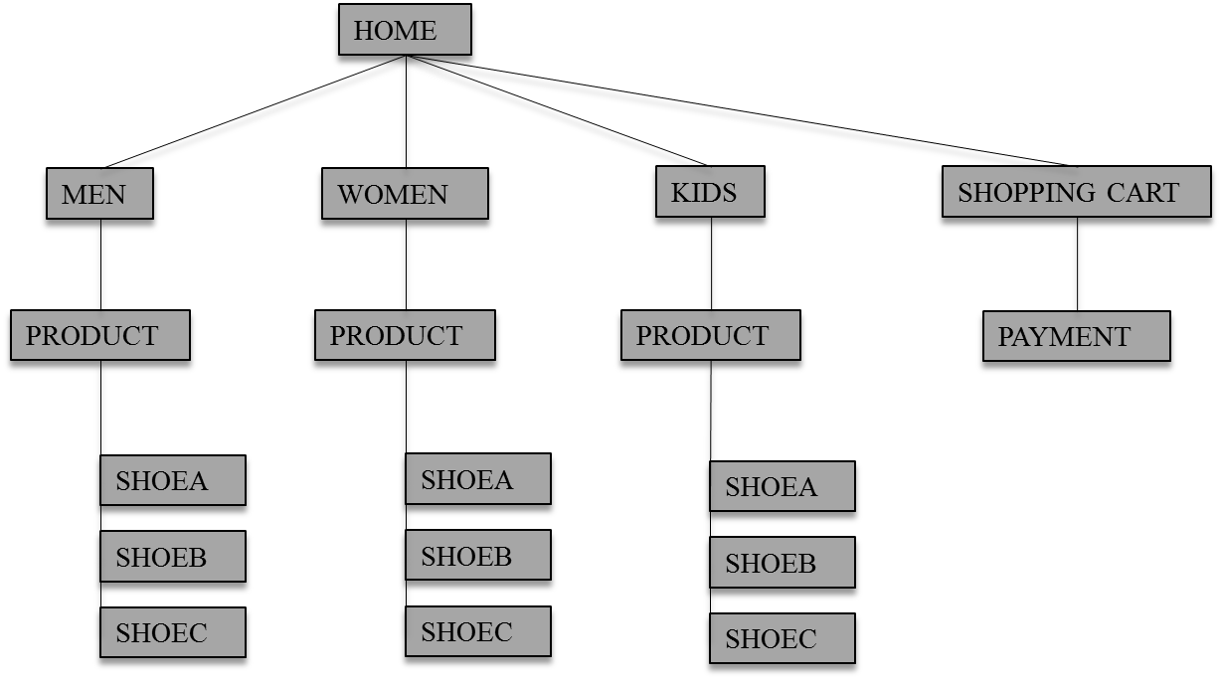

**3.2 Storyboard**

This is the main **home page**. There is a summary of the products. There will be link to different category product list including men, women and kids. iheader

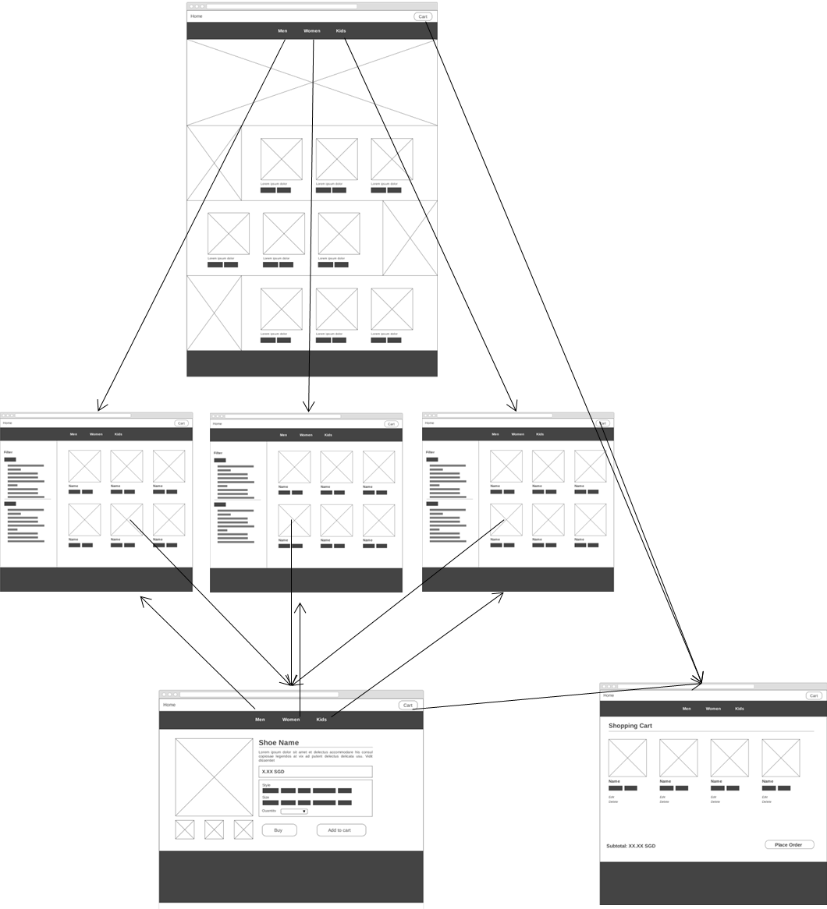

This is the **product list page**. There are more details for the product under each category. Each product links to its matching product formation page.

This is the **product detail page**. All the details for a product were listed inside this page including its name, image, price, description and adding to cart option.

This is the **shopping cart page**. From the shopping cart page, customer can remove/update products in the cart, check out and complete payment easily.

**WOMEN**

**MEN**

**KIDS**

**3.3 Wireframe**

**3.3.1 Home Page**

Page comes with a hero banner slider featuring highlight items, including new arrivals, discounts, feature products. The rest of page lists a summary of 3 main sections (Men, Women, Kids). Featured items for each section is listed for consumer to view.

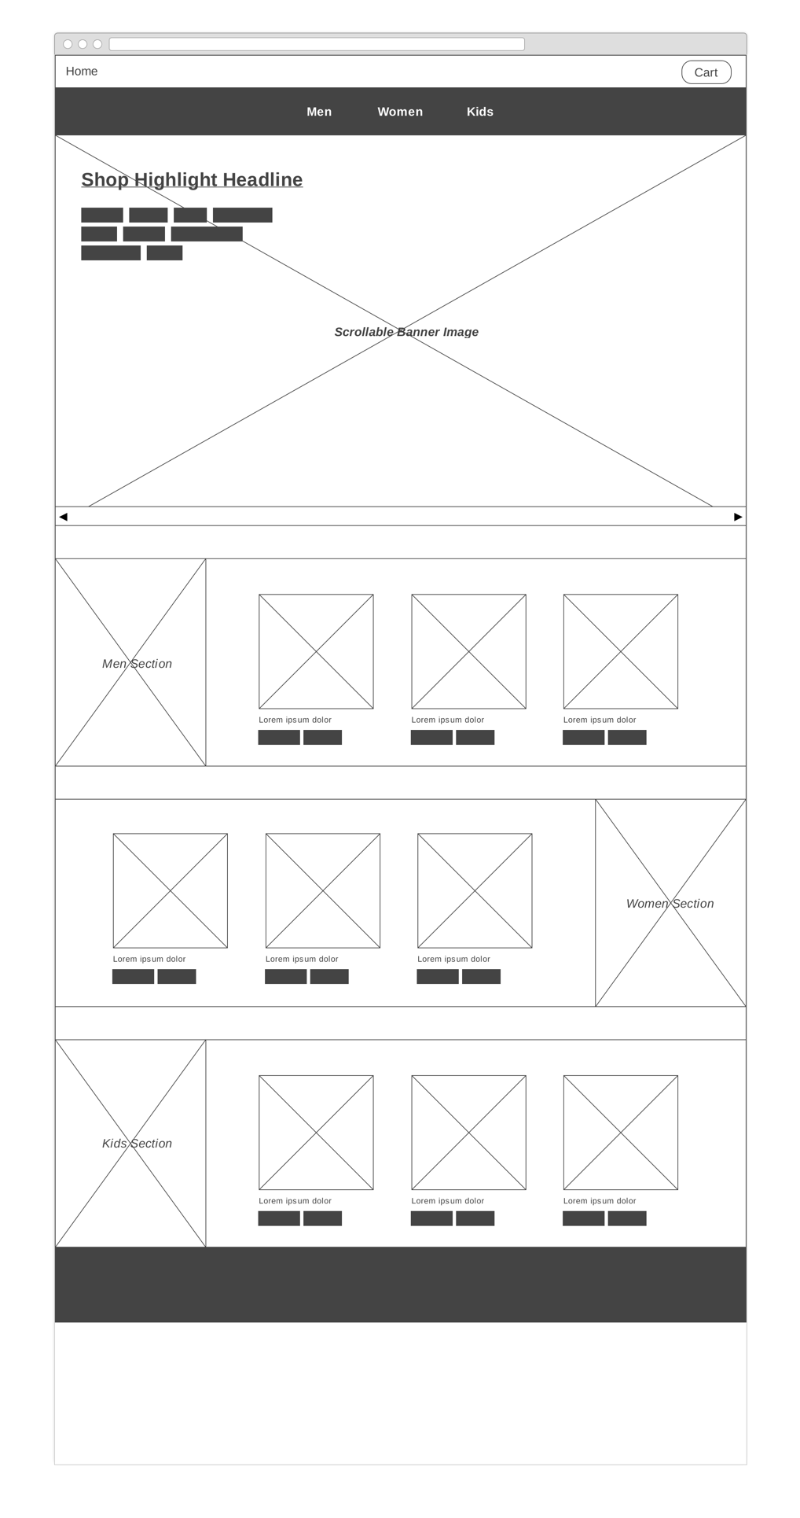

**3.3.2 Product List Page**

Men, women and kids section each has its own product list page with the same layout. The content section follows a tow-column design. Filters with different options are displayed on the left column of the page. On the right column, a scrollable list of product is shown. Based on the filter options, consumers can filter out the preferred product based on brands, colors and etc.

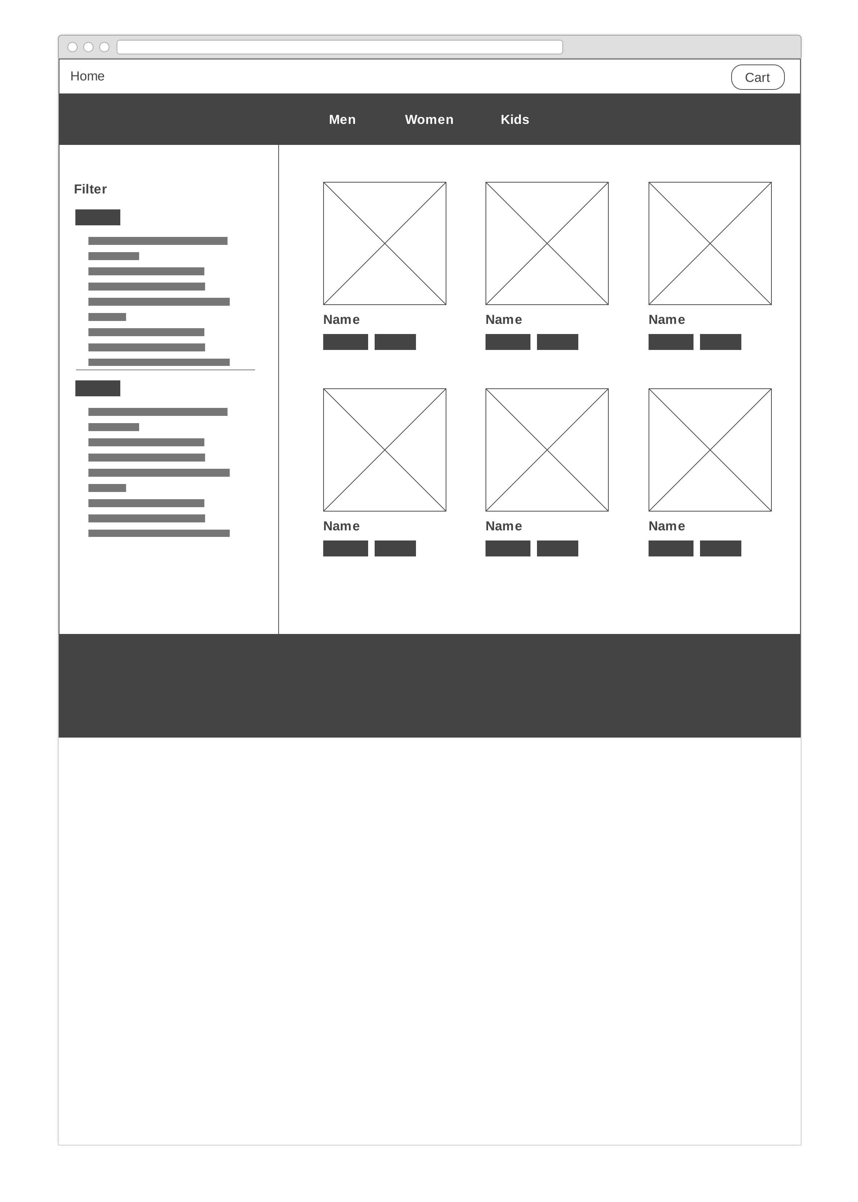

**3.3.3 Product Detail Page**

Product detail page display one single product. User can choose desired quantities, styles, sizes and the order to shopping cart.

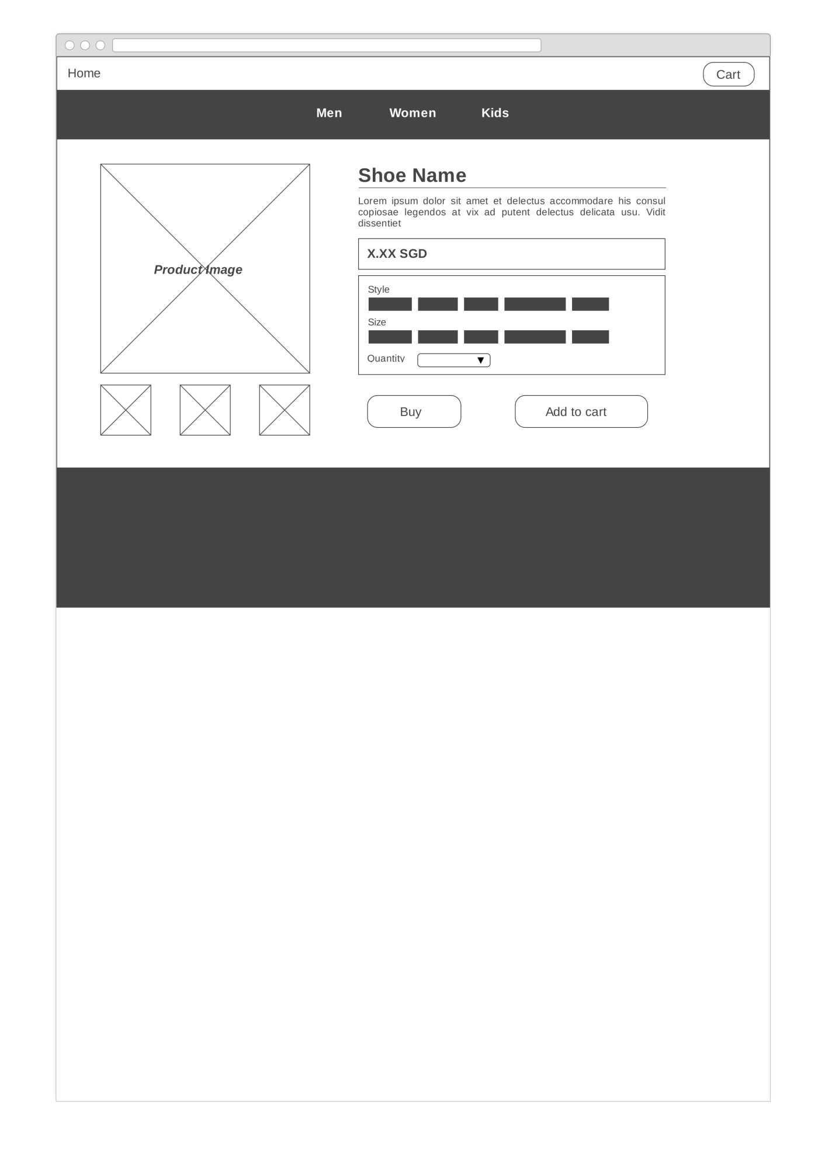

**3.3.4 Shopping Cart Page**

All the chosen products and its related information can be found in shipped cart. From the shopping cart page, customer can remove/update products in the cart, check out and complete payment easily.

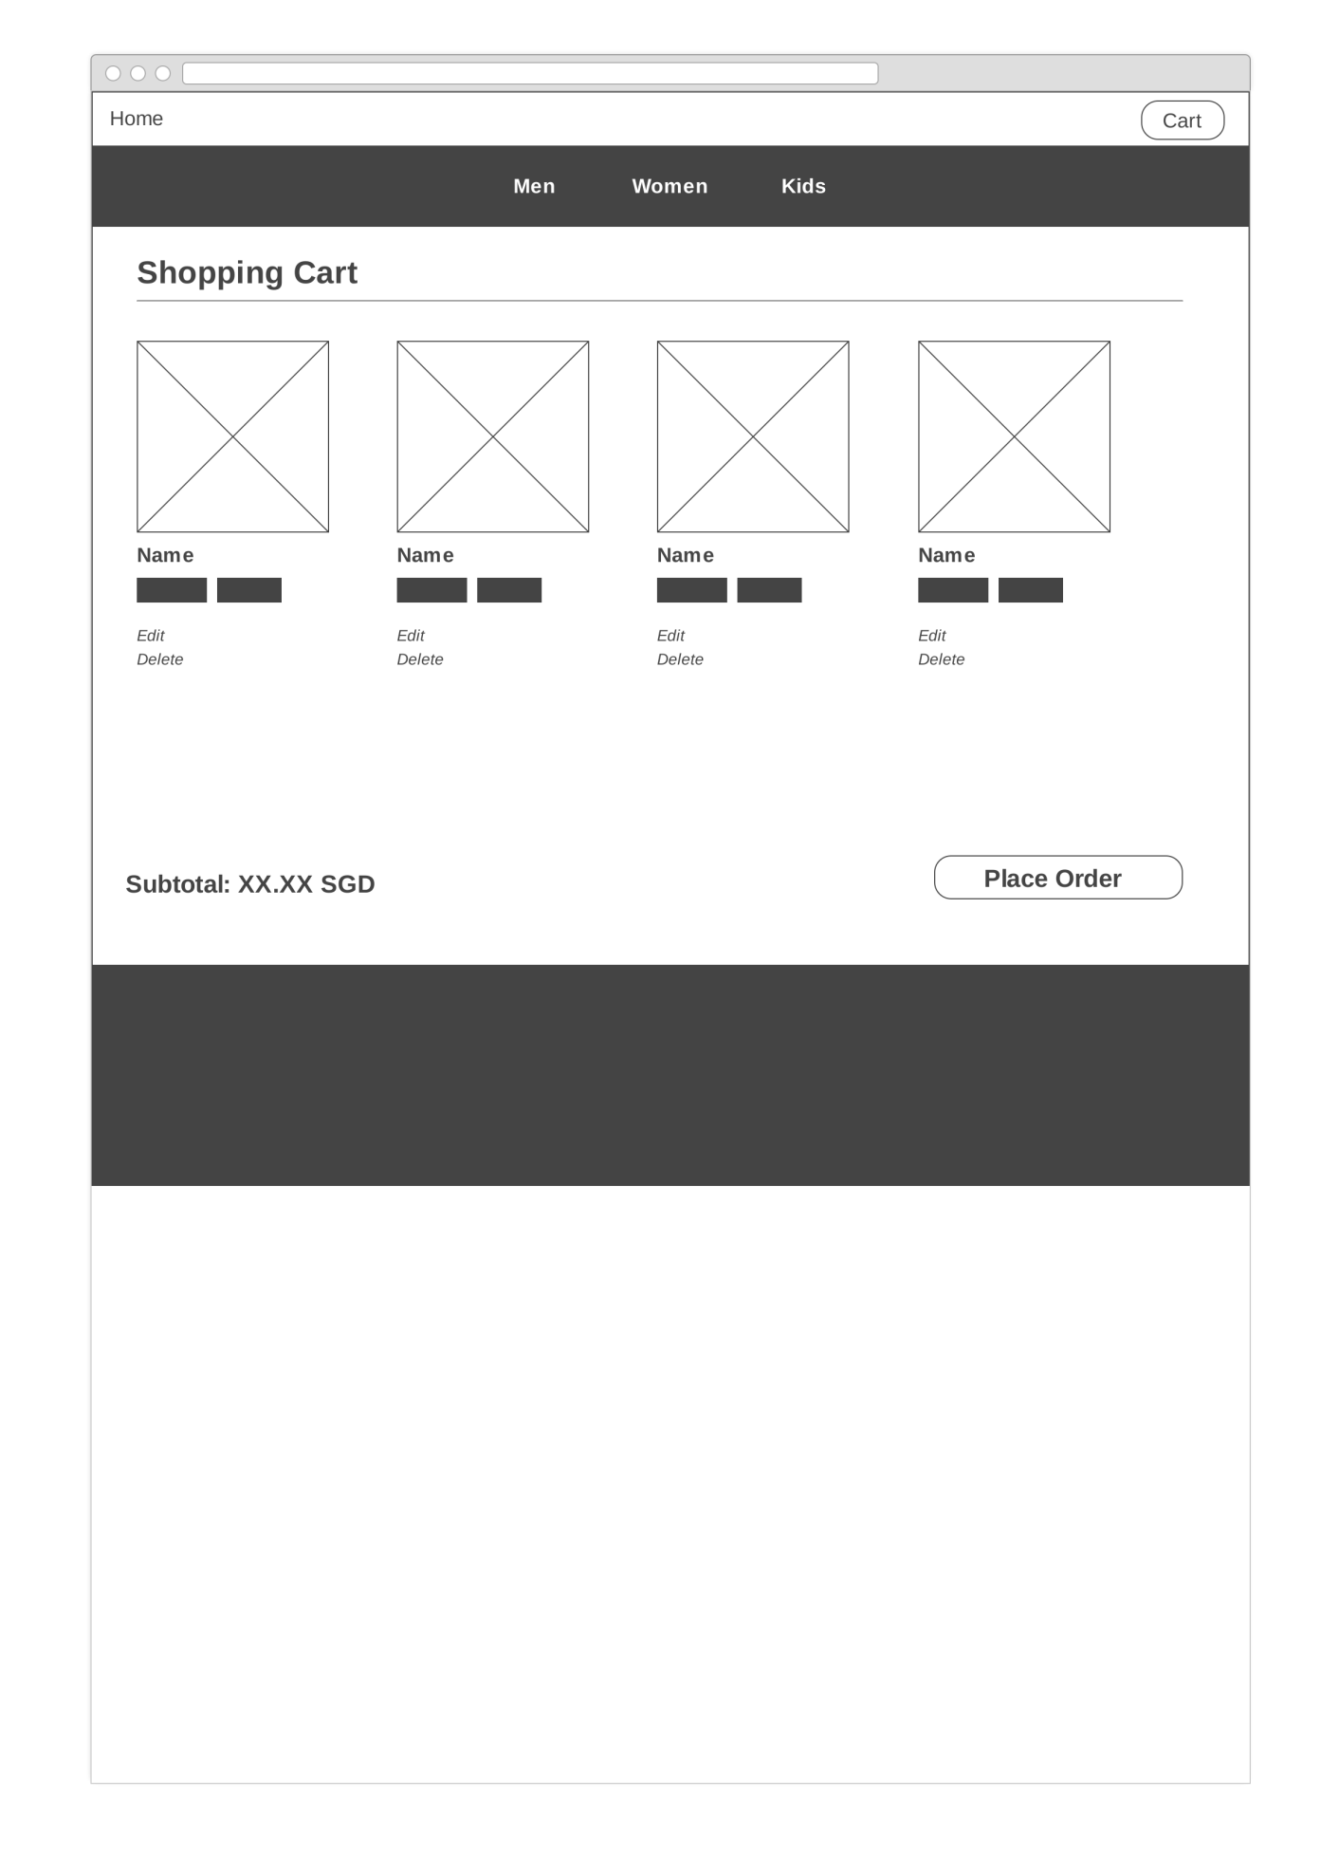

**3.4. Database**

**3.5. Web application testing plan**

|  |  |
| --- | --- |
| Testing | Testing content |
| Functionality | The links, database connection, forms used for submitting or getting information from user in the web pages |
| Usability | Navigation and interface content |
| Interface | Web server, application server and database server interface |
| Compatibility | Browser compatibility and operating system compatibility |
| Performance | Web Load |

**4. Implementation**

4.1 Coding of the web page template

4.2 Coding of the pages

4.3 Coding of the each function

**5. Testing of web application**

5.1 Functionality Testing

5.11 Link testing

All the links need to be tested. The links includes:

1. Link jumping to different page, including: men, women, kid, home and cart.
2. Internal links attached inside different product images, which is also used to jump to different pages.
3. Link jumping to different social mediums of footer
4. Link to login

5.12 Form testing

Form is used to fetch data from users, pass information to database and interact with users. The forms in our project include:

1. Login form
2. Product filter form

Both need to be test for validation and default value. For login form, there are two situations including previous user login and new user register. Wrong input needs to be test and see the remainder information for both situations. For product filter form, multiple choices, single choice and no choice need to be test.

5.13 Database testing

Data integrity and errors were checked when the database is edited, deleted or modified. The point that we need to check includes all the database queries, data retrieved and also data updated through the interface. There is also some database related testing will be addressed in web load testing below.

5.2 Usability Testing

5.21 Navigation testing

Navigation is the buttons to jump to different user pages including home, men, women, kids and login in this project. The usability inspection standard includes navigation convenience, navigation instruction and content consistency.

5.22 Content checking

Content checking includes text, image and color checking. Content is gone through several times to make sure it is meaningful, logical, spelled right and understand easily. All the anchor text links should be working properly. Images should be placed properly with proper sizes. The color that we used is also checked based on the common accepted standard such as dark colors annoys the users and should not be used in the site theme.

5.3 Interface Testing

Interfaces that need to be tested include web server, application server and database server interface. All the interactions between users and these servers were tested. If there is any error message was returned by database or web server, the detail of the error need to be displayed appropriately to the users.

5.4 Compatibility Testing

5.41 Browser compatibility

The setting and configuration of different browsers were always different. And the application needs to be compatible with different browsers. Therefore, the web application was tested on different popular browsers including Internet explorer, Safari and Chrome.

5.42 Operating systems compatibility

The setting and configuration of different operating systems were also different. There are a few technologies may not work in different operation system such as interface calls with different API. Hence the web application test was conducted on different operating systems including Windows and MAC.

5.5 Performance testing

5.51 Web Load testing

Web application should sustain to different load. Web load testing were conducted to see the web application performance. Multiple computers were connected to the interface and use the application at the same time. It needs to see whether the application can support multiple users, handle multiple user requests and interact with database.

**6. Conclusion**

An online ecommerce portal selling sports shoes is successfully implemented. The web application allows consumers to view and search for products filtered by their preference, add products to shopping cart and place orders. The products are listed with details including images, brand information and choices of styles, sizes etc. Customer can remove/update products in the cart, check out and complete payment easily.

**Appendices**

Appendix : Source Codes

Contribution to the project by each team member shown in a table.