Graph Databases and Neo4j

Comparing Relational, Document, and Graph Databases
Relational, document, and graph databases each model data differently, and those differences shape which kinds of problems each one handles well.

Data Modeling Differences
A relational database organizes data into fixed tables of rows and columns, where every row shares the same predefined schema. Relationships between tables are expressed indirectly through foreign keys, and combining related data requires a join. A document database, such as MongoDB, stores data as self-contained, JSON-like documents grouped into collections; documents in the same collection can vary in structure, and related data is often nested inside a single document rather than spread across tables, which reduces the need for joins. A graph database, such as Neo4j, represents data as nodes and relationships, where relationships are first-class objects that can carry their own properties. Rather than inferring a connection through matching key values, the connection itself is stored directly, as with the INSTANCE_OF relationship linking NutVal nodes to NutDes nodes in this assignment.

Strengths and Weaknesses for Different Scenarios
Relational databases excel with highly structured data, simple well-defined relationships, and strict consistency requirements, such as financial transactions, but become harder to maintain as schemas change often or queries require many joins. Document databases excel when data varies in shape from record to record, such as user profiles or product catalogs, since there is no fixed schema to redesign, but they are weaker when an application depends on relationships across many documents. Graph databases excel when relationships are as important as the data itself, such as recommendation engines, fraud detection, or, as in this assignment, linking a nutrient value to its description, because traversing relationships stays fast as connections grow. Their weakness shows up in simple tabular reporting or heavy aggregation across large, uniform data sets, where a relational database's set-based operations are usually more efficient.

Creating a New User and Instantiating the Database
Before working with the dataset, I instantiated a new local database management system instance named “Dani” using Neo4j Desktop, which created a running Neo4j 2026.05.0 instance accessible at neo4j://127.0.0.1:7687. Once the instance was running, I created a new database user by executing the following Cypher command in the Neo4j Query interface:
CREATE USER Dani SET PASSWORD 'Danny560' CHANGE NOT REQUIRED;

This command completed successfully, returning a confirmation of one system update, as shown in the screenshot below.
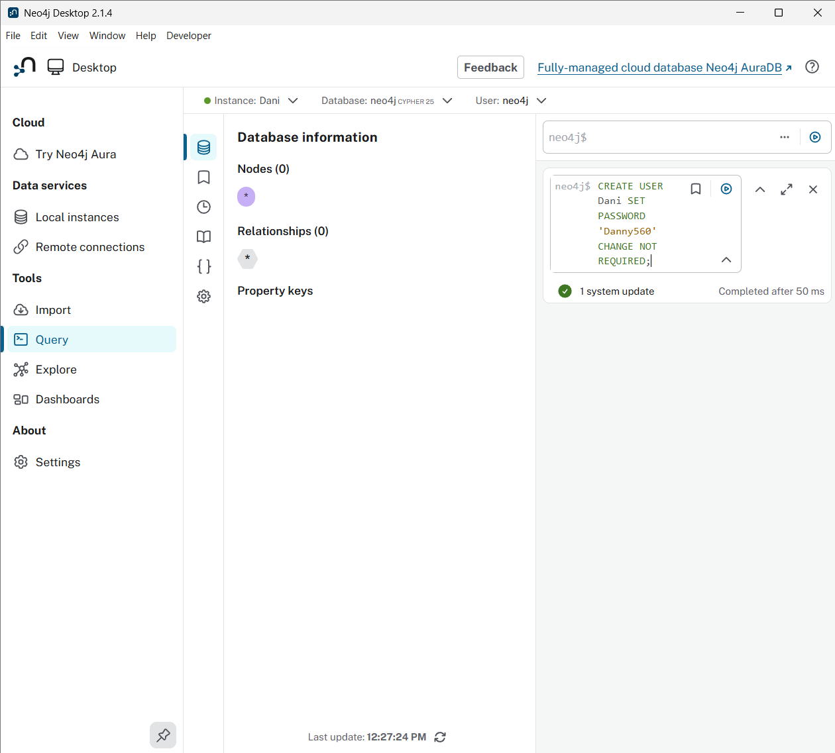
Creating a new Neo4j user named Dani.

Implementing the Schema and Performing ETL
The provided schema required two CSV data sets, Module_Six_Nut_Descs.csv and Module_Six_Nut_Vals.csv, to be loaded into Neo4j as two node types, NutDes and NutVal, and then connected through an INSTANCE_OF relationship. I copied both CSV files into the import folder of the Dani instance, since Neo4j's LOAD CSV command only reads files from that location.
During the extract, transform, and load process, I ran into a data exception loading the NutDes data set. The provided script converted the Date added and Last modified columns into Neo4j date values using date(), but the source data stored dates in United States month/day/year format, for example 10/29/1997, while Neo4j's date() function expects ISO 8601 year-month-day format. To resolve this without altering any underlying values, I used Cypher's split() function inside the query itself to break each date string into three parts and reassemble them in year-month-day order before calling date(). This is a clear example of the transform step in ETL: the values themselves were never changed, only their format was rearranged so the target system could interpret them correctly. I applied the same fix to both the NutDes and NutVal loads, since both stored dates the same way.
After applying this fix, I executed the schema scripts in order: the NutDes load, the NutVal load, and the relationship-building script. Figure 2 shows, from bottom to top, the user creation, the NutDes load creating 19 nodes with 114 properties, and the NutVal load creating 170,544 nodes with 1,364,352 properties.
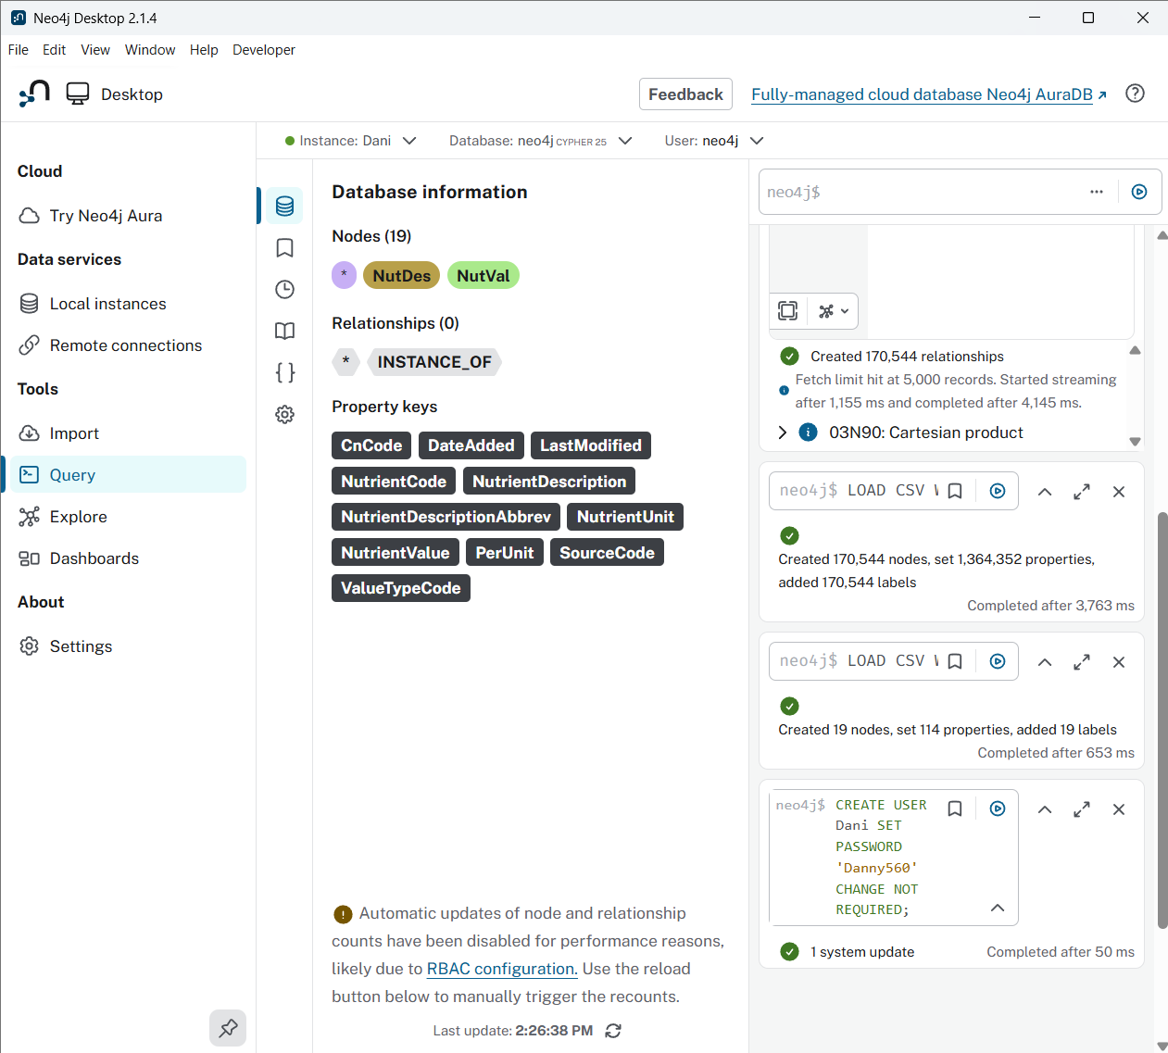
Results of the NutDes and NutVal load queries, with the user creation step visible at the bottom of the query history.
Finally, I executed the relationship script, which matched each NutVal node to its corresponding NutDes node by NutrientCode and created an INSTANCE_OF relationship between them. This created 170,544 relationships, one for every NutVal row, confirming that every nutrient value was correctly linked to its description. Figure 3 shows this result along with the resulting node and relationship counts.
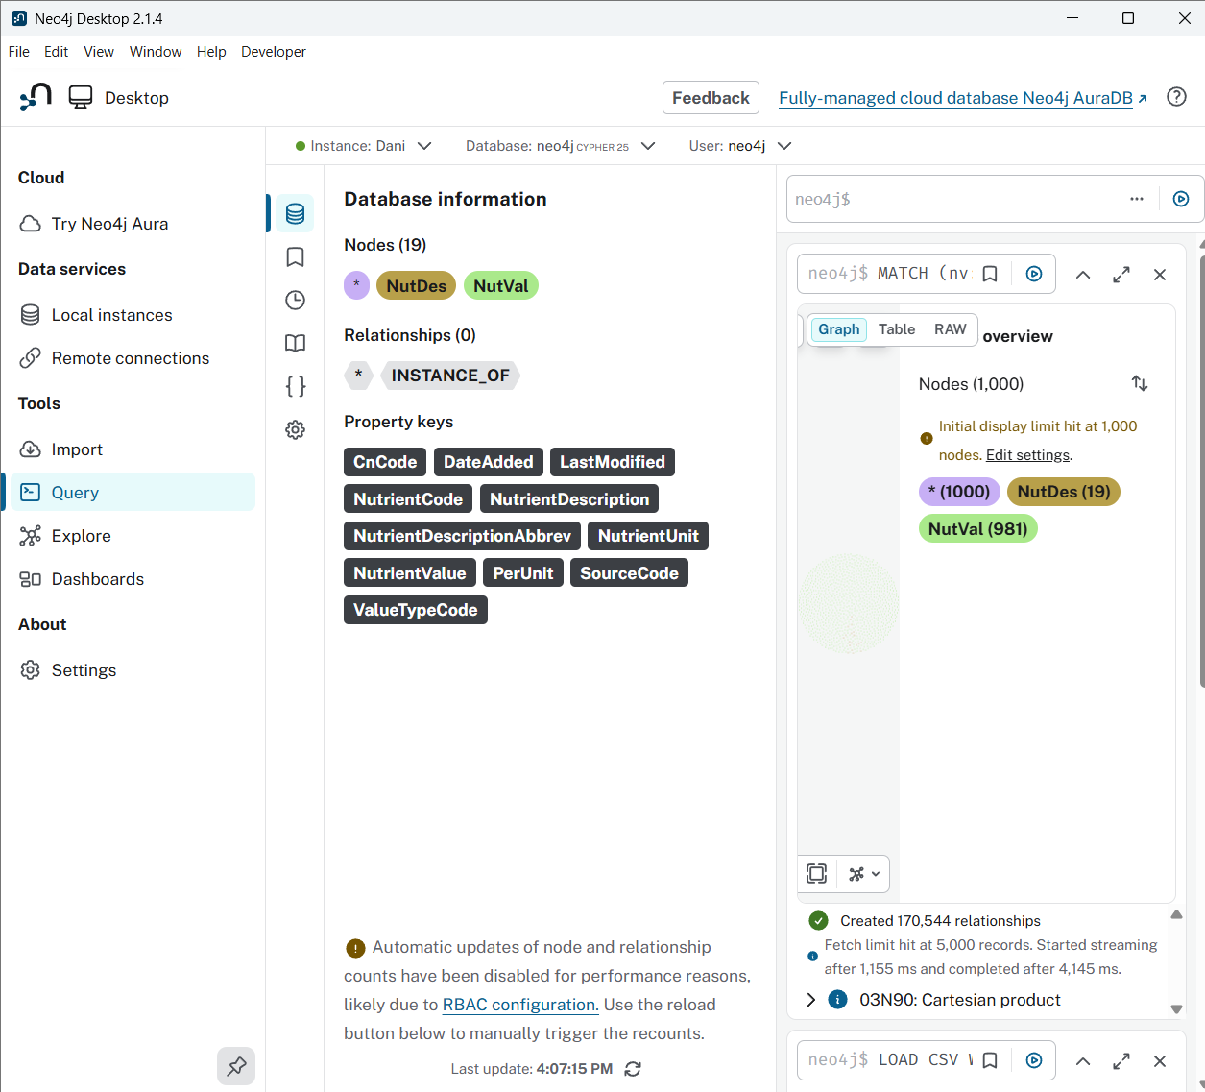
Results of the relationship-building query, showing 170,544 relationships created between NutVal and NutDes nodes.

Cypher Queries and Their Relationship to the Schema
Three Cypher queries were executed to build out the schema described above. Each one plays a distinct role in constructing the final graph.

Query 1: Loading NutDes Nodes
LOAD CSV WITH HEADERS from "file:///Module_Six_Nut_Descs.csv" AS row
CREATE (n:NutDes)
SET n.NutrientCode = toInteger(row.`Nutrient code`),
n.NutrientDescription = row.`Nutrient description`,
n.NutrientDescriptionAbbrev = row.`Nutrient description abbrev`,
n.NutrientUnit = row.`Nutrient unit`,
n.DateAdded = date(split(row.`Date added`,'/')[2] + '-' +
split(row.`Date added`,'/')[0] + '-' + split(row.`Date added`,'/')[1]),
n.LastModified = date(split(row.`Last modified`,'/')[2] + '-' +
split(row.`Last modified`,'/')[0] + '-' + split(row.`Last modified`,'/')[1])
What it does: Reads every row of Module_Six_Nut_Descs.csv and creates one NutDes node per row, setting six properties: nutrient code, description, abbreviated description, unit, and two dates reformatted from United States format into Neo4j date objects.
What it returns: No RETURN clause, so no result set; its effect appears as a creation summary of 19 nodes, 114 properties, and 19 labels, matching the 19 rows in the source CSV.
Relationship to the schema: Establishes the NutDes node type, the catalog of distinct nutrients that values will later be linked to.

Query 2: Loading NutVal Nodes
LOAD CSV WITH HEADERS from "file:///Module_Six_Nut_Vals.csv" AS rec
CREATE (nv:NutVal)
SET nv.CnCode = toInteger(rec.`Cn Code`),
nv.NutrientCode = toInteger(rec.`Nutrient code`),
nv.NutrientValue = toFloat(rec.`Nutrient value`),
nv.PerUnit = rec.`Per unit`,
nv.ValueTypeCode = toInteger(rec.`Value type code`),
nv.SourceCode = toInteger(rec.`Source code`),
nv.DateAdded = date(split(rec.`Date added`,'/')[2] + '-' +
split(rec.`Date added`,'/')[0] + '-' + split(rec.`Date added`,'/')[1]),
nv.LastModified = date(split(rec.`Last modified`,'/')[2] + '-' +
split(rec.`Last modified`,'/')[0] + '-' + split(rec.`Last modified`,'/')[1])
What it does: Performs the same kind of load against Module_Six_Nut_Vals.csv, creating one NutVal node per row with the food code, nutrient code, measured value and unit, value type code, source code, and the same reformatted dates.
What it returns: No result set; the creation summary for this run was 170,544 nodes and 1,364,352 properties, matching the row count of the source CSV.
Relationship to the schema: Establishes the NutVal node type, the measurement side of the schema. Each NutVal node still holds NutrientCode as a property, but at this point that code is not yet a graph relationship.

Query 3: Creating INSTANCE_OF Relationships
MATCH (nv:NutVal), (n:NutDes)
WHERE (nv.NutrientCode = n.NutrientCode)
CREATE (nv)-[:INSTANCE_OF]->(n)
RETURN nv, n
What it does: Matches every NutVal node to every NutDes node sharing the same NutrientCode, then creates a directed INSTANCE_OF relationship from the NutVal node to the matching NutDes node, turning the two separate sets of nodes into a connected graph.
What it returns: Returns every matched pair of nv and n nodes. With 170,544 NutVal records, this created 170,544 relationships, one per nutrient value. Given the size of the result, I also ran a count-only version during testing to confirm the total without rendering all node pairs.
Relationship to the schema: Implements the actual edge of the schema, connecting each measurement back to the nutrient it describes. Without this step, NutVal and NutDes would remain two disconnected sets of nodes; with it, a query can traverse directly from a value to its description or from a description to every recorded value, the central advantage of the graph model described earlier in this paper.

