Developing a Schema for a Graph Database

Identifying Logical Entities
The data sets provided for this assignment, Module_Six_CTGNME.csv, Module_Six_FDES.csv, Module_Six_GPCNME.csv, and Module_Six_WGHT.csv, describe a food composition database. Reviewing the columns in each file makes clear that the data represents four distinct logical entities.
- Food: the central entity, drawn from Module_Six_FDES.csv. Each row describes one specific food item, identified by a unique Cn code, along with a descriptor, an abbreviated descriptor, brand information, and the form the food takes.
- Food Category: drawn from Module_Six_CTGNME.csv. Each row is a broad classification that groups related foods together, such as “Dairy and Egg Products” or “Spices and Herbs.”
- GPC Classification: drawn from Module_Six_GPCNME.csv. Each row represents a Global Product Classification code and description, a separate, more granular classification system than the food category.
- Weight Measure: drawn from Module_Six_WGHT.csv. Each row represents one unit of measure for a specific food, such as a cup, tablespoon, or individual piece, along with its equivalent weight in grams.
A food connects to a food category through a shared category code, to a GPC classification through a shared GPC product code, and to one or more weight measures through a shared Cn code. These shared identifiers are the basis for the relationships in the schema below.

Developing the Graph Schema
Each logical entity above becomes a node label in the graph, and each foreign-key-style relationship between entities becomes a directed relationship between nodes. The sections below summarize the four node types and the property data types assigned to each.

Food Node
Label: Food. Properties: CnCode (Integer), Descriptor (String), AbbreviatedDescriptor (String), FoodCategoryCode (Integer, nullable), GpcProductCode (Integer, nullable), BrandOwnerName (String), BrandName (String), FormOfFood (String), SourceCode (Integer), DateAdded (Date), LastModified (Date). The FoodCategoryCode and GpcProductCode properties are nullable because a sizable portion of the source rows leave these columns blank; only about 6,848 of the 8,976 food rows have a category code, and only about 2,522 have a GPC product code.

Food Category Node
Label: FoodCategory. Properties: CategoryCode (Integer), CategoryDescription (String), DateAdded (Date), LastModified (Date).

GPC Classification Node
Label: GpcClassification. Properties: GpcCode (Integer), GpcDescription (String), DateAdded (Date), LastModified (Date).

Weight Measure Node
Label: WeightMeasure. Properties: CnCode (Integer), SequenceNum (Integer), Amount (Float), MeasureDescription (String), UnitAmount (Float), TypeOfUnit (String), SourceCode (Integer), DateAdded (Date), LastModified (Date).

Relationships
- (Food)-[:BELONGS_TO_CATEGORY]->(FoodCategory), matched where Food.FoodCategoryCode equals FoodCategory.CategoryCode.
- (Food)-[:CLASSIFIED_AS]->(GpcClassification), matched where Food.GpcProductCode equals GpcClassification.GpcCode.
- (Food)-[:HAS_WEIGHT_MEASURE]->(WeightMeasure), matched where Food.CnCode equals WeightMeasure.CnCode.
Food sits at the center of the schema because it is the entity every other entity describes or classifies; category and GPC classification each describe what kind of food it is, while weight measure describes how that food is quantified.

Visual Schema Diagram
The screenshot below illustrates the full schema described above: all four node types, their properties and assigned data types, and the three relationships connecting Food to FoodCategory, GpcClassification, and WeightMeasure.
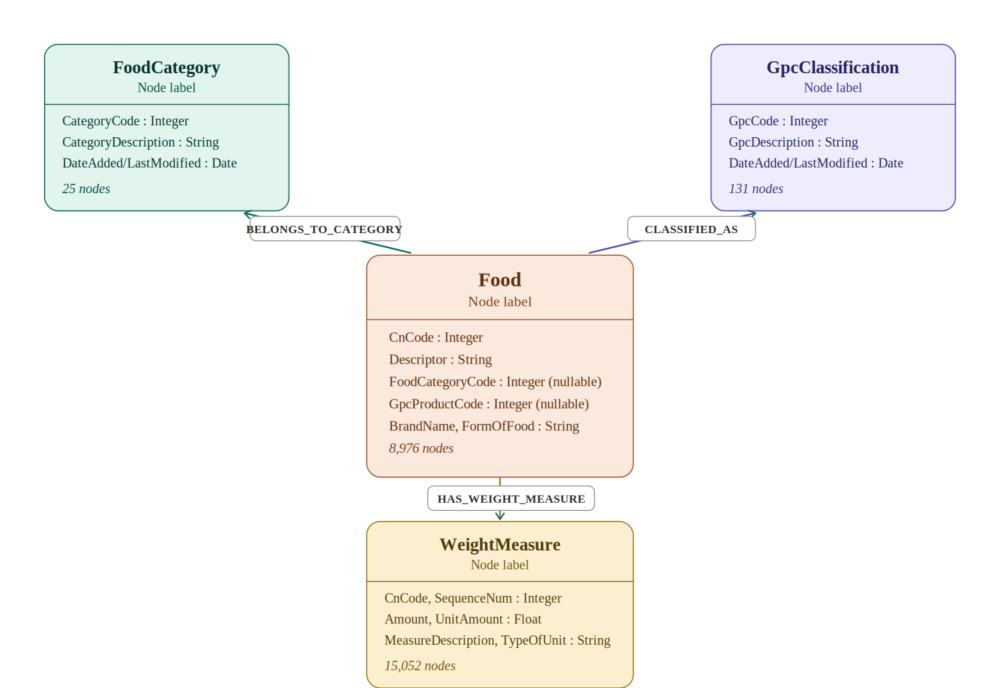
This diagram was created using a custom-built SVG illustration to clearly represent each node's properties, assigned data types, and the directional relationships connecting them, matching the schema implemented in Neo4j below.

Implementing the Schema and Performing ETL
I implemented this schema in the same local Neo4j Desktop instance used in a previous assignment, named Dani, adding the new node labels alongside data that already existed there. I copied all four CSV files into the instance's import folder, then loaded each entity as its own node type using LOAD CSV.
As with the nutrient data set used previously, the Date added and Last modified columns in all four CSVs stored dates in United States month/day/year format, which Neo4j's date() function cannot parse directly. I resolved this the same way as before, using Cypher's split() function to break each date string apart and reassemble it in year-month-day order before converting it with date(). I also handled a second ETL issue specific to this data set: the Food category code and Gpc product code columns in Module_Six_FDES.csv are blank for many rows, since not every food has been assigned a category or GPC classification. Calling toInteger() directly on a blank string would either error or silently convert to an unexpected value, so I wrapped those two conversions in a CASE expression that only converts the value when the column is not empty, and stores null otherwise. This preserved every value exactly as recorded without forcing a category onto foods that the source data never categorized.
After loading all four node types, I built the three relationships described above by matching nodes on their shared identifier columns. The first attempt at this step revealed a data integrity issue worth noting: the relationship counts came back roughly double what the source data should have produced. Investigating with a count-based query showed that the Food load had been executed twice, creating two identical nodes for every Cn code; matching against two Food nodes per food item doubled every relationship as a side effect. I corrected this by deleting all Food nodes with DETACH DELETE, which also removed their relationships, confirming a count of zero before reloading the CSV exactly once and rebuilding the three relationships. Screenshot below shows the corrected implementation result.
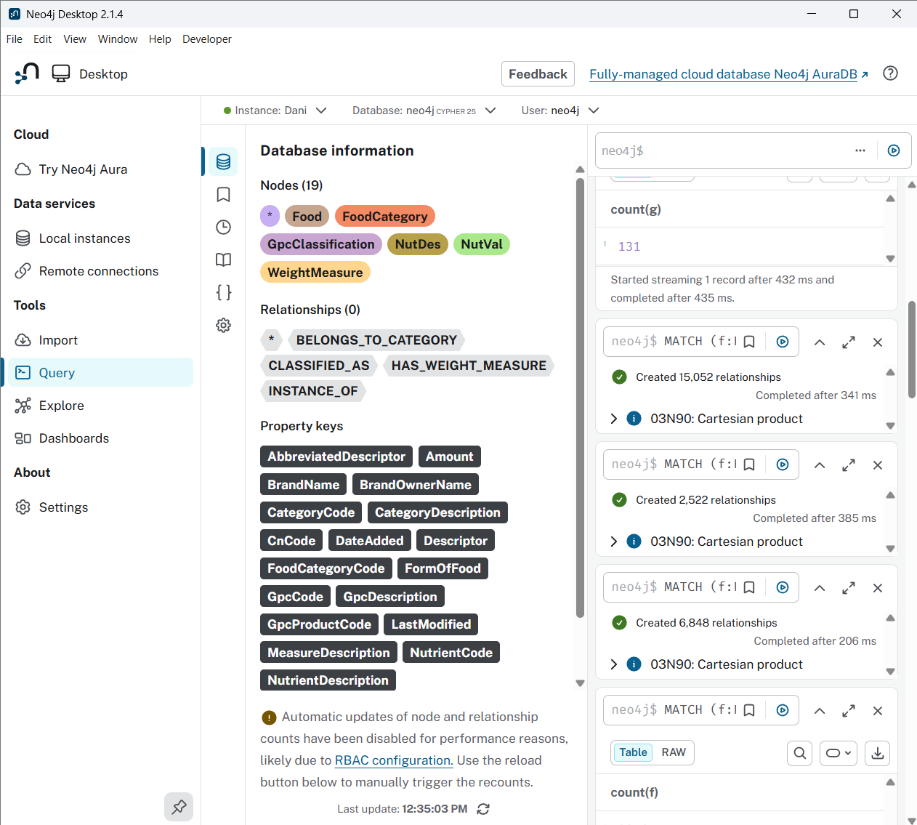
.

Verifying Integration with Cypher Queries
The assignment provided four verification queries that counted nodes by label: GPCNME, FDes, CTGNME, and WGHT. Since my schema uses more descriptive node labels reflecting the entities they represent rather than the raw file names, I adapted the provided queries to match my implemented schema while keeping the same verification purpose, confirming that every node type loaded the expected number of records.
MATCH (g:GpcClassification) RETURN count(g)
MATCH (f:Food) RETURN count(f)
MATCH (c:FoodCategory) RETURN count(c)
MATCH (w:WeightMeasure) RETURN count(w)

Each query returns a single integer representing the total number of nodes carrying that label. Running all four confirmed 131 GpcClassification nodes, 8,976 Food nodes, 25 FoodCategory nodes, and 15,052 WeightMeasure nodes, each matching the row count of its corresponding source CSV exactly. show these results.
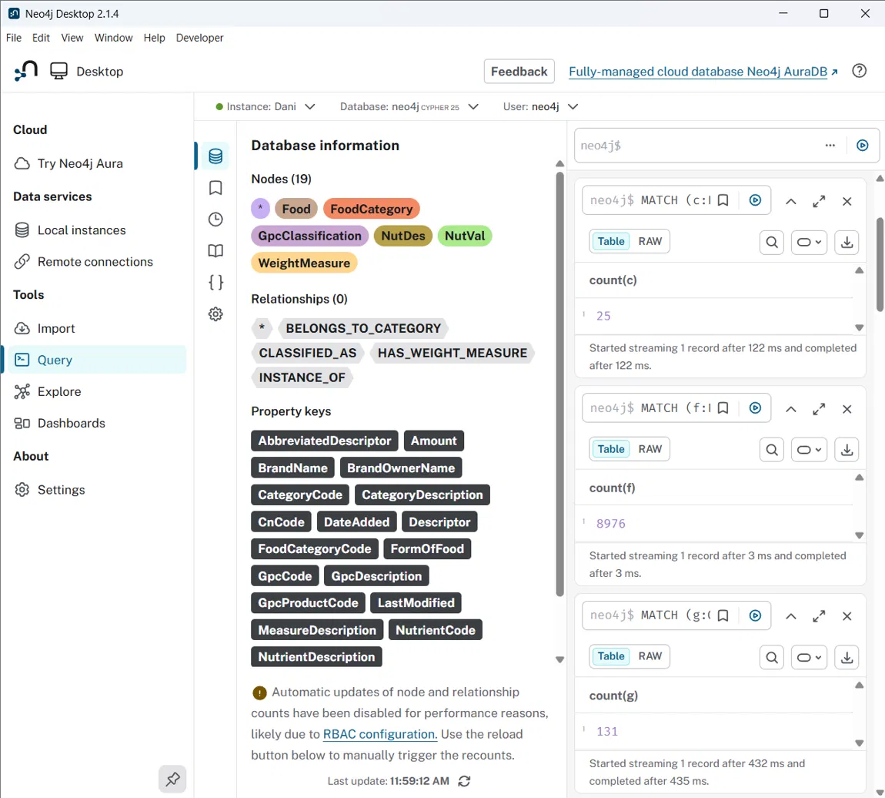
Verification query results for FoodCategory (25), Food (8,976), and GpcClassification (131).
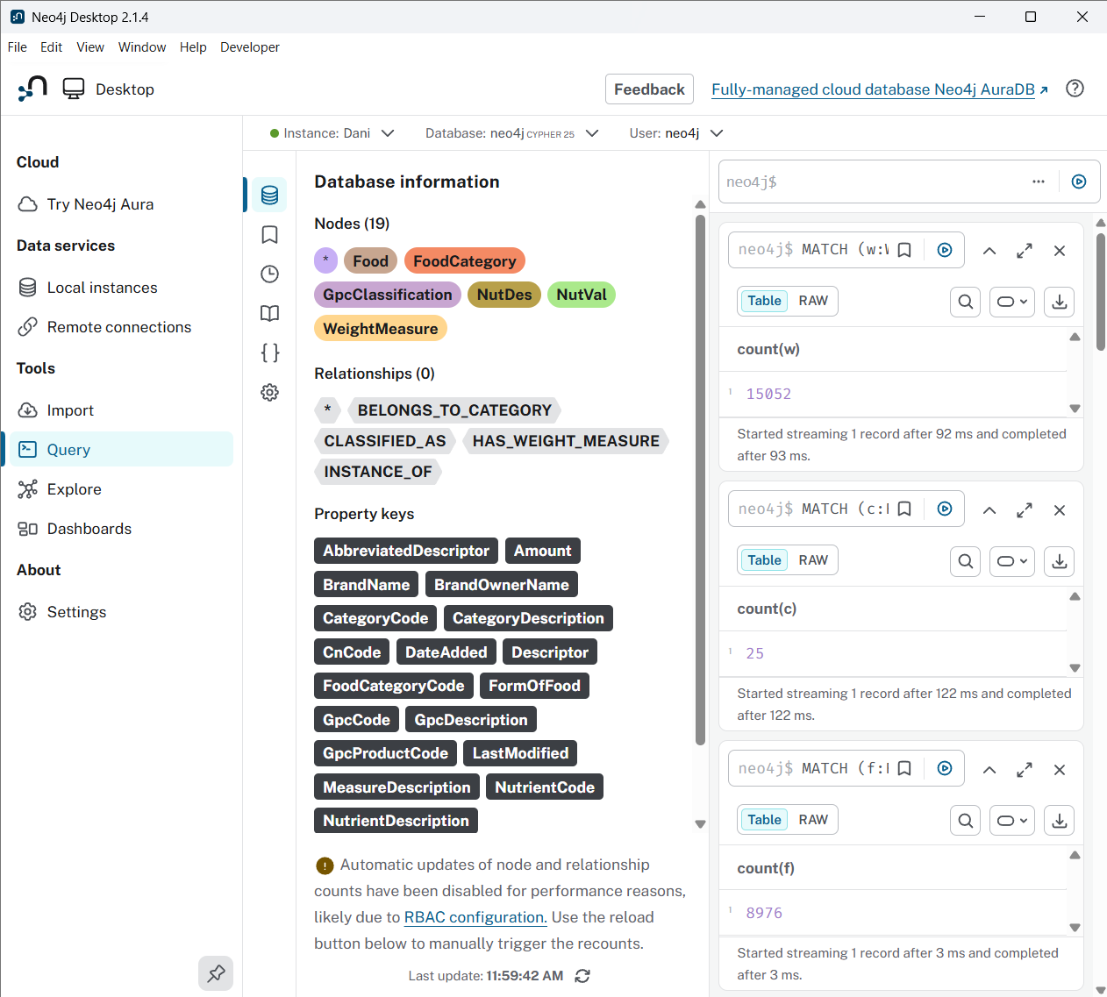
Verification query results for WeightMeasure (15,052), FoodCategory (25), and Food (8,976).
These results confirm that the schema is fully and correctly integrated: every node type loaded with the expected count, the date ETL transformation succeeded across all four data sets, and the relationships connect each Food node to its category, classification, and weight measures exactly as designed.

