CS 570: Applying Machine Learning
Evaluating a Traditional Machine Learning Algorithm and a Neural Network for Modeling Structured Product Data
Technical Report
Prepared by: Dani
Course: CS 570 - Applying Machine Learning
Date: September 1, 2026

1. Introduction
This report evaluates modeling options for a product team considering a machine-learning feature. Part 1 implements and optimizes k-nearest neighbors (kNN) on the Car Evaluation data set and empirically compares it against Naive Bayes and linear discriminant analysis (LDA), the other classification options permitted by the project. Part 2 builds, trains, and tunes a multilayer perceptron (MLP) neural network on scikit-learn's load_digits data set. Every figure below was generated by the accompanying Python source code (Pedregosa et al., 2011).
2. Part 1: k-Nearest Neighbors Classifier for the Car Evaluation Data Set
2.1 Summary of Data Set Attributes
The Car Evaluation data set (Bohanec, 1997) contains 1,728 instances with six predictor attributes and a class label, and no missing values. Every column, including the target, is stored as text and is categorical, and every attribute's categories have a natural rank order, making all seven columns ordinal (not nominal) categorical data. Table 1 summarizes the attributes.
Attribute | Format | Ordered Categories | Meaning
buying | Ordinal (string) | low<med<high<vhigh | Buying price
maint | Ordinal (string) | low<med<high<vhigh | Maintenance cost
doors | Ordinal (string) | 2<3<4<5more | Number of doors
persons | Ordinal (string) | 2<4<more | Passenger capacity
lug_boot | Ordinal (string) | small<med<big | Luggage boot size
safety | Ordinal (string) | low<med<high | Safety rating
class (target) | Ordinal (string) | unacc<acc<good<vgood | Car acceptability
The six predictors form a complete factorial design (4×4×4×3×3×3 = 1,728), so predictor levels are perfectly balanced, but the target is imbalanced: 70.0% unacc, 22.2% acc, 4.0% good, 3.8% vgood (Figure 1). This imbalance affected model evaluation, discussed in section 2.7.
2.2 Data Exploration and Visualization
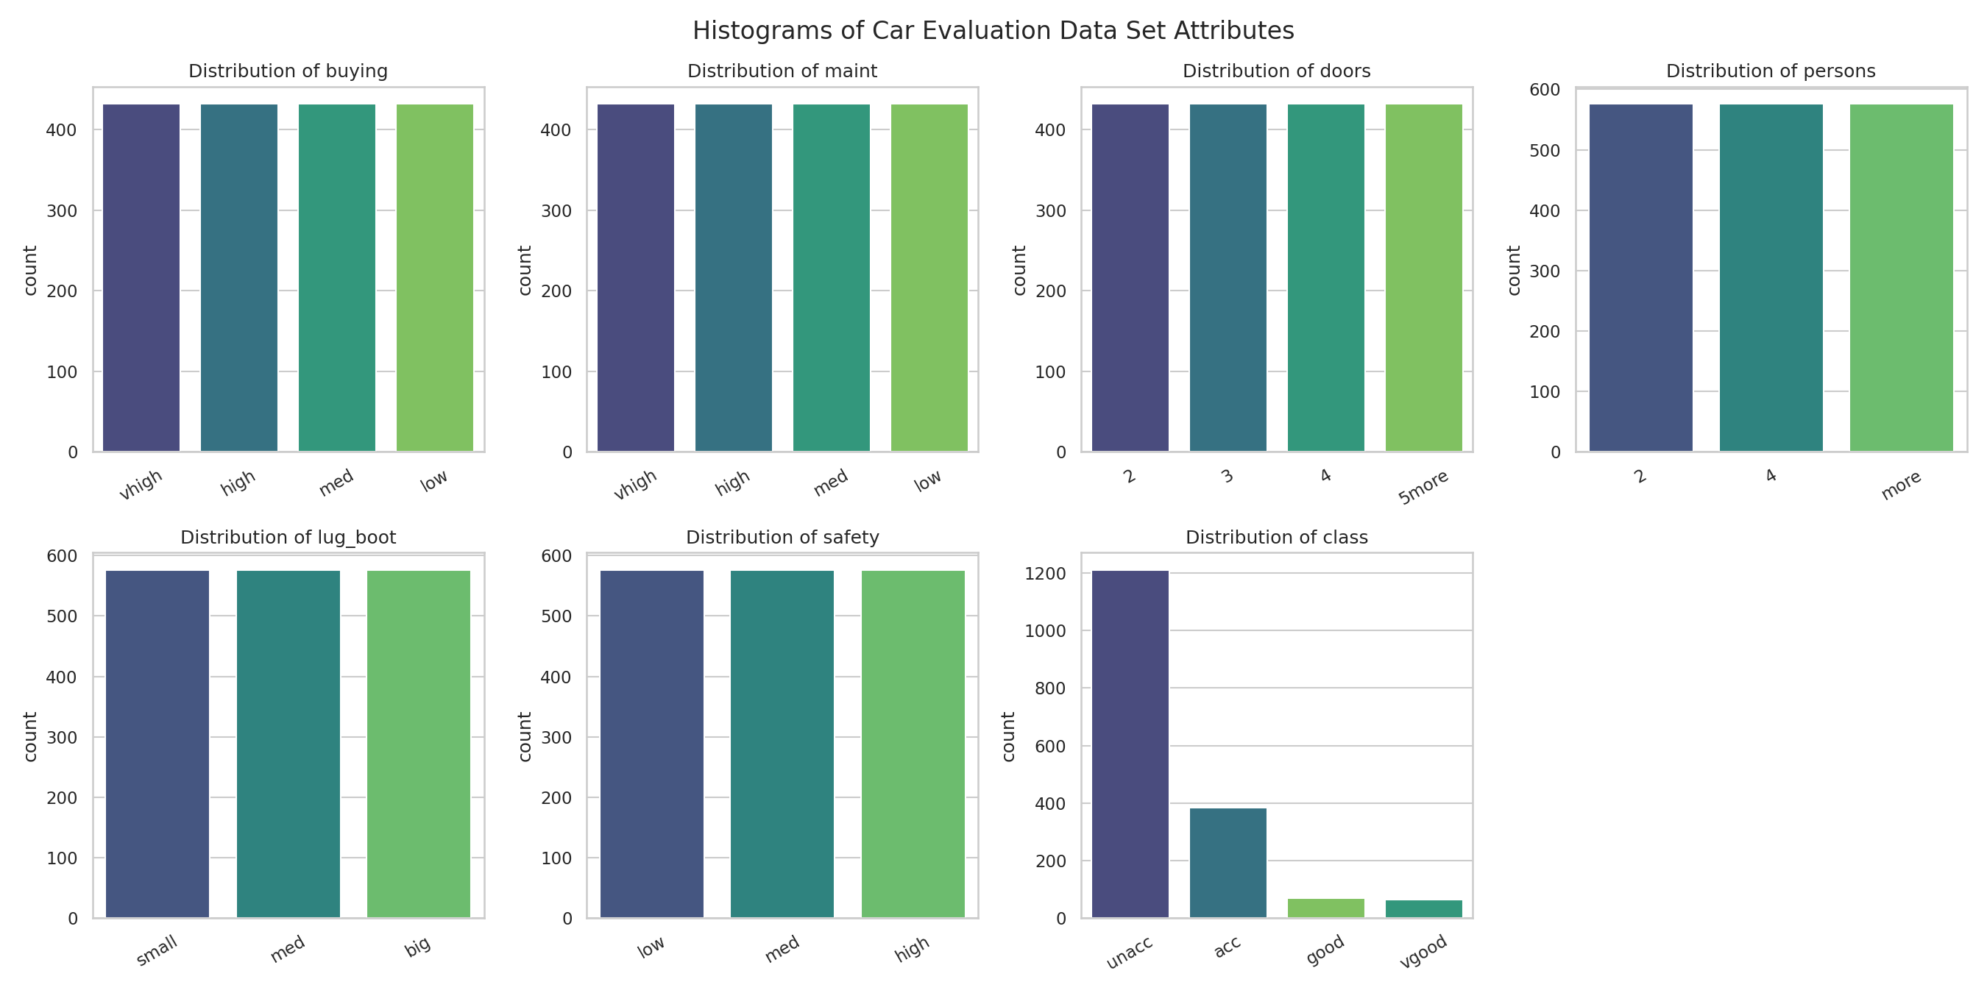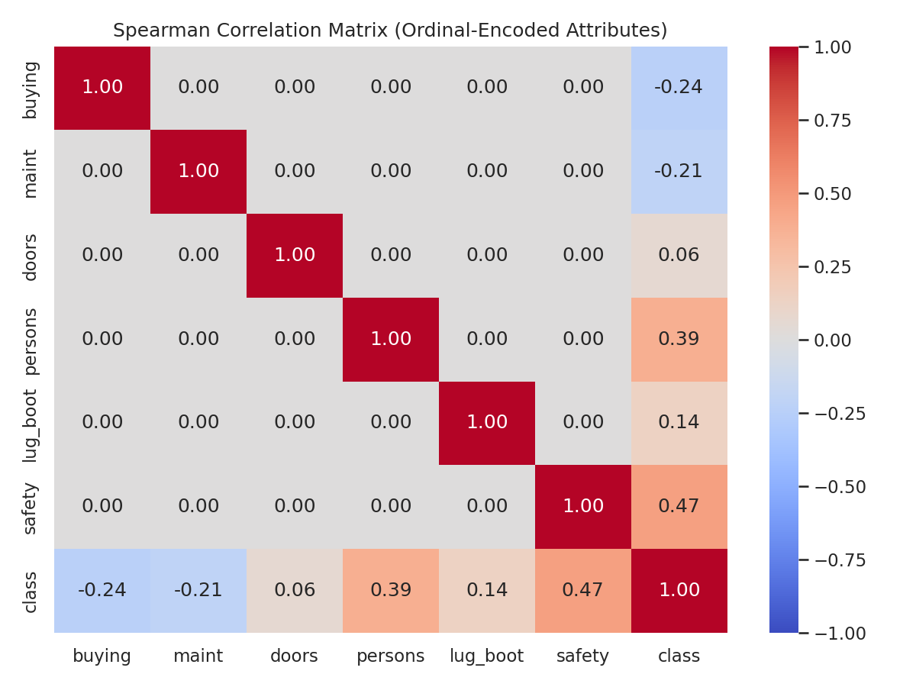
Figure 1 (left). Histograms of all six predictor attributes and the class label. Figure 2 (right). Spearman correlation matrix of the ordinal-encoded attributes.
Predictors are mutually uncorrelated by design. Safety (ρ=0.47) and persons (ρ=0.39) are the strongest single predictors of acceptability; buying (ρ=-0.24) and maint (ρ=-0.21) are moderately negative; doors (ρ=0.06) contributes almost no signal alone.
2.3 Data Preprocessing
All six predictors and the target were categorized as ordinal categorical variables because their category values have a meaningful order (e.g., “vhigh” buying price is three ranks from “low,” not merely “different”). This categorization determined the transformation applied.
- Transformation used: ordinal integer encoding (e.g., buying: low=0, med=1, high=2, vhigh=3) for every attribute and the target, instead of one-hot encoding.
- Why: encoding preserves the categories' rank order, which one-hot encoding discards, and it keeps the feature space at 6 numeric dimensions instead of expanding to 21 sparse one-hot columns that would dilute a distance calculation.
- How the algorithm type informed preprocessing: kNN classifies by distance to training points and has no internal mechanism to weight or scale features, so inputs must already be numeric and on comparable scales.
- Data characteristics considered: small, fixed cardinality per attribute (3-4 levels), ordinal rather than nominal ordering, no missing values, and an imbalanced target.
- Other/algorithmic constraints: all encoded attributes landed on comparable 0-3 ranges, so no separate scaling step was needed (confirmed empirically); low dimensionality also kept per-prediction distance computation efficient.
2.4 Algorithm Evaluation and Selection
The project allowed kNN, discriminant analysis, Naive Bayes, multiple linear regression, or kNN regression. The two regression options were excluded from experimentation because class is a four-level categorical label, not a continuous quantity. The remaining three classifiers were fit on identical splits and cross-validation folds for a fair comparison (Table 2).
Algorithm | Mean CV Acc. | Test Acc. | Test F1 (macro) | Test Kappa
kNN (tuned) | 0.9493 | 0.9624 | 0.8943 | 0.9162
Naive Bayes (Categorical) | 0.8444 | 0.8410 | 0.5415 | 0.6329
Linear Discriminant Analysis | 0.8191 | 0.8006 | 0.5447 | 0.5320
kNN outperformed both alternatives because its assumptions fit this data best. Naive Bayes assumes conditional feature independence (true here by design) but cannot represent interaction/threshold rules such as “low safety forces unacc regardless of other attributes.” LDA assumes continuous, near-normal predictors and linear class boundaries, both violated by small-cardinality categorical attributes and a non-linear decision rule, which produced its weak macro F1 (0.54, driven by poor minority-class recall). kNN makes neither assumption and instead classifies by similarity to nearby examples, matching this data set's local, rule-like structure.
2.5 Model Training
The encoded data was split into training (80%, 1,382 rows) and a held-out test set (20%, 346 rows) using a stratified split. A baseline kNN (k=5, uniform weights, Euclidean distance) was fit with a single call to KNeighborsClassifier.fit(), reaching 91.62% test accuracy before any tuning.
2.6 Model Optimization
- Validation method: 5-fold stratified cross-validation (shuffled, random_state=42) on the training set throughout, so folds preserve class proportions despite the imbalance. The baseline model's fold accuracies were 0.906, 0.950, 0.924, 0.949, 0.935 (mean 93.27%, SD 1.64%).
- Tuning technique: GridSearchCV over n_neighbors (1-25), weights (uniform/distance), and metric (Euclidean/Manhattan) — chosen because these three hyperparameters directly control kNN's bias-variance trade-off and how attribute differences combine into a distance. The best combination was n_neighbors=7, weights='distance', metric='manhattan' (CV accuracy 94.93%), shown in Figure 3.
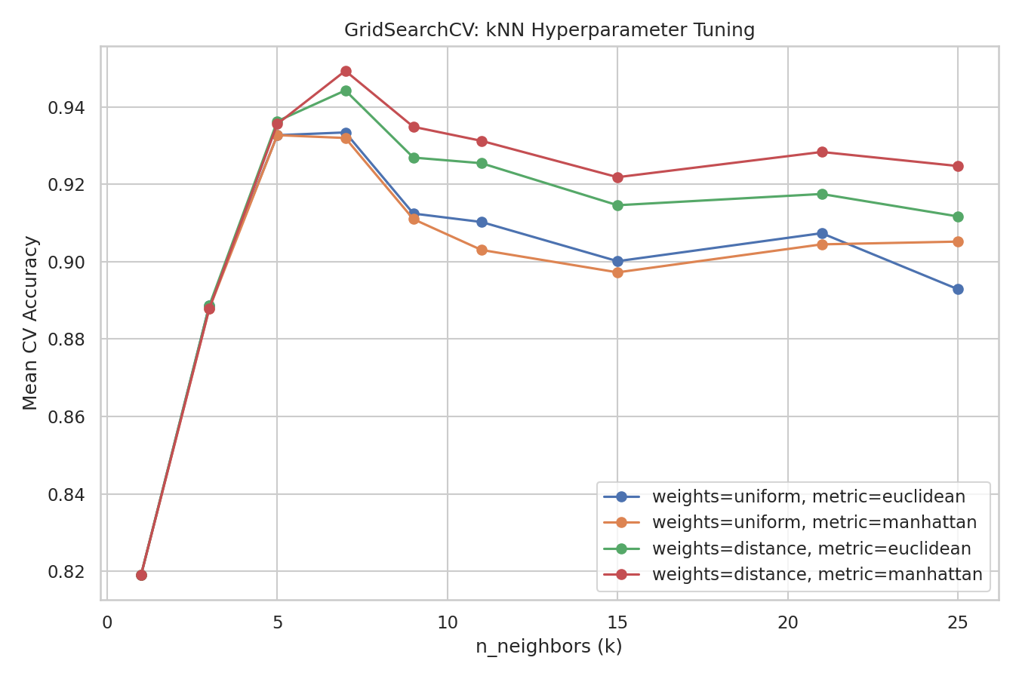
Figure 3. GridSearchCV mean CV accuracy across n_neighbors, weights, and distance metric.
2.7 Model Evaluation Results
The tuned model was refit on the full training set and evaluated once on the untouched test set (Table 3, Figure 4).
Metric | Value | Metric | Value
Accuracy | 0.9624 | F1 (macro) | 0.8943
Precision (macro) | 0.9539 | F1 (weighted) | 0.9609
Precision (weighted) | 0.9628 | Cohen's Kappa | 0.9162
Recall (macro) | 0.8550 | Recall (weighted) | 0.9624
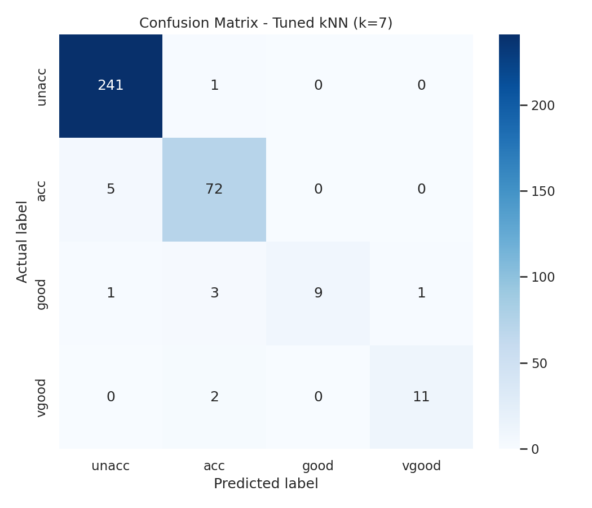
Figure 4. Confusion matrix of the tuned kNN model (test set).
Descriptive statistics (actual vs. predicted test-set counts): unacc 242/247, acc 77/78, good 14/9, vgood 13/12. The gap between macro (0.855 recall) and weighted (0.962 recall) metrics reflects the class imbalance: unacc/acc are predicted almost perfectly, but good has recall of only 0.64 (9 of 14). Kappa of 0.916 confirms agreement far beyond chance.
2.8 Strengths and Weaknesses of kNN for This Data Set
- Strength: no distributional assumptions, unlike LDA, which matters since the encoded predictors are not normally distributed.
- Strength: captures the data's non-linear, threshold-rule structure (e.g., safety overriding other attributes) better than a global linear separator.
- Strength: simple and fast at this scale (6 low-cardinality attributes, 1,728 rows); its lack of a training phase was not a practical drawback here.
- Weakness: sensitive to class imbalance — rare classes are more easily outvoted by nearby majority-class neighbors (lower macro recall).
- Weakness: no automatic feature weighting; a wider-range attribute could dominate distance without scaling (not an issue here, but a general limitation).
- Weakness: prediction cost scales with training-set size, since every prediction compares to (in principle) every training point.
2.9 Modeling Recommendations
kNN is the most appropriate of the permitted algorithms: highest accuracy (96.2%) and Kappa (0.916), with no distributional assumptions for this categorical, interaction-driven data set to violate. Linear/kNN regression are inapplicable since the target is categorical. Outside the five options, a decision tree is worth a future look, since these labels came from an explicit hierarchical rule set a tree could represent directly, potentially improving minority-class (good) recall. Tuned kNN is recommended now for its accuracy and simplicity.
3. Part 2: Multilayer Perceptron Neural Network for the Digits Data Set
3.1 Summary of Data Set Attributes
scikit-learn's load_digits data set (Alpaydin & Kaynak, 1998) contains 1,797 samples, each an 8×8 grayscale digit image already flattened into 64 numeric pixel-intensity features (0-16) with an integer label (0-9). Unlike Part 1, every attribute is already continuous/numeric rather than categorical. There are no missing values, and the ten classes are nearly balanced (174-183 samples each).
3.2 Data Exploration and Visualization
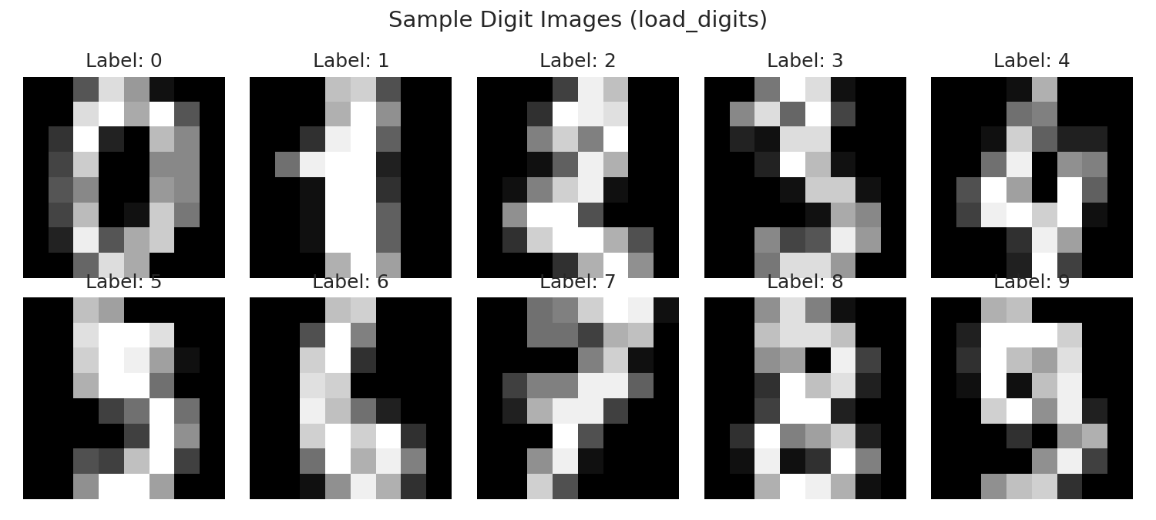
Figure 5. Sample 8×8 digit images with true labels.
3.3 Data Preprocessing for the Neural Network
Because all 64 features are already numeric, no categorical encoding was needed — the only transformation was standardizing every pixel feature to zero mean/unit variance (fit on training data only, then applied to validation/test).
- How the algorithm type informed preprocessing: an MLP is trained by gradient-based backpropagation, which converges faster and more reliably when inputs share a comparable small scale; unscaled 0-16 pixels (many near zero) can cause uneven gradients across weights.
- Data characteristics considered: all 64 attributes are homogeneous, continuous pixel intensities, so a single uniform scaling rule (rather than a per-attribute encoding decision as in Part 1) was appropriate.
- Other/algorithmic constraints: MLP weights are updated via a fixed learning-rate rule from random initialization, so poorly scaled inputs would bias the effective learning rate seen by different weights; standardization removes that bias.
3.4 Training and Validation Split
The data was split twice: 80/20 into a train+validation pool and a held-out test set (stratified), then the pool was split 80/20 into training and validation sets. Overall: 1,149 training (64.0%), 288 validation (16.0%), 360 test (20.0%) samples. Only the training set updated weights; the validation set monitored generalization each epoch; the test set was touched only once, for final evaluation.
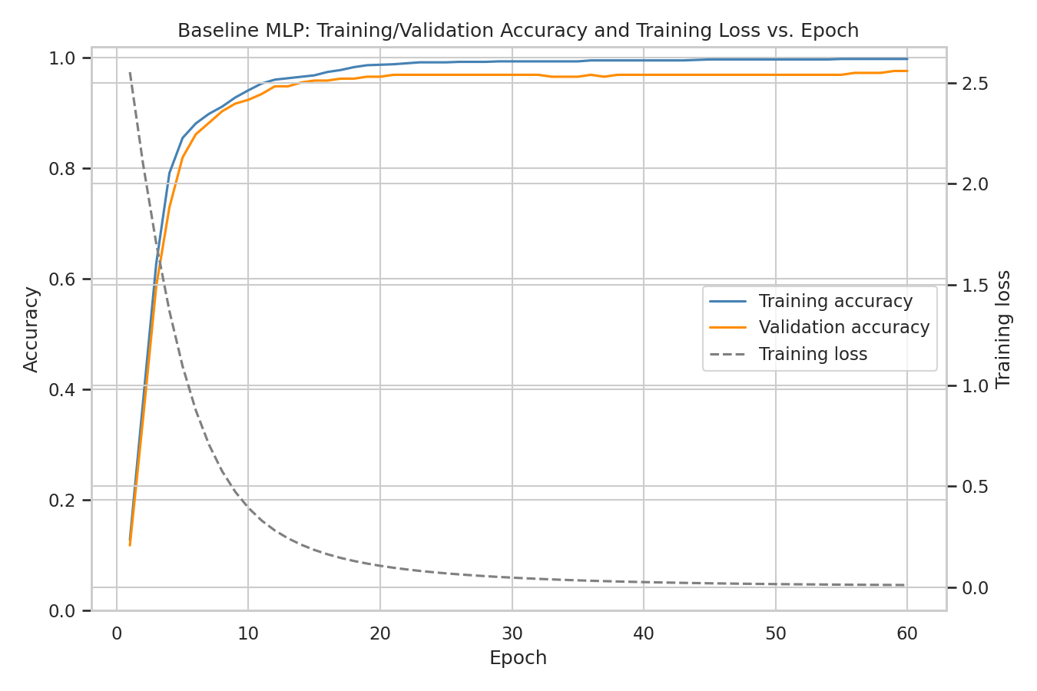
Figure 6. Baseline MLP training/validation accuracy and training loss across 60 epochs.
Training accuracy (0.997 final) rose slightly above validation accuracy (0.976 final), indicating mild, stable overfitting after roughly epoch 20 rather than worsening divergence.
3.5 Neural Network Training Algorithm
- Algorithm: backpropagation combined with the Adam optimizer (adaptive moment estimation), scikit-learn's default MLPClassifier solver (Kingma & Ba, 2015).
- Why chosen: Adam adapts each weight's learning rate from running gradient-moment estimates and converges faster/more robustly than plain SGD without careful learning-rate tuning; every one of the ten best GridSearchCV combinations (section 3.6) used solver='adam', none used 'sgd'.
3.6 Neural Network Training Methods and Hyperparameter Tuning
- Manual vs. algorithmic: training was entirely algorithmic — weights were updated only by scikit-learn's backpropagation/Adam implementation. Manually deriving backprop updates would be impractical and error-prone for a multilayer network. The only "manual" element was looping over epochs to record training/validation accuracy for monitoring (Figure 6), not computing gradients by hand.
- Initial hyperparameters: hidden_layer_sizes=(100,), activation='relu', solver='adam', learning_rate_init=0.001, batch_size='auto', max_iter=60 (monitoring run) / 300 (CV and tuning runs).
5-fold cross-validation of the baseline architecture gave fold accuracies 0.972, 0.979, 0.976, 0.969, 0.986 (mean 97.63%, SD 0.60%). GridSearchCV then searched hidden_layer_sizes ((50,), (100,), (100,50)), activation (relu, tanh), solver (adam, sgd), learning_rate (constant, adaptive), and batch_size (auto, 64), with 3-fold CV. The best combination was hidden_layer_sizes=(100,), activation='relu', solver='adam', batch_size='auto' (CV accuracy 97.08%); Figure 7 summarizes results by architecture and activation.
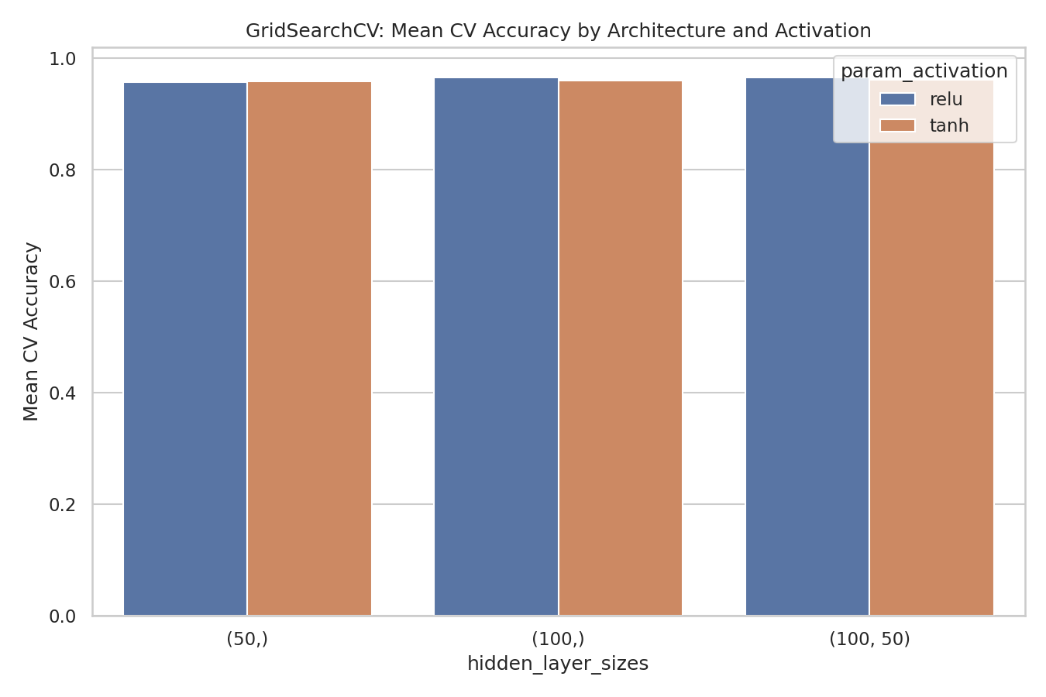
Figure 7. GridSearchCV mean CV accuracy by architecture and activation function.
- Hyperparameter adaptation: the single-layer (100,) architecture was kept over the deeper (100,50) network, which did not measurably improve accuracy; solver was confirmed as 'adam' over 'sgd', which scored lower across every architecture tested; max_iter was raised to 300 for tuning/final runs to ensure full convergence.
3.7 Model Evaluation Results
The best model was refit on the full training+validation pool and evaluated once on the test set (Table 4, Figure 8).
Metric | Value | Metric | Value
Accuracy | 0.9750 | F1 (macro) | 0.9746
Precision (macro) | 0.9748 | F1 (weighted) | 0.9748
Precision (weighted) | 0.9749 | Cohen's Kappa | 0.9722
Recall (macro) | 0.9747 | Recall (weighted) | 0.9750
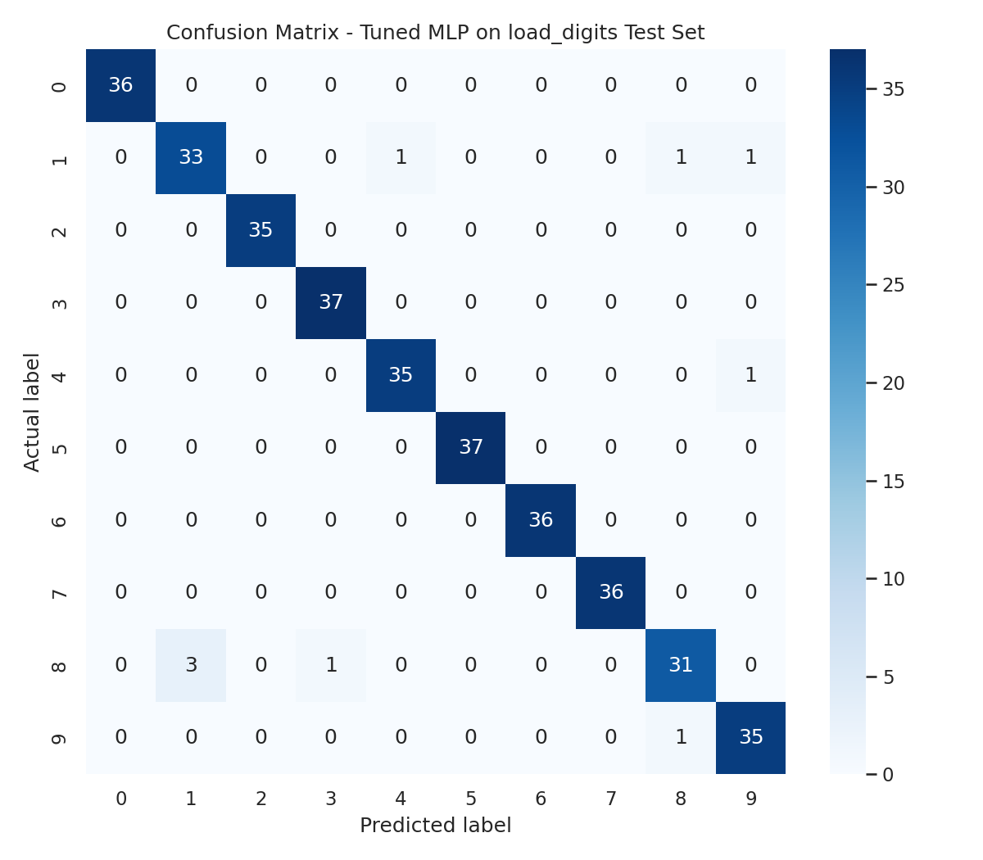
Figure 8. Confusion matrix of the tuned MLP model (test set).
Because the ten classes are balanced, macro and weighted metrics are nearly identical. Errors concentrate among visually similar digits: three true 8s were predicted as 1, and single 9s were confused with 4 and 8, giving digit 1 the lowest precision (0.92) and digit 8 the lowest recall (0.89). Kappa of 0.972 indicates near-perfect agreement beyond chance.
4. Conclusion and Overall Recommendations
Both models are strong, validated candidates. Tuned kNN reached 96.2% test accuracy (Kappa 0.916) on the Car Evaluation data, empirically beating Naive Bayes and LDA because its assumption-free approach fits this categorical, rule-driven data set. The tuned MLP reached 97.5% test accuracy (Kappa 0.972) on load_digits, with cross-validation and GridSearchCV confirming one 100-unit hidden layer with Adam was sufficient. The best next step for Part 1 is a tree-based algorithm to improve minority-class (good) recall; for Part 2, remaining errors sit in a few visually ambiguous digit pairs that more training data would likely help more than further tuning.
References
Alpaydin, E., & Kaynak, C. (1998). Optical Recognition of Handwritten Digits [Dataset]. UCI Machine Learning Repository. https://doi.org/10.24432/C50P49
Bohanec, M. (1997). Car Evaluation [Dataset]. UCI Machine Learning Repository. https://doi.org/10.24432/C5JP48
Cohen, J. (1960). A coefficient of agreement for nominal scales. Educational and Psychological Measurement, 20(1), 37–46. https://doi.org/10.1177/001316446002000104
Kingma, D. P., & Ba, J. (2015). Adam: A method for stochastic optimization. In Proceedings of the 3rd International Conference on Learning Representations (ICLR).
Pedregosa, F., Varoquaux, G., Gramfort, A., Michel, V., Thirion, B., Grisel, O., Blondel, M., Prettenhofer, P., Weiss, R., Dubourg, V., Vanderplas, J., Passos, A., Cournapeau, D., Brucher, M., Perrot, M., & Duchesnay, E. (2011). Scikit-learn: Machine learning in Python. Journal of Machine Learning Research, 12, 2825–2830.

