Coding and Training a Perceptron: Brute Force, Random Search, and Gradient Descent

How the Perceptron Was Coded
The perceptron() function multiplies each input by its matching weight, sums the products into a weighted sum, and passes that sum through activation_function(), a linear (identity) activation, f(x) = x, so the output is returned unchanged rather than forced to exactly 0 or 1 (Figure 1).
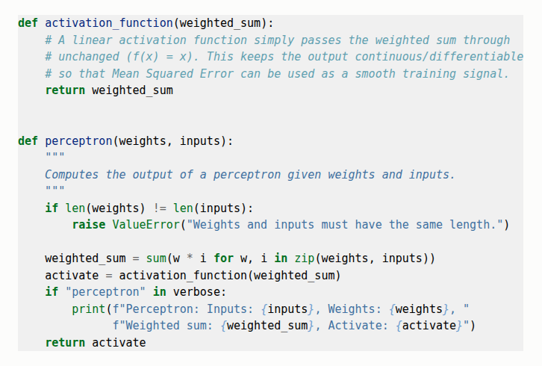

Why a Linear Activation Function Instead of a Step Function?
Rosenblatt's (1958) original perceptron used a hard step activation that outputs exactly 0 or 1. A step function is flat almost everywhere, so nudging a weight up or down by a small amount almost never changes the output — the MSE surface becomes a staircase of flat plateaus, making it impossible to tell whether a small weight change helped or hurt. A linear activation keeps the output continuous, so MSE varies smoothly as weights change, weights that are “almost right” produce a lower MSE than weights that are far off — the graded signal every search method here depends on.

Brute-Force Training and Learning Rate
find_weights_using_brute_force() searches a cubic grid of candidate weights (w1, w2, w3), stepping through a weight_range in increments of learning_rate, and stops once a combination drives the batch MSE below 0.005. Here “learning rate” is the spacing between adjacent grid points rather than a gradient step size. A weight_range of (−1, 1) was used throughout, since the known good weights for the AND-like data (about 0.9, −0.1, 0.1) fall well inside it.
Learning rate strongly affected both success and search time. Coarse rates of 0.5 and 0.25 never found suitable weights (64 and 512 grid points) because the grid was too sparse to land near the solution. A rate of 0.1 succeeded after 7,812 epochs, and the finer rate of 0.05 also succeeded but needed 61,543 epochs — roughly eight times more, since halving the step size cubes the number of grid points to check (Figure 2a).
The perceptron was also brute-force trained on XOR at rates of 0.5, 0.25, 0.2, and 0.1. Every run searched to completion (up to 8,000 grid points) without ever reaching MSE below 0.005, as expected: XOR is not linearly separable, so no linear combination of the three inputs can reproduce it. The best MSE found anywhere on the XOR grid was 0.25 — essentially just guessing the mean output — versus 0.005 for the AND-like data (Figure 2b). No amount of extra search time changes this: a single linear perceptron cannot represent XOR (Minsky & Papert, 1969).
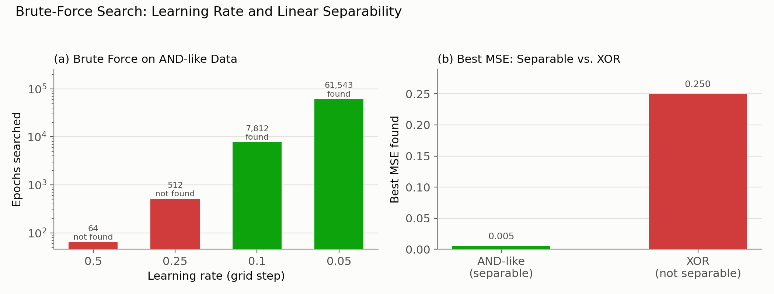

Random Weight Search
find_weights_using_random_search() draws all three weights from uniform(−1, 1) on each attempt and accepts the first draw with MSE below 0.005, giving up after 10,000 attempts. Called ten times on the AND-like data, every call eventually succeeded, but epochs needed ranged from 316 (trial 2) to 9,811 (trial 7), nearly the cap (Table 1, Figure 3). The lowest MSE achieved was 0.000893 (trial 7).
Random search results.
Trial | Epochs to Converge | Final MSE
1 | 491 | 0.001932
2 | 316 | 0.004178
3 | 2,923 | 0.004023
4 | 1,736 | 0.003585
5 | 833 | 0.003321
6 | 404 | 0.004530
7 | 9,811 | 0.000893
8 | 2,172 | 0.002698
9 | 3,934 | 0.003799
10 | 1,803 | 0.002625
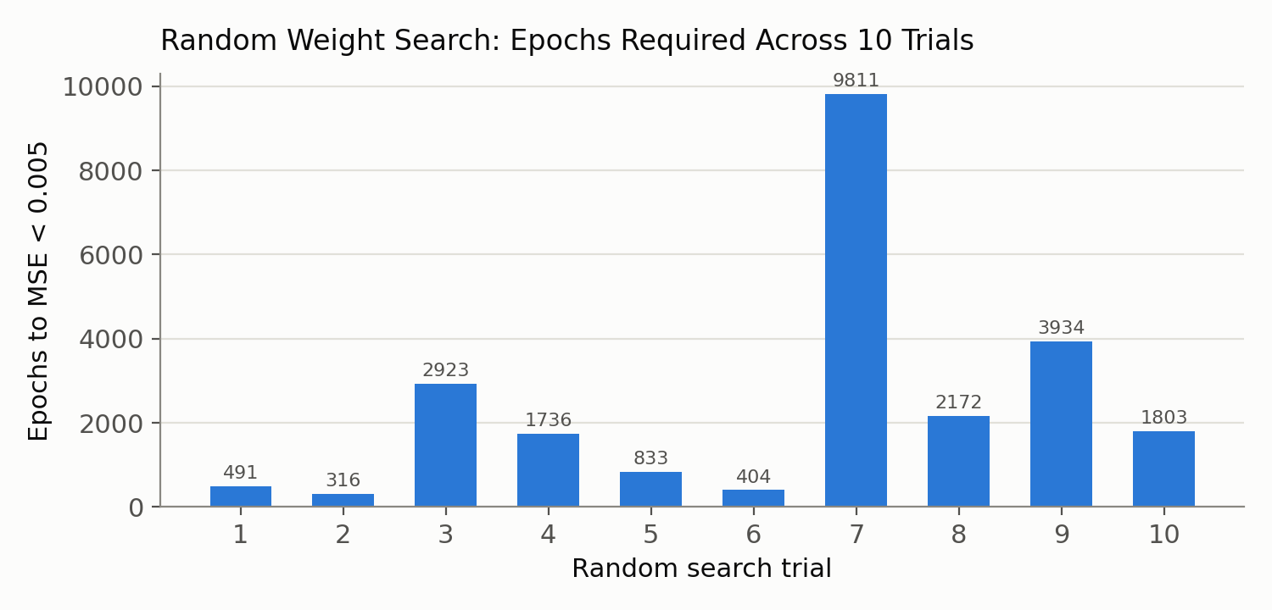
Random guessing cannot be relied on for training because it has no memory or direction: each draw is independent of every draw before it, so the search never gets systematically closer to a good answer — it only gets lucky or unlucky. That was tolerable here with only three weights and a generous 0.005 threshold, but the attempts needed grow extremely quickly as weights increase or the acceptable error shrinks. A network with thousands of weights could never be trained this way in practical time.

Batch Gradient Descent
train_with_batch_gradient_descent() starts from random initial weights and repeats a loop: compute MSE over the whole training set, stop if it is below 0.001 or the epoch limit is reached, otherwise estimate the gradient of MSE with respect to each weight and update every weight by subtracting learning_rate × gradient (Figure 4). Because each update uses the error averaged over the entire training set, this is “batch” gradient descent.
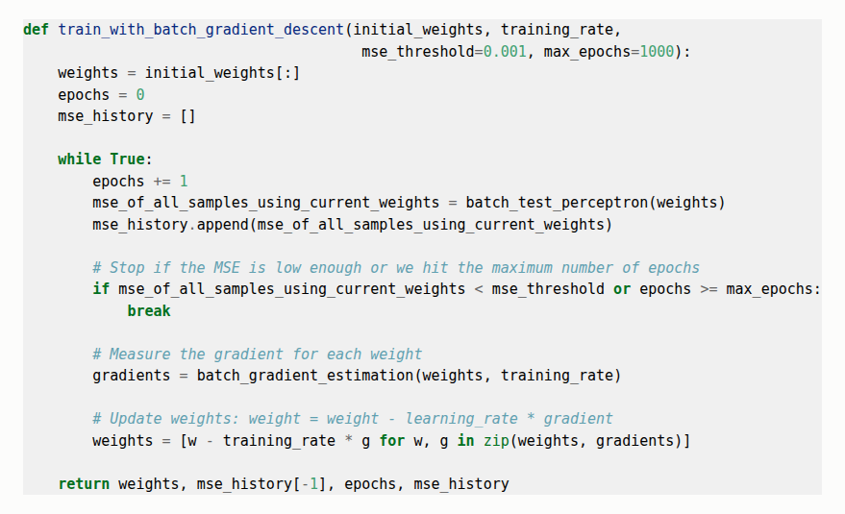

Starting from the same random weights, learning rates of 0.01, 0.1, 0.5, 0.6, 0.7, and 1.0 were compared. Smaller rates converged reliably but slowly: 0.01 needed 812 epochs, while 0.1 reached the threshold in only 81. Rate 0.5 converged in 16 epochs and 0.6 in 15 — right at the edge of stability (Figure 5a). Rates 0.7 and 1.0 did not converge at all: each update overshot the minimum by more than the last, so MSE grew without bound well before the 2,000-epoch cap (Figure 5b).
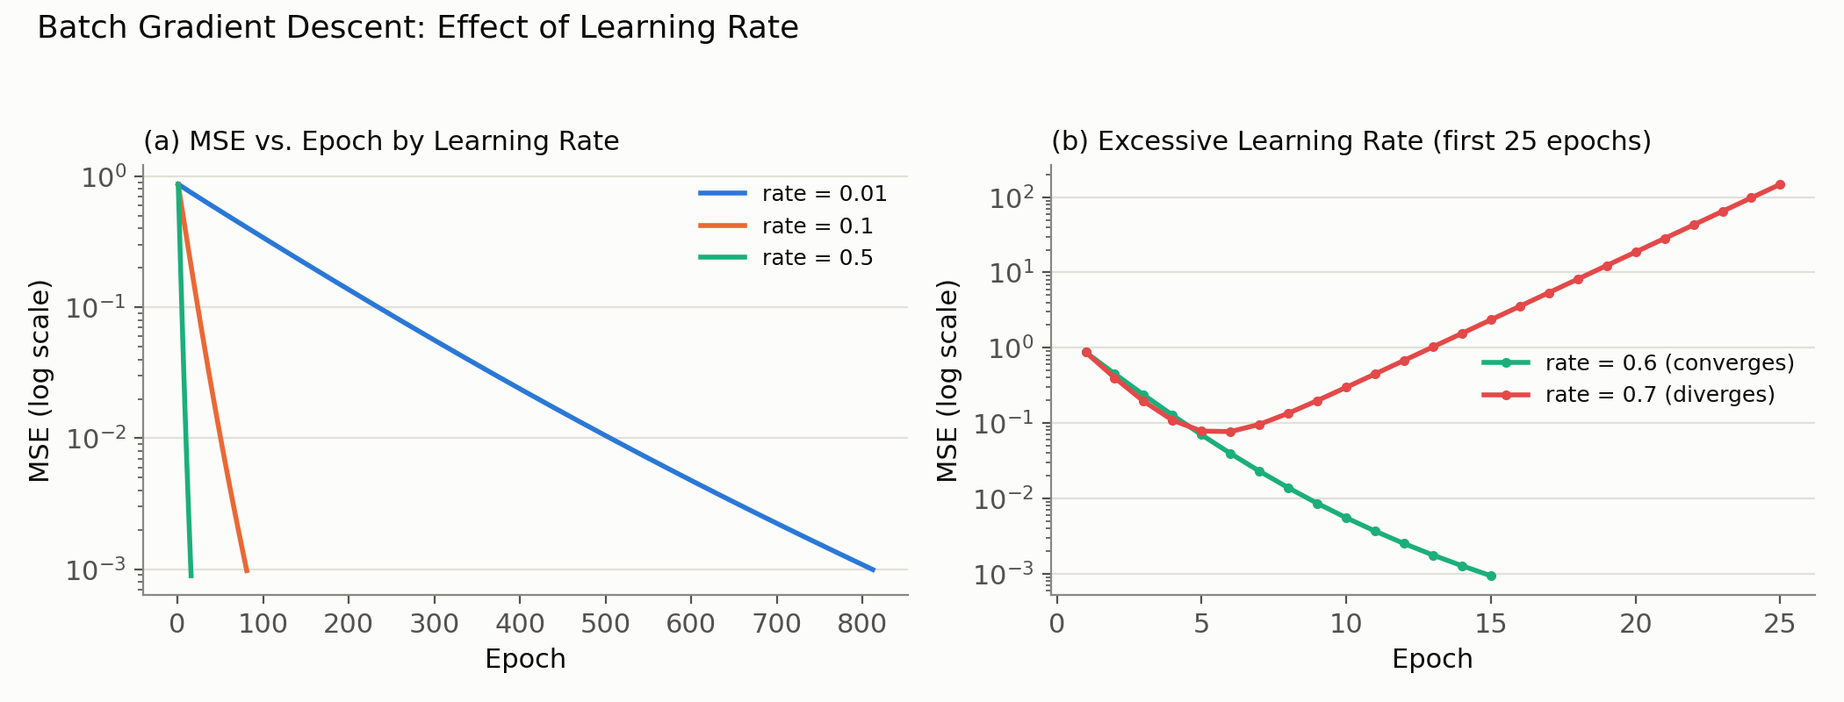

How batch_gradient_estimation() Determines the Gradient
batch_gradient_estimation() does not compute a derivative symbolically. For each weight it nudges that weight up by training_rate and down by training_rate, recomputes the batch MSE both ways, and estimates the slope as (mse_up − mse_down) / (2 × training_rate) — a central-difference numerical approximation of the partial derivative of MSE with respect to that weight, repeated for each weight using the entire training set both times. A gradient is the vector of partial derivatives of a function with respect to each of its inputs; it points toward steepest increase, and its magnitude reflects how steep that increase is (Goodfellow et al., 2016). Because the goal is to minimize MSE, the loop moves each weight opposite the gradient — weight = weight − learning_rate × gradient — moving “downhill” on the error surface.

Batch Gradient Descent vs. Stochastic Gradient Descent
The implementation here is batch gradient descent: every update uses the MSE and gradient computed from all training examples at once, so exactly one update happens per full pass (epoch) through the data — a smooth, predictable descent (Figure 5) that requires evaluating the whole training set before changing the weights even once.
Stochastic gradient descent (SGD) instead updates the weights after looking at just one training example at a time, using that example's error as a noisy stand-in for the true gradient. One epoch of SGD performs one update per example rather than one update total, so weights move far more often on much less information; the error curve is noisier, and SGD often benefits from a learning rate that shrinks over time. In exchange, each update is cheaper to compute, and the noise can help escape a shallow local minimum that batch descent would settle into.
Applied here, SGD would replace the outer batch loop with an inner loop over individual examples (ideally reshuffled each epoch). Two functions would change: batch_gradient_estimation() would estimate the gradient from one (inputs, expected) pair — computing squared_error(expected, perceptron(weights, inputs)) with the weight nudged up and down — instead of calling batch_test_perceptron() over the whole data set; and the training loop would update weights after every example, not once per epoch. Because per-example loss is noisy, the stopping check would still need to evaluate the full set periodically rather than trust any single example.

References
Goodfellow, I., Bengio, Y., & Courville, A. (2016). Deep learning. MIT Press.
Lemaréchal, C. (2012). Cauchy and the gradient method. Documenta Mathematica, Extra Volume: Optimization Stories, 251–254.
Minsky, M., & Papert, S. A. (1969). Perceptrons: An introduction to computational geometry. MIT Press.
Rosenblatt, F. (1958). The perceptron: A probabilistic model for information storage and organization in the brain. Psychological Review, 65(6), 386–408. https://doi.org/10.1037/h0042519

