Data Exploration and Preprocessing for Linear Regression: Car Evaluation Dataset

Introduction
This report documents the exploration and preprocessing of the Module 5 car evaluation dataset in preparation for a linear regression model. The dataset contains categorical attributes describing vehicles (buying price, maintenance cost, number of doors, passenger capacity, luggage boot size, and safety rating) along with a target class label indicating overall acceptability. Because the raw data consists entirely of text categories and contains missing values, several preprocessing steps were required before the dataset could be used with scikit-learn's LinearRegression algorithm.

Summary of Data Attributes
The dataset was loaded into a pandas DataFrame and explored using df.info(), df.isna().sum(), and df[column].unique() to understand its size, structure, and missingness.
Number of features: 6 (Feature1 through Feature6). The seventh column, Class, is the target label used for prediction and is not counted as an input feature.
Number of samples: 1,727 rows (instances).
Unique values for each feature and the class label are summarized in the table below.

Column | Unique Values | Missing Count
Feature1 (buying price) | low, med, high, vhigh | 274
Feature2 (maintenance cost) | low, med, high, vhigh | 293
Feature3 (doors) | 2, 3, 4, 5more | 265
Feature4 (persons) | 2, 4, more | 314
Feature5 (lug_boot) | small, med, big | 302
Feature6 (safety) | low, med, high | 279
Class (target) | unacc, acc, good, vgood | 0

Each of the six features contains between roughly 15% and 18% missing values, while the Class label has no missing values. The bar charts below show the distribution of categories within each feature and the class label.
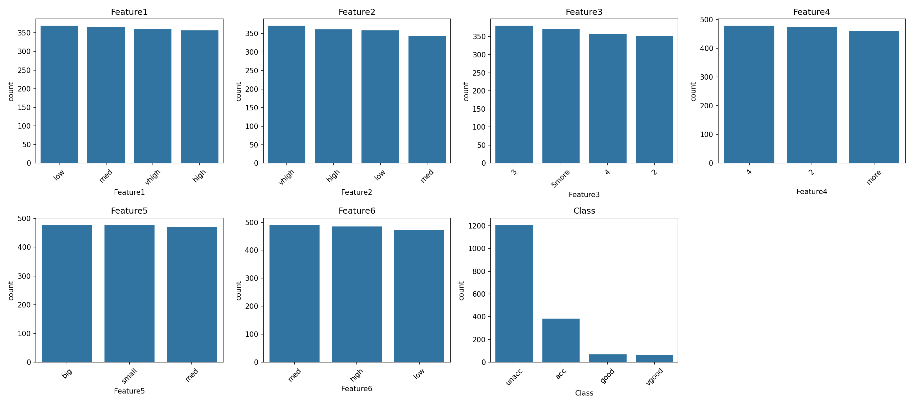
The distribution plots show that most features are fairly evenly distributed across their categories, with the notable exception of Class, which is heavily imbalanced: the majority of vehicles fall into the 'unacc' (unacceptable) category, while 'good' and 'vgood' are comparatively rare.

Correlation Matrix
The dataset had to be transformed before a correlation matrix could be generated. pandas' DataFrame.corr() method only operates on numeric columns, and the original features were stored as text strings (e.g., 'low', 'high', '5more'). Each feature was therefore encoded into numeric form using OrdinalEncoder before the correlation matrix could be computed. In addition, because the correlation calculation cannot handle missing values, the dataset was imputed (using IterativeImputer) prior to generating the heatmap below, so that every cell had a numeric value.
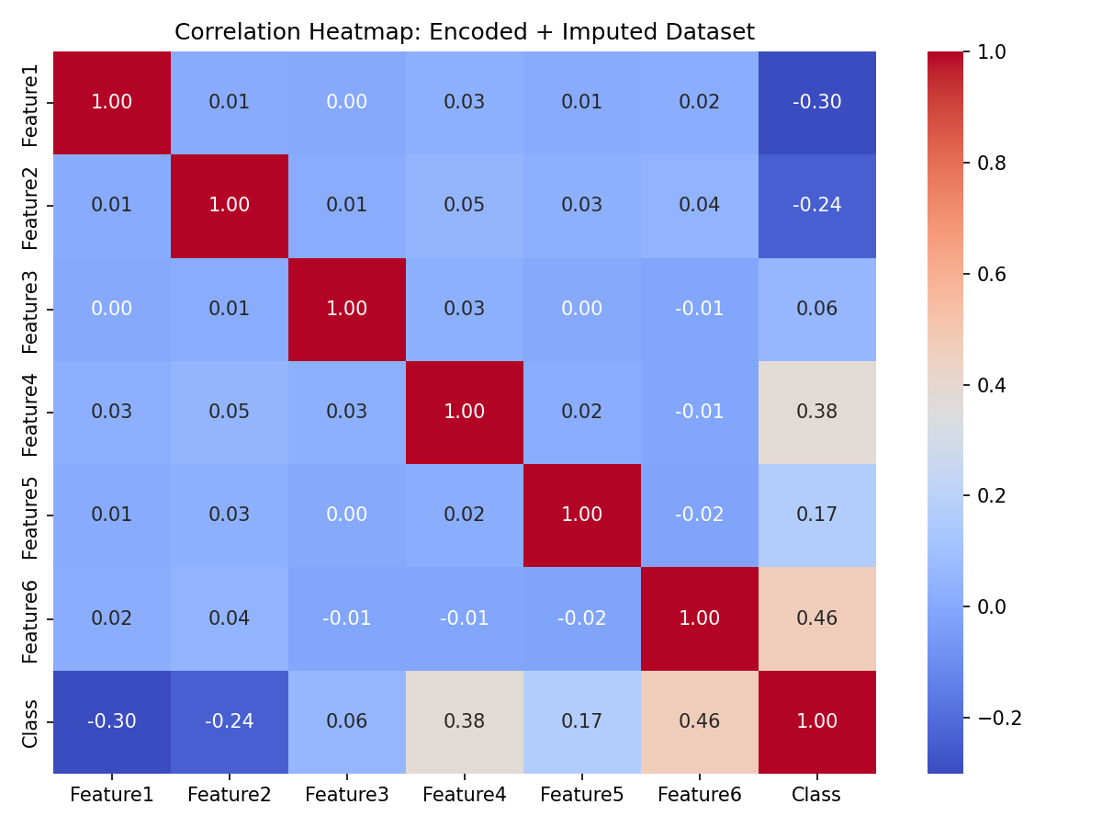
The heatmap shows that the encoded features are largely uncorrelated with one another (values close to 0.00-0.05), which is expected since the original categories (e.g., safety rating and luggage size) describe independent vehicle attributes. The strongest relationships appear between individual features and the Class label: Feature6 (safety) shows the highest correlation with Class (0.46), followed by Feature4 (persons, 0.38) and Feature1 (buying price, -0.30). This suggests that safety rating, seating capacity, and buying price are the attributes most predictive of overall vehicle acceptability.

Model Score Before Imputation
Before any preprocessing was applied, the raw dataset was passed directly into the get_score() function, which fits a LinearRegression model using 4-fold cross-validation. This call failed immediately with the following error:
ValueError: Input contains NaN
This error occurred for two independent reasons. First, scikit-learn's LinearRegression requires purely numeric input, and the raw features were text strings (e.g., 'low', 'high'), which triggered a 'could not convert string to float' error when the categorical columns were tested individually. Second, once the target and feature columns were encoded, the presence of missing (NaN) values still caused the model fitting step to fail, since LinearRegression cannot process incomplete rows. Because the model could not be trained at all, no meaningful MSE or standard deviation score could be produced for the raw dataset; this result is recorded as a failure/undefined score rather than a numeric value.

Preprocessing Approach
1. Required data types. scikit-learn's LinearRegression algorithm requires all input features (X) and the target variable (y) to be numeric, with no missing values and no infinite values. It cannot accept raw strings/categorical text, and it will raise an error if any NaN values remain in the data at fit time.
2. Transformations used. Two categories of transformation were applied. First, encoding: each categorical feature, as well as the Class target, was converted to numeric form using scikit-learn's OrdinalEncoder. An explicit category order was specified for each feature (for example, buying price was ordered low < med < high < vhigh) so that the resulting numeric codes reflect the real-world ranking of each category rather than an arbitrary alphabetical order. This was preferred over one-hot encoding because the features have a natural, meaningful order rather than being purely nominal categories, and ordinal encoding keeps the feature space compact (one column per feature instead of many binary columns). Second, imputation: because roughly 15-18% of values in each feature were missing, four different imputation strategies were tested and compared, SimpleImputer with a constant fill value of zero, SimpleImputer using the mean of each column, KNNImputer, and IterativeImputer, to determine which approach produced the most accurate downstream regression model.
3. Factors that informed preprocessing decisions.
- Algorithm type: Because LinearRegression is a strictly numeric algorithm with no built-in support for categorical data or missing values, preprocessing had to fully resolve both issues before the model could run at all. This ruled out leaving any column as text or leaving any missing cells unfilled.
- Data characteristics: Each feature's categories had a clear real-world order (e.g., safety: low < med < high), which made ordinal encoding an appropriate and interpretable choice rather than expanding the feature space with one-hot encoding. The relatively even spread of missing values across all six features (roughly 15-18% each) meant that no single feature needed to be dropped entirely; imputation was a viable strategy for all of them.
- Algorithmic constraints: The OrdinalEncoder was configured with handle_unknown='use_encoded_value' and unknown_value=np.nan so that missing values would pass through the encoding step as NaN rather than raising an error, which allowed the imputers to be applied afterward as a separate, independent step. This two-stage design (encode, then impute) made it possible to compare multiple imputation strategies on the same encoded dataset without re-running the encoding step each time.

Comparison of Imputation Methods
After encoding, the four imputation strategies were each combined with the LinearRegression model in a scikit-learn pipeline and evaluated using 4-fold cross-validation with negative mean squared error (neg MSE) as the scoring metric. Because the metric is negative MSE, values closer to zero indicate better model performance (lower error).
Imputation Method | Mean Neg. MSE | Std. Deviation
Zero (constant fill) | -0.392 | 0.071
Mean | -0.342 | 0.048
KNN | -0.357 | 0.052
Iterative | -0.342 | 0.048

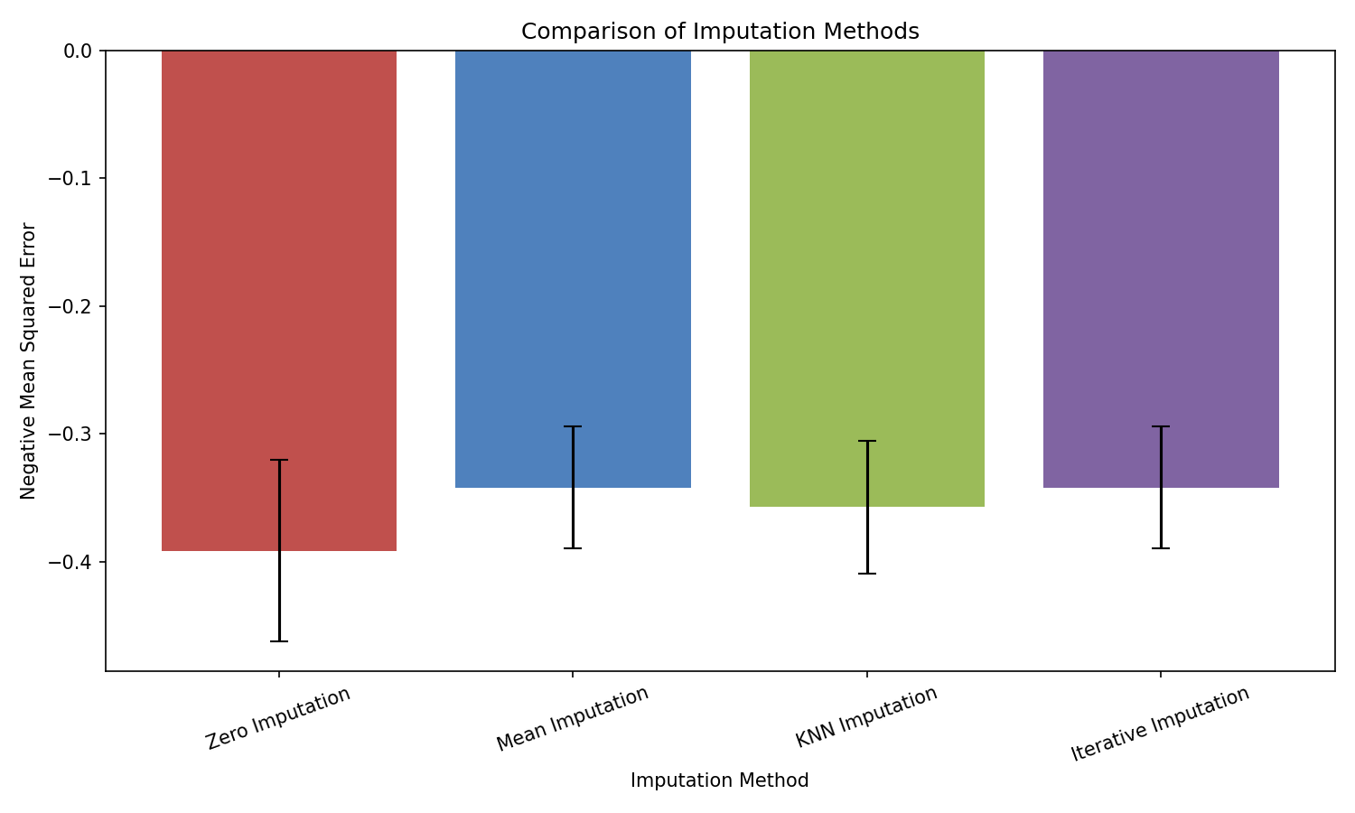
Mean imputation and Iterative imputation produced the best (least negative) and most consistent results, both averaging approximately -0.342 MSE with the smallest standard deviations. KNN imputation performed slightly worse (-0.357), and constant zero-fill imputation performed worst overall (-0.392), with the largest error and highest variability. This makes intuitive sense: filling missing values with zero introduces an artificial value that does not correspond to any real category in the encoded scale, distorting the relationship between features and the target, whereas mean and iterative imputation produce more statistically representative fill values. Given the near-identical performance of Mean and Iterative imputation on this dataset, either would be a reasonable choice going forward; Iterative imputation may offer a slight advantage on datasets with stronger inter-feature relationships, since it models each feature as a function of the others rather than using a single global statistic.

Conclusion
The raw dataset could not be used with LinearRegression until it was fully numeric and free of missing values. Ordinal encoding resolved the categorical data type issue while preserving the natural ranking of each attribute, and comparing four imputation strategies showed that mean and iterative imputation produced the most accurate and stable linear regression results for this dataset.

