LC2102a
2U CubeSat Structure
User Manual

Document change log
Rev. | Date | Author | Pages | Description
0 | 2014-07-12 | Artur Scholz | All | Initial release

Table of Contents
1 Introduction 3
2 Applicable and reference documents 4
3 Definitions and abbreviations 4
4 Specification 5
4.1 Absolute maximum ratings 5
4.2 Physical characteristics 5
4.3 Other characteristics 5
5 Interfaces 6
5.1 Mechanical interfaces 6
5.2 Electrical interfaces 9
6 Design description 10
6.1 Main structure 10
6.2 Side panels 10
6.3 Deployment switches and separation springs 10
6.4 Antenna ring and deployment 10
7 Handling and storage 11

Introduction
The LC-2102a 2U CubeSat Structure is a rigid and modular structure for nanosatellites that fully conforms to the CubeSat specification. It consists of four anodized side frames and a bottom frame, an antenna mounting ring, and panels. The frame and panels are made of 6061 aluminium alloy, while the antenna mounting ring is made of PEEK. The product fits CubeSat-Kit compatible boards and standard PC104 boards. It is easily assembled with 46 screws (plus 44 panel screws).

Illustration 1 is an exploded view of the product with two panels removed. It shows the annotation for the main components of the product. The coordinate systems shown are the CubeSat reference frame and the reference frame for handling and assembly.

Deployment switch
Separation spring
Access port opening

Front panel (-X)

Secondary frame

Sun sensor opening

Board mounting block

Frame C
Top panel (-Z)

Frame A

Frame B

Rail

Right panel (+Y)

Antenna ring
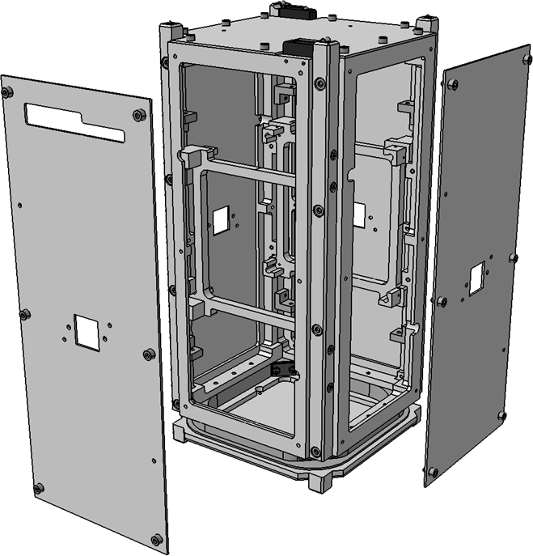Illustration 1: Exploded view of product
Up

Front
Right
+XCRF

+YCRF

+ZCRF
Features:
- Rigid 2 mm 6061 aluminium frame and 1mm 6061 aluminium panels
- Modular design
- Easy to assemble and integrate
- Redundant separation springs and redundant deployment switches
- Antenna mounting ring
- For CubeSat-Kit compatible boards and PC104 boards
- Total mass: 704 grams
- Qualified for PSLV, DNEPR and other launch rockets
- First natural frequency > 400 Hz

Applicable and reference documents

Reference | Title | Issue
AD1 | CubeSat Design Specification | 12 or later

Reference | Title | Issue
RD1 | CubeSat Board Specification

Definitions and abbreviations

Term | Definition
Assembly | The process of mating parts to obtain a low level configuration
Integration | The process of physically and functionally combining lower level products to obtain a particular functional configuration
Fixing | The permanent locking of fasteners
Mounting | Mating of parts using fasteners

Abbreviation | Definition
CRF | CubeSat reference frame
ESD | Electrostatic discharge
RBF | Remove-before-flight
SMS | Structure and mechanisms system

Specification

Absolute maximum ratings

Parameter | Min | Max | Unit
Current through deployment switch |  | 10 | A

 | Exceeding the limits specified in the table above may result in permanent damage to the device and harm to products and personal.

Physical characteristics

Parameter | Min | Nom | Max | Unit
Total mass |  | 704 |  | g
First natural frequency | 400 |  |  | Hz
Centre of gravity, Gx |  | 0.11 |  | mm
Centre of gravity, Gy |  | 0 |  | mm
Centre of gravity, Gz |  | 4.67 |  | mm
Moment of inertia, Ixx |  | 6.00E-003 |  | kg*m**2
Moment of inertia, Iyy |  | 5.00E-003 |  | kg*m**2
Moment of inertia, Izz |  | 3.00E-003 |  | kg*m**2
Moment of inertia, off-diagonal |  |  | 1.00E-005 | kg*m**2
* All values are given with respect to the CubeSat reference frame, with its origin in the geometric centre of the CubeSat

Other characteristics

Technology readiness level
The product in its configuration has TRL 8 and is qualified for space operation. It has been qualified against typical launch loads and low earth space environment.

Compatibility
The product is in full conformance with the CubeSat Design Specification. It can integrate boards that conform to the CubeSat Board Specification form factor and other custom-made boards.

Interfaces

Mechanical interfaces

External interfaces
The product has interfaces to the deployer during launch and it has interfaces to mechanical ground support equipment during assembly and testing. The external dimensions of the product are shown in Illustration 2. Also shown are the dimensions of the access port opening. These, and any other side panel openings (such as for the sun sensor) are fully customizable. The side panels allow for mounting of components such as sensors and solar panels.

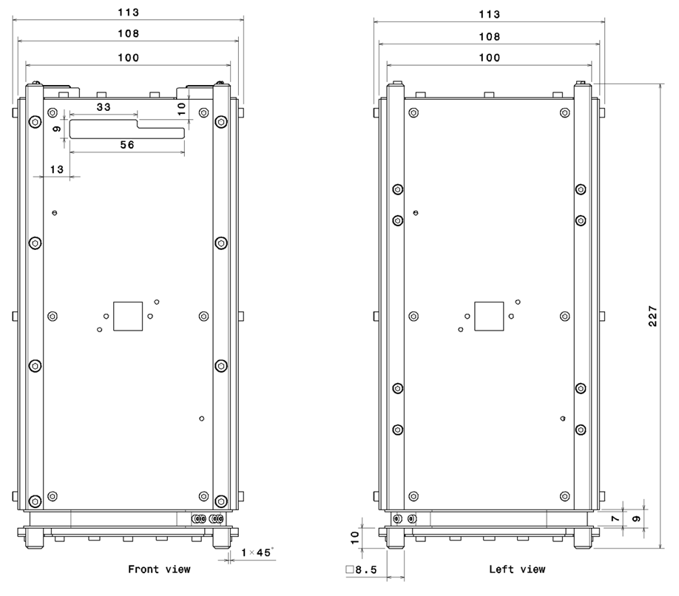Illustration 2: External dimensions

Internal interfaces
The product interfaces to the interior satellite components through its main structure. The structure provides through-holes for M2.5 screws at each frame A as shown in Illustration 3. These can be used to either mount components (such as payload) directly onto the frame, or by using mounting blocks for the boards as shown in Illustration 4.

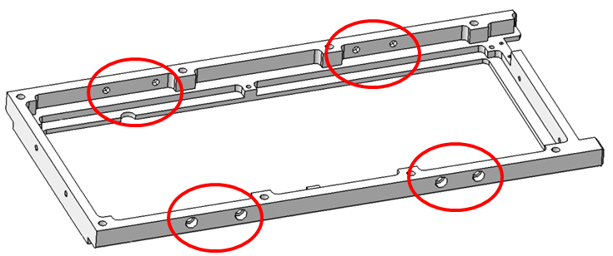Illustration 3: Mounting holes
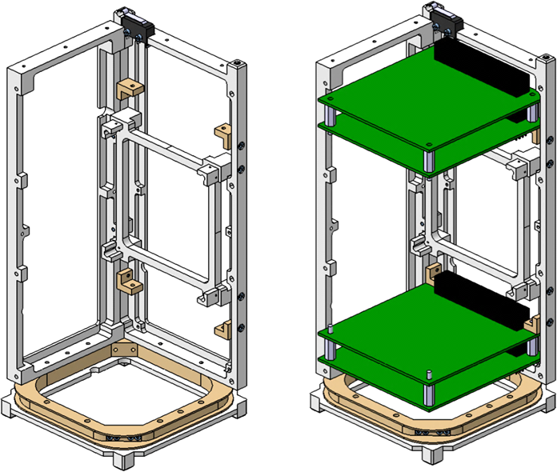Illustration 4: Example of a mounting configuration for interior components
Up

Front Right
The interior boards should conform to the board shape as specified in the CubeSat Board Specification and shown in Illustration 5.

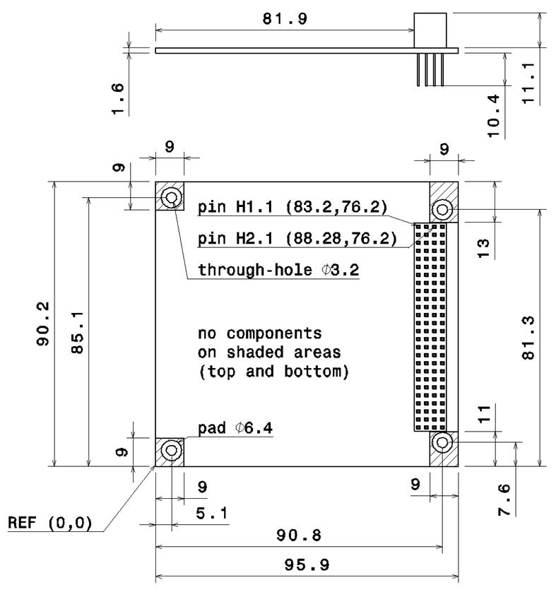Illustration 5: Recommended shape of interior boards

Electrical interfaces
The only electrical interfaces of the product are the deployment switches. The functioning of the switch is shown in Illustration 6. Depending on the deployment switch circuit logic of the satellite, not all of the terminals may be used and can be removed.

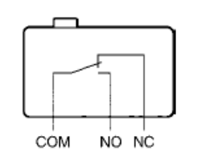Illustration 6: Deployment switch diagram

Design description

Main structure
The main structure was designed not for optimized (low) weight, but for rigidity and modularity. All screws are easily accessible and the structure can be assembled and disassembled quickly.

Side panels
The side panels can be customized to fit sensors and solar panels. The current design allows for mounting of attitude sensors and/or cameras in the centre. It also provides an access window to the hosted subsystem boards on the front panel.

Deployment switches and separation springs
Separation springs are integrated on the top end of two opposite rails. On the two remaining rails, the deployment switches are mounted on top. This mechanism combines robustness with simplicity.

Antenna ring and deployment
The antenna ring provides for mounting an UHF dipole antenna. The antenna is stored during launch and released upon orbit injection. This is usually done via melting a nylon string that holds the free ends of the dipoles together. The mechanisms requires an external system to provide the power for this mechanism.

Handling and storage
Be careful when handling the product and observe cleanliness requirements. To clean the product, use a lightly moist tissue.

Use gloves when handling the product and ensure cleanliness at all times.

Be careful in particular not to break the deployment switch levers.

Store the product in a clean and dry environment at room temperature. The product may be stored in assembled or disassembled configuration.

