Adnan Hassan

GluGo

Residual Analysis of ML Algorithm (12/2/16)

R code:

attach(`gluPredict(15min)`)

gluResid <- V3-V2

plot(V2, gluResid, pch= 20, main = "Predicated Values vs Residuals")

abline(h=0)

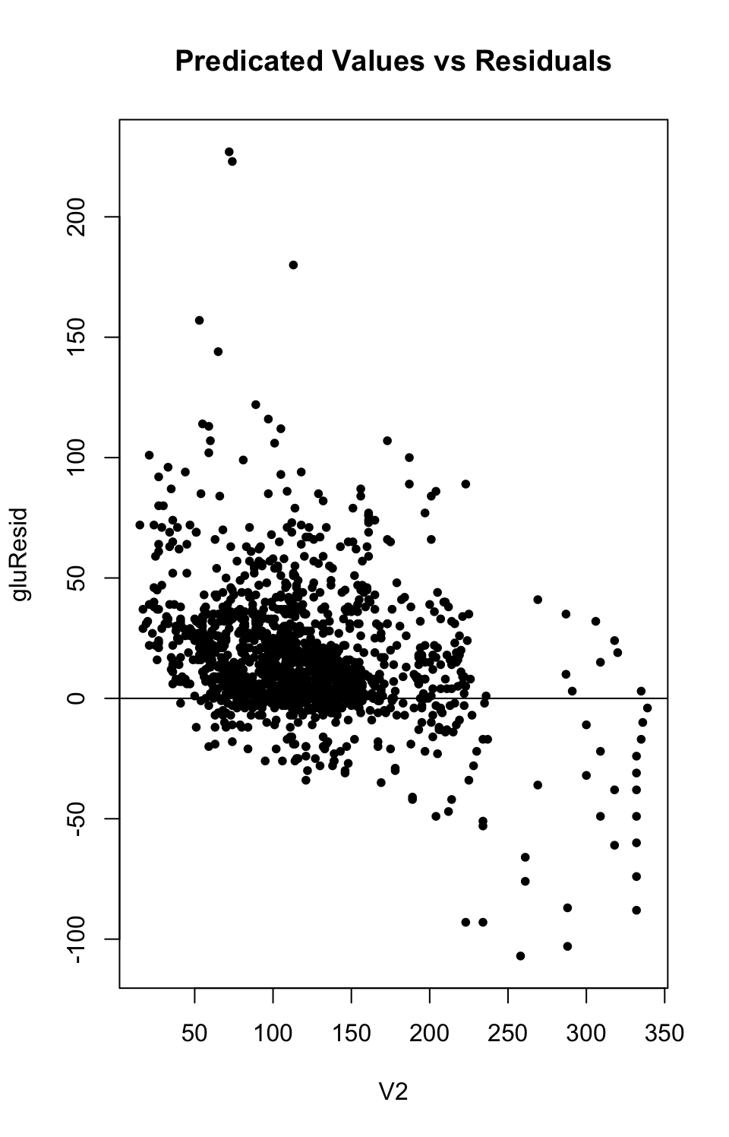

Based on the residual plot, there seems to be some consistency in the variance of predicated glucose levels between 50 and 200 mg/dL, but there is high variability in predicated glucose levels above 250 mg/dL (abnormal levels).