ASSIGNMENT 4

Daniel Angel

2010-12-23

# Markdown Basics

## My Favorite Cuisines

1. Mexican : (Enchiladas, Tacos, Tamales, Tortas)
2. Thai : (Pad Kee Mao, Pad Thai, Pad See Ew, Satay Gai, Kao Pad)
3. Mediterranean : (Hummus, Baba Ganoush, Dolmas, Tabouli, Falafel, Spanakopita)

## Logarithmic Graph of Covid-19 Cases - Florida, New York, and California (February-April)

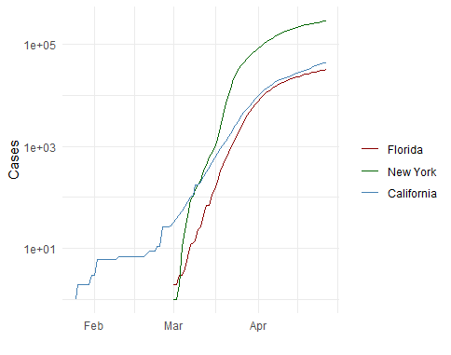

All Cases (Log Plot)

## One of my favorite Yogiisms

“When you come to a fork in the road, take it.” - Yogi Berra

## Prime Number Theorem:

### The number of primes in the first N numbers approaches N divided by the logarithm of N for sufficiently large N.

$$π\left(N\right)∼\frac{N}{\text{ln}\left(N\right)}$$

*In other words, the probably of finding a prime in the first N numbers, for large N, is close to the reciprocal of the logarithm of N.*

## A note about the above equation.

I actually did my undergraduate thesis on the Prime Number Theorem[1]

## Citations for Course Textbooks

* Lander (2014)
* Field et al. (2012)

# Code Chunks

This code chunk operating invisibly (behind-the-scenes) is loading in the data for the next graph.

## NY Times COVID-19 Data

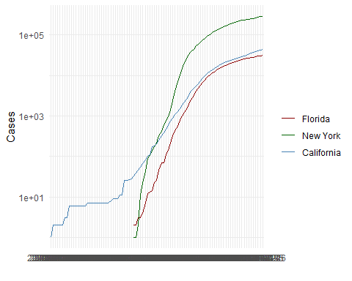

## R4DS Height vs Earnings

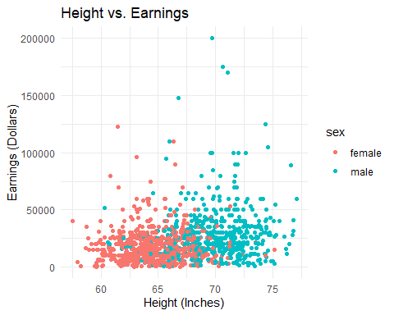 # Tables

## Knitr Table with Kable

First, we will load the knitr package. Then we will load our data before proceeding to create a table using the kable() function.

One Ring to Rule Them All

|  |  |  |  |  |
| --- | --- | --- | --- | --- |
| name | race | in_fellowship | ring_bearer | age |
| Aragon | Men | TRUE | FALSE | 88 |
| Bilbo | Hobbit | FALSE | TRUE | 129 |
| Frodo | Hobbit | TRUE | TRUE | 51 |
| Galadriel | Elf | FALSE | FALSE | 7000 |
| Sam | Hobbit | TRUE | TRUE | 36 |
| Gandalf | Maia | TRUE | TRUE | 2019 |
| Legolas | Elf | TRUE | FALSE | 2931 |
| Sauron | Maia | FALSE | TRUE | 7052 |
| Gollum | Hobbit | FALSE | TRUE | 589 |

## Pandoc Table

(Simple Table) Lord of the Rings’ Characters Minus Elves and Gollum (Sorry Smeagol)

|  |  |  |  |  |
| --- | --- | --- | --- | --- |
| Name | Race | In Fellowship? | Is Ring-Bearer? | Age |
| Aragon | Men | Yes | No | 88 |
| Bilbo | Hobbit | No | Yes | 129 |
| Frodo | Hobbit | Yes | Yes | 51 |
| Sam | Hobbit | Yes | Yes | 36 |
| Sauron | Maia | No | Yes | 7052 |

(Grid Table) Lord of the Rings’ Characters Minus Elves and Gollum ~~(Sorry Smeagol)~~

|  |  |  |  |  |
| --- | --- | --- | --- | --- |
| Name | Race | In Fellowship? | Ring Bearer? | Age |
| Aragon | Men | Yes | No | 88 |
| Bilbo | Hobbit | No | Yes | 129 |
| Frodo | Hobbit | Yes | Yes | 51 |
| Sam | Hobbit | Yes | Yes | 36 |
| Sauron | Maia | No | Yes | 7052 |

# References

Field, A., Miles, J., & Field, Z. (2012). *Discovering statistics using r*. SAGE Publications. <https://books.google.com/books?id=wd2K2zC3swIC>

Lander, J. P. (2014). *R for everyone: Advanced analytics and graphics*. Addison-Wesley. <https://books.google.com/books?id=3eBVAgAAQBAJ>

1. I don’t have a copy unless I can get my old laptop to start working again.