Project Proposal

**Team Molyneux 3**

Daniel Beales

James Masterton

Jordon Spowart

Contents

“Terrifying open world woodland survival experience” 2

Outline 3

Description 3

Objective 3

Gameplay 3

Conditions 3

The winning condition 3

The losing condition 4

Target Platform 4

Operating System 4

Peripherals 4

Multiplayer 4

Development Tools 4

Game Engine 4

Design 4

Source Control 5

Management and Team Tools 5

Submission and Completion 5

# “Terrifying open world woodland survival experience”

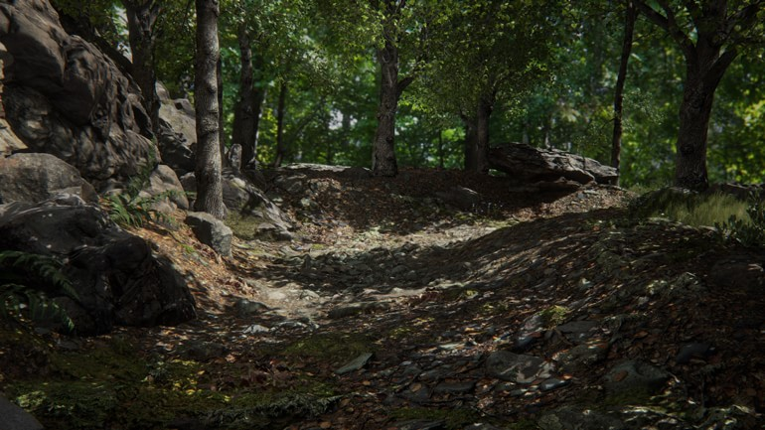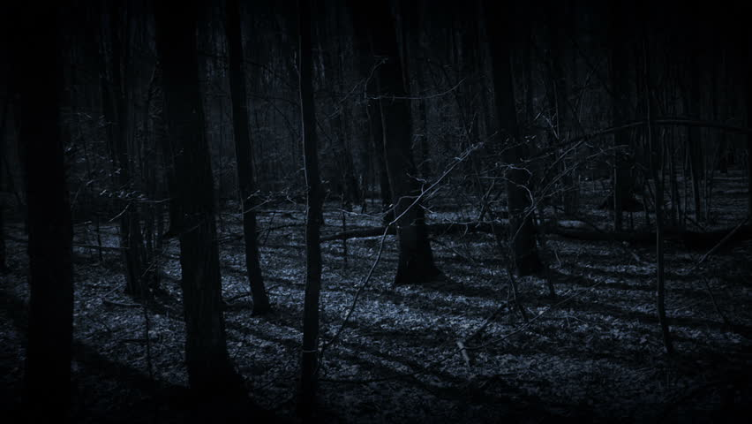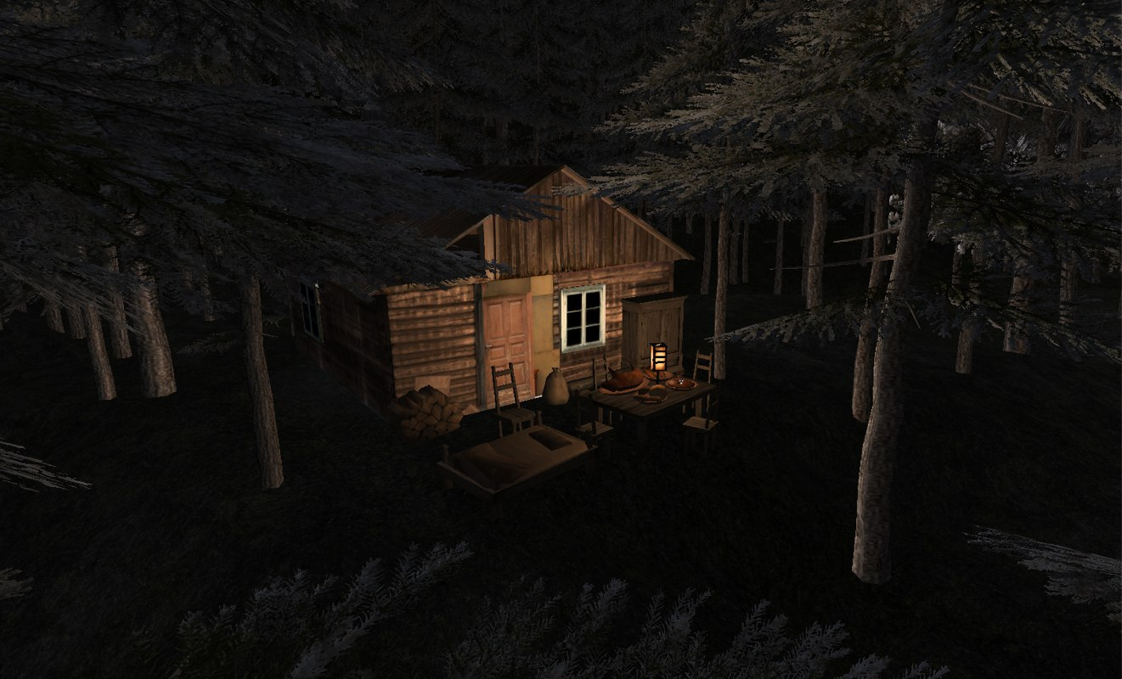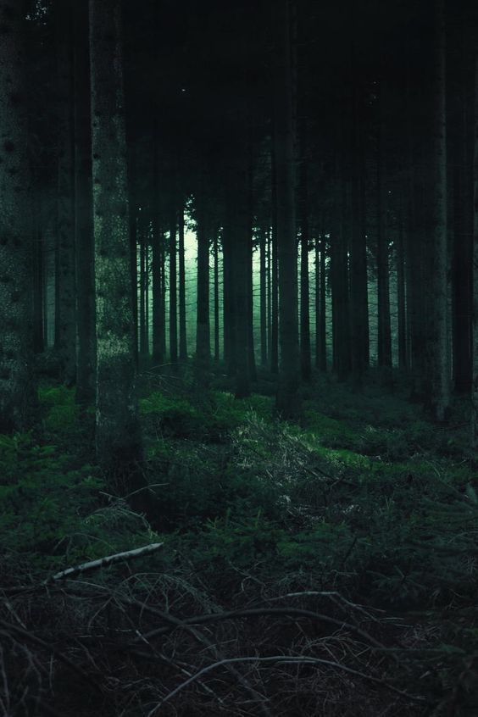

# Outline

### Description

Team Molyneux are aiming to create an immersive open world horror experience, that will receive emotional responses from the player using visual and sound cues. This game will revolve around a log fire based within a log cabin situated in a dark moonlit woodland, surrounded by snow covered rocky mountains.

### Objective

The players sole objective in this experience is to keep the sole Lightsource within the cabin a-light in doing so protecting themselves from an unknown adversary hiding in the woods. To keep the log fire burning the player will be required to venture out into the dense; dark woodland to collect fuel for the fire, doing so quickly and effectively with caution avoiding and escaping any danger that may come to pass.

# Gameplay

The player will start within the log cabin with a log fire burning in front of their character, this fire will slowly be running out of fuel and providing less light and security. Using visual clues and information the player will be told to search for logs that will be laying on the ground on the outside of the cabin within the woods. These logs will not be highlighted and may blend into the foliage but once found can be interacted with using the interaction key press. The log will then disappear from sight, but a number on the players HUD will increment up symbolising adding that log to their inventory. The player then will be able to return to the cabin and interact with the fire to re fuel.

# Conditions

The winning condition of this game is to keep the fire going until the allotted time, ie 10 minutes in the games current form conforming to the outlined brief.

To stop this winning condition becoming boring or monotonous each time the player goes into the forest, sound cues will increase in the attempt to construct a state of fear or paranoia within the player.

The losing condition of this game is purely the fire going out, although the game will make the player feel they are in danger within the woodland, in fact it is more dangerous to stay in the cabin as the fire dims. The game over will be shown as a black screen potentially with a death animation representing the light going out and the danger coming from outside in.

The game is required to have a cheat function, to do this the player is going to have the ability to get a hint, this hint will direct the player to a torch that has been in plain sight, this torch will allow the player to light up the woodland. This will help finding logs more effectively, while also alleviating a level of fear.

# Target Platform

### Operating System

The operating system this project will be designed for is Windows 7/8/10.

### Peripherals

The game will require a keyboard and mouse and will not have any extra/custom controller functionality at this time.

### Multiplayer

We will not be developing the game with the concept of multiplayer capabilities or a networked connection in mind.

# Development Tools

The development tools that will be used within this project will vary from team member, but on a primary basis every team member will be using the same game engine and version.

### Game Engine

Unreal Engine: 4.20.3

### Design

3D modelling programs will also be used, as a team we have access to Maya and a multitude of other development packages, but we may have to rely on free packages like Blender.

### Source Control

We will be using a source control program called GitHub to control the versions of our projects, while also keeping any documents and source files relevant to the production of the project on the repository that will be accessible to every team member.

***The repository can be found here:***

<https://github.com/dannybeales/Team-Molyneux-3>

# Management and Team Tools

The team will be managing weekly tasks set by the project manager using Trello. This will allow us as a team to see how each member is preforming on their tasks, Keeping tasks on time and managing workloads.

***Our project board can be found here:***

<https://trello.com/b/spFI2Jv9/team-molyneux>

The team will communicate using outlook and our Northumbria student emails and also meet in person every **Wednesday** at **13:15pm** at the university campus. This is allow us as a team to build our skills together, work on the project as a team and help other team members where needed. It is also much easier to communicate to other team members, especially when trying to explain design ideas using verbal communications rather than written.

# Submission and Completion

Team Molyneux as a responsibility to get both documents and project files to the university for the set deadlines.

**Proposal and Skills Audit: 22nd February at 23:59pm 2019**

**Software and Documentation Presentation: 13th May 2019**