October 15, 2018

Sent via email to «respEmail»

RE:

Case No.

Dear :

The division has completed its investigation into the complaint filed against and the following is a summary of our findings.

Based on the details above, the division will be closing this investigation without a finding of violation by the association. Thank you for your cooperation with this investigation.

Please feel free to contact me if you have any questions or need further clarification regarding the resolution of this complaint.

Sincerely,

BUREAU OF COMPLIANCE

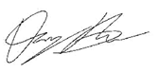

Danny Brown

Financial Examiner/Analyst II