# Week 9 - Notes: Driven Oscillations

We have seen that oscillators that have only a potential energy term will oscillate forever – energy is conserved. While the oscillations can take any shape, they are periodic.

Damped oscillators dissipate energy, and so the oscillations will eventually die out. With the damped harmonic oscillator, the oscillations are still periodic, but the amplitude decreases over time. For that model,

we found that the relative strengths of and determined the type of oscillation. But the motion always died out because the damping removed energy from the system.

**What if we kept putting energy into the system?**

We can replenish the energy that is lost to damping by adding a driving force. These are driven oscillators, sometimes called forced oscillators. The driving force is a time dependent force that is added to the system.

:::{admonition} Time Dependent Force Not Periodic :class : tip

Here we used time dependent force to mean a force that depends on nearly any function of time . The force does not have to be perdiodic, but it can be.

Systems can be given a kick or pulse of energy (which we might model with a [delta function](https://en.wikipedia.org/wiki/Delta_function) or a [step function](https://en.wikipedia.org/wiki/Heaviside_step_function), or they can be driven by a periodic force.

For most of our examples, we will use a periodic driving force. :::

## Driving the Oscillator

For the damped harmonic oscillator, we had

Now we will add a driving force to the system, so that the equation of motion becomes

We can represent that setup in the picture below. The blue spring with spring constant is attached to a red mass . There is a dashpot (damping) in green with damping constant . The driving force is shown in black and called “driver”.

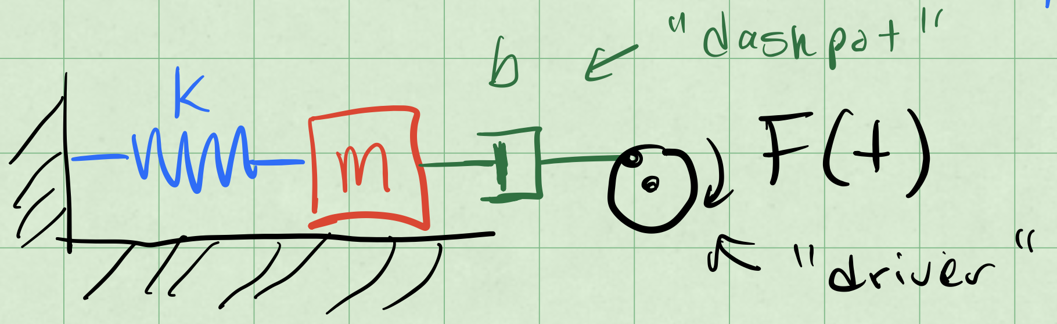

driven oscillator

We write that differential equation as:

where and . The function is the driving force per unit mass.

**Note that this differential equation remains linear.**

Why? Because the “operations” on x(t) are linear.

## Linearity of Differential Equations

A linear differential equation has many nice properties. In particular, the superposition of solutions and the uniqueness of solutions. So it is worth knowing when you have one.

**Claim:** is a linear operator.

What is an operator? It is simply a function that takes a function as an input and returns another function as an output. The derivative is a function that takes a function and returns another function, namely the slope of the tangent line to the original function everywhere it is defined and differentiable.

Let’s prove that is a linear operator.

Let , where and are two functions. Then

We can distribute the derivative across the sum of the two functions. Thus is a linear operator.

This also suggests that constants and other simple derivatives are linear operators (e.g., and ). And because of the distributive property, any linear sum of linear operators is also a linear operator (e.g., ).

We can write the diffferential equation for the driven oscillator as

We group the terms of the left hand side into a single operator, , so that

The operator is a linear differential operator. This compact notation expresses the linearity of the differential equation.

### Effect of a Linear Operator on our Solutions

Because is a linear operator, we can distribute it. This results in our finding a linear combination of solutions to the differential equation. This is built up quite easily in three steps.

1. We can allow the operator to act on a function scaled by a scalar constant :
2. We can allow the operator to act on a sum of functions:
3. We can allow the operator to act on a linear combination of functions:

This is the superposition principle in action. But we have to be careful when we apply it. For example, when,

we must first solve the homogeneous equation, .

## Homogeneous and Particular Solutions

The damped driven oscillator is a linear differential equation. But that means that any solution to the equation where the driving force is zero is a solution to the equation where the driving force is non-zero. And, thus must be added to the solution of the non-homogeneous equation.

Let’s use the language of differential operators to express this. We want to solve:

where is a linear differential operator. But any solution to the homogeneous equation, , is a solution to the non-homogeneous equation.

We use the notation to denote the solution to the homogeneous equation.

So let’s use the superposition principle to write the solution to the non-homogeneous equation as a sum of two parts:

where is a particular solution to the non-homogeneous equation. We will get to the name of in a moment. Let’s the focus on the mathematical properties of the solution for a moment.

With the homogeneous solution, , we have

That is what defines the particular solution. In our case, that it is specific to the driving force we have chosen.

**Summary:** When solving , the solution is the sum of the homogeneous solution and a particular solution . We typically solve the homogeneous equation first.

The solutions satisfies the unknowns set by the initial conditions. The particular solution is a solution to the non-homogeneous equation , so it will not depend on the initial conditions, how it is particular to the driving force .

## Example: Sinusoidal Driving Force

Let’s consider a sinusoidal driving force. We will use the following notation for the driving force:

where is the amplitude of the driving force and is the angular frequency of the driving force. **Note that is not necessarily the same as .**

So we can write the differential equation for the driven oscillator as

where is the linear differential operator

Note that if instead , then we would have

where is the solution to the differential equation with a sine driving force and is the same linear differential operator. Writing both the of differential equations out, we have

### Two Birds, One Stone

We can cleverly combine these two equations into a singlle differential equation by using complex numbers.

We can similarly write as a complex sum:

Now because of linearity, we can write the differential equation for as

Written out, we have

### Particular Solution

We note the particular solution depends on the driving force. We can try one that follows the complex exponential form of the driving force.

where is a complex constant. We can find by substituting into the differential equation.

We can cancel the terms on both sides of the equation, and we are left with

We can solve for :

We found and it is fully determined. But it is a complex number. Ultimately, we want a real valued solution, but we remember that

And we can write the coefficient as a magnitude and a phase :

### Writing the Complex Amplitude

Let’s find that form of .

So the amplitude of the particular solution is

We can find the phase by looking at :

Note that both and are real numbers, so the complex phase of is determined by the complex number on the right side of the equation.

That is, the phase of the term and the phase of the complex number are the same. So we can write ratio of their imaginary and real parts as,

Again, this number is fully determined without initial conditions.

### Back to the Particular Solution

We proposed a solution , where is a complex constant. This became

where is a real number and is a real number. Note we can write the particular solutions for both and as

### General Solution

The proposed general solution was

And for our sinusoidal driving force, we have found the particular solution, so that we can write:

where is the solution to the homogeneous equation, .

We propose a solution form for that is a linear combination of two exponential functions (as we did before):

These are solutions to the damped oscillator, and we refer to them as the “transient” solutions. They are transient because they die out over time due to damping.

For a weakly damped system, , which is the case that is most interesting to us, we can write the solution as,

where is the amplitude of the transient solution, is the damped frequency (per usual), and is the phase of the transient solution.

## Resonance and Tuning

A curious thing about the long term behavior (after the transients die out) is that we can observe large amplitudes at particular choices of driving. Consider the long term (stady state) solution to the driven damped harmonic oscillator:

where,

Let’s allow to be small so that is small. If we focus on the denominator, we can see that the amplitude will be small when is far from . But if we choose to be close to , then the denominator will be small, and the amplitude will be large.

The second result is a [resonance](https://en.wikipedia.org/wiki/Resonance) effect. The system will resonate at a particular frequency, , and the amplitude of the oscillations will be large. Below is a sketch of the response of a driven damped harmonic oscillator to a sinusoidal driving force. The amplitude of the oscillations is plotted as a function of the driving frequency .

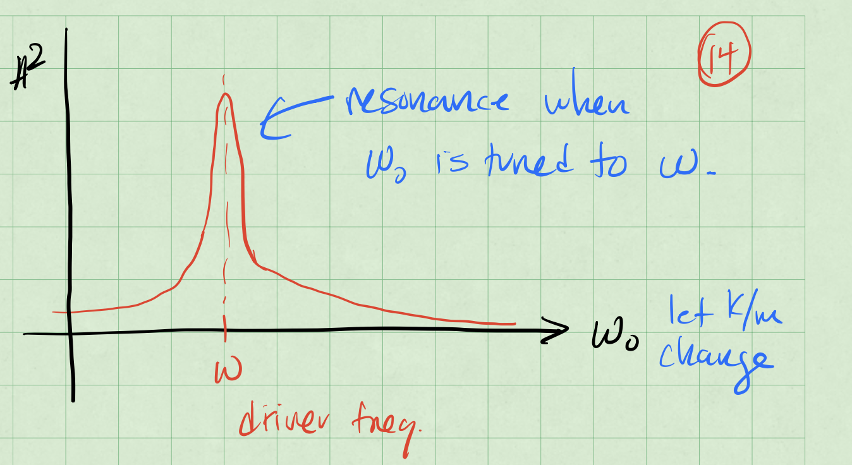

Resonance Sketch

### Achieving Resonance

There’s two ways that we can approach this. Let’s focus on the denominator of the amplitude equation:

When that denominator is small, the amplitude will be large. There’s two ways to make the denominator small.

**Case 1:** Tune the (the natural frequency of the system) to be close to (the driving frequency). This is how a car radio works. You change the resistance of the radio circuit to change the natural frequency of the radio circuit. You can then tune the radio to a particular station that is broadcasting at a particular frequency. This gives an amplified signal,

When , then the denominator is equal to . The amplitude is

**Case 2:** Tune the driver () to be close to .

Because we are adjusting the driver, we are seeking the driving frequency that minizes the denominator. We can do this by setting the derivative of the denominator with respect to to zero.

Thie first solution is when there is no driver. But the second, , is the frequency that minimizes the denominator. We can write that as

We can a strong response when or when .