HR Chatbot

for Human Resource Policies

of the Government of B.C.

By Danny, George, Ellen

September 4, 2025

**Background**

In every organization, employees frequently call HR department about various HR policy questions related to compensation, leave of absence, health and safety, privacy, employment standards, etc.

The HR staff depend on the organization’s HR policy documents to answer any queries. This is an area where AI chatbots can make a meaningful impact. We choose to implement a HR chatbot to modernize employee experience and streamline HR processes.

**Data Gathering**

We searched the Internet for public human resource policy documents. There are many available documents from Canadian resources. For example,

* [The Government of British Columbia](https://www2.gov.bc.ca/gov/content/careers-myhr/managers-supervisors/employee-labour-relations/conditions-agreements/policy/hr-policy-pdf)
* [The Government of Prince Edward Island](https://psc.gpei.ca/human-resource-policy-and-procedures-manual)
* [Archery Canada](https://archerycanada.ca/wp-content/uploads/2019/07/Human-Resource-Policy-Manual.pdf)
* [University of Toronto](https://people.utoronto.ca/policies/)

The HR policy documents of the Government of B.C are picked for our project since they are of the proper size – 24 pdf files plus appendices with total of less than 3 MB disk space. They are very high quality data and no cleaning is needed.

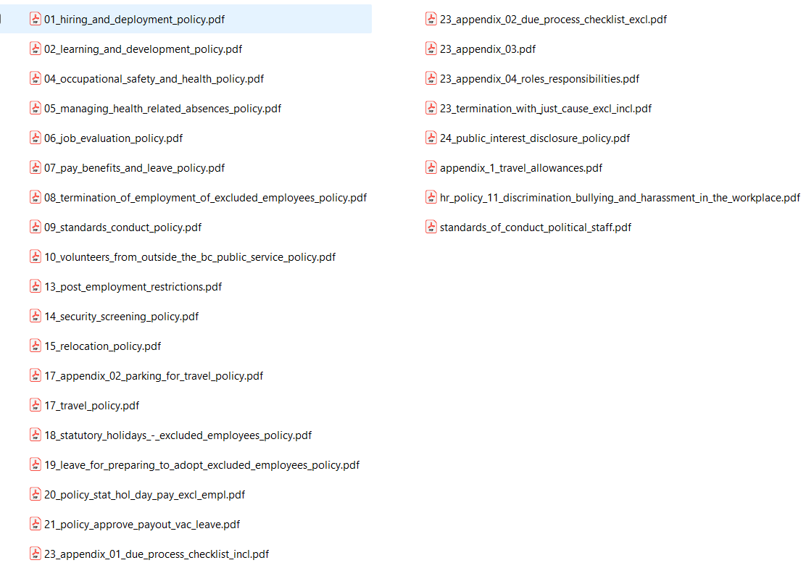

**Models**

Chat completion: gpt-4.1

Embedding model: text-embedding-3-large

**Services**

Azure AI Foundry

Azure OpenAI Service

AI Search Service

AI Services

Blob Storage Account

**Data Ingestion**

We use the integrated vectorization feature in Azure AI Search. Integrated vectorization takes care of document format cracking, data extraction, chunking, vectorization, and indexing.

The data ingestion process is implemented in the module *load_data_create_index.py*.

1. Upload pdf documents to Azure Blob Storage

Blob Service

1. upload local pdf



2. Store pdf in blob



Azure Blob Storage

Local pdf documents

2. Chunk documents and generate embeddings

3. fetch data



1. create data source connector

2. create search index

4. chunk documents

AI Search Service

Azure Blob Storage

HR Chatbot

5. generate embeddings



Azure OpenAI Service

Retrieval and Generation

The RAG process is implemented in the module *retrieval_generation.py*.





1. do retrieval

AI Search Service

HR Chatbot

2. do generation



Azure OpenAI Service

HR Chatbot

Currently HR Chatbot supports command line only.

HR Chatbot consists of three modules:

main.py

load_data_create_index.py

*retrieval_generation.py*

The main module invokes load_data_create_index() and then

in a while loop, it takes the user query and invokes *retrieval_generation(user_input).*

Demo

Sample questions:

1. What will an organization of the Government of British Columbia do if an employee got health problems?

2. Which HR policy document talks about occupational safety and health?

3. What is the role of political staff?

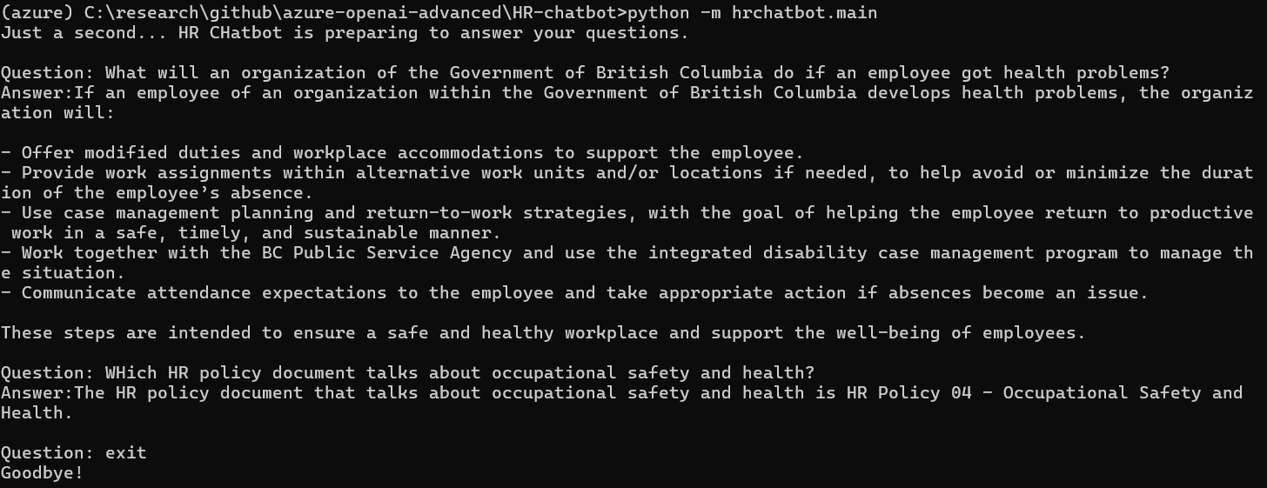

Q & A