MATH 501

COURSEWORK

2024

**BY**

10842878, 10882588, 10892938, 10893087.

**BY**

**10892938; 10882588; 10842878; 10864307**

Math 501 Modelling and Analytics for Data Science Coursework

10892938; 10882588; 10842878; 10864307

2024-04-11

# Machine Learning Task

## Machine Learning Part (A)

## type body surface   
## Length:37 Min. :4.65 Min. :3.71   
## Class :character 1st Qu.:5.22 1st Qu.:4.24   
## Mode :character Median :5.59 Median :4.46   
## Mean :5.56 Mean :4.67   
## 3rd Qu.:5.94 3rd Qu.:4.93   
## Max. :6.47 Max. :6.34

From these summaries, we can infer the following:

* The average body-wave magnitude is very close to the median, indicating a relatively symmetrical distribution of body-wave magnitude values around the central value.
* The average surface-wave magnitude is also close to the median, suggesting a similar symmetrical distribution for surface-wave magnitudes.
* There is a broader range of surface-wave magnitudes (from 3.71 to 6.34) compared to body-wave magnitudes (from 4.65 to 6.47). This might indicate that surface-wave magnitudes can vary more widely for the events in the dataset.

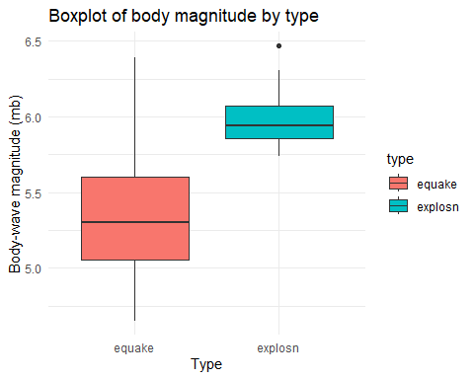

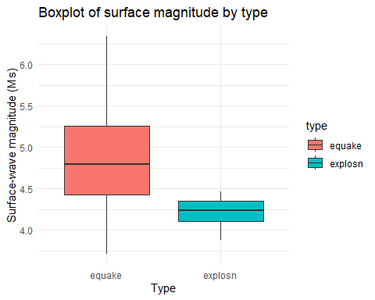

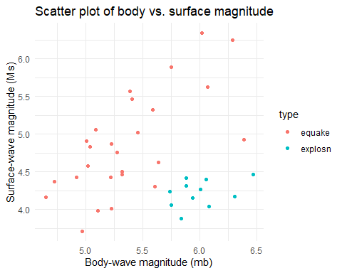

The scatter plot depicts the relationship between body-wave magnitude (mb) and surface-wave magnitude (Ms) for seismic events, which are classified into two types: earthquakes (red points) and nuclear explosions (cyan points).

From the scatter plot, we can observe the following:

* There appears to be a positive correlation between body-wave and surface-wave magnitudes for earthquakes, meaning as the magnitude of body-waves increases, the surface-wave magnitude also tends to increase.
* The separation between the two types of events is quite clear, with only a small overlap. This suggests that the two features, body-wave and surface-wave magnitudes, could be useful in constructing a rule to distinguish between earthquakes and nuclear explosions.

These insights would be valuable in creating a machine-learning model to classify seismic events accurately. The next steps would typically involve applying classification algorithms to the data and validating their performance in distinguishing between the two types of seismic events.

## Machine Learning Part (B)

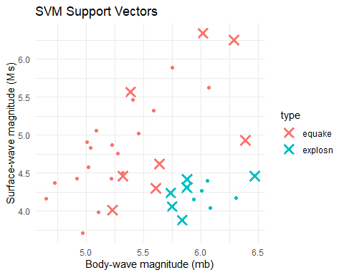

## 1   
## equake   
## Levels: equake explosn

## NULL

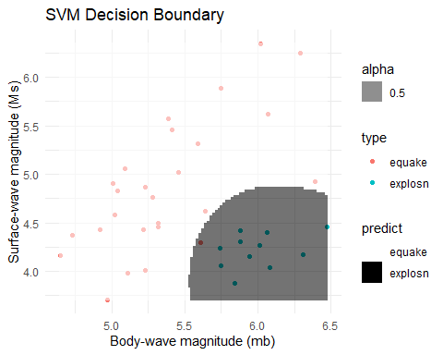

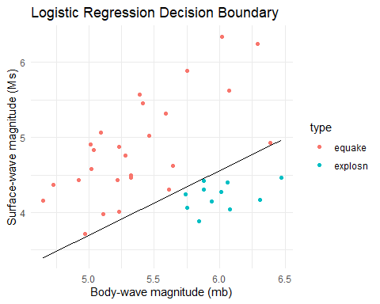

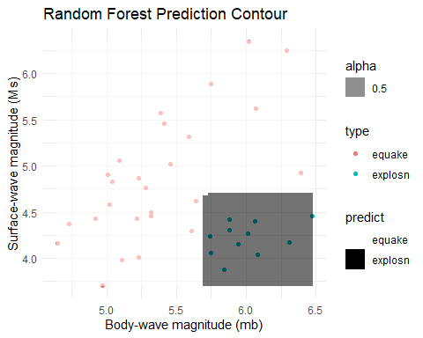

## parameter Accuracy Kappa  
## 1 none 0.9459459 0.8770764

## mtry Accuracy Kappa  
## 1 2 0.972973 0.9369676

**Model Selection Justification:**

Logistic Regression is chosen because it is a fundamental classification algorithm particularly suited for binary classification problems. It models the probability that an instance belongs to a particular class.

Random Forest is an ensemble learning method that builds multiple decision trees and merges them for a more accurate and stable prediction. It was chosen because it is less likely to overfit than a single decision tree and is good at handling complex interactions between features.

**Model Tuning:**

The logistic regression model does not have hyperparameters that need tuning for its basic version. For the random forest, we tuned the number of trees (ntree) and the number of variables to split at each node (mtry). The tuning is done using leave-one-out cross-validation (LOOCV), which is a good choice for small datasets because it uses the maximum amount of data for training. However, the output suggests that there was only one unique complexity parameter in the default grid, which indicates that perhaps the grid could be expanded or customised further for more extensive tuning.

**Model Evaluation:**

The LOOCV results for logistic regression show an accuracy of approximately 94.59% with a Kappa statistic of about 0.877, which indicates a high level of agreement between predicted and actual values, correcting for chance. The random forest classifier has an even higher LOOCV accuracy of approximately 97.30% and a Kappa statistic of about 0.937, suggesting an excellent predictive performance.

**Comments on the Results and Graphs:**

The logistic regression model has provided a high level of accuracy, which is quite good for a simple linear model. This suggests that the relationship between the predictors (body and surface) and the response variable (type) may be approximately linear.

The random forest model has achieved a higher accuracy than logistic regression, indicating that the model’s additional complexity and ability to capture non-linear relationships may benefit this dataset. The contour plot for random forest provides an intuitive visualisation of how predictions vary across the feature space, with different regions corresponding to different predicted explosion types. Both classifiers have performed well, but the random forest has a slight edge regarding predictive accuracy.

## Machine Learning Part (C)

**Performance Metrics:**

* **Logistic Regression**:
  + Accuracy: 0.946
  + Kappa: 0.877
  + High accuracy and Kappa, but warnings indicate possible overfitting or separation issues.
* **Random Forest**:
  + Accuracy: 0.973
  + Kappa: 0.937
  + Highest accuracy and Kappa, indicating excellent performance across metrics.

**Advantages and Disadvantages:**

* **Logistic Regression**:
  + **Advantages**: Simple, interpretable, effective with small datasets, provides outcome probabilities.
  + **Disadvantages**: Assumes linearity, sensitive to outliers, may underperform with non-linear relationships.
* **Random Forest**:
  + **Advantages**: It handles non-linear data well, is less sensitive to outliers, manages feature interactions, and is robust to overfitting.
  + **Disadvantages**: Less interpretable than logistic regression, computationally expensive, may struggle with noisy data.

**Overall Recommendation:**

* The **Random Forest** classifier is recommended due to its superior accuracy and Kappa scores, its robustness in handling non-linear relationships and interactions between features, and its ensemble nature that helps prevent overfitting.
* **Justification** for the recommendation includes Random Forest’s ability to handle complex data relationships, higher performance metrics, and robustness.

In conclusion, the Random Forest classifier is recommended for classifying explosion types based on seismic features, attributed to its strong performance in accuracy and kappa statistics and suitability for complex data structures.

## Machine Learning Part (D)

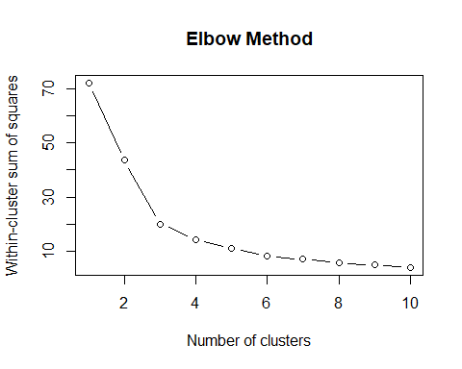

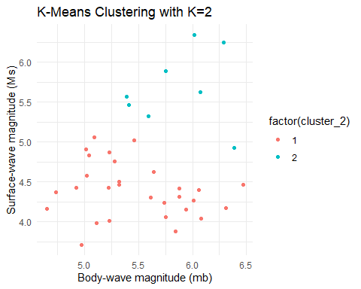

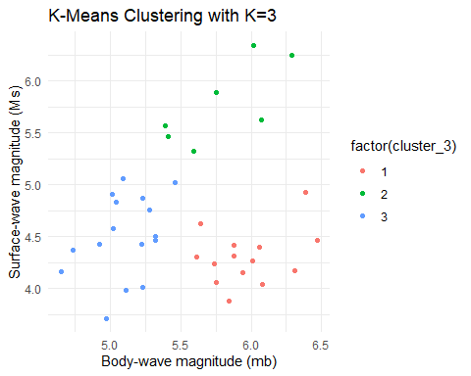

## [1] 0.4144626

## [1] 0.4940785

**Summary:**

* **Elbow Method Plot**: This method indicates the optimal number of clusters by looking for the point where the WCSS no longer decreases significantly. For the data in question, the elbow point suggests that the optimal number of clusters is 2 or 3.
* **K-means Clustering**: Models with K=2 and K=3 have been trained. In the K=2 model, two distinct clusters emerged, one with lower and another with higher magnitude data points, colour-coded red and blue. A third cluster in the K=3 model indicates a middle group with moderate magnitudes, colour-coded as green.
* **Interpretation**: The K=3 cluster model appears to provide a more refined segmentation of the seismic data, potentially identifying a third category that was not distinguished when using only two clusters.

**Comments on Findings**: The clustering seems useful, with the different clusters possibly correlating to different magnitudes of seismic events. However, the interpretation remains speculative without specific ‘type’ information, such as labels indicating whether an event is an earthquake or an explosion.

# First Sub-Task: Frequentist One-way Analysis of Variance

## Bayesian Statistics Part (A)

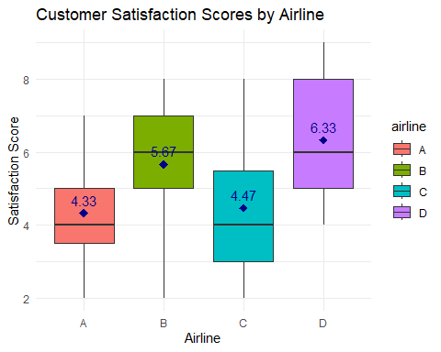

**From the boxplot, we can make several observations:**

* **Airlines Satisfaction Overview**:
  + Four airlines (A, B, C, D) are evaluated based on customer satisfaction scores.
  + A boxplot for each airline represents satisfaction scores.
* **Comparative Insights**:
  + **Central Tendency**: Airline D has the highest median satisfaction score.
  + **Variability**: Airline A shows the least variability, while Airlines C and D have more variability in customer satisfaction.
  + **Range**: Airlines B and D have a broader range of scores, indicating more diverse customer opinions.
  + **Skewness**: Airlines B and D’s score distributions are skewed towards higher ratings.

## Bayesian Statistics Part (B)

In the described one-way Analysis of Variance (ANOVA) model, the parameter α4 represents the difference in the mean satisfaction score between Airline 4 and Airline 1.

* yij ∼ N(µij , σ2 ),: This indicates that the satisfaction score (yij) for the j-th customer on the i-th airline is normally distributed with a mean satisfaction score of µij and a common variance σ2.
* µ1j = µ1: This specifies that the mean satisfaction score for all Airline 1 customers is µ1, which serves as the baseline mean. (µ1) is the mean satisfaction score for Airline 1 customers.
* µ2j = µ1 + α2: The mean satisfaction score for Airline 2 is modelled as the baseline mean plus an additional effect, α2. ( µ2 )) is the mean satisfaction score for Airline 2 customers, and it is modelled as the mean of Airline 1 plus an adjustment factor α2.
* µ3j = µ1 + α3: Similarly, the mean satisfaction score for Airline 3 is the baseline mean plus α3. ( µ3 )) is the mean satisfaction score for Airline 3 customers, and it is modelled as the mean of Airline 1 plus an adjustment factor α3.
* µ4j = µ1 + α4: For Airline 4, the mean satisfaction score is the baseline mean plus α4. ( µ4 )) is the mean satisfaction score for Airline 4 customers, and it is modelled as the mean of Airline 1 plus an adjustment factor α4.

Thus, α4 quantifies the extent to which the average satisfaction score of Airline 4 differs from that of Airline 1. If α4 is positive, it indicates that Airline 4 has a higher mean satisfaction score than Airline 1, whereas a negative α4 would suggest that Airline 4 has a lower mean satisfaction score than Airline 1. If α4 is zero, it would mean that the mean satisfaction scores of Airline 1 and Airline 4 are the same. Therefore, α4 represents how much higher or lower the average satisfaction score for Airline 4 is compared to Airline 1.

## Bayesian Statistics Part (C)

##   
## Call:  
## lm(formula = satisfactionscore ~ airline, data = airline_data)  
##   
## Residuals:  
## Min 1Q Median 3Q Max   
## -3.6667 -1.3333 -0.3333 1.3333 3.5333   
##   
## Coefficients:  
## Estimate Std. Error t value Pr(>|t|)   
## (Intercept) 4.3333 0.4194 10.333 1.38e-14 ***  
## airlineB 1.3333 0.5931 2.248 0.02852 *   
## airlineC 0.1333 0.5931 0.225 0.82294   
## airlineD 2.0000 0.5931 3.372 0.00136 **   
## ---  
## Signif. codes: 0 '***' 0.001 '**' 0.01 '*' 0.05 '.' 0.1 ' ' 1  
##   
## Residual standard error: 1.624 on 56 degrees of freedom  
## Multiple R-squared: 0.2208, Adjusted R-squared: 0.1791   
## F-statistic: 5.29 on 3 and 56 DF, p-value: 0.00278

## Analysis of Variance Table  
##   
## Response: satisfactionscore  
## Df Sum Sq Mean Sq F value Pr(>F)   
## airline 3 41.867 13.9556 5.29 0.00278 **  
## Residuals 56 147.733 2.6381   
## ---  
## Signif. codes: 0 '***' 0.001 '**' 0.01 '*' 0.05 '.' 0.1 ' ' 1

## Df Sum Sq Mean Sq F value   
## Min. : 3.00 Min. : 41.87 Min. : 2.638 Min. :5.29   
## 1st Qu.:16.25 1st Qu.: 68.33 1st Qu.: 5.467 1st Qu.:5.29   
## Median :29.50 Median : 94.80 Median : 8.297 Median :5.29   
## Mean :29.50 Mean : 94.80 Mean : 8.297 Mean :5.29   
## 3rd Qu.:42.75 3rd Qu.:121.27 3rd Qu.:11.126 3rd Qu.:5.29   
## Max. :56.00 Max. :147.73 Max. :13.956 Max. :5.29   
## NA's :1   
## Pr(>F)   
## Min. :0.00278   
## 1st Qu.:0.00278   
## Median :0.00278   
## Mean :0.00278   
## 3rd Qu.:0.00278   
## Max. :0.00278   
## NA's :1

## NULL

* **Mean Satisfaction Scores:**
  + Airline 1 (A) has a baseline mean satisfaction score of 4.3333.
* **Differences in Satisfaction Scores Relative to Airline 1**:
  + Airline 2 (B) has a higher mean satisfaction score by 1.3333 points (statistically significant).
  + Airline 3 (C) has a higher mean satisfaction score by 0.1333 points (not statistically significant).
  + Airline 4 (D) has a higher mean satisfaction score by 2.0000 points (statistically significant).
* **Statistical Significance:**
  + The difference for Airline B is significant, with a p-value of 0.02852.
  + The difference for Airline C is not significant, with a p-value of 0.82294.
  + The difference for Airline D is highly significant, with a p-value of 0.00136.
* **ANOVA Results:**
  + The F-statistic is 5.29, indicating at least one significant difference in mean satisfaction scores among the airlines.
  + The p-value of 0.00278 from the ANOVA confirms that these differences are statistically significant at a 0.05 significance level.
* **Conclusions:**

There is statistically significant evidence that Airline D has a notably higher customer satisfaction score than Airline A, followed by Airline B, which also scores higher but to a lesser extent. Airline C’s satisfaction score is not significantly different from Airline A.

## Bayesian Statistics Part (D)

## Tukey multiple comparisons of means  
## 95% family-wise confidence level  
##   
## Fit: aov(formula = satisfactionscore ~ airline, data = airline_data)  
##   
## $airline  
## diff lwr upr p adj  
## B-A 1.3333333 -0.2370805 2.9037471 0.1229720  
## C-A 0.1333333 -1.4370805 1.7037471 0.9959461  
## D-A 2.0000000 0.4295862 3.5704138 0.0072205  
## C-B -1.2000000 -2.7704138 0.3704138 0.1917762  
## D-B 0.6666667 -0.9037471 2.2370805 0.6763548  
## D-C 1.8666667 0.2962529 3.4370805 0.0136641

The output from the Tukey Honest Significant Difference (HSD) test provides the differences in mean satisfaction scores (**diff**), the lower (**lwr**) and upper (**upr**) bounds of the 95% confidence intervals for these differences, and the adjusted p-values (**p adj**) for all pairwise comparisons between the airlines.

Based on the Tukey HSD test, we can make the following conclusions:

* There is a statistically significant difference in mean satisfaction scores between Airline D and Airline A, with Airline D scoring higher on average.
* There is also a statistically significant difference between Airline D and Airline C, with Airline D again scoring higher.
* At the 0.05 significance level, there are no significant differences in the mean satisfaction scores between Airline B and Airline A, Airline C and Airline A, Airline C and Airline B, or Airline D and Airline B.

The confidence intervals provide a range of values that are likely to contain the true mean difference between the airlines. A confidence interval that includes zero (as seen in the comparisons B-A, C-A, C-B, and D-B) suggests that the true difference might be zero, which is consistent with not rejecting the null hypothesis of equal means for these comparisons. Thus, the only statistically significant differences in customer satisfaction scores are between Airline D, Airline A, and Airline C. There is no significant evidence to suggest that the satisfaction scores for Airline B differ from those of the other airlines. These findings imply that Airline D could be considered superior in terms of customer satisfaction compared to Airlines A and C. At the same time, no conclusion can be drawn about its superiority compared to Airline B based on this test. The results from the Tukey HSD test provide a more detailed understanding of the differences in customer satisfaction scores among the airlines. Airline D appears to be rated significantly higher than both Airlines A and C, suggesting it has a competitive advantage in customer satisfaction. The lack of significant differences between the other pairs of airlines indicates that their customer satisfaction scores are relatively similar.

## Bayesian Statistics Part (E)

To address the question of whether the satisfaction score for Airline D is more than 3 points higher than the average satisfaction score for Airlines B and C, you would set up the following hypotheses:

* Null Hypothesis (H0): The satisfaction score for Airline D is less than or equal to 3 points higher than the average satisfaction score for Airline B and C. Mathematically, this could be represented as (µD - (µB + µC)/2) ≤ 3.
* Alternative Hypothesis (H1): The satisfaction score for Airline D is more than 3 points higher than the average satisfaction score for Airline B and C. Mathematically, this could be represented as (µD - (µB + µC)/2) > 3.

To test this hypothesis, we need to compare the estimated mean satisfaction score for Airline D with the average of the estimated mean satisfaction scores for Airlines B and C. However, the Tukey HSD test results provided earlier do not give us this comparison directly. Instead, we can use the estimates from the linear model to calculate this difference. From the Tukey HSD results, we have the following estimated differences:

* Airline D vs. Airline A (D-A): 2.0000
* Airline B vs. Airline A (B-A): 1.3333
* Airline C vs. Airline A (C-A): 0.1333

To find the average satisfaction score for Airlines B and C, we can calculate:  
(µB + µC)/2 = (µA + α2 + µA + α3)/2 = µA + (α2 + α3)/2

The estimated difference between Airline D’s satisfaction score and the average for Airlines B and C would be:  
µD - (µB + µC)/2 = (µA + α4) - (µA + (α2 + α3)/2)

Given the estimates from the model:  
µA + α4 = 4.3333 + 2.0000 = 6.3333  
µA + (α2 + α3)/2 = 4.3333 + (1.3333 + 0.1333)/2 ≈ 4.3333 + 0.7333 = 5.0667

The estimated difference is therefore:

6.3333 - 5.0667 = 1.2666

Looking at the Tukey HSD test results we’ve provided, we can calculate the average difference between airline D and airlines B and C and compare this to the value of 3.

From the Tukey HSD test:

* The mean difference between D and B (D-B) is 0.6667.
* The mean difference between D and C (D-C) is 1.8667.

Assuming equal weighting, the average of these differences would be (0.6667 + 1.8667) / 2 = 1.2667.

This average difference is not more than 3 points.

Therefore, based on the data and the Tukey HSD test results, we do not have evidence to reject the null hypothesis at the 0.05 significance level. This means that we do not have sufficient evidence to conclude that the satisfaction score for Airline D is more than 3 points higher than the average satisfaction score for Airlines B and C. Therefore, we would conclude that the satisfaction score for Airline D is not more than 3 points higher than the average satisfaction score for Airlines B and C.

# Second Sub-Task: Bayesian Two-ways Analysis of Variance

## Bayesian Statistics Part (F)

## [1] 1 1 1 1 1 2 2 2 2 2 3 3 3 3 3  
## Levels: 1 2 3

## [1] 1 2 3 4 5 1 2 3 4 5 1 2 3 4 5  
## Levels: 1 2 3 4 5

## [,1] [,2] [,3] [,4] [,5]  
## [1,] 208 216 220 226 209  
## [2,] 194 212 218 239 224  
## [3,] 199 211 227 227 221

## Compiling model graph  
## Resolving undeclared variables  
## Allocating nodes  
## Graph information:  
## Observed stochastic nodes: 15  
## Unobserved stochastic nodes: 8  
## Total graph size: 46  
##   
## Initializing model

## Inference for Bugs model at "C:/Users/User/AppData/Local/Temp/RtmpOIEBEB/model29044221c783e", fit using jags,  
## 3 chains, each with 1e+05 iterations (first 50000 discarded), n.thin = 50  
## n.sims = 3000 iterations saved  
## mu.vect sd.vect 2.5% 50% 97.5% Rhat n.eff  
## alpha[1] 0.000 0.000 0.000 0.000 0.000 1.000 1  
## alpha[2] 1.947 4.828 -7.642 1.895 11.847 1.001 3000  
## alpha[3] 1.468 4.861 -7.972 1.452 11.494 1.001 3000  
## beta[1] 0.000 0.000 0.000 0.000 0.000 1.000 1  
## beta[2] 12.859 6.321 0.216 12.814 25.901 1.001 3000  
## beta[3] 21.563 6.398 8.947 21.447 34.552 1.001 3000  
## beta[4] 30.595 6.174 18.025 30.631 43.300 1.002 3000  
## beta[5] 17.963 6.505 5.245 17.951 31.514 1.001 2200  
## m 198.939 5.290 187.816 198.847 209.371 1.001 3000  
## sigma 7.611 2.196 4.673 7.208 13.122 1.002 1700  
## tau 0.021 0.010 0.006 0.019 0.046 1.002 1700  
## deviance 102.247 5.635 94.065 101.549 115.535 1.001 3000  
##   
## For each parameter, n.eff is a crude measure of effective sample size,  
## and Rhat is the potential scale reduction factor (at convergence, Rhat=1).  
##   
## DIC info (using the rule, pD = var(deviance)/2)  
## pD = 15.9 and DIC = 118.1  
## DIC is an estimate of expected predictive error (lower deviance is better).

#### **Mean (µ) - Global Mean Level of Carbon Sequestration**

The global mean level of carbon sequestration (**m**) is estimated at about 198.939 units, with a 95% credible interval suggesting that we can be 95% confident that the true mean level of carbon sequestration across all fields and treatments is between approximately 187.816 and 209.371 units.

#### **Field Effects (αi) - Variability Due to Fields**

The field effects show that there is some variability due to fields, but the 95% credible intervals for both **alpha[2]** and **alpha[3]** include zero, which suggests that the differences might not be statistically significant.

#### **Treatment Effects (βj) - Variability Due to Treatments**

The treatment effects (**beta[2]**, **beta[3]**, **beta[4]**, and **beta[5]**) all have posterior means significantly different from zero, as their 95% credible intervals do not include zero. This indicates that these treatments have different effects on carbon sequestration.

#### **Precision (τ) and Standard Deviation (σ) - Variability in Carbon Sequestration**

The standard deviation (**sigma**) quantifies the variability in carbon sequestration measurements that are not explained by the field or treatment effects. It is relatively low, suggesting that the measurements are quite consistent. The precision (**tau**) is the inverse of the variance and further confirms this low variability.

#### **Convergence and Model Fit Indicators**

* **Rhat**: Values are close to 1 for all parameters, suggesting that convergence has been achieved.
* **Effective sample size (n.eff)**: High values for most parameters, suggesting that there are enough independent samples for reliable estimates.
* **DIC**: The DIC value is 118.1, which by itself doesn’t mean much but could be used to compare to other models if they were present.

## Bayesian Statistics Part (G)

Here’s an interpretation of the trace plots:

From these traceplots, we can infer that the MCMC chains for the parameters appear to have reached convergence, indicating that the posterior distributions should be reliable for further analysis. Good convergence implies that the sample should adequately represent the posterior distribution of the parameters, allowing for meaningful inference to be drawn from the model.

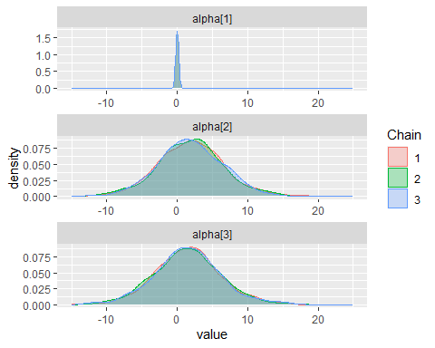

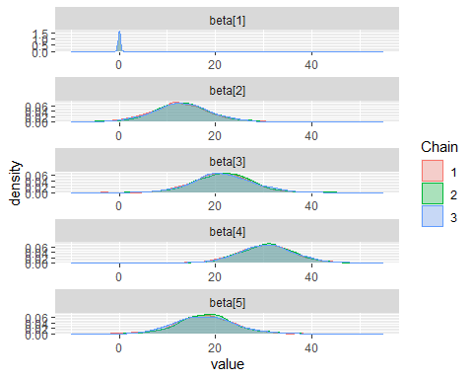

#### **Posterior Density for Global Mean Level (m)**

* The plot for ‘m’ shows a unimodal distribution that is quite narrow, centred around a value slightly below 200. This suggests that there is a high degree of certainty in the estimate of the global mean level of carbon sequestration. The peak of the distribution indicates the most probable value, and the narrowness reflects the precision of this estimate.

#### **Posterior Density for Standard Deviation (sigma)**

* The plot for ‘sigma’ is also unimodal and sharply peaks close to a value slightly above 0, with a long tail extending to the right. The peak close to the lower end of the scale implies that the standard deviation of carbon sequestration measurements is estimated to be low, indicating that the data points are not spread out widely from the mean, hence suggesting consistency in the measurements across fields and treatments.

#### **Posterior Density for Field Effect (alpha[1])**

* The plot for ‘alpha[1]’ is a single spike at zero, which is consistent with the model constraint that fixes this parameter at zero for identifiability purposes. There is no variability in this parameter, as indicated by the lack of spread in the distribution.

#### **Posterior Density for Field Effect (alpha[2])**

* The plot for ‘alpha[2]’ shows a unimodal distribution centred around a value close to zero, with a small spread of values indicating some uncertainty in the estimate. The 95% credible interval for this parameter likely includes zero, given the density around that point, suggesting that the field effect may not be statistically significant.

#### **Posterior Density for Field Effect (alpha[3])**

* The plot for ‘alpha[3]’ is similar to that for ‘alpha[2]’, with a unimodal distribution centred around zero and a small spread of sampled values. This also suggests some uncertainty and indicates that the field effect for ‘alpha[3]’ may not be statistically significant.

#### **Posterior Density for Treatment Effect (beta[1])**

* The plot for ‘beta[1]’ shows a spike at zero, which aligns with the model constraint that fixes this parameter at zero for identifiability purposes; hence, there is no variance in this parameter.

#### **Posterior Density for Treatment Effect (beta[2])**

* The plot for ‘beta[2]’ depicts a unimodal distribution centred slightly above zero with moderate spread. This indicates there is some certainty about this treatment’s effect, but the spread suggests there is still a degree of uncertainty.

#### **Posterior Density for Treatment Effect (beta[3])**

* The plot for ‘beta[3]’ is also unimodal and centred slightly above zero, similar to ‘beta[2]’. The distribution shows that this treatment likely has a positive effect on carbon sequestration, with a moderate level of certainty.

#### **Posterior Density for Treatment Effect (beta[4])**

* The plot for ‘beta[4]’ has a unimodal distribution with a peak higher than those of ‘beta[2]’ and ‘beta[3]’, suggesting a stronger effect of this treatment on carbon sequestration. The spread is relatively moderate, indicating some uncertainty around the precise effect size.

#### **Posterior Density for Treatment Effect (beta[5])**

* The plot for ‘beta[5]’ shows a unimodal distribution centred slightly above zero with a moderate spread of values, indicating that this treatment has a positive effect on carbon sequestration. However, there is some uncertainty about the magnitude of the effect.

## Bayesian Statistics Part (H)

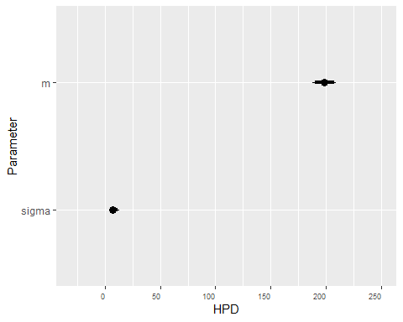

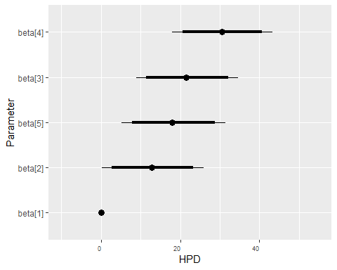

Based on the results from the Bayesian analysis, as visualised in the caterpillar plots for the treatment effects (**beta**) and field effects (**alpha**), we can draw the following conclusions:

### Treatment Effects

The credible intervals for the treatment effect parameters **beta[2]** through **beta[5]** do not include zero, which indicates that these treatments are estimated to have a significant effect on the underlying total carbon value compared to the baseline treatment (**beta[1]**). Specifically:

* **beta[2]**: Shows a significant positive effect on carbon sequestration with a moderate degree of certainty.
* **beta[3]**: Also indicates a significant positive effect, with a degree of uncertainty similar to **beta[2]**.
* **beta[4]**: Suggests a significant positive effect, potentially larger than **beta[2]** and **beta[3]**, but with more uncertainty regarding the magnitude of the effect.
* **beta[5]**: Has a significant positive effect on carbon sequestration, with a moderate level of certainty similar to **beta[2]** and **beta[3]**.

### Field Effects

The credible intervals for the field effect parameters **alpha[2]** and **alpha[3]** include zero, indicating that there is not enough evidence to conclude that the field location has a significant effect on the total carbon value. The credible intervals are wide, reflecting a higher degree of uncertainty about these estimates. The parameter **alpha[1]** is set to zero for model identifiability and does not provide information about the effect of field location.

### Conclusion

The analysis suggests that the application of different treatments significantly impacts the total carbon value. Each of the treatments represented by **beta[2]** through **beta[5]** is associated with an increase in carbon sequestration compared to the baseline treatment. This conclusion is justified because the 95% credible intervals for these treatment effects do not overlap with zero, indicating that the effects are statistically significant. In contrast, the field location does not appear to have a significant effect on the carbon value. The credible intervals for **alpha[2]** and **alpha[3]** include zero, suggesting that the differences in carbon sequestration between different fields are not statistically significant. Therefore, the data does not support any variation by field location.

## Length Class Mode   
## model 8 jags list   
## BUGSoutput 24 bugs list   
## parameters.to.save 6 -none- character  
## model.file 1 -none- character  
## n.iter 1 -none- numeric   
## DIC 1 -none- logical

##   
## Call:  
## lm(formula = y ~ field + technique)  
##   
## Coefficients:  
## (Intercept) field2 field3 technique2 technique3 technique4   
## 199.40 1.60 1.20 12.67 21.33 30.33   
## technique5   
## 17.67

## 2.5 % 97.5 %  
## (Intercept) 188.499268 210.30073  
## field2 -8.492117 11.69212  
## field3 -8.892117 11.29212  
## technique2 -0.362200 25.69553  
## technique3 8.304467 34.36220  
## technique4 17.304467 43.36220  
## technique5 4.637800 30.69553

## mean 50% 2.5% 97.5%  
## m 198.938665 198.846681 187.8155070 209.37058  
## alpha[2] 1.947057 1.894830 -7.6423182 11.84665  
## alpha[3] 1.468353 1.451746 -7.9719106 11.49368  
## beta[2] 12.859157 12.814335 0.2161204 25.90136  
## beta[3] 21.563372 21.446582 8.9465556 34.55158  
## beta[4] 30.595021 30.630993 18.0252685 43.30021  
## beta[5] 17.962632 17.951467 5.2446514 31.51405

## Analysis of Variance Table  
##   
## Response: y  
## Df Sum Sq Mean Sq F value Pr(>F)   
## field 2 6.93 3.47 0.0724 0.930763   
## technique 4 1508.93 377.23 7.8782 0.007041 **  
## Residuals 8 383.07 47.88   
## ---  
## Signif. codes: 0 '***' 0.001 '**' 0.01 '*' 0.05 '.' 0.1 ' ' 1

## Bayesian Statistics Part (I)

## [1] 1 1 1 1 1 2 2 2 2 2 3 3 3 3 3  
## Levels: 1 2 3

## [1] 1 2 3 4 5 1 2 3 4 5 1 2 3 4 5  
## Levels: 1 2 3 4 5

## [,1] [,2] [,3] [,4] [,5]  
## [1,] 208 216 220 226 209  
## [2,] 194 212 218 239 224  
## [3,] 199 211 227 227 221

## Compiling model graph  
## Resolving undeclared variables  
## Allocating nodes  
## Graph information:  
## Observed stochastic nodes: 15  
## Unobserved stochastic nodes: 8  
## Total graph size: 50  
##   
## Initializing model

## Inference for Bugs model at "C:/Users/User/AppData/Local/Temp/RtmpOIEBEB/model290444c52555", fit using jags,  
## 3 chains, each with 1e+05 iterations (first 50000 discarded), n.thin = 50  
## n.sims = 3000 iterations saved  
## mu.vect sd.vect 2.5% 50% 97.5% Rhat n.eff  
## alpha[1] 0.000 0.000 0.000 0.000 0.000 1.000 1  
## alpha[2] 1.973 5.124 -7.685 1.888 12.417 1.002 1200  
## alpha[3] 1.659 5.143 -8.647 1.677 12.177 1.001 2600  
## beta[1] 0.000 0.000 0.000 0.000 0.000 1.000 1  
## beta[2] 13.115 6.376 0.722 12.934 26.531 1.001 3000  
## beta[3] 21.584 6.548 8.675 21.609 34.004 1.001 3000  
## beta[4] 30.699 6.702 17.498 30.687 44.136 1.001 3000  
## beta[5] 17.954 6.410 5.377 17.757 30.926 1.001 3000  
## delta_beta_4_1 30.699 6.702 17.498 30.687 44.136 1.001 3000  
## delta_beta_4_2 17.584 6.787 4.118 17.670 31.379 1.001 3000  
## delta_beta_4_3 9.115 6.674 -3.680 9.064 22.381 1.001 2300  
## delta_beta_4_5 12.745 6.550 -0.268 12.798 26.215 1.001 2200  
## m 198.740 5.411 187.701 198.828 209.710 1.003 740  
## sigma 7.700 2.327 4.655 7.237 13.380 1.002 1700  
## tau 0.021 0.011 0.006 0.019 0.046 1.002 1700  
## deviance 102.692 5.984 94.297 101.630 117.291 1.001 2900  
##   
## For each parameter, n.eff is a crude measure of effective sample size,  
## and Rhat is the potential scale reduction factor (at convergence, Rhat=1).  
##   
## DIC info (using the rule, pD = var(deviance)/2)  
## pD = 17.9 and DIC = 120.6  
## DIC is an estimate of expected predictive error (lower deviance is better).

### Field Effects (alpha)

The credible intervals for both **alpha[2]** and **alpha[3]** include zero, which suggests that there is no strong evidence of a significant field effect on carbon sequestration levels.

### Treatment Effects (beta)

All **beta** coefficients have credible intervals that do not include zero, indicating that these treatments have significantly greater effects on carbon sequestration than the baseline treatment.

### Differences Between Treatment T4 and Others (delta_beta_4_x)

The credible intervals for **delta_beta_4_2**, **delta_beta_4_3**, and **delta_beta_4_5** include zero, which suggests that there is not enough evidence to claim that treatment T4 has a significantly different effect on carbon sequestration compared to treatments T2, T3, and T5. The credible interval for **delta_beta_4_1** does not include zero, which indicates a significant difference between treatment T4 and the baseline treatment T1.

### Other Parameters

* **m**: The overall mean carbon sequestration level has a posterior mean of 198.740 with a credible interval from 187.701 to 209.710.
* **sigma**: The standard deviation of carbon sequestration measurements has a posterior mean of 7.700 with a credible interval from 4.655 to 13.

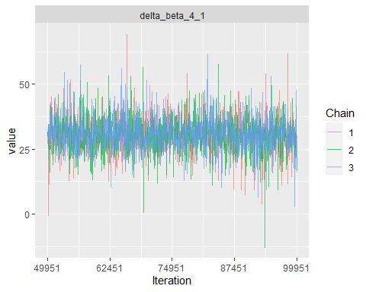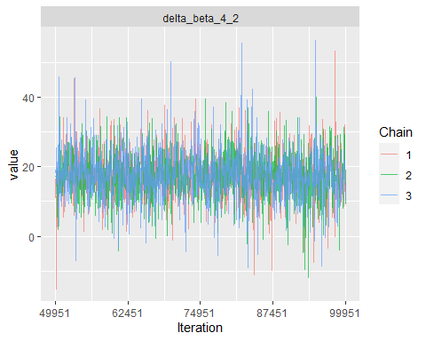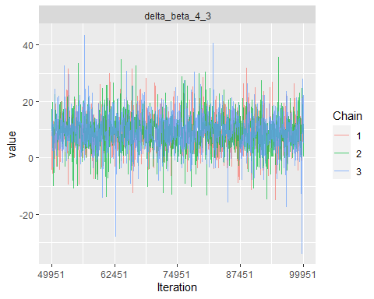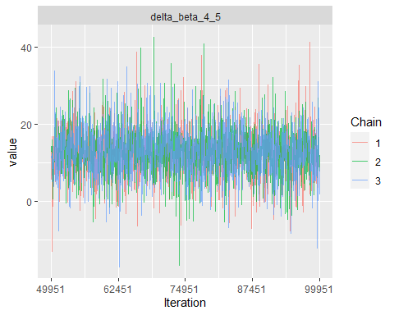

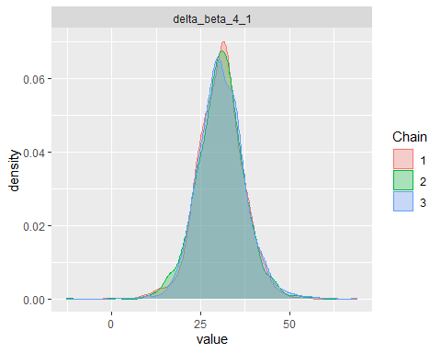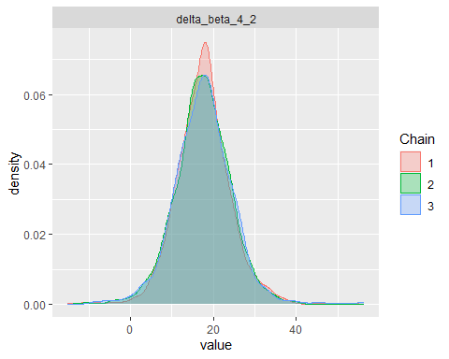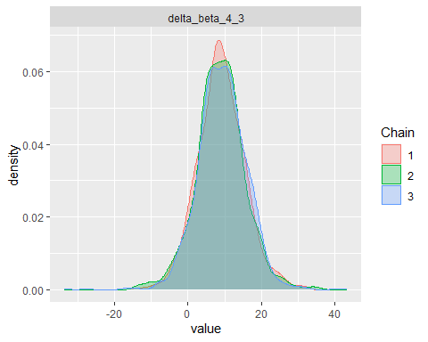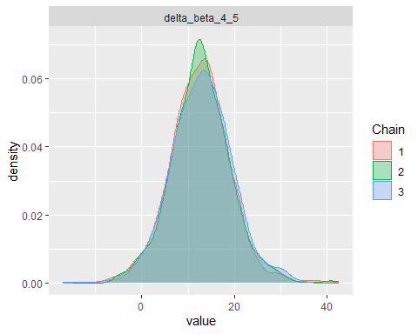

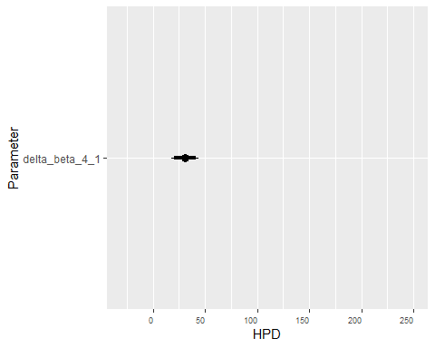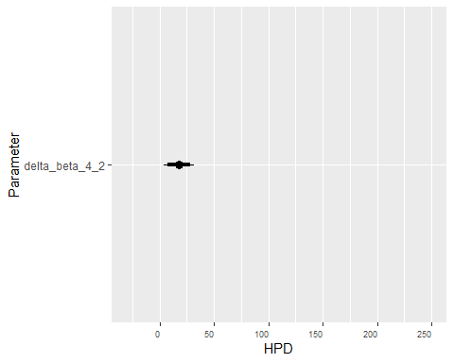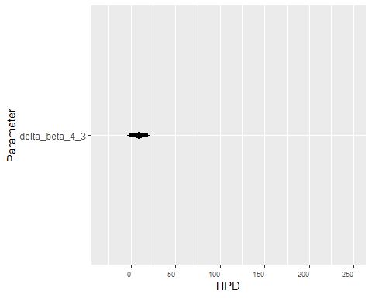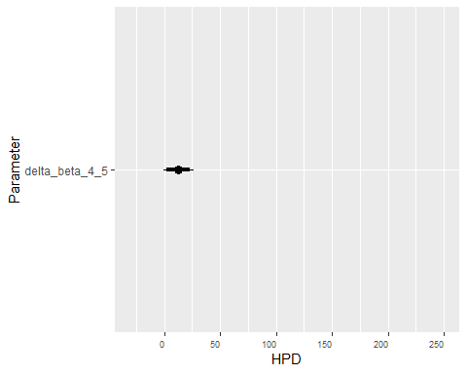

## Length Class Mode   
## model 8 jags list   
## BUGSoutput 24 bugs list   
## parameters.to.save 10 -none- character  
## model.file 1 -none- character  
## n.iter 1 -none- numeric   
## DIC 1 -none- logical

# Third Sub-Task: Simpler Bayesian model

## Bayesian Statistics Part (J)

## [1] 1 1 1 1 1 2 2 2 2 2 3 3 3 3 3  
## Levels: 1 2 3

## [1] 1 2 3 4 5 1 2 3 4 5 1 2 3 4 5  
## Levels: 1 2 3 4 5

## [,1] [,2] [,3] [,4] [,5]  
## [1,] 208 216 220 226 209  
## [2,] 194 212 218 239 224  
## [3,] 199 211 227 227 221

## Inference for Bugs model at "C:/Users/User/AppData/Local/Temp/RtmpOIEBEB/model2904449db26b1", fit using jags,  
## 3 chains, each with 1e+05 iterations (first 50000 discarded), n.thin = 50  
## n.sims = 3000 iterations saved  
## mu.vect sd.vect 2.5% 50% 97.5% Rhat n.eff  
## beta[1] 0.000 0.000 0.000 0.000 0.000 1.000 1  
## beta[2] 12.848 5.643 1.695 12.864 24.069 1.004 870  
## beta[3] 21.356 5.537 10.153 21.228 32.590 1.002 1300  
## beta[4] 30.452 5.729 19.232 30.364 41.802 1.001 2200  
## beta[5] 17.825 5.714 6.396 17.839 29.319 1.001 2800  
## m 200.121 3.992 191.865 200.131 208.052 1.003 870  
## sigma 6.756 1.641 4.419 6.480 10.713 1.001 3000  
## tau 0.026 0.011 0.009 0.024 0.051 1.001 3000  
## deviance 99.042 4.331 92.956 98.305 109.189 1.001 3000  
##   
## For each parameter, n.eff is a crude measure of effective sample size,  
## and Rhat is the potential scale reduction factor (at convergence, Rhat=1).  
##   
## DIC info (using the rule, pD = var(deviance)/2)  
## pD = 9.4 and DIC = 108.4  
## DIC is an estimate of expected predictive error (lower deviance is better).

### Treatment Effects (beta)

All **beta** parameters, except for the baseline **beta[1]**, demonstrate significant effects on carbon sequestration due to the credible intervals not including zero.

### Overall Mean (m)

* The overall mean carbon sequestration (m) has a posterior mean of 200.121 with a 95% credible interval between 191.865 and 208.052.

### Standard Deviation (sigma)

* The posterior mean for the standard deviation (sigma) is 6.756, with a 95% credible interval from 4.419 to 10.713, reflecting the variability of the data around the overall mean.

### Precision (tau)

* The precision (tau), which is the inverse of the variance, has a posterior mean of 0.026 and a 95% credible interval from 0.009 to 0.051.

### Model Diagnostics

* The Rhat values are close to 1 for all parameters, indicating that convergence has likely been reached across the chains.
* The effective sample sizes (n.eff) are adequate for all parameters except beta[2] and m, suggesting some caution in interpreting these particular estimates.

### Deviance Information Criterion (DIC)

* The DIC value is 108.4 with a pD (effective number of parameters) of 9.4. The DIC balances model fit and complexity, where a lower value generally indicates a better model.

In summary, the analysis demonstrates significant positive effects of the treatments on carbon sequestration compared to the baseline, with **beta[4]** showing the largest effect. The model appears to be well-fitted with good convergence properties.

## Bayesian Statistics Part (K)

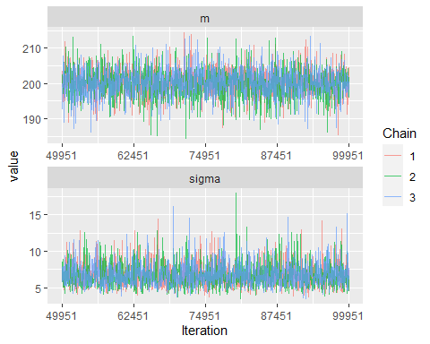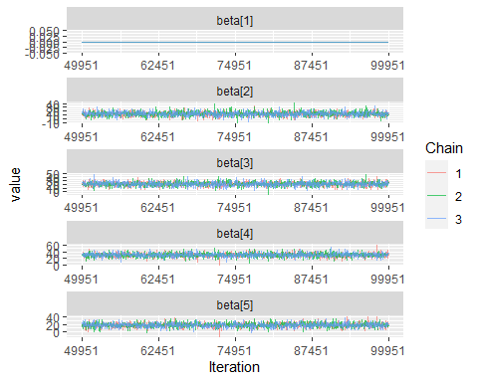

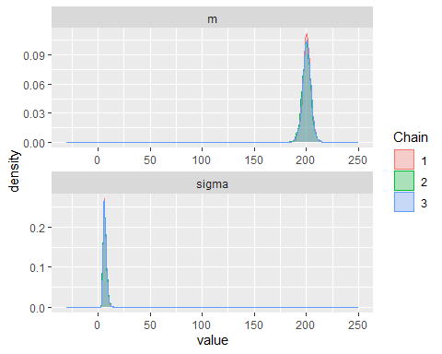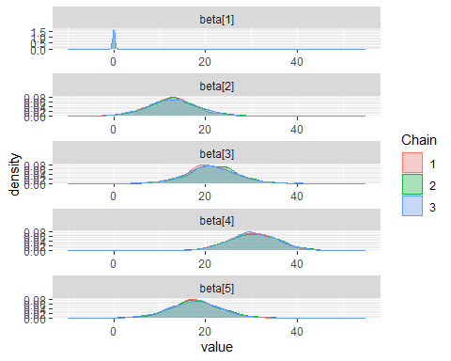

Observations from the density plots:

* **Overall Mean (m)**: The density plot for **m** is tightly concentrated around a value slightly above 200, indicating that there is a high degree of certainty in the posterior estimate of the overall mean of carbon sequestration across all treatments and fields.
* **Standard Deviation (sigma)**: The density plot for **sigma** is also quite peaked, centred around a value near 7, suggesting that the posterior estimate of the standard deviation is also quite precise. The distribution tails off quickly, reflecting a lower probability for very high or very low values of **sigma**.
* **beta[1]**: As expected, the density plot for **beta[1]** spikes at 0 because this parameter was fixed to provide a baseline for comparing with other treatment effects.
* **beta[2]**: The density plot for **beta[2]** is centred around a value just above 10, with a relatively narrow spread, indicating a precise estimate and a significant treatment effect.
* **beta[3]**: The plot for **beta[3]** is centred around a value above 20, with a narrow spread, suggesting a strong and significant treatment effect.
* **beta[4]**: The density plot for **beta[4]** shows a peak around 30 with a somewhat wider spread, yet it still indicates a substantial treatment effect.
* **beta[5]**: The plot for **beta[5]** is centred close to 20, similar to **beta[3]**, with a narrow spread, suggesting a significant treatment effect as well.

All density plots for **beta[2]** to **beta[5]** are well above zero, consistent with the previous analysis that indicated significant effects of these treatments on carbon sequestration when compared to the baseline treatment (which corresponds to **beta[1]**). The consistency of the estimates across the three chains for each parameter supports the reliability of the model’s output.

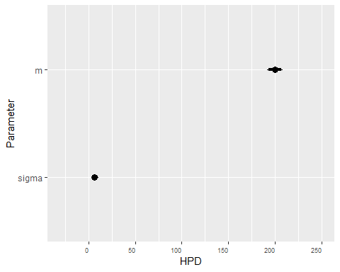

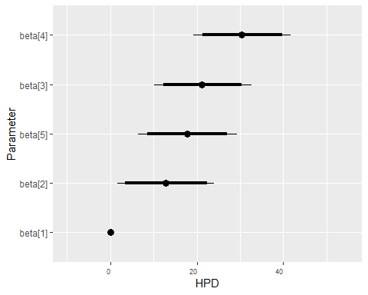

Observations from the caterpillar plot:

* **Overall Mean (m)**: The 95% HPD interval for **m** is narrow, stretching just above and below 200, with a solid dot representing the median or mean of the posterior distribution. This indicates a high degree of certainty in the estimate of the overall mean carbon sequestration.
* **Standard Deviation (sigma)**: The 95% HPD interval for **sigma** is much wider relative to the interval for **m**, which is typical for scale parameters like standard deviation. Nonetheless, the interval is relatively concentrated, with its entire range below 20, suggesting a moderate level of uncertainty.
* **beta[1]**: As expected, the HPD interval for **beta[1]** is a single point at 0 because this parameter was fixed during the analysis to serve as a reference level for the other treatments.
* **beta[2]**: The 95% HPD interval for **beta[2]** does not include 0, and the solid dot is positioned well above 0, indicating a significant positive effect of this treatment compared to the baseline.
* **beta[3]**: Similarly, the HPD interval for **beta[3]** is entirely above 0, with the solid dot indicating the central tendency, which reflects a significant positive treatment effect.
* **beta[4]**: This treatment effect has the widest HPD interval among the treatments, but it is still entirely above 0, denoting a significant positive effect, and the central dot is located towards the upper end of the interval.
* **beta[5]**: The HPD interval for **beta[5]** is also above 0, showcasing a significant positive effect of this treatment, with the solid dot near the middle of the interval.
* summary(Simpler_Bayesian_anova)
* ## Length Class Mode   
  ## model 8 jags list   
  ## BUGSoutput 24 bugs list   
  ## parameters.to.save 5 -none- character  
  ## model.file 1 -none- character  
  ## n.iter 1 -none- numeric   
  ## DIC 1 -none- logical

## Bayesian Statistics Part (L)

Between the full and simpler Bayesian models, we would lean towards the simpler model. Here’s why:

* **Performance**: Both models seem to perform adequately, with Rhat values close to 1 indicating convergence and effective sample sizes generally high. However, the simpler model has slightly better convergence indicators with higher effective sample sizes across parameters.
* **Interpretability**: The simpler model tends to be easier to interpret and communicate due to its fewer parameters. It focuses only on the treatment effects (beta) and the global mean level (m), which can be more straightforward for stakeholders to understand.
* **Similar Results**: While the simpler model excludes field effects (alpha), it still estimates treatment effects and the global mean level of carbon sequestration. The credible intervals for these parameters are similar between the two models, suggesting that the simpler model captures the essential information without unnecessary complexity.
* **Lower DIC**: The Deviance Information Criterion (DIC) is lower for the simpler model (108.4) compared to the full model (118.1). A lower DIC indicates a better model fit, suggesting that the simpler model might provide more accurate predictions.

Considering these factors, the simpler model appears to strike a good balance between performance and simplicity, making it preferable in this scenario.