PCA
The full results can be found in: plot_data_pca.ipynb
Even brute-force PCA can find split between left and right, but not in low-D.
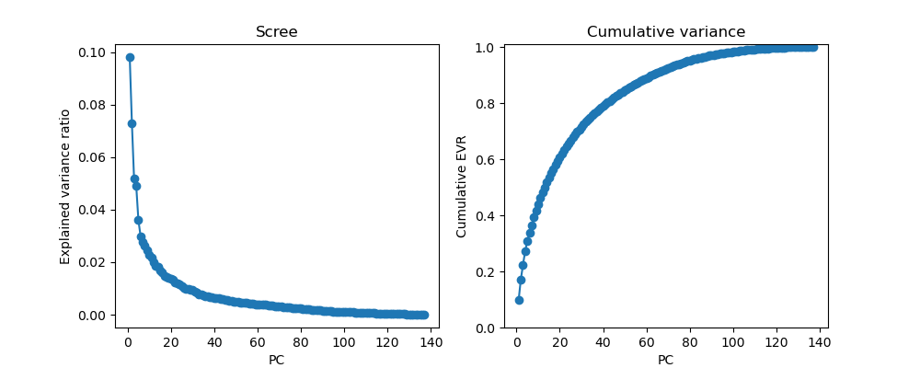
All trials | Average over target direction
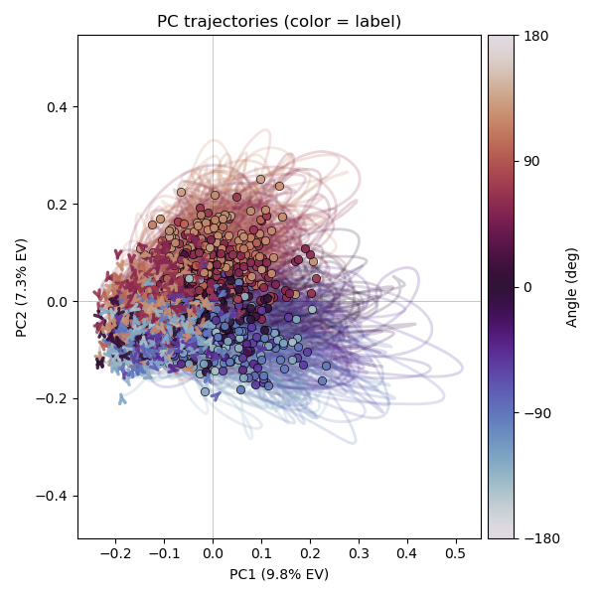 | 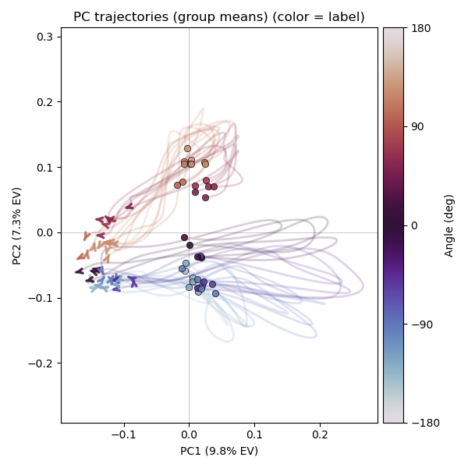
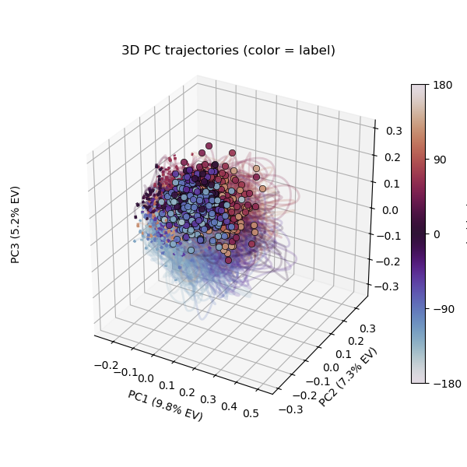 | 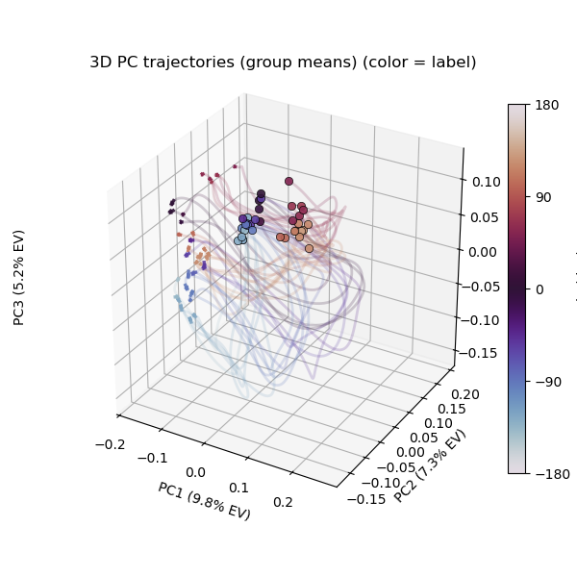
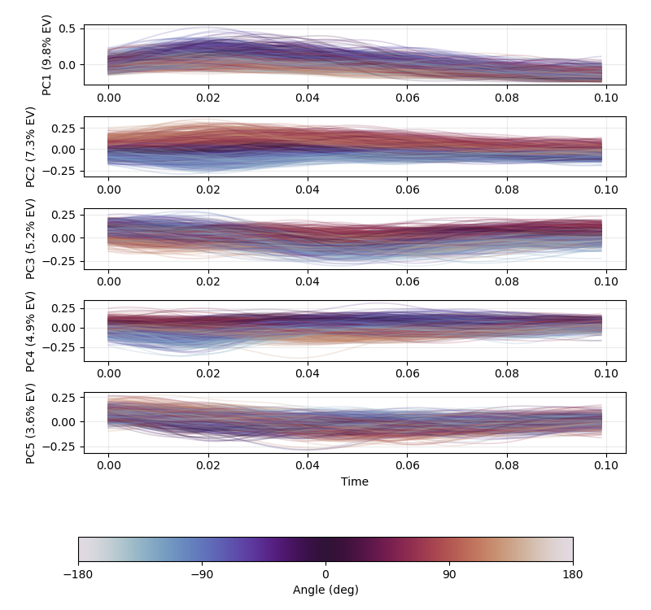 | 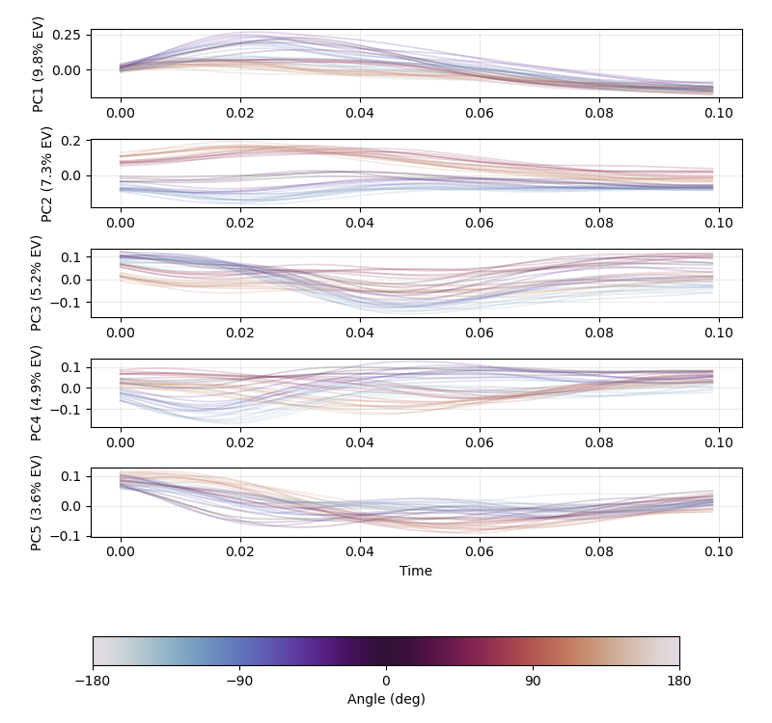

Model comparisons
The full results can be found in plot_maze_results_all.ipynb
4 models:
- latent dim = 3, dynamic flow: lag = 5
- latent dim = 3, dynamic flow: lag = 5, target location as covariate
- latent dim = 3, dynamic flow: lag = 10
- latent dim = 3, dynamic flow: lag = 10, target location as covariate
Just a very rough numeric check for time series generation when $τ=1.0$ and $τ=0.0$.
Here, I show 2 MSEs:
- Calculate MSE for each trial, and average these MSEs over trial (table)
- Calculate MSE for each trial & dimension (neuron), and average these MSEs over trial (plot)
 | $$τ=0.0$$ | $$τ=1.0$$
dim 3, lag 5 | 0.0008 | 0.0007
dim 3, lag 5, location | 0.0016 | 0.0005
dim 3, lag 10 | 0.0005 | 0.0004
dim 3, lag 10, location | 0.0006 | 0.0003

$$τ=0.0$$ | $$τ=1.0$$
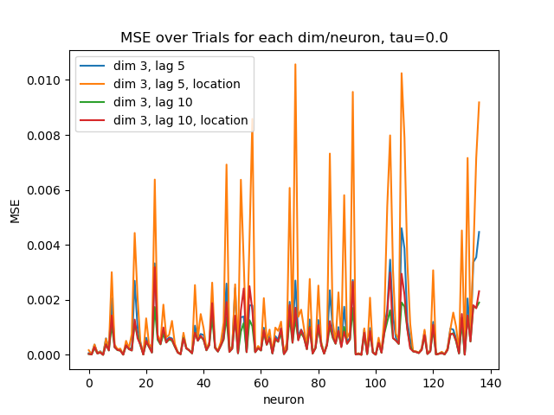 | 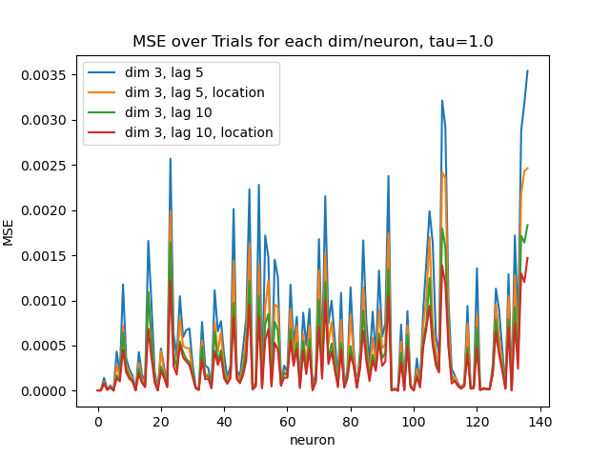

It seems including location doesn't help a lot but make things even more unstable. (maybe need smaller models/ tune parameters for covariate version)

Latent dim = 3, lag = 10, no covariates
The full results can be found in plot_maze_results_all.ipynb
Just show one model as an example.

Check the D & loading (= $L\sqrt{D}$)
First 10 diagonal elements of D:
tensor([1.0082e-13, 6.0679e-11, 7.5896e-13, 9.9540e-16, 1.5536e-16, 2.3862e-19, 7.9226e-17, 6.0119e-17, 9.9640e-16, 9.9527e-16], device='cuda:0')
first 10 column of loading matrix:
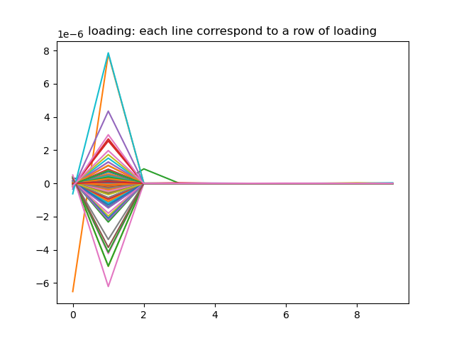
Seems 1 latent is enough (2nd latent)

Latent trajectories (the effective one)
 | All trials | Average over target direction
Simulated | 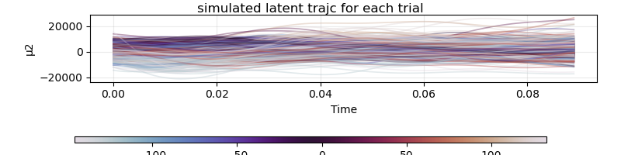 | 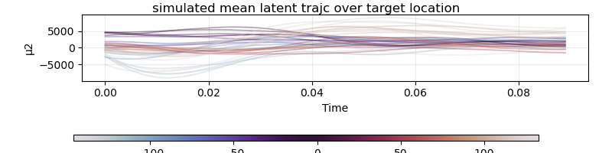
flowed | 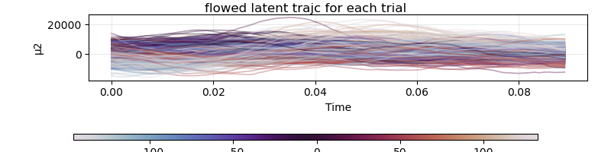 | 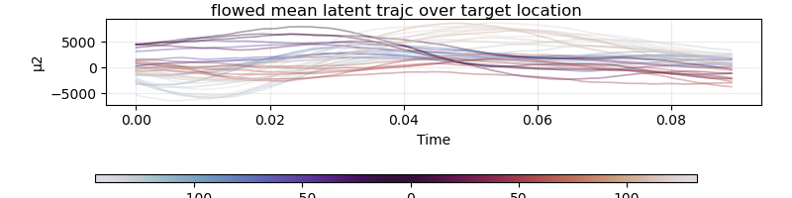

Supplementary
Although, the latent trajectories in all dim-to-keep don’t make sense, I still plot them here for reference.
Simulated
All trials | Average over target direction
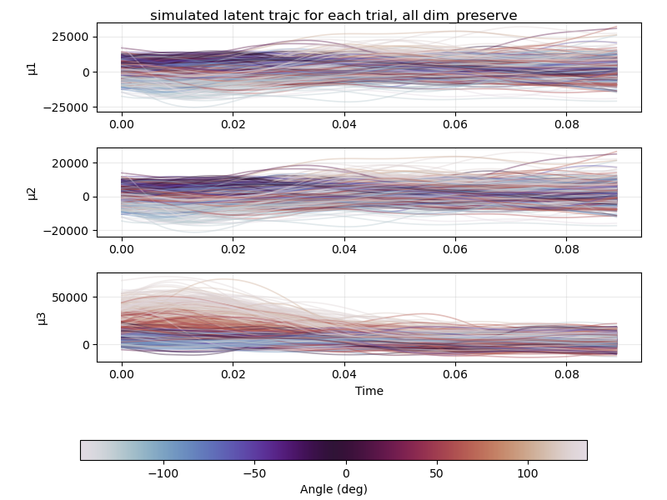 | 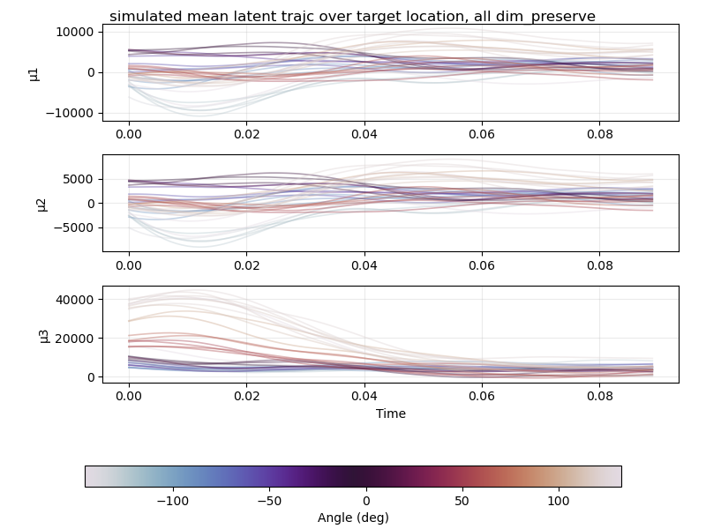
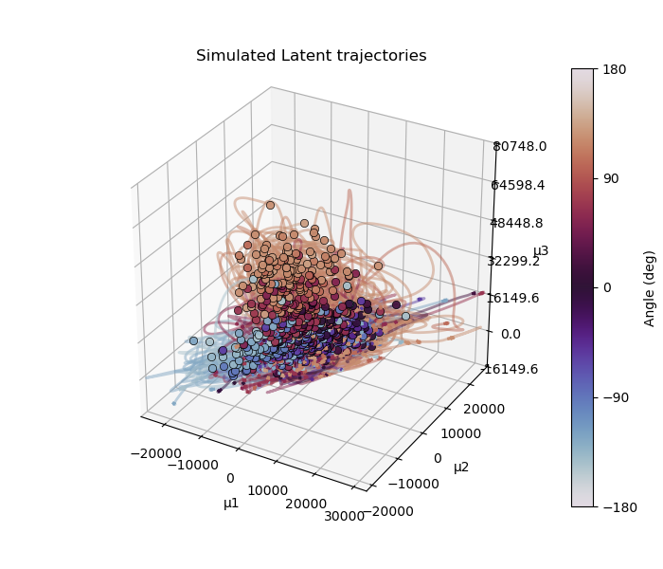 | 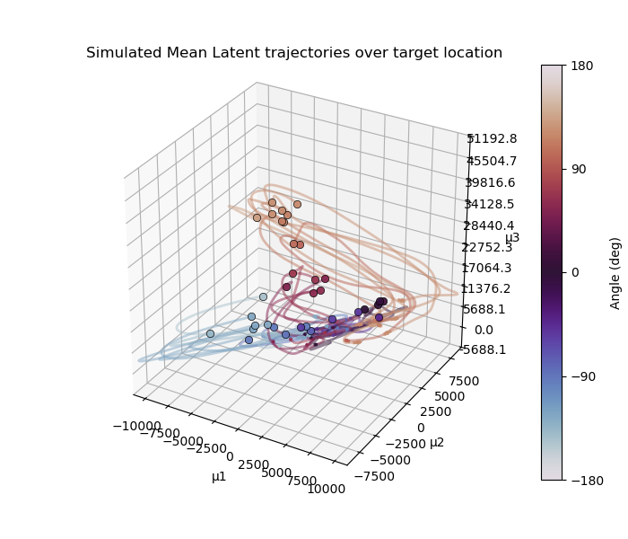

Flowed
All trials | Average over target direction
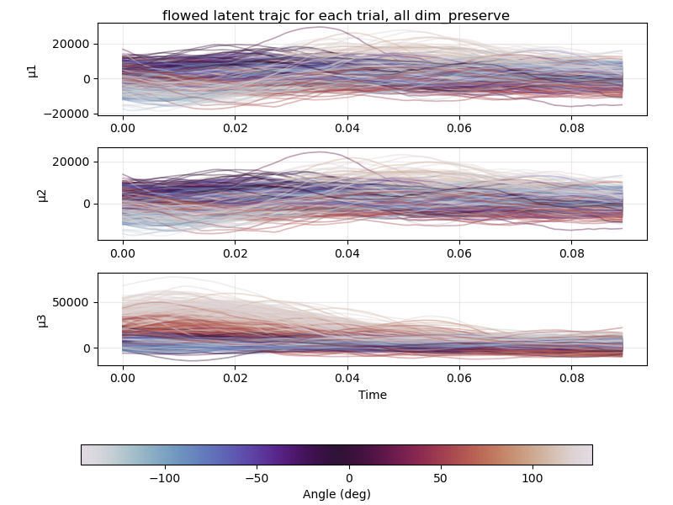 | 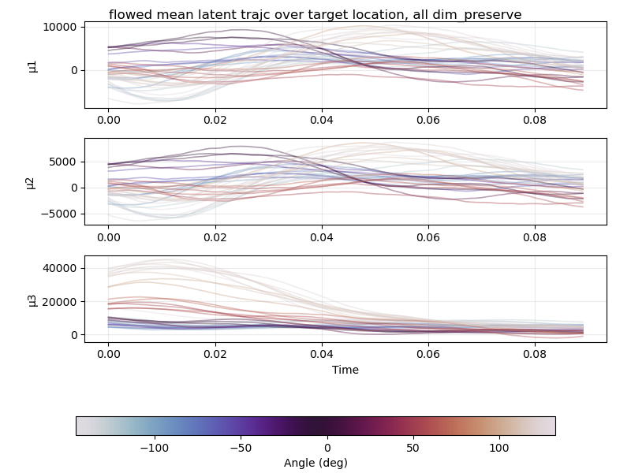
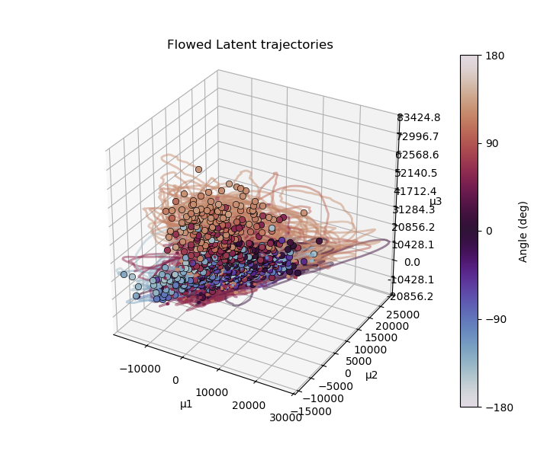 | 