MPICH2 on Windows XP:
Installing, Compiling Fortran, and Running
Brent S. Paul
Penn State University

INSTALLING MPICH2

- Main MPICH homepage:
http://www-unix.mcs.anl.gov/mpi/

- Download the Win32IA32 version of MPICH2 from:
http://www-unix.mcs.anl.gov/mpi/mpich2/

- Run the executable, mpich2-1.0.3-1-win32-ia32.msi (or a more recent version). Most likely it will result in the following error:
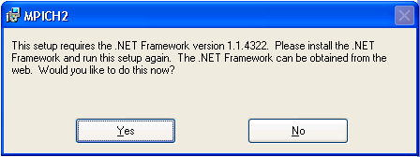

If you follow the link to download the .NET Framework it will download version 2.0. That is not compatible with MPICH2. To download version1.1 use this link:
http://www.microsoft.com/downloads/details.aspx?FamilyId=262D25E3-F589-4842-8157-034D1E7CF3A3&displaylang=en

- Install the .NET Framework program

- Install the MPICH2 executable. Write down the passphrase for future reference. The passphrase must be consistent across a network.

- Add the MPICH2 path to Windows:
    - Right click “My Computer” and pick properties
    - Select the Advanced Tab
    - Select the Environment Variables button
    - Highlight the path variable under System Variables and click edit. Add “C:\MPICH2\bin” to the end of the list, make sure to separate this from the prior path with a semicolon.

- Run the example executable to insure correct installation.
mpiexec –n 2 cpi.exe

- If installed on a dual processor machine, verify that both processors are being utilized by examining “CPU Usage History” in the Windows Task Manager.

- The first time each session mpiexec is run it will ask for username and password. To prevent being asked for this in the future, this information can be encrypted into the Windows registry by running:
mpiexec –register

The username and password are your Windows XP logon information.

Compiling Fortran with MPICH2

- The instructions below assume that MPICH2 is placed in “C:\mpich2” versus the standard location of “C:\Program Files\mpich2”. This is done to make running from a command window easier.

- If errors are received during compilation (involving mpif.h) then change all lines in “C:\mpich2\include\mpif.h” that start with “C” to start with “!”. These are the leading header files as well as the “CDEC$” lines.

- The Fortran compiler “Compaq Visual Fortran v6.6.c” is assumed. Additionally, the C++ compiler may be required. It was already installed for this installation of MPICH2. If these instructions do not work, then install the C++ compiler and try again.

- Create a new project using “Fortran Console Application”. Under Projects Tab for “New”. File out a project name and location. The Console Application should be “An empty project.”

- Add files to the “Source Files”.

- Make changes to the PROJECT SETTINGS (ALT+F7). This should be done for all configurations, i.e. debug and release, unless otherwise noted. See “Settings For” in upper left hand corner for current configuration.
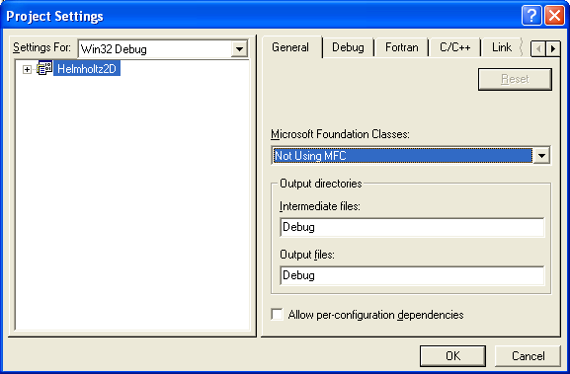

- C/C++ Tab – CATEGORY: Preprocessor
Add “C:\mpich2\include” to the “Additional include directories” box.
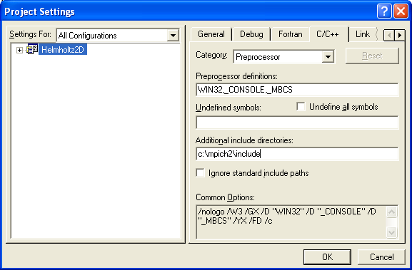

- Link Tab – CATEGORY: Input
- Add “C:\mpich2\lib” to the “Additional library path”.
- Add “cxx.lib”, “mpi.lib”, “fmpich2.lib”, “fmpich2s.lib”, and “fmpich2g.lib” to the end of the “Object/library modules” box.
- “cxxd.lib” should be used for the Debug configuration.

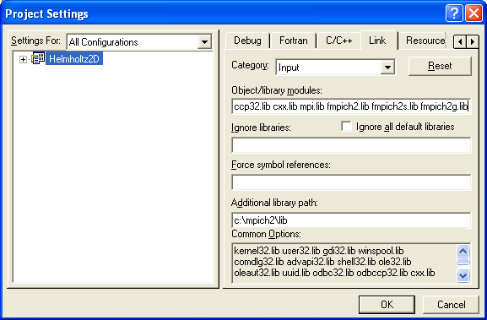

- Fortran Tab – CATEGORY: External Procedures
- Argument Passing Conventions: C, by reference
- String length argument passing: After all args
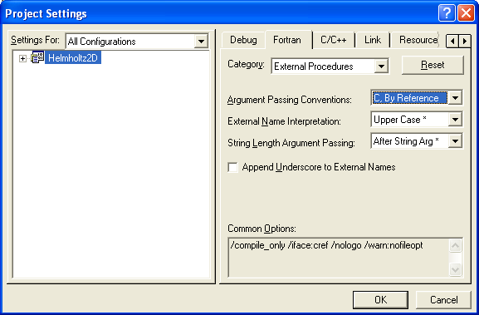

- Fortran Tab – CATEGORY: Preprocessor
- Predefined Preprocessor Symbols: MPI (add this to what is there).
(This is only really needed if preprocessing is done, but won’t hurt to add.)
- INCLUDE and USE Paths: C:\mpich2\include
- Select Use FPP
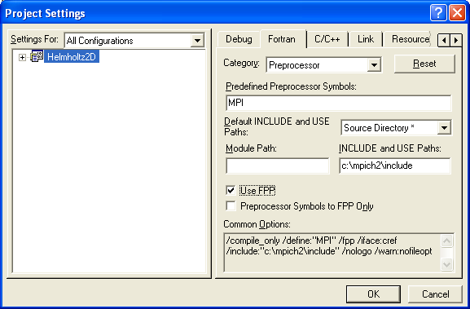

- There are additional settings that can be set, but it is unsure if they are needed. These were required by MPICH1, but it appears they are no longer required for MPICH2. They are listed here for completeness, but do not add them unless there are compiler or running issues.
A. Fortran Tab – CATEGORY: Libraries
- Use run-time library single-threaded
- Uncheck “Use Common Window Libraries”
B. Fortran Tab – CATEGORY: Listing Files
- Check source listings
    - Fortran Tab – CATEGORY: Run Time
- Check “array and string bounds” for “All Configurations”

- There is a known warning when compiling a release version:

Linking...
LINK : warning LNK4089: all references to "mpich2mpi.dll" discarded by /OPT:REF
Helmholtz2D.exe - 0 error(s), 1 warning(s)

It is unknown at this time what effect this has, or how it can be corrected.

- Finished.

Running MPICH2 Programs

There are two methods. The first is on a dual processor machine. The second is across a network by specifying the IP addresses. Across a network is typically slow due to communication times.

DUAL PROCESSOR MACHINE

      - Make sure that “C:\mpich2\bin” is in your path.
      - Change to the directory where you executable is located and type “mpiexec –n X filename.mpi”. X is the number of processors and filename.mpi is the name of the executable. The first time you run in a given logon session you will be asked for your userid and password. These are you Windows XP logon and password. You can request more processors than there are available, this does nothing except increase communication times.

ACROSS A NETWORK
- To run without passwords several steps are required (mpich2-doc-windev.pdf). DOMAIN Administrative rights are required.
  - On each node execute: “spmd –register_spn”
  - All jobs must be submitted with the –delegate command.

- Copy the executable to each machine. This should be in the same directory structure as the MASTER node. For example, “C:\bspaul\helmholtz.mpi”.

- The Windows Firewall must be adjusted to allow MPICH2 to run.
  - Bring up the Windows Firewall from the Control Panel.
  - From the Exceptions Tab, select “Add Program” and make sure “C:\mpich2\bin\smpd.exe” and “C:\mpich2\bin\mpiexec.exe” are on the list.
  - From “Add Program” add the executable to the exceptions. N.B. If the Windows Security alert appears then make sure the executable has been added.

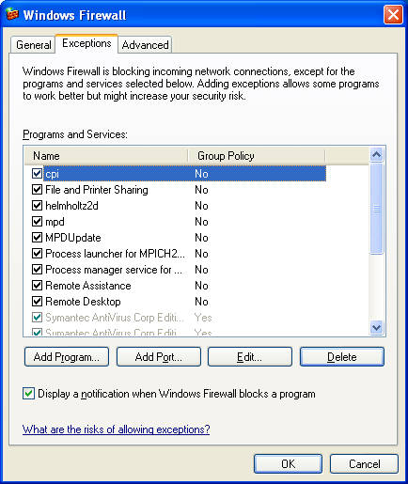

- Log on to each machine you want to run on. This is not required, but prevents anyone else logging on and using those machines.

- Run the program from a command prompt from the MASTER node by typing: “mpiexec –hosts X hostname.1.com hostname.2.com hostname.X.com”
X is the number of hosts being used and hostname.X.com are the names of the machines running one. Verification can be made by checking the Windows Task Manager of each machine to verify they are at 100%.

Troubleshooting:
- If the Windows Security Alert window appears, or if just the top part of the window (this happens due to a glitch with Windows XP handles services) make sure that the executable is on the Windows Firewall Exception List.
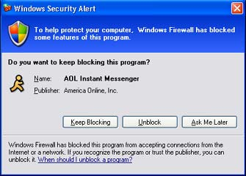

- Share the folder on the master node. From Windows Explorer right click Properties, and Select “Share this Folder”.
