library("FactoMineR")
library("factoextra")
## Loading required package: ggplot2
## Welcome! Want to learn more? See two factoextra-related books at https://goo.gl/ve3WBa
library("plotly")
##
## Attaching package: 'plotly'
## The following object is masked from 'package:ggplot2':
##
## last_plot
## The following object is masked from 'package:stats':
##
## filter
## The following object is masked from 'package:graphics':
##
## layout
library("lme4")
## Loading required package: Matrix
library("MASS")
##
## Attaching package: 'MASS'
## The following object is masked from 'package:plotly':
##
## select
library("readxl")
library("ggplot2")
library("randomForest")
## randomForest 4.7-1.2
## Type rfNews() to see new features/changes/bug fixes.
##
## Attaching package: 'randomForest'
## The following object is masked from 'package:ggplot2':
##
## margin
Stigmatomyces_R <- as.data.frame(read_excel('C:/iqtree3/iqtree-3.0.1-Windows/bin/Stigmatomyces Chile/upload to GitHub/Stigmatomyces_table_all_species_R_v2026.xlsx'))
summary(as.factor(Stigmatomyces_R$Suggested_genus))
## Appendiculina Fanniomyces
## 28 3
## Gloeandromyces Stigmatomyces s.l. group 1
## 17 16
## Stigmatomyces s.l. group 2 Stigmatomyces s.s.
## 30 80
X <- Stigmatomyces_R[, 6:19]
X <- data.frame(lapply(X, as.factor))
y <- as.factor(Stigmatomyces_R[, "Suggested_genus"])
# Train Random Forest
rf <- randomForest(x=X, y=y, ntree=10000)
# Variable importance
importance(rf)
## MeanDecreaseGini
## Host_family 22.574049
## BCA 2.048352
## BCA_distinctly_colored_compared_to_rest_of_appendage 1.489095
## BCA_fertile. 26.533784
## Appendage_cells_morphology 9.412388
## cell_divisions_appendage 4.609381
## Appendage_main_appearance 15.738792
## Length_of_appendage 1.584474
## Antheridia 18.145209
## Gelatinous 3.640033
## Direction 7.452639
## Cells_I_and_VI_in_contact 3.581543
## Length_cell_III_compared_to_cell_VI 1.788011
## Perithecium_ornamented 2.818122
varImpPlot(rf)
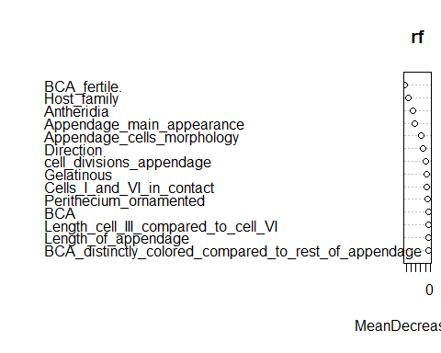
# Get variable importance
imp <- importance(rf)
# Convert to data frame for easier handling
imp_df <- data.frame(Variable = rownames(imp), imp)
# Sort by MeanDecreaseGini
imp_df_sorted <- imp_df[order(imp_df$MeanDecreaseGini, decreasing = TRUE), ]
print(imp_df_sorted)
## Variable
## BCA_fertile. BCA_fertile.
## Host_family Host_family
## Antheridia Antheridia
## Appendage_main_appearance Appendage_main_appearance
## Appendage_cells_morphology Appendage_cells_morphology
## Direction Direction
## cell_divisions_appendage cell_divisions_appendage
## Gelatinous Gelatinous
## Cells_I_and_VI_in_contact Cells_I_and_VI_in_contact
## Perithecium_ornamented Perithecium_ornamented
## BCA BCA
## Length_cell_III_compared_to_cell_VI Length_cell_III_compared_to_cell_VI
## Length_of_appendage Length_of_appendage
## BCA_distinctly_colored_compared_to_rest_of_appendage BCA_distinctly_colored_compared_to_rest_of_appendage
## MeanDecreaseGini
## BCA_fertile. 26.533784
## Host_family 22.574049
## Antheridia 18.145209
## Appendage_main_appearance 15.738792
## Appendage_cells_morphology 9.412388
## Direction 7.452639
## cell_divisions_appendage 4.609381
## Gelatinous 3.640033
## Cells_I_and_VI_in_contact 3.581543
## Perithecium_ornamented 2.818122
## BCA 2.048352
## Length_cell_III_compared_to_cell_VI 1.788011
## Length_of_appendage 1.584474
## BCA_distinctly_colored_compared_to_rest_of_appendage 1.489095
Analysis with hosts included as variable
Stigmatomyces_R_mod2 <- Stigmatomyces_R[, -c(20)]
res.mca <- MCA(Stigmatomyces_R_mod2[, 6:19], ncp = 10, graph = TRUE)
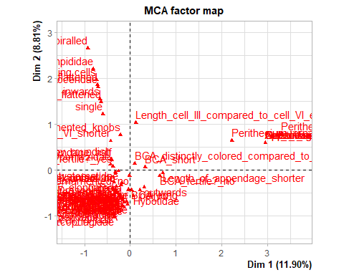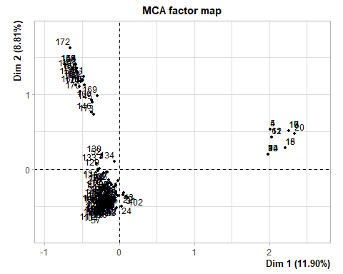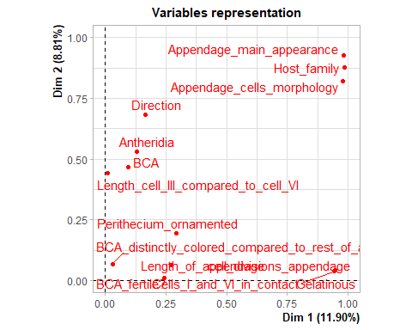
eig.val <- get_eigenvalue(res.mca)
fviz_screeplot(res.mca, addlabels = TRUE, ylim = c(0, 45))
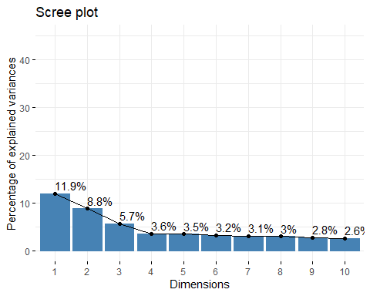
fviz_mca_var(res.mca, choice = "mca.cor",
repel = TRUE, # Avoid text overlapping (slow)
ggtheme = theme_minimal())
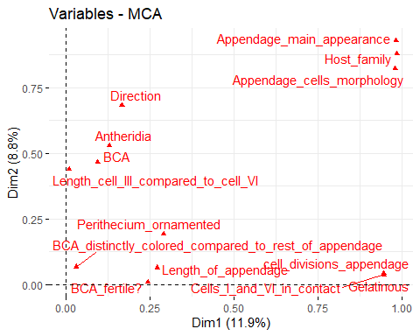
p <- fviz_mca_var(res.mca, col.var = "contrib",
gradient.cols = c("#00AFBB", "#E7B800", "#FC4E07"),
repel = TRUE, # avoid text overlapping (slow)
ggtheme = theme_minimal()
)
grp <- as.factor(Stigmatomyces_R_mod2[, "Suggested_genus"])
p <- fviz_mca_ind(res.mca, label="none", habillage=grp,
addEllipses=TRUE, ellipse.level=0.95, ellipse.type = "convex")
p
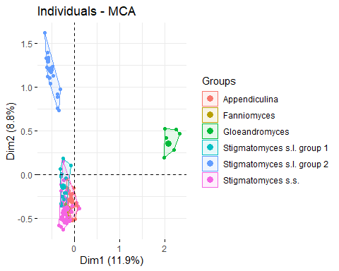
library(FactoMineR)
library(factoextra)
library(ggplot2)
Stigmatomyces_R_mod3 <- Stigmatomyces_R[, -c(7,8,10,11,13,15,16,17,18,19,20)]
my_colors <- c("Gloeandromyces" = "#b31d30ff",
"Fanniomyces" = "#67a9cfff",
"Appendiculina" = "#2166acff",
"Stigmatomyces s.s." = "#fddbc7ff",
"Stigmatomyces s.l. group 1" = "#d1e5f0ff",
"Stigmatomyces s.l. group 2" = "#ef8a62ff") # replace with your actual group names
# Run MCA
res.mca <- MCA(Stigmatomyces_R_mod3[, 6:9], ncp = 50, graph = TRUE)
## Warning: ggrepel: 18 unlabeled data points (too many overlaps). Consider
## increasing max.overlaps
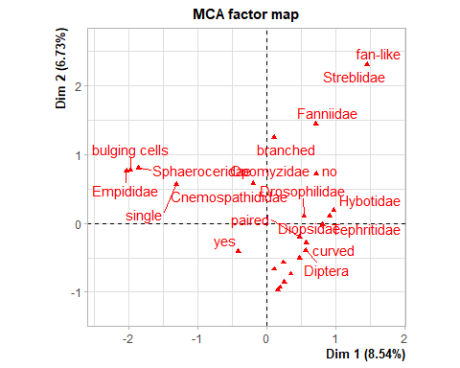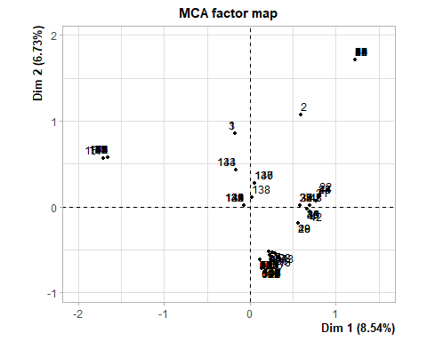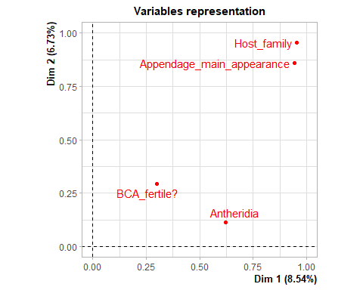
# Eigenvalues + screeplot
eig.val <- get_eigenvalue(res.mca)
fviz_screeplot(res.mca, addlabels = TRUE, ylim = c(0, 45))
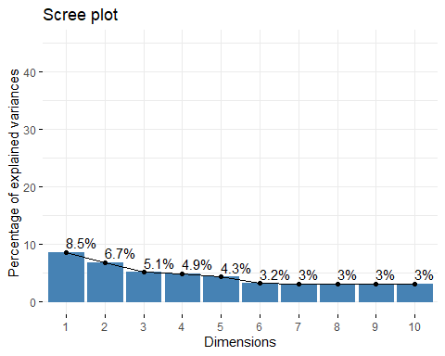
# Individuals plot + jitter
p <- fviz_mca_ind(res.mca,
label = "none",
habillage = as.factor(Stigmatomyces_R_mod3[, "Suggested_genus"]),
palette = my_colors,
addEllipses = TRUE,
ellipse.type = "convex",
ellipse.level = 0.95,
ggtheme = theme_minimal())
p_jit <- p +
geom_jitter(width = 0.1, height = 0.1, aes(color = grp)) +
theme(legend.position = "bottom",
legend.title = element_text(size = 10, face = "bold"),
legend.text = element_text(size = 9))
# Display the plot
print(p_jit)
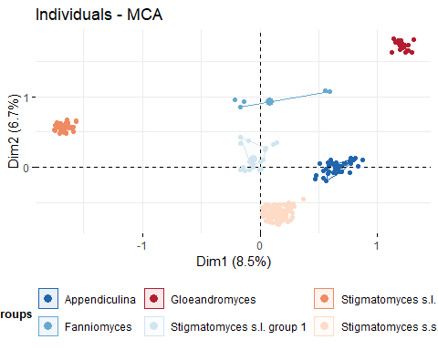
library(ggplot2)
library(factoextra)
library(FactoMineR)
p_ind <- fviz_mca_ind(res.mca,
label = "none",
habillage = grp,
addEllipses = TRUE,
ellipse.type = "convex",
ellipse.level = 0.95,
ggtheme = theme_minimal())
# Extract variable coordinates
var <- get_mca_var(res.mca)
var_coords <- as.data.frame(var$coord)
var_coords$varname <- rownames(var_coords)
names(var_coords) <- gsub(" ", ".", names(var_coords)) # fix column names
var_coords$contrib_total <- rowSums(var$contrib[, 1:2])
# Choose how many top variables to plot
n_top <- 20
# Overlay variable arrows and labels
p_combined <- p_ind +
geom_segment(data = var_coords,
aes(x = 0, y = 0, xend = Dim.1, yend = Dim.2),
arrow = arrow(length = unit(0.25, "cm")),
color = "gray30", alpha = 0.8) +
geom_text(data = var_coords,
aes(x = Dim.1, y = Dim.2, label = varname),
size = 3, vjust = -0.5, color = "black") +
ggtitle(paste("MCA: Individuals (with groups) and Top", n_top, "Variable Arrows"))
p_combined + geom_jitter(width = 0.1, height = 0.1, aes(color = grp))
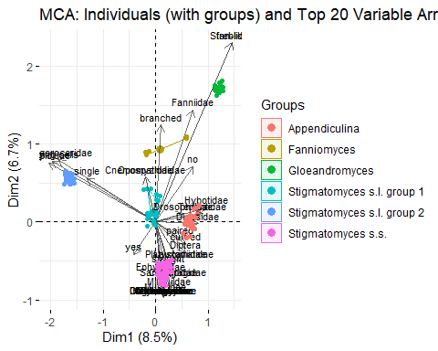
table(Stigmatomyces_R$Suggested_genus, Stigmatomyces_R$Host_family)
##
## Agromyzidae Anthomyidae Canacidae Chamaemyidae
## Appendiculina 0 0 0 0
## Fanniomyces 0 0 0 0
## Gloeandromyces 0 0 0 0
## Stigmatomyces s.l. group 1 0 0 0 0
## Stigmatomyces s.l. group 2 0 0 0 0
## Stigmatomyces s.s. 3 1 2 1
##
## Chloropidae Chyromyidae Cnemospathididae
## Appendiculina 0 0 0
## Fanniomyces 0 0 0
## Gloeandromyces 0 0 0
## Stigmatomyces s.l. group 1 0 0 1
## Stigmatomyces s.l. group 2 0 0 0
## Stigmatomyces s.s. 2 2 0
##
## Coelopidae Diopsidae Diptera Dolichopodidae
## Appendiculina 0 8 1 0
## Fanniomyces 0 0 0 0
## Gloeandromyces 0 0 0 0
## Stigmatomyces s.l. group 1 0 0 0 0
## Stigmatomyces s.l. group 2 0 0 0 0
## Stigmatomyces s.s. 1 0 1 2
##
## Drosophilidae Empididae Ephydridae Fanniidae
## Appendiculina 9 0 0 0
## Fanniomyces 0 0 0 1
## Gloeandromyces 0 0 0 0
## Stigmatomyces s.l. group 1 3 0 11 0
## Stigmatomyces s.l. group 2 0 1 0 0
## Stigmatomyces s.s. 0 0 48 0
##
## Heleomyzidae Hybotidae Lauxaniidae Lonchaeidae
## Appendiculina 0 1 2 0
## Fanniomyces 0 0 0 0
## Gloeandromyces 0 0 0 0
## Stigmatomyces s.l. group 1 0 0 0 0
## Stigmatomyces s.l. group 2 0 0 0 0
## Stigmatomyces s.s. 3 0 2 1
##
## Milichiidae Muscidae Opomyzidae Platystomatidae
## Appendiculina 0 0 0 1
## Fanniomyces 0 0 0 0
## Gloeandromyces 0 0 0 0
## Stigmatomyces s.l. group 1 0 0 1 0
## Stigmatomyces s.l. group 2 0 0 0 0
## Stigmatomyces s.s. 2 6 0 1
##
## Sarcophagidae Sphaeroceridae Streblidae
## Appendiculina 0 0 0
## Fanniomyces 0 2 0
## Gloeandromyces 0 0 17
## Stigmatomyces s.l. group 1 0 0 0
## Stigmatomyces s.l. group 2 0 29 0
## Stigmatomyces s.s. 1 0 0
##
## Tephritidae Ulidiidae
## Appendiculina 6 0
## Fanniomyces 0 0
## Gloeandromyces 0 0
## Stigmatomyces s.l. group 1 0 0
## Stigmatomyces s.l. group 2 0 0
## Stigmatomyces s.s. 0 1

