**Supplementary tables and figures**

**Genes acting in synapses and neuron projections are early targets of selection during urban colonization**

Jakob C. Mueller* 1, Martina Carrete 2,3, Stefan Boerno 4, Heiner Kuhl 4,5, José L. Tella 2, Bart Kempenaers 1

1 Department of Behavioural Ecology & Evolutionary Genetics, Max Planck Institute for Ornithology, Seewiesen, Germany

2 Department of Conservation Biology, Estación Biológica de Doñana – CSIC, Sevilla, Spain

3 Department of Physical, Chemical and Natural Systems, University Pablo de Olavide, Sevilla, Spain

4 Sequencing Core Facility, Max Planck Institute for Molecular Genetics, Berlin, Germany

5 current address: Department of Ecophysiology and Aquaculture, Leibniz-Institute of Freshwater Ecology and Inland Fisheries, Berlin, Germany

**Supplementary table 1.** Sampling information

|  |  |  |  |  |  |
| --- | --- | --- | --- | --- | --- |
| Sampling sites | Latitude | Longitude | Year | Males/Females | With FID |
| BB1urban | -38.718 to -38.693 | -62.247 to -62.214 | 2012 | 10/10 | 20 |
| BB1urban – additional temporal sample | -38.718 to -38.693 | -62.247 to -62.214 | 2006 | 7/10 | 1 |
| BB1urban – additional temporal sample | -38.718 to -38.693 | -62.247 to -62.214 | 2009 | 10/10 | 20 |
| BB1urban – additional temporal sample | -38.718 to -38.693 | -62.247 to -62.214 | 2015 | 11/9 | 20 |
| BB2urban | -38.684 to -38.660 | -62.279 to -62.230 | 2012 | 10/10 | 19 |
| BBtransition | -38.675 to -38.660 | -62.299 to -62.220 | 2012 | 9/10 | 19 |
| BBrural | -38.726 to -38.462 | -62.280 to -62.036 | 2012/2013 | 5/15 | 15 |
| SVurban | -38.143 to -38.121 | -61.795 to -61.779 | 2013/2014 | 11/9 | 18 |
| SVrural | -38.443 to -38.062 | -62.087 to -61.497 | 2013/2015/2016 | 7/10 | - |
| TAurban | -37.357 to -37.316 | -59.134 to -59.074 | 2014 | 11/9 | - |
| TArural | -37.414 to -36.929 | -59.261 to -58.926 | 2014 | 12/8 | - |

**Supplementary table 2.** All windows with mean urban-specific sweep probability > 0.8 and associated genes.

|  |  |  |  |  |
| --- | --- | --- | --- | --- |
| Chromosome | Start | End | Mean urban-specific sweep probability | Associated genes |
| chr3_part1 | 5187500 | 5212500 | 0.9743958 | RHAG,LOC113478177 |
| chr10_part1 | 17137500 | 17162500 | 0.9573462 | IL16 |
| chr4_part3 | 2737500 | 2762500 | 0.9538897 | - |
| chr7_part1 | 24137500 | 24162500 | 0.9427870 | TMEM177 |
| chr1_part1 | 26087500 | 26112500 | 0.9048193 | UFM1 |
| chr22_part1 | 3812500 | 3837500 | 0.8981357 | - |
| chr2_part1 | 102387500 | 102412500 | 0.8846463 | ENOSF1,TYMS,CLUL1 |
| chr12_part1 | 10012500 | 10037500 | 0.8816712 | - |
| chr1_part1 | 79037500 | 79062500 | 0.8796458 | FRMPD4 |
| chr2_part1 | 127787500 | 127812500 | 0.8738437 | TRIQK |
| chr2_part1 | 112587500 | 112612500 | 0.8700555 | LOC113476203 |
| chr11_part1 | 9262500 | 9287500 | 0.8653055 | LOC113484532 |
| chr14_part2 | 787500 | 812500 | 0.8567865 | - |
| chr1_part1 | 126412500 | 126437500 | 0.8564783 | - |
| chr1_part1 | 5312500 | 5337500 | 0.8557700 | - |
| chr3_part1 | 61587500 | 61612500 | 0.8556788 | - |
| chr12_part1 | 8112500 | 8137500 | 0.8540897 | - |
| chr10_part1 | 17962500 | 17987500 | 0.8539470 | - |
| chr3_part1 | 70637500 | 70662500 | 0.8535117 | - |
| chr7_part1 | 32712500 | 32737500 | 0.8500897 | LRP1B |
| chr13_part1 | 7612500 | 7637500 | 0.8462802 | FAM114A2,MFAP3 |
| chr2_part1 | 108587500 | 108612500 | 0.8430883 | LOC113476040 |
| chr9_part1 | 17537500 | 17562500 | 0.8379933 | FBXO36,TRIP12 |
| chr1_part1 | 91512500 | 91537500 | 0.8368770 | DDX3X |
| chr5_part2 | 7912500 | 7937500 | 0.8350757 | MUC5AC |
| chr8_part1 | 25187500 | 25212500 | 0.8343802 | DENND1B |
| chr6_part2 | 8462500 | 8487500 | 0.8328742 | - |
| chr2_part1 | 97787500 | 97812500 | 0.8322117 | - |
| chr19_part1 | 4587500 | 4612500 | 0.8316602 | SPECC1 |
| chr2_part1 | 79962500 | 79987500 | 0.8315022 | - |
| chr1_part1 | 110137500 | 110162500 | 0.8306190 | - |
| chr3_part1 | 77387500 | 77412500 | 0.8279112 | TCP10 |
| chr6_part2 | 1562500 | 1587500 | 0.8272760 | LDB3 |
| chr10_part1 | 10712500 | 10737500 | 0.8259473 | UBAP1L,PDCD7,CLPX |
| chr5_part3 | 9437500 | 9462500 | 0.8231528 | ABTB2 |
| chr3_part1 | 30687500 | 30712500 | 0.8204322 | - |
| chr9_part1 | 16762500 | 16787500 | 0.8187930 | SLC9A9 |
| chr13_part1 | 4462500 | 4487500 | 0.8176523 | SPOCK1 |
| chr3_part1 | 32662500 | 32687500 | 0.8170787 | ASRGL1 |
| chr1_part2 | 75587500 | 75612500 | 0.8145955 | FRMD4A |
| chr13_part1 | 3187500 | 3212500 | 0.8144653 | UBE2B |
| chr10_part1 | 20862500 | 20887500 | 0.8096755 | MYO5C,MYO5A |
| chr7_part1 | 22662500 | 22687500 | 0.8080748 | - |
| chr2_part1 | 149462500 | 149487500 | 0.8080343 | TRAPPC9 |
| chr14_part1 | 15587500 | 15612500 | 0.8058767 | RAB11FIP3,SEPT12,MYADM,LOC113485835,MSS51 |
| chr2_part2 | 8912500 | 8937500 | 0.8053208 | POU6F2 |
| chr1_part1 | 50137500 | 50162500 | 0.8046078 | - |
| chr4_part1 | 1687500 | 1712500 | 0.8011127 | ATRN |
| chr21_part1 | 5387500 | 5412500 | 0.8008010 | - |

**Supplementary table 3.** Gene set analyses. All category/family-wise significantly enriched GO terms of the gene lists associated with the top 50-1000 windows of the three association tests applied on overlapping windows (urban-rural, temporal, FID) and the top 25-500 windows of the selective sweep test and the combined test for the Bahia Blanca samples are shown.

|  |  |  |  |  |  |  |
| --- | --- | --- | --- | --- | --- | --- |
| Analysis | Top windows/genes | Category- Term ID1 | Term name | Raw p | FWER2 | Genes in enriched GO terms |
| Urban-rural | 100/37 | CC-GO:0044456 | Synapse part | 0.0000082 | 0.017 | ANKS1B,CACNA1C,CADPS2,CDH9,IL1RAPL1,MAGI2,PTPRN2,SHISA6,SLC5A7,SYNE1,TMEM163 |
|  |  | CC-GO:0045211 | Postsynaptic membrane | 0.000014 | 0.019 | ANKS1B,CACNA1C,CADPS2,CDH9,IL1RAPL1,SHISA6,SYNE1 |
|  |  | CC-GO:0016021 | Integral component of membrane | 0.000019 | 0.023 | AGMO,APOLD1,BDKRB1,BDKRB2,CACNA1C,CDH9,CLCN6,GALR1,GASK1B,IL1RAPL1,LMBRD1,PTPRN2,SGMS1,SHISA6,SLC35F4,SLC5A7,SORCS2,STS,SYNE1,TMEM144,TMEM163,VIPR1 |
|  |  | CC-GO:0031224 | Intrinsic component of membrane | 0.000031 | 0.034 | AGMO,APOLD1,BDKRB1,BDKRB2,CACNA1C,CDH9,CLCN6,GALR1,GASK1B,IL1RAPL1,LMBRD1,PTPRN2,SGMS1,SHISA6,SLC35F4,SLC5A7,SORCS2,STS,SYNE1,TMEM144,TMEM163,VIPR1 |
|  | 200/76 | CC-GO:0044456 | Synapse part | 0.000023 | 0.030 | ANKS1B,CACNA1C,CADPS2,CDH9,GABBR2,GPM6A,IL1RAPL1,KIAA1109,MAGI2,PTPRN2,RAB4A,SHISA6,SLC5A7,SYNE1,TMEM163 |
|  |  | CC-GO:0031224 | Intrinsic component of membrane | 0.000024 | 0.030 | AGMO,APOLD1,BDKRB1,BDKRB2,BEST1,CACNA1C,CDH19,CDH9,CLCN6,ESYT2,GABBR2,GALR1,GASK1B,GPM6A,GPR158,IL1RAPL1,KIAA1109,LCLAT1,LMBRD1,LSAMP,PTPRN2,RAB4A,SDK1,SGMS1,SHISA6,SLC35F4,SLC5A7,SORCS2,ST6GAL2,STS,SYNE1,TMEM144,TMEM163,UXS1,VIPR1,ZPLD1 |
|  | 500/197 | CC-GO:0045202 | Synapse | 0.00000033 | 0.003 | AKAP7,ANKS1B,APP,ARHGAP32,CACNA1C,CADM2,CADPS2,CDH10,CDH9,DLG2,DMD,DTNA,EPHB2,FGFR2,GABBR2,GPC6,GPM6A,IL1RAPL1,ITPR1,KIAA1109,MAGI2,MTHFR,MYH9,NPTN,PENK,PLEKHA5,PRKN,PTPRN2,RAB4A,SDK1,SH3KBP1,SHISA6,SLC5A7,SYNE1,TMEM163,WASF3 |
|  | 600/237 | CC-GO:0045202 | Synapse | 0.00000029 | 0.006 | AKAP7,ANKS1B,APP,ARHGAP32,CACNA1C,CADM2,CADPS2,CDH10,CDH9,DLG2,DMD,DTNA,EPHB2,FGFR2,GABBR2,GPC6,GPM6A,GRIP2,IL1RAPL1,ITPR1,KIAA1107,KIAA1109,KIF5C,KPNA1,MAGI2,MTHFR,MYH9,NPTN,PENK,PLEKHA5,PRKN,PTPRN2,RAB4A,SDK1,SH3KBP1,SHISA6,SLC5A7,SYNE1,TMEM163,WASF3,XRN1 |
|  | 700/275 | CC-GO:0045202 | Synapse | 0.00000017 | 0.007 | ACTN2,AKAP7,ANKS1B,AP2B1,APP,ARHGAP32,CACNA1C,CADM2,CADPS2,CDH10,CDH9,DLG2,DMD,DTNA,EPHB2,ERC2,FGFR2,GABBR2,GPC6,GPM6A,GRIA4,GRIP2,IL1RAPL1,ITPR1,KIAA1107,KIAA1109,KIF5C,KPNA1,MAGI2,MTHFR,MYH9,NPTN,PENK,PLEKHA5,PRKN,PTPRN2,RAB11A,RAB4A,SDK1,SH3KBP1,SHISA6,SLC5A7,SYNE1,TMEM163,WASF3,XRN1 |
|  | 800/307 | CC-GO:0045202 | Synapse | 0.00000066 | 0.023 | ACTN2,AKAP7,ANKS1B,AP2B1,APP,ARHGAP32,CACNA1C,CADM2,CADPS2,CDH10,CDH9,CTNNA2,DLG2,DMD,DTNA,EPHB2,ERC2,FGFR2,GABBR2,GABRA1,GPC6,GPM6A,GRIA4,GRIP2,IL1RAPL1,ITPR1,KIAA1107,KIAA1109,KIF5C,KPNA1,MAGI2,MTHFR,MYH9,NPTN,PENK,PLEKHA5,PRKN,PTPRN2,RAB11A,RAB4A,SDK1,SH3KBP1,SHISA6,SLC5A7,SYNE1,TMEM163,WASF3,XRN1 |
|  | 900/338 | CC-GO:0045202 | Synapse | 0.000000061 | 0.010 | ACTN2,AKAP7,ANKS1B,AP2B1,APP,ARHGAP32,BMPR2,C1QA,C1QB,C1QC,CACNA1C,CADM2,CADPS2,CDH10,CDH9,CHAT,CTNNA2,DLG2,DMD,DTNA,EPHB2,ERC2,FGFR2,GABBR2,GABRA1,GPC6,GPM6A,GRIA4,GRIP2,IL1RAPL1,ITPR1,KIAA1107,KIAA1109,KIF5C,KPNA1,MAGI2,MTHFR,MYH9,NPTN,PENK,PLEKHA5,PRKN,PTPRN2,RAB11A,RAB4A,SDK1,SH3KBP1,SHISA6,SLC5A7,SYNE1,TMEM163,TNIK,WASF3,XRN1 |
|  |  | CC-GO:0044456 | Synapse part | 0.00000074 | 0.035 | ACTN2,ANKS1B,AP2B1,APP,ARHGAP32,BMPR2,C1QA,C1QB,C1QC,CACNA1C,CADPS2,CDH10,CDH9,CHAT,CTNNA2,DLG2,DMD,EPHB2,ERC2,GABBR2,GABRA1,GPM6A,GRIA4,GRIP2,IL1RAPL1,ITPR1,KIAA1107,KIAA1109,KPNA1,MAGI2,NPTN,PENK,PLEKHA5,PRKN,PTPRN2,RAB11A,RAB4A,SHISA6,SLC5A7,SYNE1,TMEM163,TNIK,WASF3 |
|  |  | CC-GO:0098794 | Postsynapse | 0.00000085 | 0.035 | ACTN2,ANKS1B,AP2B1,APP,ARHGAP32,BMPR2,C1QA,C1QB,C1QC,CACNA1C,CADPS2,CDH10,CDH9,CTNNA2,DLG2,DMD,EPHB2,GABBR2,GABRA1,GPM6A,GRIA4,GRIP2,IL1RAPL1,ITPR1,KPNA1,MAGI2,NPTN,PLEKHA5,RAB11A,SHISA6,SYNE1,TNIK,WASF3 |
|  | 1000/373 | CC-GO:0045202 | Synapse | 0.0000000084 | 0.001 | ACTN2,AKAP7,ANKS1B,AP2B1,APP,ARHGAP32,BMPR2,C1QA,C1QB,C1QC,CACNA1C,CADM2,CADPS2,CDH10,CDH8,CDH9,CHAT,CTNNA2,DLG2,DMD,DTNA,EPHB2,ERC2,FGFR2,GABBR2,GABRA1,GLRA3,GPC6,GPM6A,GRIA4,GRIP2,IL1RAPL1,ITPR1,KIAA1107,KIAA1109,KIF5C,KPNA1,MAGI2,MAP4,MFF,MTHFR,MYH9,NPTN,PCDH15,PENK,PLCB4,PLEKHA5,PRKN,PTPRN2,RAB11A,RAB4A,SDK1,SH3KBP1,SHISA6,SLC5A7,SYNE1,TMEM163,TNIK,WASF3,XRN1 |
|  |  | CC-GO:0044456 | Synapse part | 0.00000012 | 0.009 | ACTN2,ANKS1B,AP2B1,APP,ARHGAP32,BMPR2,C1QA,C1QB,C1QC,CACNA1C,CADPS2,CDH10,CDH8,CDH9,CHAT,CTNNA2,DLG2,DMD,EPHB2,ERC2,GABBR2,GABRA1,GLRA3,GPM6A,GRIA4,GRIP2,IL1RAPL1,ITPR1,KIAA1107,KIAA1109,KPNA1,MAGI2,MAP4,MFF,NPTN,PENK,PLCB4,PLEKHA5,PRKN,PTPRN2,RAB11A,RAB4A,SHISA6,SLC5A7,SYNE1,TMEM163,TNIK,WASF3 |
|  |  | CC-GO:0098794 | Postsynapse | 0.00000035 | 0.021 | ACTN2,ANKS1B,AP2B1,APP,ARHGAP32,BMPR2,C1QA,C1QB,C1QC,CACNA1C,CADPS2,CDH10,CDH9,CTNNA2,DLG2,DMD,EPHB2,GABBR2,GABRA1,GLRA3,GPM6A,GRIA4,GRIP2,IL1RAPL1,ITPR1,KPNA1,MAGI2,MAP4,NPTN,PLCB4,PLEKHA5,RAB11A,SHISA6,SYNE1,TNIK,WASF3 |
| Temporal | 500/213 | MF-GO:0048487 | Beta-tubulin binding | 0.000019 | 0.040 | APPL1,BCAS3,PEX14,SNCA,TBCD,TTLL7 |
| FID | - | - | - | - | - | - |
| Sweep | - | - | - | - | - | - |
| Bahia Blanca: combined | 250/154 | BP-GO:0031175 | Neuron projection development | 0.0000014 | 0.018 | ALK,ANK3,CNTN1,COL25A1,CSMD3,DCLK1,ENAH,FAT4,FSTL4,GLI3,GPM6A,ITSN1,KNDC1,LAMA2,LRRC4C,MAP3K13,OPA1,PRKCI,PRKN,PTK2,ROBO2,SH3KBP1,SPOCK1,SYT1,TIAM1,TRIP11,UBE4B |
|  | 400/246 | BP-GO:0031175 | Neuron projection development | 0.0000015 | 0.043 | ALK,ANK3,CNTN1,CNTN4,COL25A1,CSMD3,CTNNA2,DCLK1,ENAH,FAT4,FSTL4,GLI3,GPM6A,ITSN1,KNDC1,LAMA2,LRRC4C,MAP3K13,MUL1,NCAM1,NCK2,NTRK3,OPA1,PRKCI,PRKN,PTK2,ROBO2,SDK1,SH3KBP1,SPOCK1,SS18L1,SYT1,TIAM1,TNIK,TRIP11,UBE4B |
|  | 450/276 | BP-GO:0031175 | Neuron projection development | 0.0000010 | 0.031 | ALK,ANK3,CNTN1,CNTN4,CNTNAP2,COL25A1,CSMD3,CTNNA2,DCLK1,DRAXIN,ENAH,FAT4,FSTL4,GLI3,GPM6A,ITSN1,KNDC1,LAMA2,LRRC4C,MAP3K13,MUL1,NCAM1,NCK2,NRXN3,NTRK3,OPA1,PRKCI,PRKN,PTK2,ROBO2,SDK1,SH3KBP1,SPOCK1,SS18L1,SYT1,TIAM1,TNIK,TRIP11,UBE4B |
|  | 500/313 | BP-GO:0031175 | Neuron projection development | 0.00000019 | 0.011 | ALK,ANK3,BCL11A,BCL2,CNTN1,CNTN2,CNTN4,CNTNAP2,COL25A1,CSMD3,CTNNA2,DCLK1,DRAXIN,ENAH,FAT4,FSTL4,GLI3,GPM6A,ITSN1,KNDC1,LAMA2,LRRC4C,MAP3K13,MUL1,NCAM1,NCK2,NFASC,NRXN3,NTRK3,OPA1,PRKCI,PRKN,PTK2,ROBO2,SDK1,SEMA5A,SH3KBP1,SPOCK1,SS18L1,SYT1,TIAM1,TNIK,TRIP11,UBE4B |
|  |  | BP-GO:0032990 | Cell part morphogenesis | 0.00000025 | 0.020 | ANK3,BCL11A,BCL2,CNTN2,CNTN4,CNTNAP2,COL25A1,CTNNA2,DCLK1,DRAXIN,ENAH,FSTL4,GLI3,GPM6A,KNDC1,LAMA2,LRRC4C,MAP3K13,MUL1,NCAM1,NFASC,NRXN3,NTRK3,OPA1,PID1,PNPT1,PRKN,PTK2,ROBO2,SEMA5A,SH3KBP1,SYT1,TIAM1,TNIK |
|  |  | BP-GO:0048666 | Neuron development | 0.00000026 | 0.020 | AGRN,ALK,ANK3,BCL11A,BCL2,CNTN1,CNTN2,CNTN4,CNTNAP2,COL25A1,CSMD3,CTNNA2,DCLK1,DRAXIN,ENAH,FAT4,FSTL4,GLI3,GPM6A,ITSN1,KNDC1,LAMA2,LRRC4C,MAP3K13,MUL1,NCAM1,NCK2,NFASC,NRXN3,NTRK3,OPA1,PRKCI,PRKN,PTK2,ROBO2,SDK1,SEMA5A,SH3KBP1,SPOCK1,SS18L1,SYT1,TBCD,TGFB2,TIAM1,TNIK,TRIP11,UBE4B |
|  |  | BP-GO:0048812 | Neuron projection morphogenesis | 0.00000065 | 0.037 | ANK3,BCL11A,BCL2,CNTN2,CNTN4,CNTNAP2,COL25A1,CTNNA2,DCLK1,DRAXIN,ENAH,FSTL4,GLI3,GPM6A,KNDC1,LAMA2,LRRC4C,MAP3K13,MUL1,NCAM1,NFASC,NRXN3,NTRK3,OPA1,PRKN,PTK2,ROBO2,SEMA5A,SH3KBP1,SYT1,TIAM1,TNIK |

1BP=biological process, CC=cellular component, MF=molecular function  
2Family-wise error rate

**Supplementary table 4.** Pairwise rank correlations of the parameter estimates (∑p, Psweep) between the four analyses (urban-rural, temporal and FID association and selective sweep analysis) on the Bahia Blanca sample. Sample size equals 41608 window pairs for all comparisons.

|  |  |  |
| --- | --- | --- |
| Analysis pair | Spearman’s rho | p-value |
| Urban-rural ~ Temporal | 0.13 | < 10-16 |
| Urban-rural ~ FID | 0.23 | < 10-16 |
| Urban-rural ~ Sweep | -0.03 | 10-7 |
| Temporal ~ FID | 0.13 | < 10-16 |
| Temporal ~ Sweep | -0.01 | 0.09 |
| FID ~ Sweep | -0.02 | 10-5 |

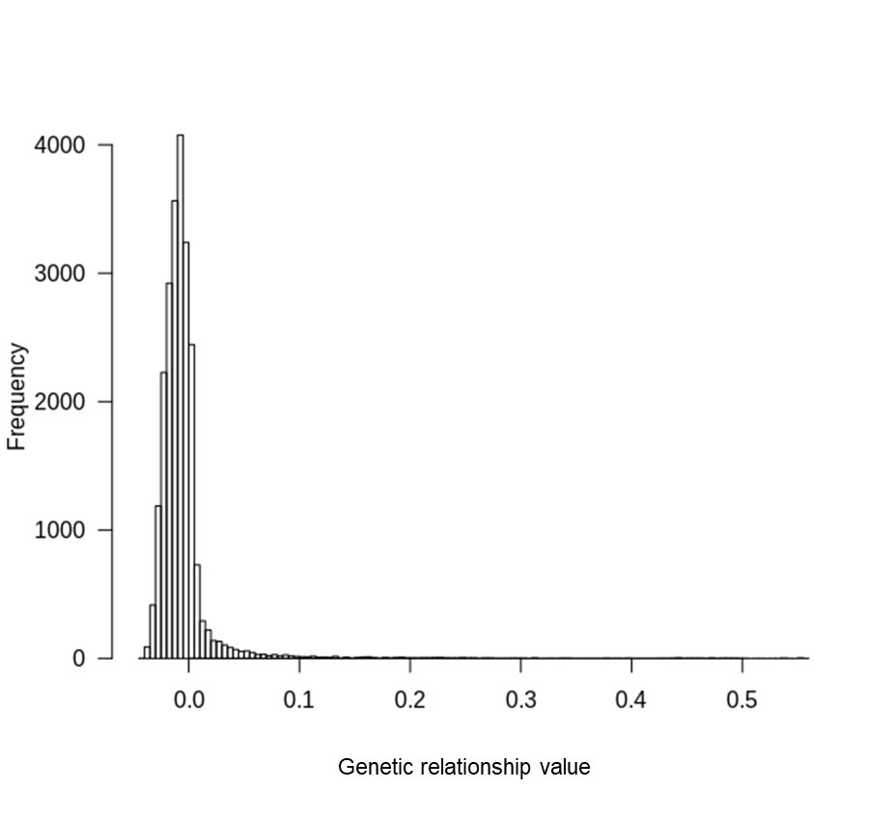

**Supplementary figure 1.** Histogram of genetic relationship values according to Yang et al. (2011) among all individuals.

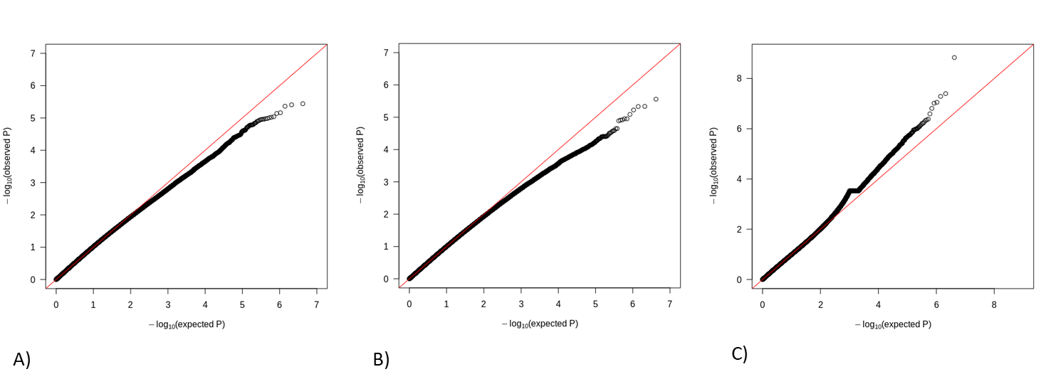

**Supplementary figure 2.** QQ plots of genome-wide associations with A) urban-rural habitat, B) year of sampling in BB1urban and C) FID.

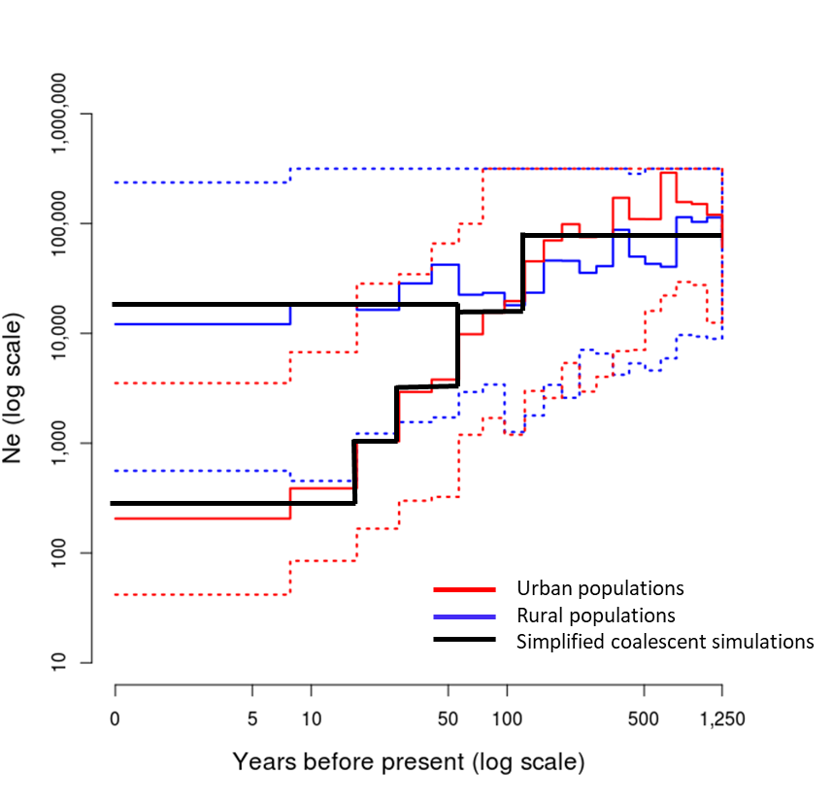

**Supplementary figure 3.** Estimated effective population size (Ne) over the last 1250 years (500 generations) for all urban and rural populations combined (median as solid line and 90% credible intervals as dotted lines). For the coalescent simulations demographic histories were simplified by medians of Ne along time intervals of little changes. Derived from figure 4 in Mueller et al. 2018.