Supplementary Tables and Figures for:
Parallel Evolution of Neurological and Muscle Development Genes in Urban Birds

Authors
Danny Jackson^{1,2}, Sabrina McNew², Scott Taylor³, Kevin McGraw^{1,4},
- Arizona State University
- University of Arizona
- University of Colorado Boulder
- Michigan State University
*Corresponding author. Email: dannyjacksonphd@gmail.com

Supplementary Figures
Figure S1: Population genomics of all samples. ADMIXTURE plot (left) and PCA (right) show unusual patterns of clustering between UWBM77548 and UWBM77718 that are consistent with these two individuals being close relatives. They were both sampled from the same location.
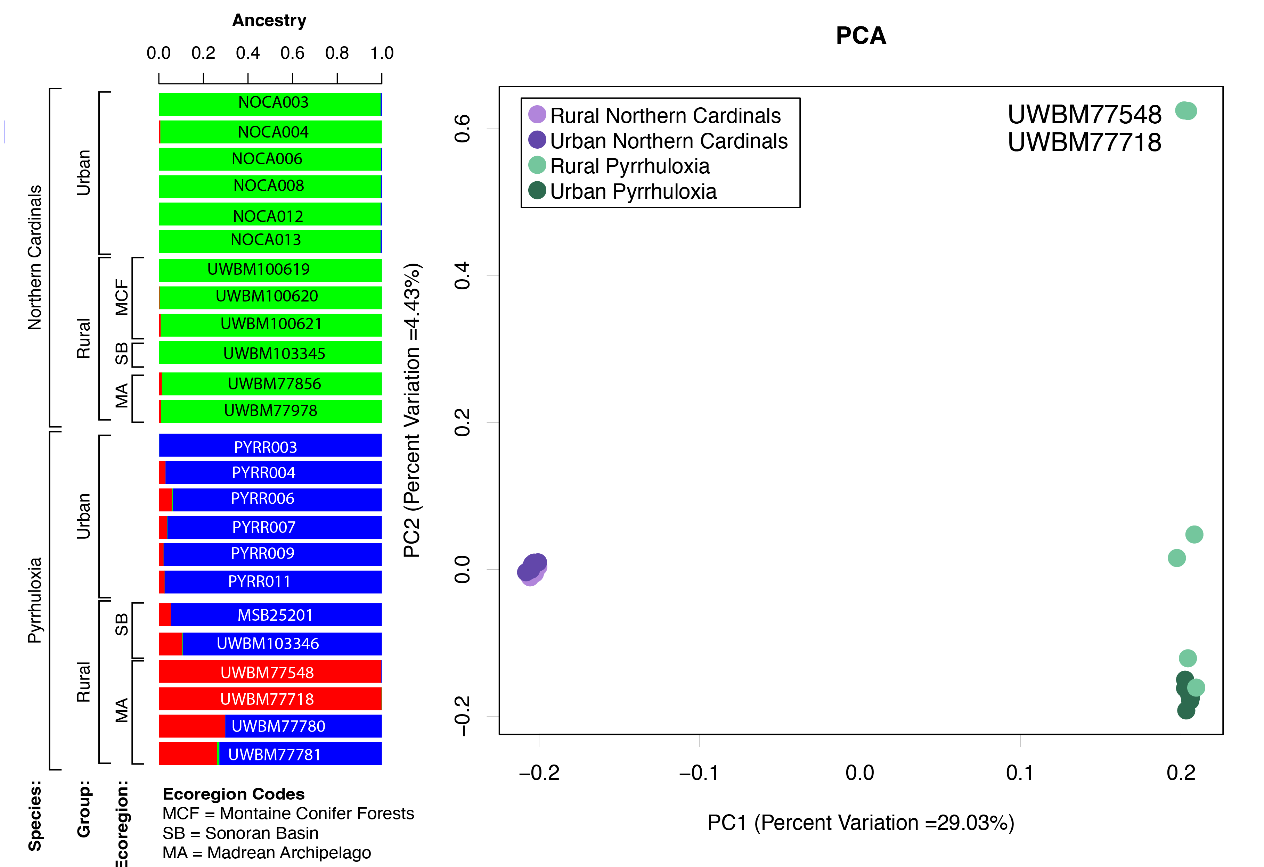
Figure S2. Signals of selection from RAiSD in pyrrhuloxia (top, green) and northern cardinals (bottom, purple). In these plots, only signals from urban samples in the absence of a signal from rural samples were considered significant. To visualize this, the rural statistics are plotted over top of the urban statistics, and only regions where the urban datapoints are visible were significant. Horizontal lines show the 1% cutoff of significance.

Pyrrhuloxia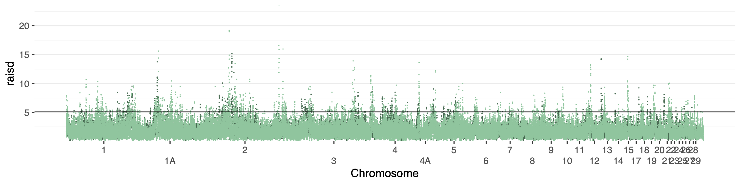Northern cardinals

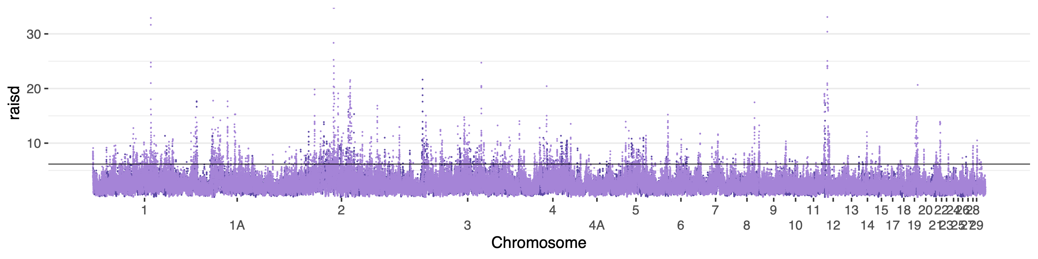

Supplementary Tables
Table S1: Interspecific Weir and Cockerham’s F_{ST} values

Pop1 | Pop2 | Unweighted F_{ST} | Weighted F_{ST}
Urban pyrrhuloxia | Urban northern cardinals | 0.414 | 0.638
Urban pyrrhuloxia | Rural northern cardinals | 0.415 | 0.638
Rural pyrrhuloxia | Urban northern cardinals | 0.416 | 0.638
Rural pyrrhuloxia | Rural northern cardinals | 0.416 | 0.637

Table S2: Significantly overrepresented GO terms in candidate gene lists from northern cardinals, pyrrhuloxia, or from more than one species. “Intersection” refers to the list of candidate genes identified in more than one taxon.

Species | Gene List | PANTHER GO Slim Biological Process | Log₂ Fold Enrichment | p-value | q-value
Northern cardinals | F_{ST} and RAiSD | platelet aggregation (GO:0070527) | 18.86 | 0.000 | 0.016
 |  | protein activation cascade (GO:0072376) | 18.86 | 0.000 | 0.016
 |  | negative regulation of blood coagulation (GO:0030195) | 17.68 | 0.000 | 0.064
 |  | platelet activation (GO:0030168) | 15.72 | 0.000 | 0.022
 |  | negative regulation of coagulation (GO:0050819) | 14.15 | 0.001 | 0.106
 |  | homotypic cell-cell adhesion (GO:0034109) | 13.47 | 0.000 | 0.035
 |  | hemostasis (GO:0007599) | 10.48 | 0.000 | 0.064
 |  | blood coagulation (GO:0007596) | 10.48 | 0.000 | 0.064
 |  | coagulation (GO:0050817) | 10.48 | 0.000 | 0.064
 |  | negative regulation of response to external stimulus (GO:0032102) | 8.84 | 0.000 | 0.022
 |  | skeletal muscle tissue development (GO:0007519) | 8.42 | 0.000 | 0.058
 |  | skeletal muscle organ development (GO:0060538) | 7.37 | 0.000 | 0.069
 |  | muscle organ development (GO:0007517) | 5.89 | 0.001 | 0.159
 |  | muscle tissue development (GO:0060537) | 4.56 | 0.002 | 0.194
 |  | cell junction assembly (GO:0034329) | 3.54 | 0.001 | 0.123
 |  | cell-cell adhesion via plasma-membrane adhesion molecules (GO:0098742) | 3.37 | 0.001 | 0.106
 |  | cell-cell adhesion (GO:0098609) | 2.78 | 0.000 | 0.022
 |  | cell adhesion (GO:0007155) | 2.14 | 0.001 | 0.159
 | F_{ST} | skeletal muscle tissue development (GO:0007519) | 12.77 | 0.000 | 0.028
 |  | skeletal muscle organ development (GO:0060538) | 11.18 | 0.000 | 0.039
 |  | muscle organ development (GO:0007517) | 8.94 | 0.000 | 0.064
 |  | adherens junction organization (GO:0034332) | 7.77 | 0.000 | 0.085
 |  | cell-cell adhesion via plasma-membrane adhesion molecules (GO:0098742) | 5.11 | 0.000 | 0.028
 |  | cell junction assembly (GO:0034329) | 4.77 | 0.000 | 0.064
 |  | cell junction organization (GO:0034330) | 3.64 | 0.000 | 0.064
 |  | cell-cell adhesion (GO:0098609) | 3.11 | 0.000 | 0.064
 |  | cell morphogenesis (GO:0000902) | 2.87 | 0.000 | 0.064
 |  | cell-cell signaling (GO:0007267) | 2.46 | 0.001 | 0.122
 |  | organonitrogen compound metabolic process (GO:1901564) | 0.56 | 0.001 | 0.124
 | RAiSD | platelet aggregation (GO:0070527) | 50.93 | 0.000 | 0.000
 |  | protein activation cascade (GO:0072376) | 50.93 | 0.000 | 0.000
 |  | negative regulation of blood coagulation (GO:0030195) | 47.75 | 0.000 | 0.003
 |  | platelet activation (GO:0030168) | 42.44 | 0.000 | 0.001
 |  | negative regulation of coagulation (GO:0050819) | 38.2 | 0.000 | 0.008
 |  | homotypic cell-cell adhesion (GO:0034109) | 36.38 | 0.000 | 0.001
 |  | hemostasis (GO:0007599) | 28.29 | 0.000 | 0.002
 |  | blood coagulation (GO:0007596) | 28.29 | 0.000 | 0.002
 |  | coagulation (GO:0050817) | 28.29 | 0.000 | 0.002
 |  | regulation of response to wounding (GO:1903034) | 27.28 | 0.000 | 0.018
 |  | calcineurin-mediated signaling (GO:0097720) | 27.28 | 0.000 | 0.018
 |  | regulation of wound healing (GO:0061041) | 27.28 | 0.000 | 0.018
 |  | regulation of coagulation (GO:0050818) | 23.87 | 0.000 | 0.025
 |  | negative regulation of response to external stimulus (GO:0032102) | 19.89 | 0.000 | 0.001
 |  | positive regulation of cell-cell adhesion (GO:0022409) | 17.36 | 0.001 | 0.060
 |  | mismatch repair (GO:0006298) | 17.36 | 0.001 | 0.060
 |  | regulation of body fluid levels (GO:0050878) | 16.98 | 0.000 | 0.013
 |  | wound healing (GO:0042060) | 13.4 | 0.000 | 0.025
 |  | response to wounding (GO:0009611) | 10.19 | 0.001 | 0.060
 |  | cell activation (GO:0001775) | 8.78 | 0.001 | 0.093
 |  | regulation of response to external stimulus (GO:0032101) | 7.64 | 0.000 | 0.018
 |  | tRNA processing (GO:0008033) | 5.58 | 0.002 | 0.170
 |  | regulation of response to stress (GO:0080134) | 5.3 | 0.001 | 0.087
 |  | tRNA metabolic process (GO:0006399) | 4.79 | 0.001 | 0.064
Pyrrhuloxia | F_{ST} and RAiSD | None | None | None | None
 | F_{ST} | secretory granule organization (GO:0033363) | 35.66 | 0.001 | 0.096
 |  | regeneration (GO:0031099) | 35.66 | 0.001 | 0.096
 |  | tissue regeneration (GO:0042246) | 35.66 | 0.001 | 0.096
 |  | insulin-like growth factor receptor signaling pathway (GO:0048009) | 21.4 | 0.000 | 0.060
 |  | regulation of phosphoprotein phosphatase activity (GO:0043666) | 21.4 | 0.000 | 0.060
 |  | regulation of phosphatase activity (GO:0010921) | 17.83 | 0.000 | 0.075
 |  | regulation of dephosphorylation (GO:0035303) | 11.89 | 0.002 | 0.153
 |  | nervous system development (GO:0007399) | 2.09 | 0.000 | 0.075
 |  | metabolic process (GO:0008152) | 0.66 | 0.000 | 0.060
 |  | nitrogen compound metabolic process (GO:0006807) | 0.64 | 0.001 | 0.092
 |  | organic substance metabolic process (GO:0071704) | 0.64 | 0.000 | 0.060
 |  | primary metabolic process (GO:0044238) | 0.63 | 0.000 | 0.060
 |  | cellular metabolic process (GO:0044237) | 0.62 | 0.000 | 0.075
 |  | macromolecule biosynthetic process (GO:0009059) | 0.44 | 0.001 | 0.115
 |  | heterocycle metabolic process (GO:0046483) | 0.44 | 0.001 | 0.115
 |  | cellular aromatic compound metabolic process (GO:0006725) | 0.44 | 0.001 | 0.115
 |  | nucleobase-containing compound metabolic process (GO:0006139) | 0.43 | 0.001 | 0.116
 |  | organic cyclic compound metabolic process (GO:1901360) | 0.42 | 0.000 | 0.075
 |  | cellular nitrogen compound metabolic process (GO:0034641) | 0.42 | 0.000 | 0.060
 |  | organic substance biosynthetic process (GO:1901576) | 0.42 | 0.000 | 0.036
 |  | biosynthetic process (GO:0009058) | 0.42 | 0.000 | 0.036
 |  | cellular biosynthetic process (GO:0044249) | 0.4 | 0.000 | 0.036
 |  | regeneration (GO:0031099) | 35.47 | 0.001 | 0.183
 |  | tissue regeneration (GO:0042246) | 35.47 | 0.001 | 0.183
 |  | regulation of centrosome duplication (GO:0010824) | 17.73 | 0.000 | 0.124
 |  | regulation of centrosome cycle (GO:0046605) | 17.73 | 0.000 | 0.124
 |  | proton transmembrane transport (GO:1902600) | 12.67 | 0.000 | 0.029
 |  | tRNA modification (GO:0006400) | 6.06 | 0.000 | 0.068
 |  | tRNA processing (GO:0008033) | 5.6 | 0.000 | 0.029
 |  | tRNA metabolic process (GO:0006399) | 4.19 | 0.000 | 0.041
 |  | RNA modification (GO:0009451) | 4.04 | 0.000 | 0.124
Intersection | All | regulation of muscle system process (GO:0090257) | 56.38 | 0.001 | 0.041
 |  | skeletal muscle tissue development (GO:0007519) | 39.03 | 0.001 | 0.075
 |  | skeletal muscle organ development (GO:0060538) | 33.83 | 0.002 | 0.095
 |  | adherens junction organization (GO:0034332) | 33.09 | 0.000 | 0.011
 |  | homophilic cell adhesion via plasma membrane adhesion molecules (GO:0007156) | 29.27 | 0.000 | 0.013
 |  | smoothened signaling pathway (GO:0007224) | 28.19 | 0.002 | 0.117
 |  | muscle organ development (GO:0007517) | 26.7 | 0.002 | 0.126
 |  | cell-cell adhesion via plasma-membrane adhesion molecules (GO:0098742) | 25.37 | 0.000 | 0.000
 |  | synapse assembly (GO:0007416) | 23.06 | 0.003 | 0.154
 |  | cell junction assembly (GO:0034329) | 21.5 | 0.000 | 0.001
 |  | cell-cell junction assembly (GO:0007043) | 20.57 | 0.000 | 0.033
 |  | synapse organization (GO:0050808) | 19.82 | 0.000 | 0.001
 |  | cell-cell junction organization (GO:0045216) | 17.7 | 0.001 | 0.047
 |  | cell junction organization (GO:0034330) | 16.75 | 0.000 | 0.000
 |  | cell-cell adhesion (GO:0098609) | 11.24 | 0.000 | 0.001
 |  | synaptic signaling (GO:0099536) | 10.08 | 0.000 | 0.004
 |  | cell morphogenesis (GO:0000902) | 9.7 | 0.000 | 0.001
 |  | axon guidance (GO:0007411) | 9.57 | 0.001 | 0.055
 |  | neuron projection guidance (GO:0097485) | 9.57 | 0.001 | 0.055
 |  | cell adhesion (GO:0007155) | 8.9 | 0.000 | 0.001
 |  | neuron development (GO:0048666) | 8.54 | 0.000 | 0.002
 |  | axonogenesis (GO:0007409) | 8.05 | 0.002 | 0.094
 |  | cell morphogenesis involved in neuron differentiation (GO:0048667) | 7.75 | 0.002 | 0.103
 |  | chemical synaptic transmission (GO:0007268) | 7.35 | 0.002 | 0.117
 |  | anterograde trans-synaptic signaling (GO:0098916) | 7.35 | 0.002 | 0.117
 |  | axon development (GO:0061564) | 7.2 | 0.002 | 0.117
 |  | trans-synaptic signaling (GO:0099537) | 7.2 | 0.002 | 0.117
 |  | neuron projection morphogenesis (GO:0048812) | 6.72 | 0.003 | 0.140
 |  | cell projection morphogenesis (GO:0048858) | 6.68 | 0.003 | 0.140
 |  | plasma membrane bounded cell projection morphogenesis (GO:0120039) | 6.68 | 0.003 | 0.140
 |  | neuron projection development (GO:0031175) | 6.61 | 0.001 | 0.061
 |  | neuron differentiation (GO:0030182) | 6.53 | 0.000 | 0.011
 |  | cell-cell signaling (GO:0007267) | 6.32 | 0.000 | 0.029
 |  | nervous system development (GO:0007399) | 6.28 | 0.000 | 0.001
 |  | generation of neurons (GO:0048699) | 6.28 | 0.000 | 0.012
 |  | cell development (GO:0048468) | 5.82 | 0.000 | 0.016
 |  | neurogenesis (GO:0022008) | 5.8 | 0.000 | 0.016
 |  | multicellular organism development (GO:0007275) | 5.72 | 0.000 | 0.000
 |  | anatomical structure morphogenesis (GO:0009653) | 5.49 | 0.000 | 0.011
 |  | system development (GO:0048731) | 5.15 | 0.000 | 0.001
 |  | multicellular organismal process (GO:0032501) | 4.52 | 0.000 | 0.000
 |  | anatomical structure development (GO:0048856) | 4.27 | 0.000 | 0.000
 |  | developmental process (GO:0032502) | 3.8 | 0.000 | 0.001
 |  | signaling (GO:0023052) | 2.9 | 0.000 | 0.011
 |  | cell communication (GO:0007154) | 2.84 | 0.000 | 0.013

Table S3: Genes associated with significant GO terms in analyses of candidate gene lists from northern cardinals, pyrrhuloxia, or from more than one species. “Intersection” refers to the list of candidate genes identified in more than one taxon.

Species | Analysis | GO_Term | Name | Genes
Northern cardinals | F_{ST} and RAiSD | GO:0070527 | platelet aggregation | FGA, FGB
 |  | GO:0072376 | protein activation cascade | FGA, FGB
 |  | GO:0030195 | negative regulation of blood coagulation | FGA, FGB
 |  | GO:0030168 | platelet activation | FGA, FGB
 |  | GO:0050819 | negative regulation of coagulation | FGA, FGB
 |  | GO:0034109 | homotypic cell-cell adhesion | FGA, FGB
 |  | GO:0007599 | hemostasis | FGA, FGB
 |  | GO:0007596 | blood coagulation | FGA, FGB
 |  | GO:0050817 | coagulation | FGA, FGB
 |  | GO:0032102 | negative regulation of response to external stimulus | SUSD4, FGA, FGB, CACTIN, PPARG
 |  | GO:0007519 | skeletal muscle tissue development | MYF5, MYF6, DMD
 |  | GO:0060538 | skeletal muscle organ development | MYF5, MYF6, DMD
 |  | GO:0007517 | muscle organ development | MYF5, MYF6, DMD
 |  | GO:0060537 | muscle tissue development | MYF5, MYF6, DMD, SGCZ
 |  | GO:0034329 | cell junction assembly | CDH11, CDH18, SDK1, CDH20, CLDN23, NLGN3, CDH9
 |  | GO:0098742 | cell-cell adhesion via plasma-membrane adhesion molecules | CDH11, ATRN, CDH18, SDK1, CNTN4, CDH20, MEGF11
 |  | GO:0098609 | cell-cell adhesion | DCHS1, FGA, CDH11, ATRN, CDH18, SDK1, CNTN4, CDH11, CDH20, FGB, MEGF11, TJP3, SDK1, NLGN3, CDON, ITGA9, FGA, CDH9
 |  | GO:0007155 | cell adhesion | DCHS1, FGA, CDH11, ATRN, CDH18, SDK1, CNTN4, CDH11, CDH20, FGB, MEGF11, TJP3, SDK1, NLGN3, CDON, ITGA9, FGA, CDH9, PCDH15, CLDN23
 | F_{ST} | GO:0007519 | skeletal muscle tissue development | MYF5, MYF6, DMD
 |  | GO:0060538 | skeletal muscle organ development | MYF5, MYF6, DMD
 |  | GO:0007517 | muscle organ development | MYF5, MYF6, DMD
 |  | GO:0034332 | adherens junction organization | CDH11, CDH18, CDH20, CDH9
 |  | GO:0098742 | cell-cell adhesion via plasma-membrane adhesion molecules | CDH11, ATRN, CDH18, SDK1, CNTN4, CDH11, CDH20, MEGF11, SDK1, CDH9
 |  | GO:0034329 | cell junction assembly | CDH11, CDH18, SDK1, CDH11, CDH20, NLGN3, CDH9
 |  | GO:0034330 | cell junction organization | CDH11, CDH18, SDK1, CNTN4, CDH11, CDH20, TJP3, SDK1, NLGN3, ERC2, CDH9
 |  | GO:0098609 | cell-cell adhesion | DCHS1, CDH11, ATRN, CDH18, SDK1, CNTN4, CDH11, CDH20, MEGF11, TJP3, SDK1, NLGN3, CDON, CDH9
 |  | GO:0000902 | cell morphogenesis | UNC5C, SLITRK1, EPHA10, CDH11, TRIO, EPHB2, CDH18, SLIT3, UNCSC, CNTN4, CDH20, FRY, CDH9
 |  | GO:0007267 | cell-cell signaling | GNAI2, BCL9, LRP2, GJB1, SYN2, GRIA2, GJA6, GLRB, FCHSD2, GRID, HTR7, DMD, GJA5, NLGN3, ERC2
 |  | GO:1901564 | organonitrogen compound metabolic process | STT3A, TRIM2, EPHA10, CHPF, SRBD1, CERS6, EPHB2, ZDHHC20, TG, VRK1, AGBL1, MRPL57, EIF2AK4, MAP4K3, GSTZ1, ENPP2, AK4, FBXO32, DPY19L3, EPHB2, RPS6KA2, EEFSEC, PSMD14, HECW1, ANKZF1, CHEK1, MGAT5B
 | RAiSD | GO:0070527 | platelet aggregation | FGA, FGB
 |  | GO:0072376 | protein activation cascade | FGA, FGB
 |  | GO:0030195 | negative regulation of blood coagulation | FGA, FGB
 |  | GO:0030168 | platelet activation | FGA, FGB
 |  | GO:0050819 | negative regulation of coagulation | FGA, FGB
 |  | GO:0034109 | homotypic cell-cell adhesion | FGA, FGB
 |  | GO:0007599 | hemostasis | FGA, FGB
 |  | GO:0007596 | blood coagulation | FGA, FGB
 |  | GO:0050817 | coagulation | FGA, FGB
 |  | GO:1903034 | regulation of response to wounding | FGA, FGB
 |  | GO:0097720 | calcineurin-mediated signaling | PPP3R1, PPP3CA, NFATC1
 |  | GO:0061041 | regulation of wound healing | FGA, FGB
 |  | GO:0050818 | regulation of coagulation | FGA, FGB
 |  | GO:0032102 | negative regulation of response to external stimulus | FGA, FGB, SUSD4, PPARG
 |  | GO:0022409 | positive regulation of cell-cell adhesion | FGA, FGB
 |  | GO:0006298 | mismatch repair | MSH2, MSH6
 |  | GO:0050878 | regulation of body fluid levels | FGA, FGB
 |  | GO:0042060 | wound healing | FGA, FGB
 |  | GO:0009611 | response to wounding | FGA, FGB
 |  | GO:0001775 | cell activation | FGA, FGB
 |  | GO:0032101 | regulation of response to external stimulus | FGA, FGB, SUSD4, PPARG, TLR5
 |  | GO:0008033 | tRNA processing | TSEN2, TRMT61B, TRMT9B, CDKAL1, TSEN2
 |  | GO:0080134 | regulation of response to stress | FGA, FGB, SUSD4, PPARG, TLR5
 |  | GO:0006399 | tRNA metabolic process | TSEN2, TRMT61B, TRMT9B, CDKAL1, TSEN2, GATB, DTD1
Pyrrhuloxia | F_{ST} and RAiSD | None | None | None
 | F_{ST} | GO:0033363 | secretory granule organization | DTNBP1
 |  | GO:0031099 | regeneration | GAP43
 |  | GO:0042246 | tissue regeneration | GAP43
 |  | GO:0048009 | insulin-like growth factor receptor signaling pathway | GIGYF2, IGF1
 |  | GO:0043666 | regulation of phosphoprotein phosphatase activity | PPP6R2, PPP6R3
 |  | GO:0010921 | regulation of phosphatase activity | PPP6R2, PPP6R3
 |  | GO:0035303 | regulation of dephosphorylation | PPP6R2, PPP6R3
 |  | GO:0007399 | nervous system development | RUNX2, GPM6A, EPHA10, DTNBP1, ABI2, WNT16, GAP43, RBFOX1, IGF2BP2, DTNBP1, SDK1, SLIT3, NAV2, NTN4, TENM3, TRAK1, KIRREL3, SDK1, ERBB4, DMD, NYAP2, NLGN3, SEMA6D
 |  | GO:0008152 | metabolic process | GGT7, STT3A, SUMO2, PDPK1, CSGALNACT1, UBA6, TRIP12, EPHA10, TASP1, MTMR4, NCF4, PLCE1, HEXA, CDKAL1, RAB19, RNGTT, EI24, OTUD7A, STK4, PBRM1, CTSC, DROSHA, G6PC2, UBE2I, DCUN1D1, CACTIN, RNF43, EIF3F, CDK14, NUP85
 |  | GO:0006807 | nitrogen compound metabolic process | GGT7, STT3A, SUMO2, PDPK1, CSGALNACT1, UBA6, TRIP12, EPHA10, TASP1, HEXA, CDKAL1, RNGTT, OTUD7A, STK4, PBRM1, CTSC, DROSHA, UBE2I, DCUN1D1, CACTIN, RNF43, EIF3F, CDK14, KYNU, MAN1A2, NOC3L, RNF13, ARIH1, DYRK1A, PRKCH, LOXL4, ANKIB1, PBRM1, TDO2, CTSO, STK4, MTA1, FUT8, BABAM2, PPP2R3B, SENP2, ENTPD1, CHEK1, SUMO2
 |  | GO:0071704 | organic substance metabolic process | GGT7, STT3A, SUMO2, PDPK1, CSGALNACT1, UBA6, TRIP12, EPHA10, TASP1, MTMR4, PLCE1, HEXA, CDKAL1, RNGTT, OTUD7A, STK4, PBRM1, CTSC, DROSHA, G6PC2, UBE2I, DCUN1D1, CACTIN, RNF43, EIF3F, CDK14, NUP85, KYNU, MAN1A2, NOC3L, RNF13, NDUFA9, ARIH1, DYRK1A, PRKCH, LOXL4, PBRM1, ANKIB1, TDO2, CTSO, STK4, MTA1, FUT8, BABAM2, PIP5K1C, PPP2R3B, SENP2, ENTPD1, CHEK1, SUMO2
 |  | GO:0044238 | primary metabolic process | STT3A, SUMO2, PDPK1, CSGALNACT1, UBA6, TRIP12, EPHA10, TASP1, MTMR4, PLCE1, HEXA, CDKAL1, RNGTT, OTUD7A, STK4, PBRM1, CTSC, DROSHA, G6PC2, UBE2I, DCUN1D1, CACTIN, RNF43, EIF3F, CDK14, KYNU, MAN1A2, NOC3L, RNF13, ARIH1, DYRK1A, PRKCH, LOXL4, ANKIB1, PBRM1, TDO2, CTSO, STK4, MTA1, FUT8, BABAM2, PIP5K1C, PPP2R3B, SENP2, ENTPD1, CHEK1, SUMO2
 |  | GO:0044237 | cellular metabolic process | GGT7, STT3A, PDPK1, CSGALNACT1, EPHA10, TASP1, MTMR4, NCF4, PLCE1, HEXA, CDKAL1, RAB19, RNGTT, EI24, STK4, PBRM1, DROSHA, G6PC2, CACTIN, RNF43, EIF3F, CDK14, NUP85, KYNU, NOC3L, NDUFA9, DYRK1A, PRKCH, PBRM1, TDO2, STK4, MTA1, FUT8, SNX7, BABAM2, PIP5K1C, PPP2R3B, ENTPD1, CHEK1
 |  | GO:0009059 | macromolecule biosynthetic process | STT3A, CSGALNACT1, TASP1, CDKAL1, RNGTT, PBRM1, DROSHA, CACTIN, EIF3F, NUP85, PBRM1, FUT8
 |  | GO:0046483 | heterocycle metabolic process | CDKAL1, RNGTT, PBRM1, DROSHA, CACTIN, KYNU, NOC3L, PBRM1, TDO2, MTA1, BABAM2, ENTPD1
 |  | GO:0006725 | cellular aromatic compound metabolic process | CDKAL1, RNGTT, PBRM1, DROSHA, CACTIN, KYNU, NOC3L, PBRM1, TDO2, MTA1, BABAM2, ENTPD1
 |  | GO:0006139 | nucleobase-containing compound metabolic process | CDKAL1, RNGTT, PBRM1, DROSHA, CACTIN, NOC3L, PBRM1, TDO2, MTA1, BABAM2, ENTPD1
 |  | GO:1901360 | organic cyclic compound metabolic process | CDKAL1, RNGTT, PBRM1, DROSHA, CACTIN, KYNU, NOC3L, PBRM1, TDO2, MTA1, BABAM2, ENTPD1
 |  | GO:0034641 | cellular nitrogen compound metabolic process | CDKAL1, RNGTT, PBRM1, DROSHA, CACTIN, EIF3F, KYNU, NOC3L, PBRM1, TDO2, MTA1, BABAM2, ENTPD1
 |  | GO:1901576 | organic substance biosynthetic process | STT3A, CSGALNACT1, TASP1, CDKAL1, RNGTT, PBRM1, DROSHA, G6PC2, CACTIN, EIF3F, NUP85, NDUFA9, PBRM1, FUT8, PIP5K1C
 |  | GO:0009058 | biosynthetic process | STT3A, CSGALNACT1, TASP1, CDKAL1, RNGTT, PBRM1, DROSHA, G6PC2, CACTIN, EIF3F, NUP85, NDUFA9, PBRM1, FUT8, PIP5K1C
 |  | GO:0044249 | cellular biosynthetic process | STT3A, CSGALNACT1, TASP1, CDKAL1, RNGTT, PBRM1, DROSHA, CACTIN, EIF3F, NUP85, NDUFA9, PBRM1, FUT8, PIP5K1C
 | RAiSD | GO:0031099 | regeneration | GAP43
 |  | GO:0042246 | tissue regeneration | GAP43
 |  | GO:0010824 | regulation of centrosome duplication | NPM1, SPICE1
 |  | GO:0046605 | regulation of centrosome cycle | NPM1, SPICE1
 |  | GO:1902600 | proton transmembrane transport | ATP1A1, OTOP3, OTOP2, ATP6V1G1
 |  | GO:0006400 | tRNA modification | CDKAL1, MTO1, THADA, QTRT2, ELP4
 |  | GO:0008033 | tRNA processing | RTCB, CDKAL1, MTO1, THADA, QTRT2, TSEN54, ELP4
 |  | GO:0006399 | tRNA metabolic process | RTCB, CDKAL1, MTO1, THADA, QTRT2, TSEN54, ELP4, EARS2
 |  | GO:0009451 | RNA modification | CDKAL1, MTO1, METTL16, THADA, QTRT2, ELP4
Intersection | All | GO:0090257 | regulation of muscle system process | DMD
 |  | GO:0007519 | skeletal muscle tissue development | DMD
 |  | GO:0060538 | skeletal muscle organ development | DMD
 |  | GO:0034332 | adherens junction organization | CDH18, CDH8, CDH9
 |  | GO:0007156 | homophilic cell adhesion via plasma membrane adhesion molecules | SDK1, CNTN4
 |  | GO:0007224 | smoothened signaling pathway | GL13
 |  | GO:0007517 | muscle organ development | DMD
 |  | GO:0098742 | cell-cell adhesion via plasma-membrane adhesion molecules | ATRN
 |  | GO:0007416 | synapse assembly | SDK1
 |  | GO:0034329 | cell junction assembly | SDK1, CDH18, CDH8, CDH9
 |  | GO:0007043 | cell-cell junction assembly | CDH18, CDH8, CDH9
 |  | GO:0050808 | synapse organization | SDK1, CNTN4, ERC2, CDH9
 |  | GO:0045216 | cell-cell junction organization | CDH18, CDH8, CDH9
 |  | GO:0034330 | cell junction organization | CDH18, SDK1, CNTN4, CDH8, ERC2, CDH9
 |  | GO:0098609 | cell-cell adhesion | ATRN, ADH18, SDK1, CNTN4, CDH8, CDH9
 |  | GO:0099536 | synaptic signaling | SYT1, HTR7, DMD, ERC2
 |  | GO:0000902 | cell morphogenesis | TRIO, EPHB2, CDH18, CNTN4, CDH8, CDH9
 |  | GO:0007411 | axon guidance | TRIO, EPHB2, CNTN4
 |  | GO:0097485 | neuron projection guidance | TRIO, EPHB2, CNTN4
 |  | GO:0007155 | cell adhesion | PCDH15, ATRN, CDH18, SDK1, CNTN4, CDH8, CDH9
 |  | GO:0048666 | neuron development | GPM6A, TRIO, EPHB2, CNTN4, DMD
 |  | GO:0007409 | axonogenesis | TRIO,EPHB2, CNTN4
 |  | GO:0048667 | cell morphogenesis involved in neuron differentiation | TRIO, EPHB2, CNTN4
 |  | GO:0007268 | chemical synaptic transmission | SYT1, HTR7, ERC2
 |  | GO:0098916 | anterograde trans-synaptic signaling | SYT1, HTR7, ERC2
 |  | GO:0061564 | axon development | TRIO, EPHB2, CNTN4
 |  | GO:0099537 | trans-synaptic signaling | SYT1, HTR7, ERC2
 |  | GO:0048812 | neuron projection morphogenesis | TRIO, EPHB2, CNTN4
 |  | GO:0048858 | cell projection morphogenesis | TRIO, EPHB2, CNTN4
 |  | GO:0120039 | plasma membrane bounded cell projection morphogenesis | TRIO, EPHB2, CNTN4
 |  | GO:0031175 | neuron projection development | GPM6A, TRIO, EPHB2, CNTN4
 |  | GO:0030182 | neuron differentiation | GPM6A, TRIO, EPHB2, CNTN4, DMD
 |  | GO:0007267 | cell-cell signaling | SYT1, HTR7, DMD, ERC2
 |  | GO:0007399 | nervous system development | GPM6A, TRIO, EPHB2, SDK1, NAV2, CNTN4, DMD
 |  | GO:0048699 | generation of neurons | GPM6A, TRIO, EPHB2, CNTN4, DMD
 |  | GO:0048468 | cell development | GPM6A, TRIO, EPHB2, CNTN4, DMD
 |  | GO:0022008 | neurogenesis | GPM6A, TRIO, EPHB2, CNTN4, DMD
 |  | GO:0007275 | multicellular organism development | GPM6A, TRIO, EPHB2, CDH18, SDK1, APOLD1, ALK, NAV2, CNTN4, DMD, CDH8, CDH9
 |  | GO:0009653 | anatomical structure morphogenesis | TRIO, EPHB2, CDH18, APOLD1, CNTN4, EPHB2, CDH8, CDH9
 |  | GO:0048731 | system development | GPM6A, TRIO, EPHB2, SDK1, APOLD1, NAV2, CNTN4, DMD
 |  | GO:0032501 | multicellular organismal process | GPM6A, TRIO, EPHB2, CDH18, SDK1, APOLD1, ALK, NAV2, CNTN4, DMD, CDH8, CDH9
 |  | GO:0048856 | anatomical structure development | GPM6A, TRIO, EPHB2, CDH18, SDK1, APOLD1, ALK, NAV2, CNTN4, DMD, CDH8, CDH9
 |  | GO:0032502 |  | GPM6A, TRIO, EPHB2, CDH18, SDK1, APOLD1, ALK, NAV2, CNTN4, DMD, CDH8, CDH9
 |  | GO:0023052 |  | CHRM3, SYT1, BDKRB1, EPHB2, VRK1, GLI3, ALK, ANKS1B, HTR7, DMD, ERC2
 |  | GO:0007154 |  | GPM6A, TRIO, EPHB2, CDH18, SDK1, APOLD1, ALK, NAV2, CNTN4, DMD, CDH8, CDH9

Table S4: List of all candidate genes for the four species in this study (see accompanying CSV file).

