Parallel Evolution of Genes Related to Neurological Function and
Muscle Development in Urban Birds

Authors
[Removed for double-blind review]
Abstract
Human activities have reshaped ecosystems globally and have created new selective regimes to which wild animals must adapt. Urban settings present wildlife with novel challenges that are consistent across cities (e.g. artificial light at night, noise pollution, novel resource distributions). A handful of bird species show within-species parallel evolution in response to urbanization, with consistent changes across multiple cities. However, the extent of parallel evolution across taxa is largely unknown, and genomic studies of closely related sympatric species can provide new insights into interspecific patterns of urban evolution. Here we analyzed whole genome sequences of Northern Cardinals (Cardinalis cardinalis) and Pyrrhuloxia (C. sinuatus) from urban and rural areas of Arizona, USA to test for the presence of parallel evolution to urban environments. We compare our candidate urban adaptation gene lists with published datasets of urban-selected genes in Burrowing Owls (Athene cunicularia) and Great Tits (Parus major). Across the four avian taxa, we demonstrate evidence of parallel urban selection on the same genes, many of which affect the function and development of neurological and muscular tissues. Additionally, we identified genes under selection in urban environments that are involved in blood physiology and immune function in both cardinal species. Our findings emphasize that adaptation to anthropogenic change can be repeatable but is also dependent on species-specific traits.

Key words:
Anthropogenic, Burrowing Owl, genomic, Great Tit, Northern Cardinal, parallel evolution, Pyrrhuloxia, urbanization

Lay summary:
Humans are rapidly changing natural environments, and urbanization represents a severe ecological disturbance for native birds. Studying how birds adapt to urban environments can reveal important insights about evolution and how some species thrive in cities while others do not. We studied two cardinal species in Tucson, Arizona – Northern Cardinals and Pyrrhuloxia – for evidence of urban-selection. We also compared our findings to two other studies on urban selection in birds, one on Burrowing Owls and another on Great Tits. Across all four species, we found that brain and muscle function experienced selection in the urban environment. We also found that some changes were unique to individual species, including blood physiology in Northern Cardinals and insulin function in Pyrrhuloxia. These findings show that, while some effects of human disturbances on wildlife are consistent across species, the unique traits of each species also shape how they respond to urbanization.
Introduction
Ecological disturbances from human activities are reshaping natural selective environments and creating novel challenges for wild species across the globe (Otto, 2018). Our understanding of the effects of human activities on avian evolution comes from studies of only a few species (Caizergues et al., 2021; Giraudeau et al., 2014; Hutton & McGraw, 2016; Isaksson & Andersson, 2007), and the extent to which these evolutionary patterns can be extended to different taxa remains an essential question to address. Parallelism of evolutionary responses to multidimensional stressors can occur across populations and species (Cerca et al., 2023; Reid et al., 2016), but is not guaranteed (Thurman et al., 2023), with variation in the degree of parallelism (Oke et al., 2017). While some evolutionary responses are likely generalizable across species, others may be specific to the focal taxon, and complex factors influence the repeatability of responses to human disturbance across populations, species, and environments at (Bolnick et al., 2018; Jackson et al., 2026). Comparative studies of multiple taxa in response to the same disturbance can indicate which evolutionary patterns are consistent across lineages.

Cities worldwide are characterized by novel environmental changes that drive evolution in wildlife (Biondi et al., 2020; Castano et al., 2024; Sarkar & Bhadra, 2022). Yet despite this novelty, many aspects of environmental change are consistent across urban landscapes. Cities are characterized by high percentages of impervious land surface, with plant growth limited to areas without concrete, asphalt, and buildings (Perillo et al., 2017). Sources of shelter, food, and water are patchily distributed and urban birds rely on many human-mediated resources for survival including food, nesting sites, and even air conditioning (Arnold et al., 2021; Mills & McGraw, 2021). Urban birds also face novel stressors including increased disease risk (Minias, 2023; Pikus et al., 2021), noise pollution (Perillo et al., 2017), and an increase in inter- and intraspecific conflict (Lane et al., 2023; Martin & Bonier, 2018). While aspects of urbanization are consistent across cities, they vary in intensity and have unique interactions with local ecosystems. For instance, urban heat exacerbates summer stress in very hot climates but relieves winter stress in colder climates (Sumasgutner et al., 2023).
Nonetheless, some degree of parallelism is expected across all urban landscapes, and the effects of urbanization on genetic variation can be consistent within a species across different urban environments (e.g. Mueller et al., 2013; Winchell et al., 2023). For example, Great Tits (Parus major) display evidence of selection on neural and developmental genes across the European continent (Laine et al., 2016); however, because this study combined both urban and rural populations, these signals may be confounded by urbanization. Studies that compare urban with rural populations find urban-associated selection on these pathways (Salmón et al., 2021), although with little parallelism at the genotypic or epigenetic level (Caizergues et al., 2022). Similarly, parallel evolution was documented in Burrowing Owls (Athene cunicularia) in genes related to cognition across many South American cities (Mueller et al., 2020). Despite these lines of evidence for parallel evolutionary responses to urbanization within species, much less is known about whether closely related species respond to urban environments through similar genetic mechanisms. Comparative analyses of related species that occupy similar ecological niches but differ in their persistence in urban environments provide a powerful opportunity to identify the genetic and functional bases of species-specific responses to urbanization.
Northern Cardinals (Cardinalis cardinalis) and Pyrrhuloxia (Cardinalis sinuatus) are sister species that both occupy the metropolitan area of Tucson, Arizona and largely share an ecological niche. Both species co-occur across the entirety of the range of Pyrrhuloxia and will breed in overlapping territories throughout the Sonoran and Chihuahuan Deserts and nearby highlands (Gould, 1961).The range of Northern Cardinals extends substantially beyond that of Pyrrhuloxia, and they also occupy more highly urbanized areas than Pyrrhuloxia (Jackson, 2023; Sullivan et al., 2009). Northern Cardinals and Pyrrhuloxia are approximately 5.1 million years divergent (CI: 4.2 - 6.0 MY; Barker et al., 2015; Hooper & Price, 2017; Kumar et al., 2017), and while phenotypic hybrids have been observed, no genetic datasets have been used to investigate hybridization between the species. Slight differences within the largely similar genetic backgrounds of these two species could potentially underlie their documented differences in urban persistence, and a comparison of the two may illuminate mechanisms associated with urban adaptation.
We generated and analyzed whole genome sequence data from urban and rural Northern Cardinals and Pyrrhuloxia to identify regions that may have undergone positive selection in the urban environment. We tested for evidence of parallel selection across taxa at the gene level between Pyrrhuloxia and Northern Cardinals in Tucson, comparing our results to recent results from Great Tits in Europe (Salmón et al., 2021), and Burrowing Owls in Argentina (Mueller et al., 2020). We then investigated potential targets of selection through Gene Ontology (GO) analyses. We predicted that the genes under selection would be diverse but that some degree of parallelism would be observed across taxa, and that Northern Cardinals would show a stronger genomic response to urbanization than Pyrrhuloxia.

Methods
Tissue collection, DNA sequencing, and SNP filtering:
Between 2021-2022, we collected blood samples from a total of 12 birds – six Northern Cardinals and six Pyrrhuloxia –in Tucson, Arizona spanning approximately 22 miles of the city (Table 1, Figure 1). Cardinalis species in rural areas were difficult if not impossible to capture in part due to fieldwork limitations during the COVID-19 pandemic, so we also accessed muscle tissue samples from 12 birds (six Northern Cardinals and six Pyrrhuloxia) from the University of Washington Burke Museum and the Museum of Southwestern Biology collected during years 1999-2007. This produced a sample size of six individuals per species per population (urban vs. rural) for a total of 24 samples, which is sufficient for substantially reducing false positives in allele frequency estimates and for identifying outliers (Hahn, 2018; Lou & Therkildsen, 2022). We extracted DNA from each sample at the University of Colorado using a Qiagen DNeasy Blood & Tissue kit, and we measured DNA concentrations on a Thermofisher Qubit 3.0. Whole genome paired-end 150 base pair sequencing libraries were prepared and sequenced using the Illumina NovaSeq 6000 platform by Novogene, Sacramento, CA.
Table 1: Accession information for the individual cardinals (wild caught and museum specimens) from which we sequenced genomes. UWBM = University of Washington Burke Museum. MSB = Museum of Southwestern Biology.

Sample | Species | Population | Year | Source
NOCA_003 | Northern Cardinal | Urban | 2021 | This study
NOCA_004 | Northern Cardinal | Urban | 2021 | This study
NOCA_006 | Northern Cardinal | Urban | 2021 | This study
NOCA_008 | Northern Cardinal | Urban | 2021 | This study
NOCA_012 | Northern Cardinal | Urban | 2022 | This study
NOCA_013 | Northern Cardinal | Urban | 2022 | This study
PYRR_003 | Pyrrhuloxia | Urban | 2021 | This study
PYRR_004 | Pyrrhuloxia | Urban | 2021 | This study
PYRR_006 | Pyrrhuloxia | Urban | 2021 | This study
PYRR_007 | Pyrrhuloxia | Urban | 2021 | This study
PYRR_009 | Pyrrhuloxia | Urban | 2022 | This study
PYRR_012 | Pyrrhuloxia | Urban | 2022 | This study
UWBM100619 | Northern Cardinal | Rural | 2007 | UWBM
UWBM100620 | Northern Cardinal | Rural | 2007 | UWBM
UWBM100621 | Northern Cardinal | Rural | 2007 | UWBM
UWBM103345 | Northern Cardinal | Rural | 1999 | UWBM
UWBM103346 | Pyrrhuloxia | Rural | 1999 | UWBM
UWBM77548 | Pyrrhuloxia | Rural | 2004 | UWBM
UWBM77718 | Pyrrhuloxia | Rural | 2004 | UWBM
UWBM77780 | Pyrrhuloxia | Rural | 2004 | UWBM
UWBM77781 | Pyrrhuloxia | Rural | 2004 | UWBM
UWBM77856 | Northern Cardinal | Rural | 2003 | UWBM
UWBM77978 | Northern Cardinal | Rural | 2003 | UWBM
MSB25201 | Pyrrhuloxia | Rural | 2004 | MSB

We trimmed raw sequence fasta files using Trimmomatic (Bolger et al., 2014) and assessed quality using FastQC (Andrews, 2010). We aligned the trimmed sequence reads to the closest relative with an available chromosome-level genome assembly, the Small Tree Finch (Camarhynchus parvulus) genome STF-HiC (1.28 GB; Genbank accession number: GCF_901933205.1), using bwa mem (H. Li & Durbin, 2009). Then we sorted the bam files using samtools (H. Li et al., 2009) and picard-tools (Picard Toolkit, 2019), clipped overlapping read pairs using BamUtil (Jun et al., 2015), realigned around indels using GATK (McKenna et al., 2010) and indexed the resulting using samtools and picard-tools. We dropped all scaffolds and sex chromosomes from downstream analyses. Because our average coverage was <10 for all samples, we employed a genotype likelihood approach using angsd (Korneliussen et al., 2014). First, we generated a list of varying sites with a minimum SNP p-value of 1e-6, minimum individual depth of 4, minimum of 20 individuals, minimum minor allele frequency of 0.05, and minimum mapping quality of 30. Our quality control and filtering steps left a dataset of 2,618,696 SNPs across our samples. We additionally tested for batch effects between museum and field-collected samples using a Principal Component Analysis following the same methods as above and MapDamage (Jónsson et al., 2013; Lou & Therkildsen, 2022). We found a very slight and non-significant increase in transversion rates in museum specimens compared to field specimens (Wilcox test: Northern cardinals field mean = 0.024, museum mean = 0.025, p-value = 0.240; Pyrrhuloxia field mean = 0.024, museum mean = 0.026, p-value = 0.180). Importantly, we confirmed that our museum specimens did not show evidence of DNA degradation by comparing a PCA of the samples with and without transition sites and finding no difference. We also confirmed that the genomes in our Principal Component Analysis (PCA) clustered by ecoregion rather than by source (museum vs. field), as the latter possibility would have suggested evidence of batch effects (Figure 1B, S1). After filtering, we had an average depth of coverage of 5.08 across all samples.

Population Structure Analyses
We analyzed relationships between our samples using PCA and ADMIXTURE (Alexander & Lange, 2011). We first used angsd to generate a bcf file, which we input into plink (Purcell et al., 2007) to filter for unlinked SNPs (--indep-pairwise 50kb 1 0.5). We used pcangsd (Meisner & Albrechtsen, 2018) to output a covariance matrix from which we computed eigenvectors that we visualized in R and to output an ADMIXTURE plot. These revealed that two of our rural Pyrrhuloxia samples from eastern Arizona may be close relatives, so we removed the individual with lower depth of coverage from all downstream analyses (UWBM77718). We show results from the population structure analyses without that individual (Figure 1), but the full results are in the supplement (Figure S1).
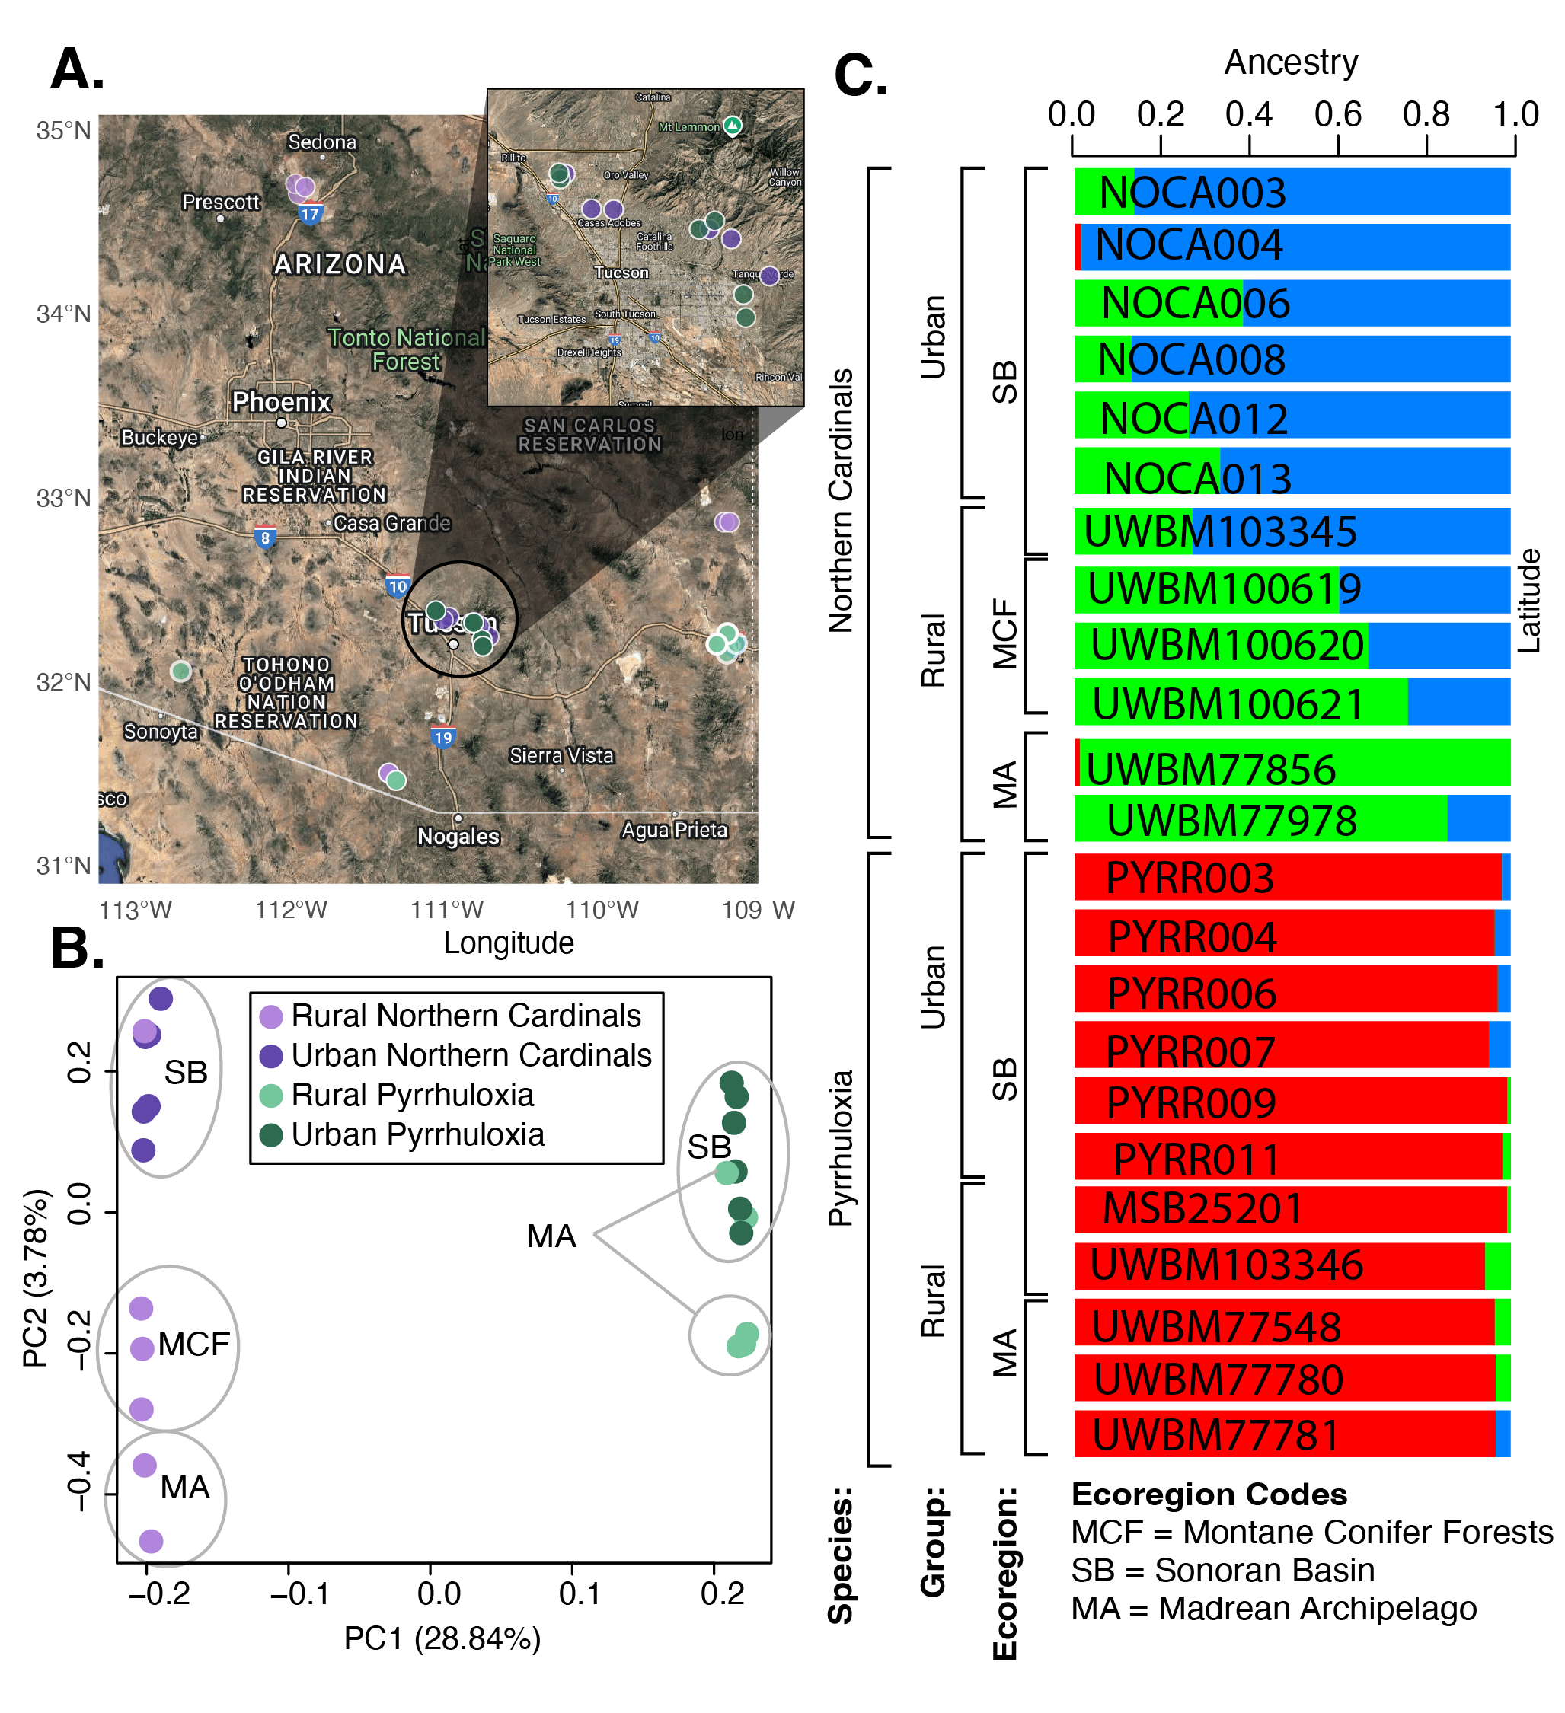 Figure 1: A. Sampling locations across the state of Arizona, with Northern Cardinals in purple and Pyrrhuloxia in green. A map with an alternative base layer is provided in Figure S1 for additional clarity. B. PCA of all genomes retained after filtering for potential close relatives (Northern Cardinals: urban N=6, rural N=6; Pyrrhuloxia: urban N=6; rural N=5). C. Admixture plot ordered by species and then by ecoregion. Samples cluster by ecoregion rather than by source (museum vs. field), suggesting minimal batch effects.

Tests for positive selection
To identify regions of the genome that have either recently undergone positive selection due to urbanization or that are associated with urban versus rural areas, we used two statistical approaches. F_{ST} is sensitive to signatures of divergence while RAiSD is sensitive to signatures of recent or ongoing selective sweeps. Although both statistics can reflect selection, they are sensitive to different stages of the selective process, with RAiSD detecting ongoing or recent sweeps and F_{ST} capturing divergence following selection. First, we employed sliding window F_{ST} scans to compare urban populations with rural populations of the same species using 50 kb windows with a 12.5 kb step size following similar approaches used in previous genomic selection scans (Khalkhali-Evrigh et al., 2022; Moreira & Smith, 2023; Zhang et al., 2024). Next, we employed RAiSD, a software that detects selective sweeps based on multiple signatures implemented in a μ statistic. The μ statistic combines signatures from the site-frequency spectrum, linkage disequilibrium, and genetic diversity to detect regions under selection (Alachiotis & Pavlidis, 2018). We computed windowed μ statistics in RAiSD across genomes from the urban population and separately across genomes from the rural population, and we considered regions that were significant within urban but not within rural populations of the same species to be regions of relevance to selection within an urban environment (Alachiotis & Pavlidis, 2018). RAiSD determines window sizes by number of informative sites rather than total base pair numbers, so we used windows containing 50 SNPs. We identified any gene that overlapped with a window in the top 1% of either statistic ( F_{ST} or μ) as a putative candidate gene under selection in the urban environment. This empirical percentile threshold provides comparable sets of putative candidate genes across the two species, facilitating tests for overlap in highly differentiated genomic regions.
To test for significant urban parallel evolution across avian taxa, we compared our lists of candidate genes from both cardinal species with lists from two major recent investigations of parallel avian urban genomic responses (Mueller et al., 2020; Salmón et al., 2021). One of these studies investigated urban evolution in Burrowing Owls (Athene cunicularia) across multiple cities in Argentina and the other investigated urban evolution of Great Tits (Parus major) across multiple European cities (Mueller et al., 2020; Salmón et al., 2021). Each study identified candidate genes using different analytical approaches, reflecting differences in sample size, sampling design, and sequencing methods. We therefore rely on their reported candidate gene lists rather than reanalyzing their data using a uniform approach. Methodological details can be found in the respective studies. We tested for significant overlap in candidate genes using a Fisher’s exact test for count data between taxa and we used the Benjamini-Hochberg procedure to correct for false discovery rate (FDR).
To identify putative functions of regions under selection in Northern Cardinals and Pyrrhuloxia, we tested for significant overrepresentation of GO terms among candidate gene lists within each Cardinalis species using the PANTHER classification system (Thomas et al., 2003). We also performed similar GO term analyses using lists of genes identified in two or more taxa. To curate our list of background genes, we started with all genes in the reference genome and then filtered out any gene with low mapability (< 0.95 SNP calling rate in SNPable http://lh3lh3.users.sourceforge.net/snpable.shtml Olkkonen & Löytynoja, 2023) and with less than 3x average depth from our unfiltered bams or greater than 2 standard deviations above the mean depth of the sample (28.15 reads). Genes excluded from the background gene list were also removed from any candidate gene lists, as we inferred that they were in regions prone to alignment or sequencing error. We corrected for multiple testing by using a false discovery rate using the Benjamini-Hochberg FDR test with a significance level of q < 0.2 (Z.-H. Li et al., 2013; Osborn et al., 2013; Wagner et al., 2020). F_{ST} and RAiSD are sensitive to different signatures of selection, as F_{ST} measures genetic differentiation while RAiSD detects recent or ongoing selective sweeps. We therefore tested for overrepresented GO terms for each species in a combined list of genes identified by both programs as well as independent lists from each statistic. We visualized the overrepresented GO terms in rrvgo (Sayols, 2023), which produces a scatterplot from the PCA of the dissimilarity matrix of the semantic similarity of overrepresented GO terms. Terms in these plots cluster by gene function, but the units of the axes are arbitrary and are therefore not included.

Results
Population structure analyses (PCA, admixture)
PC1 explained interspecific variation for all individuals (28.84% variation, Figure 1B). PC2 (3.78% variation) separated Northern Cardinals by ecotype, with clusters associated with the Sonoran basin, montane conifer forests, and the Madrean archipelago. Pyrrhuloxia did not segregate distinctly by ecotype, and neither species clustered by urbanization category (Figure 1). The ADMIXTURE analysis recovered no clusters below the species level but showed more variation within Northern Cardinals that suggests a genomic cline from the Madrean archipelago to the montane conifer forests to the Sonoran basin.

Population genetic results
Global F_{ST} between urban and rural populations of both cardinal species was very low (weighted Weir and Cockerham F_{ST} for Northern Cardinals = 0.013, Pyrrhuloxia = 0.015). The top 1% cutoff for Northern Cardinals was 0.213, and for Pyrrhuloxia was 0.232. Global F_{ST} between the cardinal species was high (weighted Weir and Cockerham F_{ST} for Northern Cardinals vs. Pyrrhuloxia = 0.638) and did not differ when comparing urban vs. urban, rural vs rural, or either combination of urban vs. rural (Table S1).

Overrepresented GO Terms in Each Cardinalis Species
In Northern Cardinals, 18 significantly overrepresented GO terms emerged in analyses of candidate genes identified by the combination of F_{ST} and RAiSD (Figure 4, Table S2). Two genes were associated with nine of these 18 GO terms, most of which were related to blood physiology. Both of these genes, FGA (fibrinogen alpha chain) and FGB (fibrinogen beta chain), are located in an ~15kb long segment of chromosome 4. Four GO terms were related to cell adhesion, with twenty genes associated with various cell adhesion GO terms. Four GO terms were related muscle development, but only four genes drove this signal: MYF5, MYF6 (Myogenic Factor 5 and 6), DMD (Dystrophin), and SGCZ (Sarcoglycan Zeta). Five genes were associated with the significant GO term negative regulation of response to external stimulus (GO:0032102, q = 0.022), SUSD4 (Sushi Domain Containing 4), FGA, FBG, CACTIN (Cactin), and PPARG (Peroxisome Proliferator-Activated Receptor Gamma). Analyses of genes identified in just F_{ST} or RAiSD revealed similar patterns, with the addition of one new overrepresented GO term identified only in the gene list curated from F_{ST} scans (GO:1901564 organonitrogen compound metabolic process, q = 0.124). Twenty-four new GO terms were identified in the gene list curated from RAiSD analyses, including blood physiology and cell adhesion as well as five additional processes (Table S2).

Parallel evolution
Pairwise comparisons of lists of candidate genes between Northern Cardinals, Pyrrhuloxia, Burrowing Owls, and Great Tits found significant evidence of overlapping genes in five of the six possible species pairs (Figure 2 and 3; Northern Cardinals and Pyrrhuloxia q < 0.001, Northern Cardinals and Burrowing Owls q < 0.001, Northern Cardinals and Great Tits q = 0.012, Pyrrhuloxia and Burrowing Owls q = 0.008, Burrowing Owls and Great Tits q = 0.012; FDR corrected Fisher’s exact test). Only Pyrrhuloxia and Great Tits did not demonstrate significant overlap of candidate genes (q = 0.601).
In both species of cardinals, 132 genes were identified as a candidate gene by either the F_{ST} and/or RAiSD analyses. However, no GO terms were overrepresented in this list of overlapping genes. Three genes were identified by both analyses in both species: CDKAL1 (CDK5 Regulatory Subunit Associated Protein 1 Like 1), COL15A1 (Collagen Type XV Alpha 1 Chain), and TGFBR1 (Transforming Growth Factor Beta Receptor 1). These three genes are all present within the same 3.4 Mb block of chromosome 2 which shows distinct evidence of a selective sweep in both urban taxa (Figure 2).
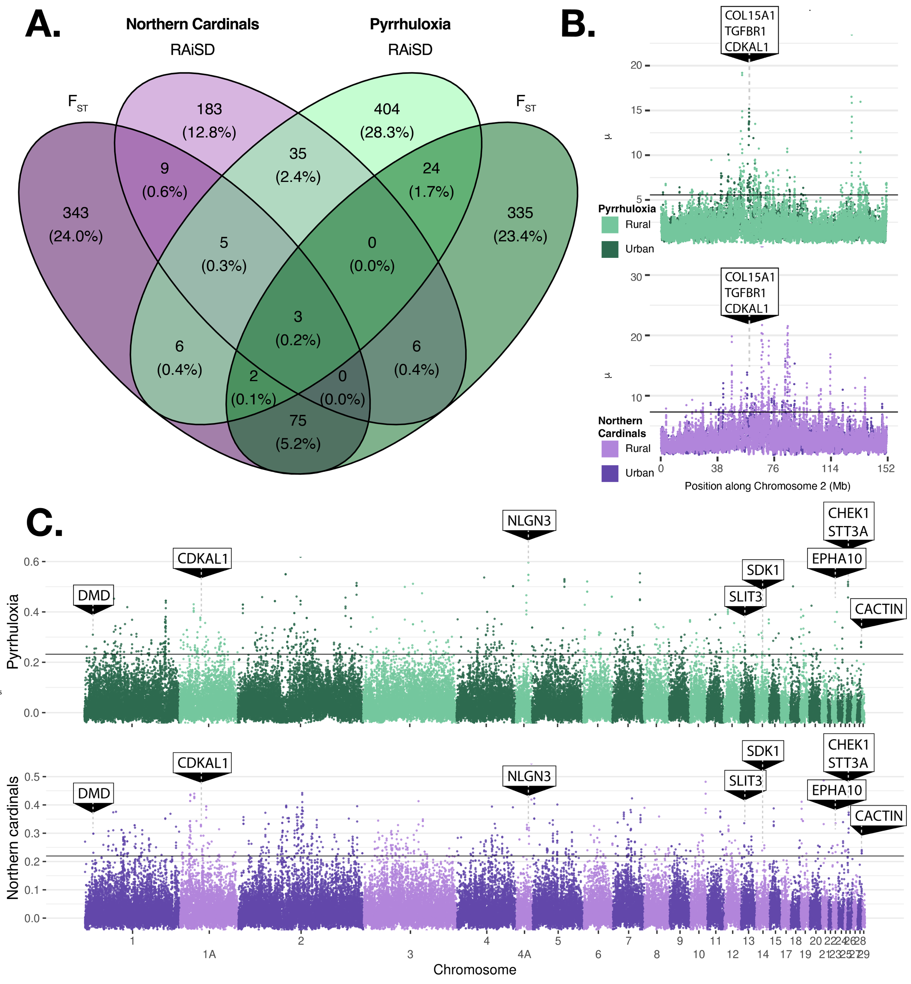
Figure 2. Evidence of parallel evolution in the two cardinal species. A. Venn diagrams of genes identified in either cardinal species by F_{ST} or RAiSD analyses. B. Evidence of selection in the same region on chromosome 2 in Pyrrhuloxia (top) and Northern Cardinals (bottom). In these plots, only signals from urban samples in the absence of a signal from rural samples were considered significant. To visualize this, the rural statistics are plotted over top of the urban statistics. Horizontal lines show the 1% cutoff of significance. The full genome plot can be found in Figure S3. C. Sliding window F_{ST} plots comparing urban and rural samples in Pyrrhuloxia (top) and Northern Cardinals (bottom). The annotated genes are the 9 genes identified in both cardinal species that also were associated with a significant GO term in both species (Table S2).
Overrepresented GO Terms in multiple species
No genes were identified as a candidate gene associated with urbanization in all four species. Our analyses identified forty-five outlier genes that showed evidence of selection across taxa, appearing in at least one cardinal species and in at least one non-cardinal species. We also identified forty-five GO terms that were significantly overrepresented in this list of candidate genes, many of which were associated with muscle development (e.g. GO:0090257 regulation of muscle system process q = 0.041) and neuronal processes (e.g. GO:0007399 nervous system development, q < 0.001, Figure 3, Table 2). One gene in particular drove the signal associated with muscle development, DMD (dystrophin), while many genes were associated with various neural developmental processes (Table 2). Twenty-four genes under selection were associated with one or more of these GO terms, with most identified in either Northern Cardinals (19) or Burrowing Owls (17), and much fewer in Pyrrhuloxia (eight) or in Great Tits (six). Only four of these genes were identified as under selection in three species, all of which were identified in Northern Cardinals, Pyrrhuloxia, and Burrowing Owls: APOLD1 (Apolipoprotein L Domain Containing 1), DMD, PCDH15 (Protocadherin related 15), and SDK1 (Sidekick Cell Adhesion Molecule 1). The remaining genes emerged as candidates in analyses of Northern Cardinals and Burrowing Owls (nine genes), followed by Northern Cardinals and Great Tits (five genes), Pyrrhuloxia and Burrowing Owls (three genes), and Pyrrhuloxia and Great Tits (one gene; Table 2).
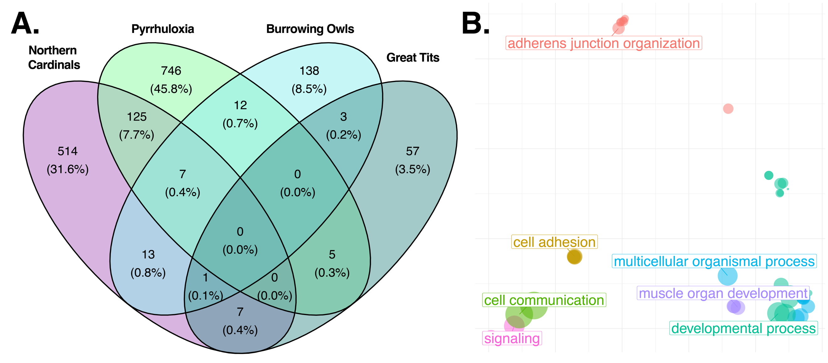
Figure 3. Evidence of parallel evolution across Northern Cardinals, Pyrrhuloxia, Great Tits, and Burrowing Owls. A. Venn diagram of genes under urban selection in the four species, and B. PCA dissimilarity plots of semantic similarity for FDR-corrected overrepresented GO terms of the list of genes found to be present in one of either cardinal species and at least one of the other two species (Burrowing Owls or Great Tits). Terms in this plot cluster by gene function, but the units of the axes are arbitrary and are therefore not included.
Table 2: Candidate genes identified in more than one taxon associated with a significantly overrepresented GO term. All GO terms could be categorized as either general development, signaling, neural development, synapse function, muscle development, or cell adhesion, and these broad categories are described in the Processes column. Specific GO terms are defined in Tables S2 and S3.
Species | Gene symbol | Gene name | Processes
Northern Cardinals, Pyrrhuloxia, and Burrowing Owls | APOLD1 | Apoliopoprotein L Domain Containing 1 | Development
 | DMD | Dystrophin | Signaling, neural development, muscle development
 | PCDH15 | Protocadherin Related 15 | Cell adhesion
 | SDK1 | Sidekick Cell Adhesion Molecule 1 | Cell adhesion, neural development, synapse
Northern Cardinals and Burrowing Owls | ALK | ALK Receptor Tyrosine Kinase | Signaling
 | ANKS1B | Ankyrin Repeat And Sterile Alpha Motif Domain Containing 1B | Signaling
 | ATRN | Attractin | Cell adhesion
 | BDKRB1 | Bradykinin Receptor B1 | Signaling
 | CDH9 | Cadherin 9 | Development, cell adhesion, synapse
 | CNTN4 | Contactin 4 | Neural development
 | EPHB2 | EPH Receptor B2 | Neural development, signaling
 | ERC2 | ELKS/RAB6-Interacting/CAST Family Member 2 | Signaling, synapse
 | GLI3 | GLI Family Zinc Finger 3 | Signaling
Northern Cardinals and Great Tits | CDH18 | Cadherin 18 | Development, cell adhesion
 | CHRM3 | Cholinergic Receptor Muscarinic 3 | Signaling
 | HTR7 | 5-Hydroxytryptamine Receptor 7 | Signaling, synapse
 | TRIO | Trio Rho Guanine Nucleotide Exchange Factor | Neural development
 | VRK1 | VERK Serine/Threonine Kinase 1 | Signaling
Pyrrhuloxia and Burrowing Owls | CDH8 | Cadherin 8 | Development, cell adhesion
 | GPM6A | Glycoprotein M6A | Neural development
 | SYT1 | Synaptotagmoin 1 | Signaling, synapse
Pyrrhuloxia and Great Tits | NAV2 | Neuron Navigator 2 | Neural development

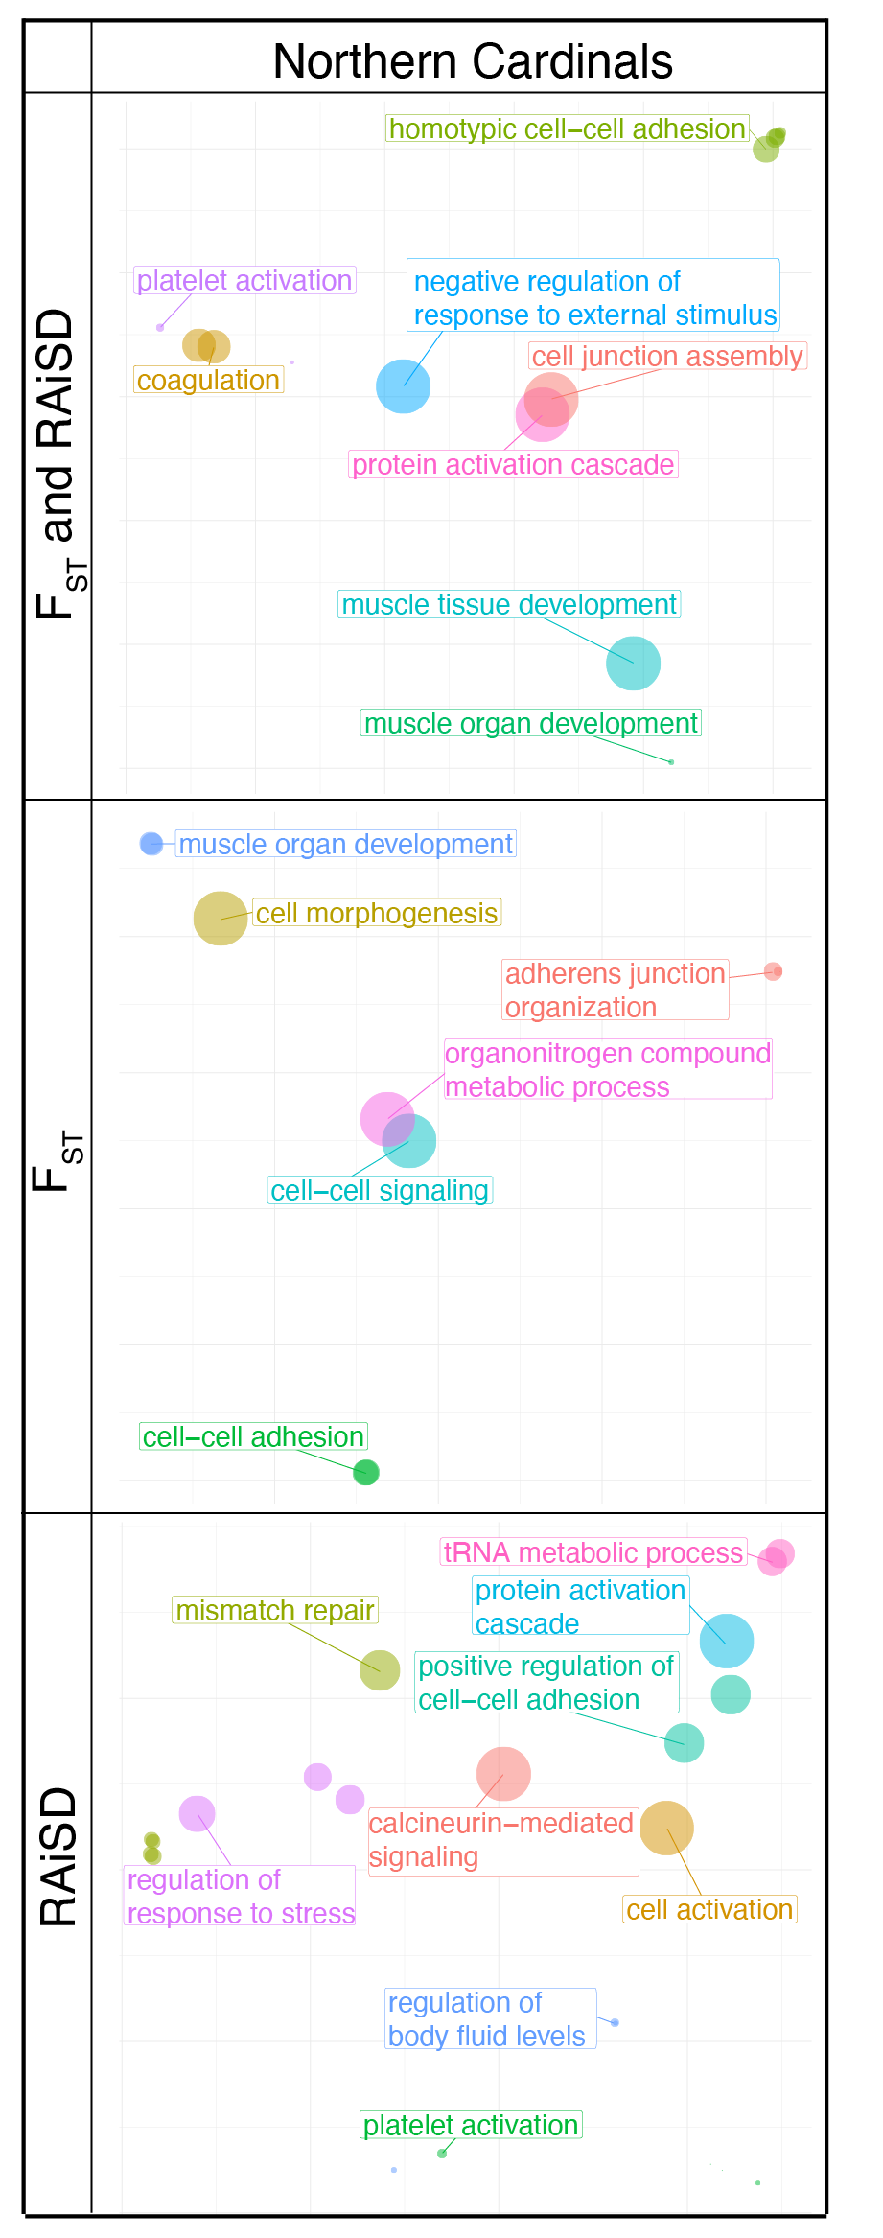
Figure 4: PCA plots of semantic similarity for FDR-corrected overrepresented GO terms in Northern Cardinals for (top) the full list of candidate genes identified by either F_{ST} or RAiSD analyses, (middle) only genes identified by F_{ST}, and (bottom) only genes identified by RAiSD. Terms in these plots cluster by meaning, but the units of the axes are arbitrary and are therefore not included.

In Pyrrhuloxia, no GO terms passed the FDR threshold from the combined list of F_{ST} and RAiSD outliers. Two GO terms – GO:0031099 regeneration and GO:0042246 tissue regeneration – were identified as overrepresented in the separate analyses of F_{ST} and of RAiSD gene lists (but not in the combined analyses of both lists), driven in both cases by the gene GAP43 (Growth Associated Protein 43).
Twenty-two GO terms in F_{ST} were significantly overrepresented among F_{ST} outlier genes. Fourteen terms related to various metabolic and biosynthetic processes, three related to phosphatase activity, and two related to tissue regeneration (Figure 5, Table S2). Three additional GO terms were identified: nervous system development (GO:0007399), secretory granule organization (GO:0033363), and insulin-like growth factor receptor signaling pathway (GO:0048009). Two candidate genes are involved in the insulin-like growth factor (IGF) receptor signaling pathway, GIGYF2 (GRB10 Interacting GYF Protein) and IGF1 (Insulin Like Growth Factor 1). We identified 23 candidate genes associated with nervous system development (Table S3).
Nine GO terms were overrepresented in the candidate genes identified by RAiSD, with four terms related to RNA processing, two terms related to centrosome regulation, the same two terms related to tissue regeneration as were identified by F_{ST} analyses, and one term related to energy metabolism (Figure 5).
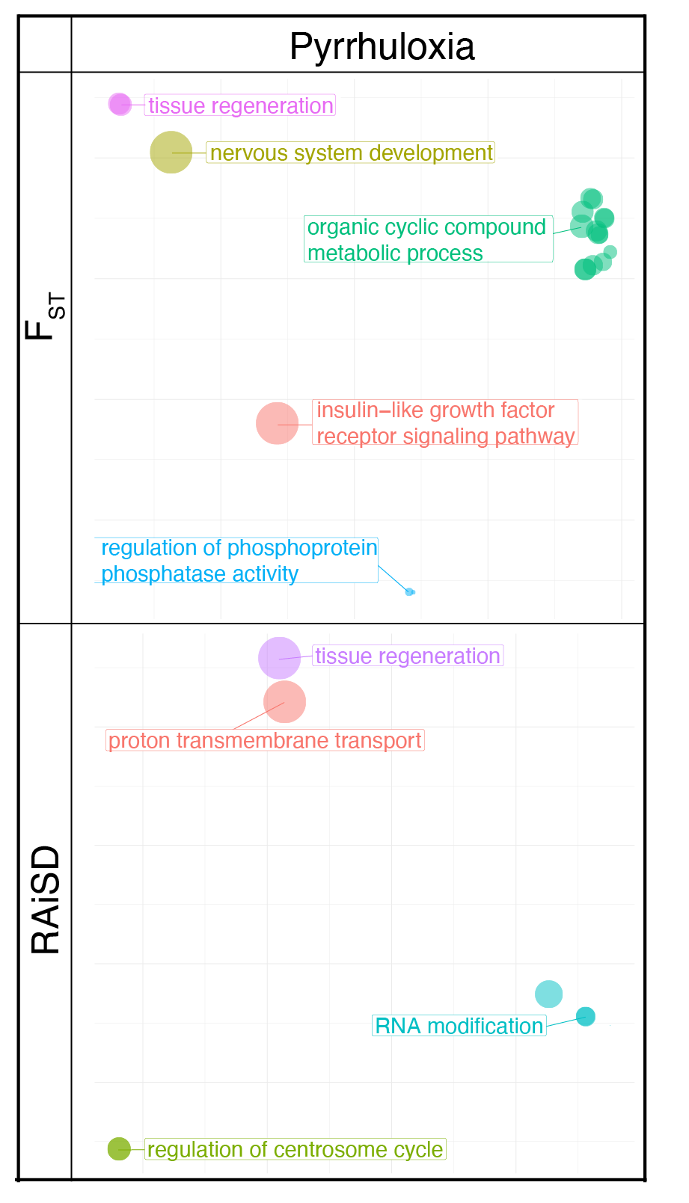

Figure 5: PCA dissimilarity plots of semantic similarity for FDR-corrected overrepresented GO terms in Pyrrhuloxia for (top) genes identified by F_{ST} and (bottom) genes identified by RAiSD. Analyses of the full list of candidate genes identified by either F_{ST} or RAiSD analyses revealed no significantly overrepresented GO terms. Terms in these plots cluster by meaning, but the units of the axes are arbitrary and are therefore not included.
Discussion
We reveal novel genomic evidence for parallel evolution in response to anthropogenic disturbance in two congeneric bird species. By comparing our results to literature from two other bird species (one owl, one songbird), we also demonstrate parallel urban selection for genes related to neural and muscle tissue development. We documented distinct responses to urbanization in our focal Cardinalis taxa, which may help explain observed differences in the persistence of the two species in the urban environment (Jackson, 2023). Although urbanization generally selected for similar processes and genes in these taxa, we found no evidence of even a single gene that experienced selection across all four evaluated species. Importantly, we also demonstrate many differences in the specific processes under selection across taxa (e.g. immune and metabolic processes). Our work contributes novel genomic evidence from two congeneric avian species to the literature on parallel evolution in response to anthropogenic disturbance.
We found a signal of selection by urbanization on muscle tissue development in three of the four focal taxa, driven largely by the gene DMD. This gene produces part of the dystrophin-associated glycoprotein complex (DGC), which is a fundamental structural protein in skeletal and cardiac muscle cells and regulates insulin receptor activity in these cells with major effects on muscle development (Eid Mutlak et al., 2020). Evidence for selection on muscle tissue development was found in fewer genes in Pyrrhuloxia than in Northern Cardinals, and this difference may play an important role in limiting the persistence of Pyrrhuloxia in the urban landscape. In Northern Cardinals, we detected selection on another candidate gene involved in the DGC (SGCZ), on two additional genes essential for muscle development (MYF5 and MYF6) and on 33 candidate genes linked to tissue integrity processes such as cell-adhesion, junction, morphogenesis, and signaling (Table S2). Pyrrhuloxia showed evidence of selection on two genes in the insulin-like growth factor (IGF) receptor signaling pathway. One of the two genes driving this signal, IGF-1, mediates flexibility in muscle physiology during acute exercise (Price et al., 2011) and growth rates in birds (Lodjak et al., 2017). Evidently, metabolic shifts facilitate urban adaptation in Cardinalis taxa. The highly polygenic response in Northern Cardinals but more limited response in Pyrrhuloxia suggests that species-level metabolic differences may be limiting the urban persistence of Pyrrhuloxia.

Despite these differences, we also found distinct evidence of parallel evolution in muscle development between the two species. Only three genes were identified by both RAiSD and F^{ST} as under selection in urban environments in both Northern Cardinals and Pyrrhuloxia: CDKAL1, COL15A1, and TGFBR1. Given the physical linkage between these genes, we cannot identify which one(s) might be driving the signal of selection. However, each of these three genes is associated with different aspects of muscle development. Variants in CDKAL1 lead to misfolded insulin, which stimulates muscle protein synthesis (Ghosh et al., 2022). COL15A1 is associated with chicken pectoral muscle disorders (Bordini et al., 2022). TGFBR1 affects muscle tissue development (Hillege et al., 2022). While no biological processes emerged in the GO term analyses of candidate genes identified in both taxa, we show evidence of parallel evolution between these species and identify this linkage block as potentially important for urban adaptation in birds. The mechanisms driving this change are speculative, but our findings suggest that variation in muscle tissues underlie urban adaptation in birds.
Urbanization might drive changes in muscle development and physiology in a variety of ways, all of which are speculative and require further validation. Urbanization is associated with a higher metabolic demand across diverse taxa (Franco-Belussi et al., 2024; Kreling et al., 2025; Shang et al., 2023), and we present new evidence that suggests urban-associated muscle tissue changes across species at the genetic level. Differences in gluconeogenesis plasticity have been documented in urban birds due to variation in urban food availability (Shang et al., 2023), which could also drive differences in muscle physiology and insulin sensitivity. Additionally, the movement ecology of urban landscapes is dramatically shifted, and nonmigratory species exhibit difficulties navigating patchy urban landscapes with major barriers to movement (Dayananda et al., 2021). Muscle physiology may also change in response to urban related threats, similar to how cliff swallow (Petrochelidon pyrrhonota) wing length has increased due to selection from traffic collisions (Brown & Brown, 2013). These signals of selection on muscle-related genes could mean that urban birds require different muscle physiology than rural birds, or that urban birds require different processes to achieve the same muscle physiology under different conditions, and more work is required to disentangle between the two.
Across the four taxa, selection on neural function emerged as a consistent driver of adaptation in urban avian populations. Tying these genetic signals to phenotypic patterns, however, is an emergent problem for urban evolutionary biology. Many phenotypes related to neural function are associated with urbanization. Diverse behavioral changes accompany urbanization in bird species, including changes to phenology, aggression, communication, cognition, and avoidance (Biondi et al., 2020; Castano et al., 2024; Giraudeau et al., 2014; Lane et al., 2023; Martin & Bonier, 2018; Sarkar & Bhadra, 2022). Neurological functions could underlie diverse physiological and morphological differences as well (Bohler et al., 2021). Therefore, while we identify parallelism at the level of neural function across species, the phenotypes under selection that drive this parallelism could be quite diverse and complex.
We also uncovered multiple lines of evidence of urban-related selection on neural function and stress, with putative ties to noise pollution. First, in Pyrrhuloxia, the gene GAP43 was identified as a candidate gene by both F_{ST} and RAiSD analyses and drove a significant overrepresentation of tissue regeneration GO terms in analyses of both datasets. This gene is associated with neural plasticity and behaviorally plastic responses to changing environments (Holahan, 2015), and expression of GAP43 is associated with potential increased risk of heart disease resulting from noise-induced stress in lab rat experiments (Rattus norvegicus domesticus, Wei et al., 2022). As noise pollution is a well-documented feature of urban landscapes, noise-induced stress could be a possible driver of urban adaptation in Pyrrhuloxia. Second, PCDH15 was identified as a candidate gene in three of the four species (all but Great Tits), and is essential for the development of mechanosensory hair cells involved in hearing (Fritzsch, 2021). And finally, we found evidence of selection on five genes in Northern Cardinals related to negative regulation of response to external stimulus. Of note among these genes, SUSD4 has been shown to impact behavior, with SUSD4 knockout mice exhibiting anxiety behaviors (Zhu et al., 2020). Noise pollution and exposure to novel features of the urban landscape like cars, construction, humans, and feral cats could be related to this pattern of consistent selection. However, the other genes involved in neural function did not appear to be involved in noise pollution. Likely this strong signal of parallel selection on neural function across taxa derives from a multifaceted selective regime on diverse behavioral, physiological, and morphological changes facilitated by neural function.
The parallel signals of urban selection across taxa and localities demonstrates a degree of repeatability of evolutionary responses to similar anthropogenic disturbances. However, urban ecosystems vary substantially across continents in climate, infrastructure, vegetation, and community composition, meaning that the urban–rural gradients experienced by great tits in Europe, burrowing owls in South America, and cardinal species in North America are unlikely to be identical. Despite this heterogeneity, urban environments consistently introduce novel ecological conditions, including altered acoustic environments, modified temperature regimes, novel predators and food sources, and increased human activity. Across studies of burrowing owls, great tits, and two cardinal species, urbanization has repeatedly been associated with selection on neurological and muscle-related genes. These patterns suggest that, although cities differ in many ecological details, some common challenges associated with urbanization may drive parallel changes in physiological systems related to behavior and mobility. Alterations to the nervous system could underlie a wide range of phenotypic responses, whether behavioral, morphological, or physiological. We present evidence documenting neurological changes, but future work is required to understand the phenotypes that emerge from these changes. Likewise, selection on muscle development genes could reflect altered mobility demands in urban environments or differences in the developmental pathways required to maintain movement under altered nutritional conditions. The findings of this study are limited by the sample size, and further investigations with greater sampling would provide increased resolution and clarity into the evolutionary processes associated with urbanization. While our results highlight shared genomic targets of urban selection, the extent to which the resulting phenotypes are similar across species and cities remains an important question for future work.
Conclusion
Our analyses uncovered evidence of both parallel and unique patterns of selection between Northern Cardinals and Pyrrhuloxia when comparing individuals from rural and urban populations. Importantly, the genes that we identified as under parallel selection are largely associated with muscle development and neural function. This latter function has emerged from studies of Burrowing Owls and Great Tits as a core process that experiences selection in novel urban environments, and we expand the evidence of this trend to include two new species. We contribute evidence on muscle function as a process under selection across avian taxa in urban landscapes, suggesting that the unique energetic demands of the city determine survival. We also highlight neuronal development as a key process under selection in the city, and we emphasize the need for deeper investigations into the phenotypic effects of neural differences between urban and rural birds. Despite showing different levels of persistence in an urban environment, both cardinal taxa demonstrate selective responses on similar functional categories, although Pyrrhuloxia showed a less consistent signal of selection particularly in muscle development and metabolic-related genes. Comparative morphological, behavioral, and physiological studies of these taxa informed by our findings could elucidate the phenotypic effects emerging from these genetic differences. This work contributes to a growing body of literature highlighting parallel responses of birds to urbanization and contributes evidence of species-specific genetic nuance in response to human disturbance.

Acknowledgements
[Removed for double blind review]

Funding Statement
[Removed for double blind review]

Ethics statement
[Removed for double blind review]

Permits
[Removed for double blind review]

Conflict of Interest
The authors declare no conflicts of interest.

Author Contributions
[Removed for double blind review]

Data availability:
The genomic sequence data has been uploaded to the National Center for Biotechnology Information Sequence Read Archive (NCBI SRA) and will be published upon manuscript acceptance. All code used in these analyses can be found on GitHub and will be archived permanently using Zenodo upon acceptance (link removed for double-blind review).
References
Alachiotis, N., & Pavlidis, P. (2018). RAiSD detects positive selection based on multiple signatures of a selective sweep and SNP vectors. Communications Biology, 1(1), 1–11. https://doi.org/10.1038/s42003-018-0085-8
Alexander, D. H., & Lange, K. (2011). Enhancements to the ADMIXTURE algorithm for individual ancestry estimation. BMC Bioinformatics, 12(1), Article 1. https://doi.org/10.1186/1471-2105-12-246
Andrews, S. (2010). FastQC: A quality control tool for high throughput sequence data. https://cir.nii.ac.jp/crid/1370584340724053142
Arnold, Z. J., Wenger, S. J., & Hall, R. J. (2021). Not just trash birds: Quantifying avian diversity at landfills using community science data. PLOS ONE, 16(9), e0255391. https://doi.org/10.1371/journal.pone.0255391
Barker, F. K., Burns, K. J., Klicka, J., Lanyon, S. M., & Lovette, I. J. (2015). New insights into New World biogeography: An integrated view from the phylogeny of blackbirds, cardinals, sparrows, tanagers, warblers, and allies. The Auk, 132(2), 333–348. https://doi.org/10.1642/auk-14-110.1
Biondi, L. M., Fuentes, G. M., Córdoba, R. S., Bó, M. S., Cavalli, M., Paterlini, C. A., Castano, M. V., & García, G. O. (2020). Variation in boldness and novelty response between rural and urban predatory birds: The Chimango Caracara, Milvago chimango as study case. Behavioural Processes, 173, 104064. https://doi.org/10.1016/j.beproc.2020.104064
Bohler, M. W., Chowdhury, V. S., Cline, M. A., & Gilbert, E. R. (2021). Heat Stress Responses in Birds: A Review of the Neural Components. Biology, 10(11), 1095. https://doi.org/10.3390/biology10111095
Bolger, A. M., Lohse, M., & Usadel, B. (2014). Trimmomatic: A flexible trimmer for Illumina sequence data. Bioinformatics, 30(15), 2114–2120. https://doi.org/10.1093/bioinformatics/btu170
Bolnick, D. I., Barrett, R. D. H., Oke, K. B., Rennison, D. J., & Stuart, Y. E. (2018). (Non)Parallel Evolution. Annual Review of Ecology, Evolution, and Systematics, 49(Volume 49, 2018), 303–330. https://doi.org/10.1146/annurev-ecolsys-110617-062240
Bordini, M., Soglia, F., Davoli, R., Zappaterra, M., Petracci, M., & Meluzzi, A. (2022). Molecular Pathways and Key Genes Associated With Breast Width and Protein Content in White Striping and Wooden Breast Chicken Pectoral Muscle. Frontiers in Physiology, 13. https://doi.org/10.3389/fphys.2022.936768
Brown, C. R., & Brown, M. B. (2013). Where has all the road kill gone? Current Biology, 23(6), R233–R234. https://doi.org/10.1016/j.cub.2013.02.023
Caizergues, A. E., Charmantier, A., Lambrechts, M. M., Perret, S., Demeyrier, V., Lucas, A., & Grégoire, A. (2021). An avian urban morphotype: How the city environment shapes great tit morphology at different life stages. Urban Ecosystems, 24(5), 929–941. https://doi.org/10.1007/s11252-020-01077-0
Caizergues, A. E., Le Luyer, J., Grégoire, A., Szulkin, M., Senar, J., Charmantier, A., & Perrier, C. (2022). Epigenetics and the city: Non‐parallel DNA methylation modifications across pairs of urban‐forest Great tit populations. Evolutionary Applications, 15(1), 149–165. https://doi.org/10.1111/eva.13334
Castano, M. V., Zumpano, F., Biondi, L. M., & García, G. O. (2024). Does urbanization affect behavioral responses to novel objects in marine birds? The Olrog’s Gull as a case of study. Urban Ecosystems, 27(2), 427–437. https://doi.org/10.1007/s11252-023-01465-2
Cerca, J., Cotoras, D. D., Bieker, V. C., De-Kayne, R., Vargas, P., Fernández-Mazuecos, M., López-Delgado, J., White, O., Stervander, M., Geneva, A. J., Andino, J. E. G., Meier, J. I., Roeble, L., Brée, B., Patiño, J., Guayasamin, J. M., Torres, M. de L., Valdebenito, H., Castañeda, M. del R., … Martin, M. D. (2023). Evolutionary genomics of oceanic island radiations. Trends in Ecology & Evolution, 38(7), 631–642. https://doi.org/10.1016/j.tree.2023.02.003
Dayananda, S. K., Mammides, C., Liang, D., Kotagama, S. W., & Goodale, E. (2021). A review of avian experimental translocations that measure movement through human-modified landscapes. Global Ecology and Conservation, 31, e01876. https://doi.org/10.1016/j.gecco.2021.e01876
Eid Mutlak, Y., Aweida, D., Volodin, A., Ayalon, B., Dahan, N., Parnis, A., & Cohen, S. (2020). A signaling hub of insulin receptor, dystrophin glycoprotein complex and plakoglobin regulates muscle size. Nature Communications, 11(1), 1381. https://doi.org/10.1038/s41467-020-14895-9
Franco-Belussi, L., de Oliveira Júnior, J. G., Goldberg, J., De Oliveira, C., Fernandes, C. E., & Provete, D. B. (2024). Multiple morphophysiological responses of a tropical frog to urbanization conform to the pace-of-life syndrome. Conservation Physiology, 12(1), coad106. https://doi.org/10.1093/conphys/coad106
Fritzsch, B. (2021). An Integrated Perspective of Evolution and Development: From Genes to Function to Ear, Lateral Line and Electroreception. Diversity, 13(8), Article 8. https://doi.org/10.3390/d13080364
Ghosh, C., Das, N., Saha, S., Kundu, T., Sircar, D., & Roy, P. (2022). Involvement of Cdkal1 in the etiology of type 2 diabetes mellitus and microvascular diabetic complications: A review. Journal of Diabetes & Metabolic Disorders, 21(1), 991–1001. https://doi.org/10.1007/s40200-021-00953-6
Giraudeau, M., Nolan, P. M., Black, C. E., Earl, S. R., Hasegawa, M., & McGraw, K. J. (2014). Song characteristics track bill morphology along a gradient of urbanization in house finches (Haemorhous mexicanus). Frontiers in Zoology, 11(1). https://doi.org/10.1186/s12983-014-0083-8
Gould, P. J. (1961). Territorial Relationships between Cardinals and Pyrrhuloxias. The Condor, 63(3), 246–256. https://doi.org/10.2307/1365686
Hahn, M. W. (2018). Molecular Population Genetics. Oxford University Press.
Hillege, M. M., Shi, A., Galli, R. A., Wu, G., Bertolino, P., Hoogaars, W. M., & Jaspers, R. T. (2022). Lack of Tgfbr1 and Acvr1b synergistically stimulates myofibre hypertrophy and accelerates muscle regeneration. eLife, 11, e77610. https://doi.org/10.7554/eLife.77610
Holahan, M. R. (2015). GAP-43 in synaptic plasticity: Molecular perspectives. Research and Reports in Biochemistry, 5, 137–146. https://doi.org/10.2147/RRBC.S73846
Hooper, D. M., & Price, T. D. (2017). Chromosomal inversion differences correlate with range overlap in passerine birds. Nature Ecology &amp; Evolution, 1(10), 1526–1534. https://doi.org/10.1038/s41559-017-0284-6
Hutton, P., & McGraw, K. J. (2016). Urban–Rural Differences in Eye, Bill, and Skull Allometry in House Finches (Haemorhous mexicanus). Integrative and Comparative Biology, 56(6), 1215–1224. https://doi.org/10.1093/icb/icw077
Isaksson, C., & Andersson, S. (2007). Carotenoid diet and nestling provisioning in urban and rural great tits Parus major. Journal of Avian Biology, 38(5), 564–572. https://doi.org/10.1111/j.0908-8857.2007.04030.x
Jackson, D. (2023). Evolution and Speciation in Birds: Insights From Cardinals and Boobies - ProQuest. https://www.proquest.com/openview/6e0e0d6eb8da94b3f8e3e345d938ef03/1?pq-origsite=gscholar&cbl=18750&diss=y
Jackson, D., Deese, H. A., Placko, A., Weiler, I. L. G., & McNew, S. M. (2026). Forecasting Genomic Change with Time Series Sequence Data. The American Naturalist, 207(3), 448–465. https://doi.org/10.1086/739046
Jónsson, H., Ginolhac, A., Schubert, M., Johnson, P. L. F., & Orlando, L. (2013). mapDamage2.0: Fast approximate Bayesian estimates of ancient DNA damage parameters. Bioinformatics, 29(13), 1682–1684. https://doi.org/10.1093/bioinformatics/btt193
Jun, G., Wing, M. K., Abecasis, G. R., & Kang, H. M. (2015). An efficient and scalable analysis framework for variant extraction and refinement from population scale DNA sequence data. Genome Research, gr.176552.114. https://doi.org/10.1101/gr.176552.114
Khalkhali-Evrigh, R., Hedayat, N., Ming, L., & Jirimutu. (2022). Identification of selection signatures in Iranian dromedary and Bactrian camels using whole genome sequencing data. Scientific Reports, 12(1), 9653. https://doi.org/10.1038/s41598-022-14376-7
Korneliussen, T. S., Albrechtsen, A., & Nielsen, R. (2014). ANGSD: Analysis of Next Generation Sequencing Data. BMC Bioinformatics, 15(1), 356. https://doi.org/10.1186/s12859-014-0356-4
Kreling, S. E. S., Vance, S. E., & Carlen, E. J. (2025). Adaptation in the Alleyways: Candidate Genes Under Potential Selection in Urban Coyotes. Genome Biology and Evolution, 17(1), evae279. https://doi.org/10.1093/gbe/evae279
Kumar, S., Stecher, G., Suleski, M., & Hedges, S. B. (2017). TimeTree: A Resource for Timelines, Timetrees, and Divergence Times. Molecular Biology and Evolution, 34(7), 1812–1819. https://doi.org/10.1093/molbev/msx116
Laine, V. N., Gossmann, T. I., Schachtschneider, K. M., Garroway, C. J., Madsen, O., Verhoeven, K. J. F., de Jager, V., Megens, H.-J., Warren, W. C., Minx, P., Crooijmans, R. P. M. A., Corcoran, P., Sheldon, B. C., Slate, J., Zeng, K., van Oers, K., Visser, M. E., & Groenen, M. A. M. (2016). Evolutionary signals of selection on cognition from the great tit genome and methylome. Nature Communications, 7(1), 10474. https://doi.org/10.1038/ncomms10474
Lane, S. J., VanDiest, I. J., Brewer, V. N., Linkous, C. R., Fossett, T. E., Goodchild, C. G., & Sewall, K. B. (2023). Indirect effects of urbanization: Consequences of increased aggression in an urban male songbird for mates and offspring. Frontiers in Ecology and Evolution, 11. https://doi.org/10.3389/fevo.2023.1234562
Li, H., & Durbin, R. (2009). Fast and accurate short read alignment with Burrows–Wheeler transform. Bioinformatics, 25(14), 1754–1760. https://doi.org/10.1093/bioinformatics/btp324
Li, H., Handsaker, B., Wysoker, A., Fennell, T., Ruan, J., Homer, N., Marth, G., Abecasis, G., & Durbin, R. (2009). The Sequence Alignment/Map format and SAMtools. Bioinformatics, 25(16), 2078–2079. https://doi.org/10.1093/bioinformatics/btp352
Li, Z.-H., Xu, H., Zheng, W., Lam, S. H., & Gong, Z. (2013). RNA-Sequencing Analysis of TCDD-Induced Responses in Zebrafish Liver Reveals High Relatedness to In Vivo Mammalian Models and Conserved Biological Pathways. PLOS ONE, 8(10), e77292. https://doi.org/10.1371/journal.pone.0077292
Lodjak, J., Mägi, M., Sild, E., & Mänd, R. (2017). Causal link between insulin-like growth factor 1 and growth in nestlings of a wild passerine bird. Functional Ecology, 31(1), 184–191. https://doi.org/10.1111/1365-2435.12679
Lou, R. N., & Therkildsen, N. O. (2022). Batch effects in population genomic studies with low-coverage whole genome sequencing data: Causes, detection and mitigation. Molecular Ecology Resources, 22(5), 1678–1692. https://doi.org/10.1111/1755-0998.13559
Martin, P. R., & Bonier, F. (2018). Species interactions limit the occurrence of urban-adapted birds in cities. Proceedings of the National Academy of Sciences, 115(49), E11495–E11504. https://doi.org/10.1073/pnas.1809317115
McKenna, A., Hanna, M., Banks, E., Sivachenko, A., Cibulskis, K., Kernytsky, A., Garimella, K., Altshuler, D., Gabriel, S., Daly, M., & DePristo, M. A. (2010). The Genome Analysis Toolkit: A MapReduce framework for analyzing next-generation DNA sequencing data. Genome Research, 20(9), 1297–1303. https://doi.org/10.1101/gr.107524.110
Meisner, J., & Albrechtsen, A. (2018). Inferring Population Structure and Admixture Proportions in Low-Depth NGS Data. Genetics, 210(2), 719–731. https://doi.org/10.1534/genetics.118.301336
Mills, R., & McGraw, K. J. (2021). Cool birds: Facultative use by an introduced species of mechanical air conditioning systems during extremely hot outdoor conditions. Biology Letters, 17(3), 20200813. https://doi.org/10.1098/rsbl.2020.0813
Minias, P. (2023). The effects of urban life on animal immunity: Adaptations and constraints. Science of The Total Environment, 895, 165085. https://doi.org/10.1016/j.scitotenv.2023.165085
Moreira, L. R., & Smith, B. T. (2023). Convergent genomic signatures of local adaptation across a continental-scale environmental gradient. Science Advances, 9(20), eadd0560. https://doi.org/10.1126/sciadv.add0560
Mueller, J. C., Carrete, M., Boerno, S., Kuhl, H., Tella, J. L., & Kempenaers, B. (2020). Genes acting in synapses and neuron projections are early targets of selection during urban colonization. Molecular Ecology, 29(18), 3403–3412. https://doi.org/10.1111/mec.15451
Mueller, J. C., Partecke, J., Hatchwell, B. J., Gaston, K. J., & Evans, K. L. (2013). Candidate gene polymorphisms for behavioural adaptations during urbanization in blackbirds. Molecular Ecology, 22(13), 3629–3637. https://doi.org/10.1111/mec.12288
Oke, K. B., Rolshausen, G., LeBlond, C., & Hendry, A. P. (2017). How Parallel Is Parallel Evolution? A Comparative Analysis in Fishes. The American Naturalist, 190(1), 1–16. https://doi.org/10.1086/691989
Olkkonen, E., & Löytynoja, A. (2023). Analysis of population structure and genetic diversity in low-variance Saimaa ringed seals using low-coverage whole-genome sequence data. STAR Protocols, 4(4), 102567. https://doi.org/10.1016/j.xpro.2023.102567
Osborn, M. P., Park, Y., Parks, M. B., Burgess, L. G., Uppal, K., Lee, K., Jones, D. P., & Jr, M. A. B. (2013). Metabolome-Wide Association Study of Neovascular Age-Related Macular Degeneration. PLOS ONE, 8(8), e72737. https://doi.org/10.1371/journal.pone.0072737
Otto, S. P. (2018). Adaptation, speciation and extinction in the Anthropocene. Proceedings of the Royal Society B: Biological Sciences, 285(1891), 20182047. https://doi.org/10.1098/rspb.2018.2047
Perillo, A., Mazzoni, L. G., Passos, L. F., Goulart, V. D. L. R., Duca, C., & Young, R. J. (2017). Anthropogenic noise reduces bird species richness and diversity in urban parks. Ibis, 159(3), 638–646. https://doi.org/10.1111/ibi.12481
Picard Toolkit. (2019). Broad Institute. https://cir.nii.ac.jp/crid/1370013168858971926
Pikus, E., Włodarczyk, R., Jedlikowski, J., & Minias, P. (2021). Urbanization processes drive divergence at the major histocompatibility complex in a common waterbird. PeerJ, 9, e12264. https://doi.org/10.7717/peerj.12264
Price, E. R., Bauchinger, U., Zajac, D. M., Cerasale, D. J., McFarlan, J. T., Gerson, A. R., McWilliams, S. R., & Guglielmo, C. G. (2011). Migration- and exercise-induced changes to flight muscle size in migratory birds and association with IGF1 and myostatin mRNA expression. Journal of Experimental Biology, 214(17), 2823–2831. https://doi.org/10.1242/jeb.057620
Purcell, S., Neale, B., Todd-Brown, K., Thomas, L., Ferreira, M. A. R., Bender, D., Maller, J., Sklar, P., de Bakker, P. I. W., Daly, M. J., & Sham, P. C. (2007). PLINK: A Tool Set for Whole-Genome Association and Population-Based Linkage Analyses. The American Journal of Human Genetics, 81(3), 559–575. https://doi.org/10.1086/519795
Reid, N. M., Proestou, D. A., Clark, B. W., Warren, W. C., Colbourne, J. K., Shaw, J. R., Karchner, S. I., Hahn, M. E., Nacci, D., Oleksiak, M. F., Crawford, D. L., & Whitehead, A. (2016). The genomic landscape of rapid repeated evolutionary adaptation to toxic pollution in wild fish. Science, 354(6317), 1305–1308. https://doi.org/10.1126/science.aah4993
Salmón, P., Jacobs, A., Ahrén, D., Biard, C., Dingemanse, N. J., Dominoni, D. M., Helm, B., Lundberg, M., Senar, J. C., Sprau, P., Visser, M. E., & Isaksson, C. (2021). Continent-wide genomic signatures of adaptation to urbanisation in a songbird across Europe. Nature Communications, 12(1). https://doi.org/10.1038/s41467-021-23027-w
Sarkar, R., & Bhadra, A. (2022). How do animals navigate the urban jungle? A review of cognition in urban-adapted animals. Current Opinion in Behavioral Sciences, 46, 101177. https://doi.org/10.1016/j.cobeha.2022.101177
Sayols, S. (2023). rrvgo: A Bioconductor package for interpreting lists of Gene Ontology terms. microPublication Biology, 2023, 10.17912/micropub.biology.000811. https://doi.org/10.17912/micropub.biology.000811
Shang, J., Cun, S., Zhang, S., & Liang, W. (2023). Metabolic adjustment in urban birds: Glycometabolic enzyme activities in urban and rural tree sparrows (Passer montanus). Urban Ecosystems, 26(6), 1607–1614. https://doi.org/10.1007/s11252-023-01408-x
Sullivan, B. L., Wood, C. L., Iliff, M. J., Bonney, R. E., Fink, D., & Kelling, S. (2009). eBird: A citizen-based bird observation network in the biological sciences. Biological Conservation, 142(10), 2282–2292. https://doi.org/10.1016/j.biocon.2009.05.006
Sumasgutner, P., Cunningham, S. J., Hegemann, A., Amar, A., Watson, H., Nilsson, J. F., Andersson, M. N., & Isaksson, C. (2023). Interactive effects of rising temperatures and urbanisation on birds across different climate zones: A mechanistic perspective. Global Change Biology, 29(9), 2399–2420. https://doi.org/10.1111/gcb.16645
Thomas, P. D., Campbell, M. J., Kejariwal, A., Mi, H., Karlak, B., Daverman, R., Diemer, K., Muruganujan, A., & Narechania, A. (2003). PANTHER: A Library of Protein Families and Subfamilies Indexed by Function. Genome Research, 13(9), 2129–2141. https://doi.org/10.1101/gr.772403
Thurman, T. J., Palmer, T. M., Kolbe, J. J., Askary, A. M., Gotanda, K. M., Lapiedra, O., Kartzinel, T. R., Man in’t Veld, N., Revell, L. J., Wegener, J. E., Schoener, T. W., Spiller, D. A., Losos, J. B., Pringle, R. M., & Barrett, R. D. H. (2023). The Difficulty of Predicting Evolutionary Change in Response to Novel Ecological Interactions: A Field Experiment with Anolis Lizards. The American Naturalist, 201(4), 537–556. https://doi.org/10.1086/723209
Wagner, D. N., Curry, R. L., Chen, N., Lovette, I. J., & Taylor, S. A. (2020). Genomic regions underlying metabolic and neuronal signaling pathways are temporally consistent in a moving avian hybrid zone. Evolution, 74(7), 1498–1513. https://doi.org/10.1111/evo.13970
Wei, Y., Li ,Wei, Yang ,Shuang, Zhong ,Peng, Bi ,Yingying, & and Tang, Y. (2022). Noise exposure and its relationship with postinfarction cardiac remodeling: Implications for NLRP3 inflammasome activation. Bioengineered, 13(5), 12127–12140. https://doi.org/10.1080/21655979.2022.2073126
Winchell, K. M., Campbell-Staton, S. C., Losos, J. B., Revell, L. J., Verrelli, B. C., & Geneva, A. J. (2023). Genome-wide parallelism underlies contemporary adaptation in urban lizards. Proceedings of the National Academy of Sciences, 120(3), e2216789120. https://doi.org/10.1073/pnas.2216789120
Zhang, R., Wang, W., Zhang, Z., Wang, D., Ding, H., Liu, H., Zang, S., & Zhou, R. (2024). Genome-wide re-sequencing reveals selection signatures for important economic traits in Taihang chickens. Poultry Science, 103(11), 104240. https://doi.org/10.1016/j.psj.2024.104240
Zhu, H., Meissner, L. E., Byrnes, C., Tuymetova, G., Tifft, C. J., & Proia, R. L. (2020). The Complement Regulator Susd4 Influences Nervous-System Function and Neuronal Morphology in Mice. iScience, 23(3). https://doi.org/10.1016/j.isci.2020.100957

