Group 8: Eliahou, Adham, Danny

Proposal:

* Use magnetometer to determine the direction to walk in. When linked to vibrators and button, it will vibrate you to face north when the button is clicked, and the person will know to turn to the east when near the door.
* An ultrasonic sensor on shoe or low, so that we can sense an object on the floor that might be in front of us. Will emit a sound at some frequency (tone) if something is within 3 ft in front of us
* An IR sensor chest high to sense if an object in front of us, Will emit a sound at some frequency (tone, but different than other tone) if something is within 3 ft in front of us
* We know how far we’ve gone by using an accelerometer as a pedometer. We will measure the number of steps we have and determine when we are at the doors, and emit a tone to notify the walker it’s time to turn right
* Ultrasonic sensors on right and left hand to determine general surroundings, and depth of the walls to determine if the hallway expanded so we know when we are near the cafe

Parts:

|  |  |  |  |  |
| --- | --- | --- | --- | --- |
| Name | Item Number | Quantity | Price | Link |
| Vibrating Motor Mini Disc | 1201 | 1 | $1.95 | https://www.adafruit.com/product/1201 |
| Piezo Buzzer | 160 | 2 | $1.50 | https://www.adafruit.com/product/160 |
| Accelerometer & Magnetometer | 1120 | 1 | $13.46 | https://www.adafruit.com/product/1120 |

GanttChart:

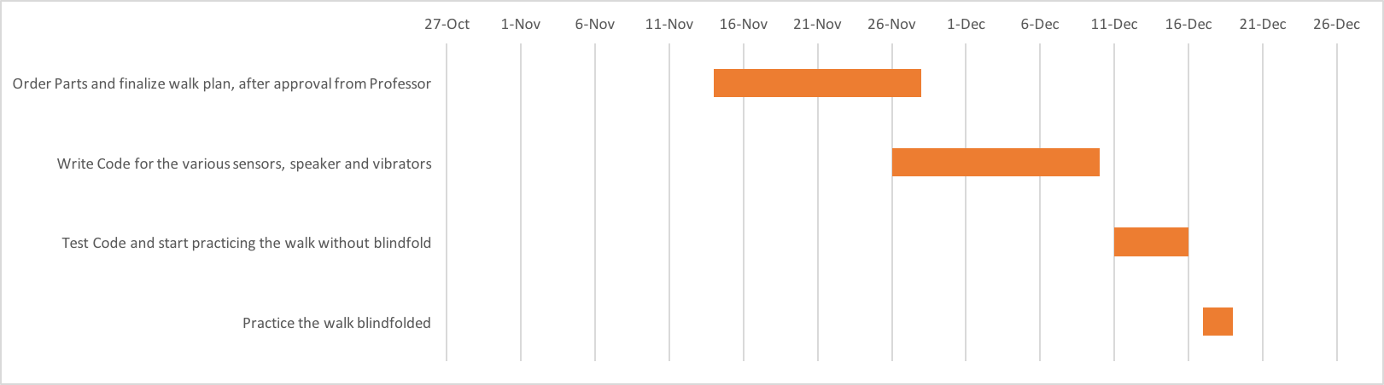

Task Assignment:

* Choosing Sensors and come up with ideas for the walk - group effort
* Each Member will get a job to do the coding for 1 sensor, and their interrupts and the vibrators. e.g. Eliahou does Ultrasonic code, Danny does I.R code, Adham does code for Acceremetor etc, and tests it
* We swap the code with our partners, study it and test it, each member studies his 2 teammates’ code
* Practice the walk as a group