Mortality from COVID

Danny Wong

19/03/2020

## Mortality Models from COVID-19

We would like to see what the mortality might be going forward. We can do a log transformation of the total deaths and regress against the Days since 10 deaths.

Table 1: Coefficients of linear regression models for log(DEATHS) against DAYS since 10 deaths.

|  |  |  |  |  |  |
| --- | --- | --- | --- | --- | --- |
| Country.Region | term | estimate | std.error | statistic | p.value |
| China | (Intercept) | 1.396 | 0.05204 | 26.84 | 3.702e-17 |
| China | Days | 0.08762 | 0.004242 | 20.66 | 5.819e-15 |
| France | (Intercept) | 1.164 | 0.03799 | 30.63 | 3.227e-11 |
| France | Days | 0.1142 | 0.005851 | 19.52 | 2.722e-09 |
| Germany | (Intercept) | 1.09 | 0.01126 | 96.73 | 0.0001069 |
| Germany | Days | 0.01043 | 0.006021 | 1.732 | 0.2254 |
| Italy | (Intercept) | 1.025 | 0.0296 | 34.62 | 2.522e-19 |
| Italy | Days | 0.1204 | 0.002413 | 49.92 | 1.811e-22 |
| Japan | (Intercept) | 1.143 | 0.02502 | 45.69 | 6.285e-10 |
| Japan | Days | 0.04568 | 0.005256 | 8.691 | 5.352e-05 |
| United Kingdom | (Intercept) | 0.9483 | 0.05511 | 17.21 | 1.214e-05 |
| United Kingdom | Days | 0.179 | 0.01528 | 11.71 | 7.971e-05 |
| United States | (Intercept) | 0.9947 | 0.018 | 55.26 | 8.223e-17 |
| United States | Days | 0.07853 | 0.002188 | 35.89 | 2.172e-14 |

Table 2: Fit statistics of linear regression models for log(DEATHS) against DAYS since 10 deaths.

|  |  |  |  |  |  |  |  |  |  |  |  |
| --- | --- | --- | --- | --- | --- | --- | --- | --- | --- | --- | --- |
| Country.Region | r.squared | adj.r.squared | sigma | statistic | p.value | df | logLik | AIC | BIC | deviance | df.residual |
| China | 0.9552 | 0.953 | 0.1262 | 426.7 | 5.819e-15 | 2 | 15.37 | -24.73 | -21.46 | 0.3186 | 20 |
| France | 0.9744 | 0.9719 | 0.06997 | 381 | 2.722e-09 | 2 | 15.98 | -25.97 | -24.51 | 0.04896 | 10 |
| Germany | 0.6 | 0.4 | 0.01346 | 3 | 0.2254 | 2 | 12.94 | -19.88 | -21.72 | 0.0003625 | 2 |
| Italy | 0.992 | 0.9916 | 0.0718 | 2492 | 1.811e-22 | 2 | 27.78 | -49.55 | -46.28 | 0.1031 | 20 |
| Japan | 0.9152 | 0.9031 | 0.04071 | 75.53 | 5.352e-05 | 2 | 17.17 | -28.34 | -27.75 | 0.0116 | 7 |
| United Kingdom | 0.9648 | 0.9578 | 0.08088 | 137.2 | 7.971e-05 | 2 | 8.849 | -11.7 | -11.86 | 0.0327 | 5 |
| United States | 0.99 | 0.9892 | 0.03662 | 1288 | 2.172e-14 | 2 | 29.4 | -52.79 | -50.67 | 0.01743 | 13 |

Table 3: Coefficients of linear regression models for log(DEATHS_PER_CAPITA) against Days since 10 deaths.

|  |  |  |  |  |  |
| --- | --- | --- | --- | --- | --- |
| Country.Region | term | estimate | std.error | statistic | p.value |
| China | (Intercept) | -2.747 | 0.05204 | -52.8 | 5.945e-23 |
| China | Days | 0.08762 | 0.004242 | 20.66 | 5.819e-15 |
| France | (Intercept) | -1.662 | 0.03799 | -43.75 | 9.351e-13 |
| France | Days | 0.1142 | 0.005851 | 19.52 | 2.722e-09 |
| Germany | (Intercept) | -1.829 | 0.01126 | -162.4 | 3.792e-05 |
| Germany | Days | 0.01043 | 0.006021 | 1.732 | 0.2254 |
| Italy | (Intercept) | -1.757 | 0.0296 | -59.34 | 5.832e-24 |
| Italy | Days | 0.1204 | 0.002413 | 49.92 | 1.811e-22 |
| Japan | (Intercept) | -1.959 | 0.02502 | -78.27 | 1.462e-11 |
| Japan | Days | 0.04568 | 0.005256 | 8.691 | 5.352e-05 |
| United Kingdom | (Intercept) | -1.874 | 0.05511 | -34.01 | 4.13e-07 |
| United Kingdom | Days | 0.179 | 0.01528 | 11.71 | 7.971e-05 |
| United States | (Intercept) | -2.52 | 0.018 | -140 | 4.745e-22 |
| United States | Days | 0.07853 | 0.002188 | 35.89 | 2.172e-14 |

Table 4: Fit statistics of linear regression models for log(DEATHS) against DAYS since 10 deaths.

|  |  |  |  |  |  |  |  |  |  |  |  |
| --- | --- | --- | --- | --- | --- | --- | --- | --- | --- | --- | --- |
| Country.Region | r.squared | adj.r.squared | sigma | statistic | p.value | df | logLik | AIC | BIC | deviance | df.residual |
| China | 0.9552 | 0.953 | 0.1262 | 426.7 | 5.819e-15 | 2 | 15.37 | -24.73 | -21.46 | 0.3186 | 20 |
| France | 0.9744 | 0.9719 | 0.06997 | 381 | 2.722e-09 | 2 | 15.98 | -25.97 | -24.51 | 0.04896 | 10 |
| Germany | 0.6 | 0.4 | 0.01346 | 3 | 0.2254 | 2 | 12.94 | -19.88 | -21.72 | 0.0003625 | 2 |
| Italy | 0.992 | 0.9916 | 0.0718 | 2492 | 1.811e-22 | 2 | 27.78 | -49.55 | -46.28 | 0.1031 | 20 |
| Japan | 0.9152 | 0.9031 | 0.04071 | 75.53 | 5.352e-05 | 2 | 17.17 | -28.34 | -27.75 | 0.0116 | 7 |
| United Kingdom | 0.9648 | 0.9578 | 0.08088 | 137.2 | 7.971e-05 | 2 | 8.849 | -11.7 | -11.86 | 0.0327 | 5 |
| United States | 0.99 | 0.9892 | 0.03662 | 1288 | 2.172e-14 | 2 | 29.4 | -52.79 | -50.67 | 0.01743 | 13 |

Table 5: Coefficients of linear regression models for log(CASES) against DAYS since 100 cases.

|  |  |  |  |  |  |
| --- | --- | --- | --- | --- | --- |
| Country.Region | term | estimate | std.error | statistic | p.value |
| China | (Intercept) | 2.95 | 0.06857 | 43.03 | 3.446e-21 |
| China | Days | 0.0945 | 0.005589 | 16.91 | 2.595e-13 |
| France | (Intercept) | 2.944 | 0.02155 | 136.6 | 1.082e-17 |
| France | Days | 0.0972 | 0.003318 | 29.29 | 5.015e-11 |
| Germany | (Intercept) | 3.694 | 0.01045 | 353.5 | 8.005e-06 |
| Germany | Days | 0.07628 | 0.005586 | 13.66 | 0.00532 |
| Italy | (Intercept) | 2.675 | 0.03486 | 76.74 | 3.483e-26 |
| Italy | Days | 0.09264 | 0.002842 | 32.6 | 8.235e-19 |
| Japan | (Intercept) | 2.779 | 0.01211 | 229.4 | 7.889e-15 |
| Japan | Days | 0.02239 | 0.002545 | 8.801 | 4.933e-05 |
| United Kingdom | (Intercept) | 2.786 | 0.02758 | 101 | 1.804e-09 |
| United Kingdom | Days | 0.1057 | 0.007649 | 13.82 | 3.561e-05 |
| United States | (Intercept) | 2.257 | 0.0125 | 180.5 | 1.741e-23 |
| United States | Days | 0.1208 | 0.00152 | 79.47 | 7.399e-19 |

Table 6: Fit statistics of linear regression models for log(CASES) against DAYS since 100 cases.

|  |  |  |  |  |  |  |  |  |  |  |  |
| --- | --- | --- | --- | --- | --- | --- | --- | --- | --- | --- | --- |
| Country.Region | r.squared | adj.r.squared | sigma | statistic | p.value | df | logLik | AIC | BIC | deviance | df.residual |
| China | 0.9346 | 0.9313 | 0.1663 | 285.9 | 2.595e-13 | 2 | 9.296 | -12.59 | -9.319 | 0.5533 | 20 |
| France | 0.9885 | 0.9873 | 0.03968 | 858.1 | 5.015e-11 | 2 | 22.79 | -39.58 | -38.12 | 0.01575 | 10 |
| Germany | 0.9894 | 0.9841 | 0.01249 | 186.5 | 0.00532 | 2 | 13.24 | -20.48 | -22.32 | 0.000312 | 2 |
| Italy | 0.9815 | 0.9806 | 0.08457 | 1063 | 8.235e-19 | 2 | 24.18 | -42.35 | -39.08 | 0.143 | 20 |
| Japan | 0.9171 | 0.9053 | 0.01971 | 77.46 | 4.933e-05 | 2 | 23.7 | -41.4 | -40.81 | 0.002719 | 7 |
| United Kingdom | 0.9745 | 0.9694 | 0.04048 | 191 | 3.561e-05 | 2 | 13.69 | -21.39 | -21.55 | 0.008191 | 5 |
| United States | 0.9979 | 0.9978 | 0.02543 | 6316 | 7.399e-19 | 2 | 34.87 | -63.73 | -61.61 | 0.008408 | 13 |

Table 7: Coefficients of linear regression models for log(CASES_PER_CAPITA) against DAYS since 100 cases.

|  |  |  |  |  |  |
| --- | --- | --- | --- | --- | --- |
| Country.Region | term | estimate | std.error | statistic | p.value |
| China | (Intercept) | -2.747 | 0.05204 | -52.8 | 5.945e-23 |
| China | Days | 0.08762 | 0.004242 | 20.66 | 5.819e-15 |
| France | (Intercept) | -1.662 | 0.03799 | -43.75 | 9.351e-13 |
| France | Days | 0.1142 | 0.005851 | 19.52 | 2.722e-09 |
| Germany | (Intercept) | -1.829 | 0.01126 | -162.4 | 3.792e-05 |
| Germany | Days | 0.01043 | 0.006021 | 1.732 | 0.2254 |
| Italy | (Intercept) | -1.757 | 0.0296 | -59.34 | 5.832e-24 |
| Italy | Days | 0.1204 | 0.002413 | 49.92 | 1.811e-22 |
| Japan | (Intercept) | -1.959 | 0.02502 | -78.27 | 1.462e-11 |
| Japan | Days | 0.04568 | 0.005256 | 8.691 | 5.352e-05 |
| United Kingdom | (Intercept) | -1.874 | 0.05511 | -34.01 | 4.13e-07 |
| United Kingdom | Days | 0.179 | 0.01528 | 11.71 | 7.971e-05 |
| United States | (Intercept) | -2.52 | 0.018 | -140 | 4.745e-22 |
| United States | Days | 0.07853 | 0.002188 | 35.89 | 2.172e-14 |

Table 8: Fit statistics of linear regression models for log(CASES) against DAYS since 100 cases.

|  |  |  |  |  |  |  |  |  |  |  |  |
| --- | --- | --- | --- | --- | --- | --- | --- | --- | --- | --- | --- |
| Country.Region | r.squared | adj.r.squared | sigma | statistic | p.value | df | logLik | AIC | BIC | deviance | df.residual |
| China | 0.9552 | 0.953 | 0.1262 | 426.7 | 5.819e-15 | 2 | 15.37 | -24.73 | -21.46 | 0.3186 | 20 |
| France | 0.9744 | 0.9719 | 0.06997 | 381 | 2.722e-09 | 2 | 15.98 | -25.97 | -24.51 | 0.04896 | 10 |
| Germany | 0.6 | 0.4 | 0.01346 | 3 | 0.2254 | 2 | 12.94 | -19.88 | -21.72 | 0.0003625 | 2 |
| Italy | 0.992 | 0.9916 | 0.0718 | 2492 | 1.811e-22 | 2 | 27.78 | -49.55 | -46.28 | 0.1031 | 20 |
| Japan | 0.9152 | 0.9031 | 0.04071 | 75.53 | 5.352e-05 | 2 | 17.17 | -28.34 | -27.75 | 0.0116 | 7 |
| United Kingdom | 0.9648 | 0.9578 | 0.08088 | 137.2 | 7.971e-05 | 2 | 8.849 | -11.7 | -11.86 | 0.0327 | 5 |
| United States | 0.99 | 0.9892 | 0.03662 | 1288 | 2.172e-14 | 2 | 29.4 | -52.79 | -50.67 | 0.01743 | 13 |

## Plots

Now we can plot the data and the models.

### Deaths

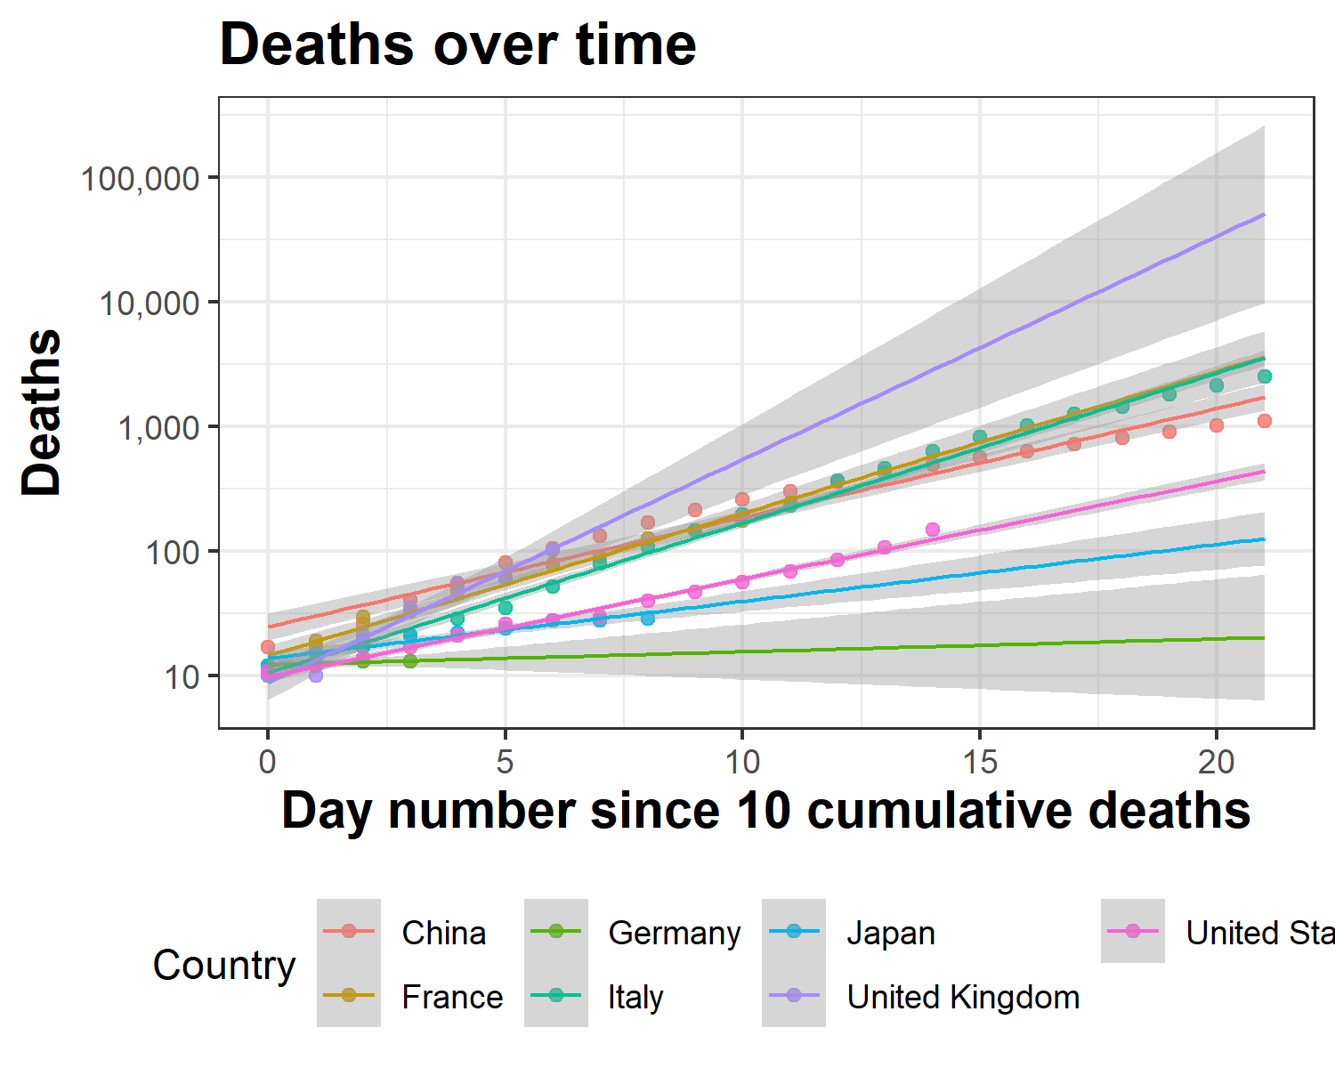

### Deaths Per Capita

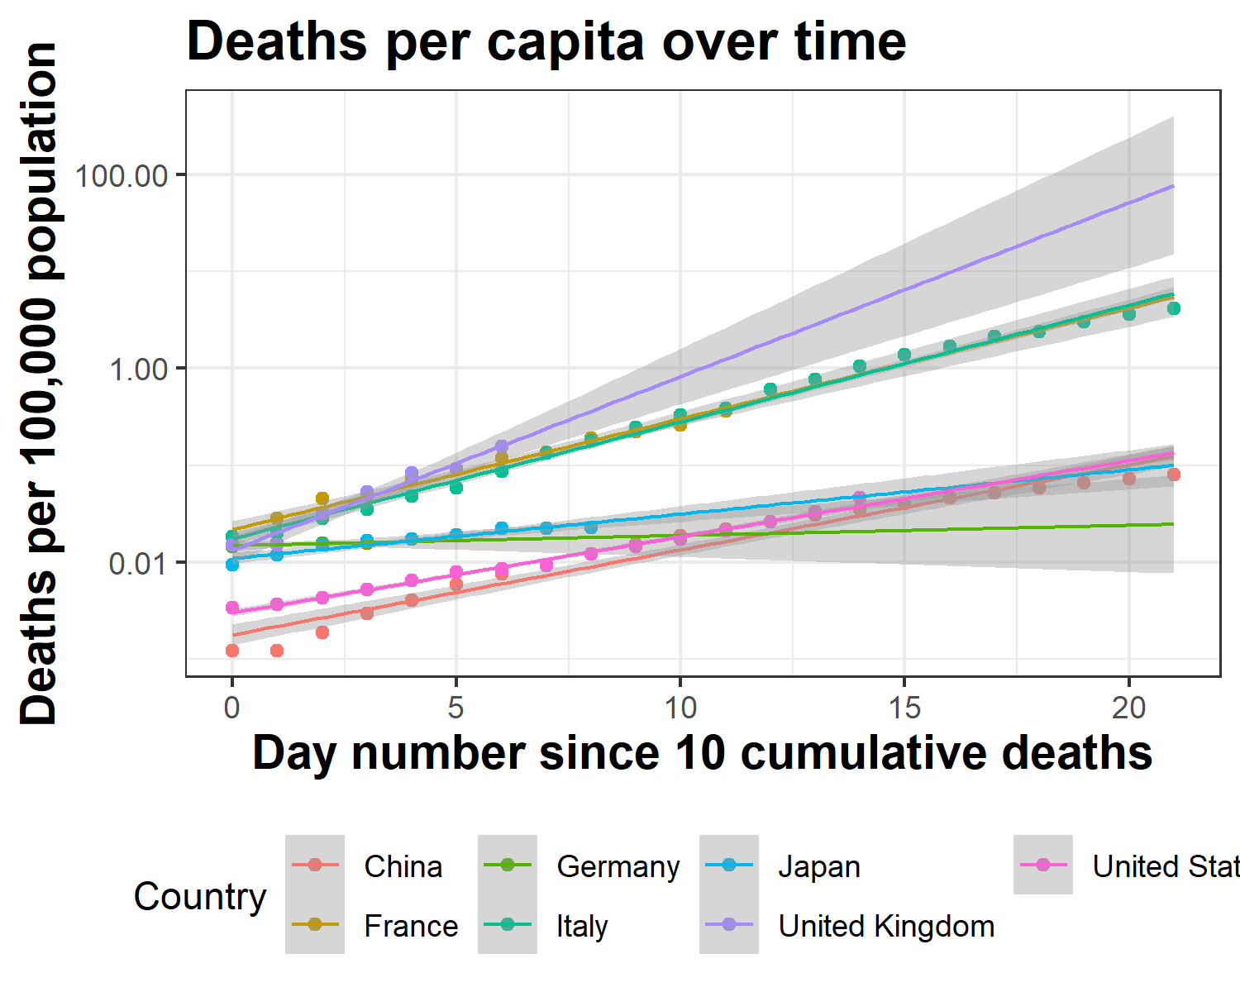

### Cases

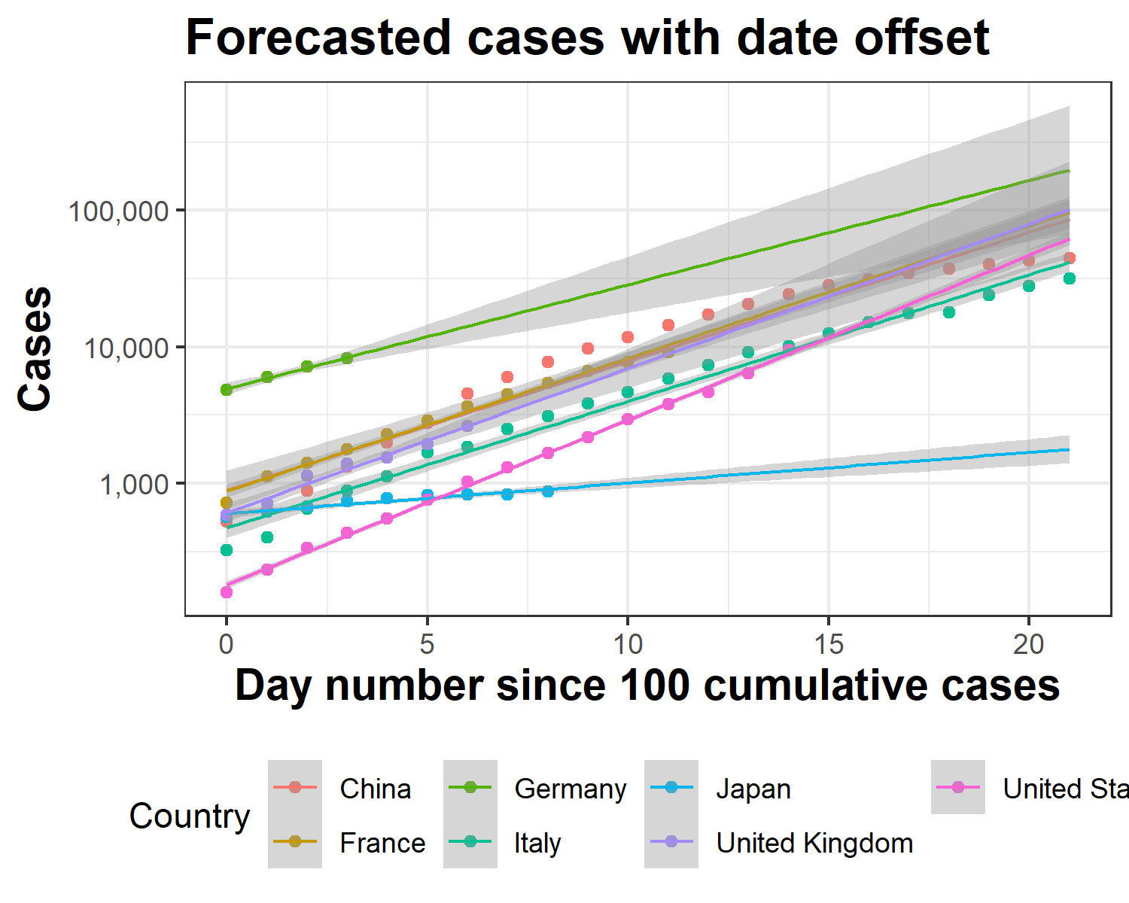

### Cases Per Capita

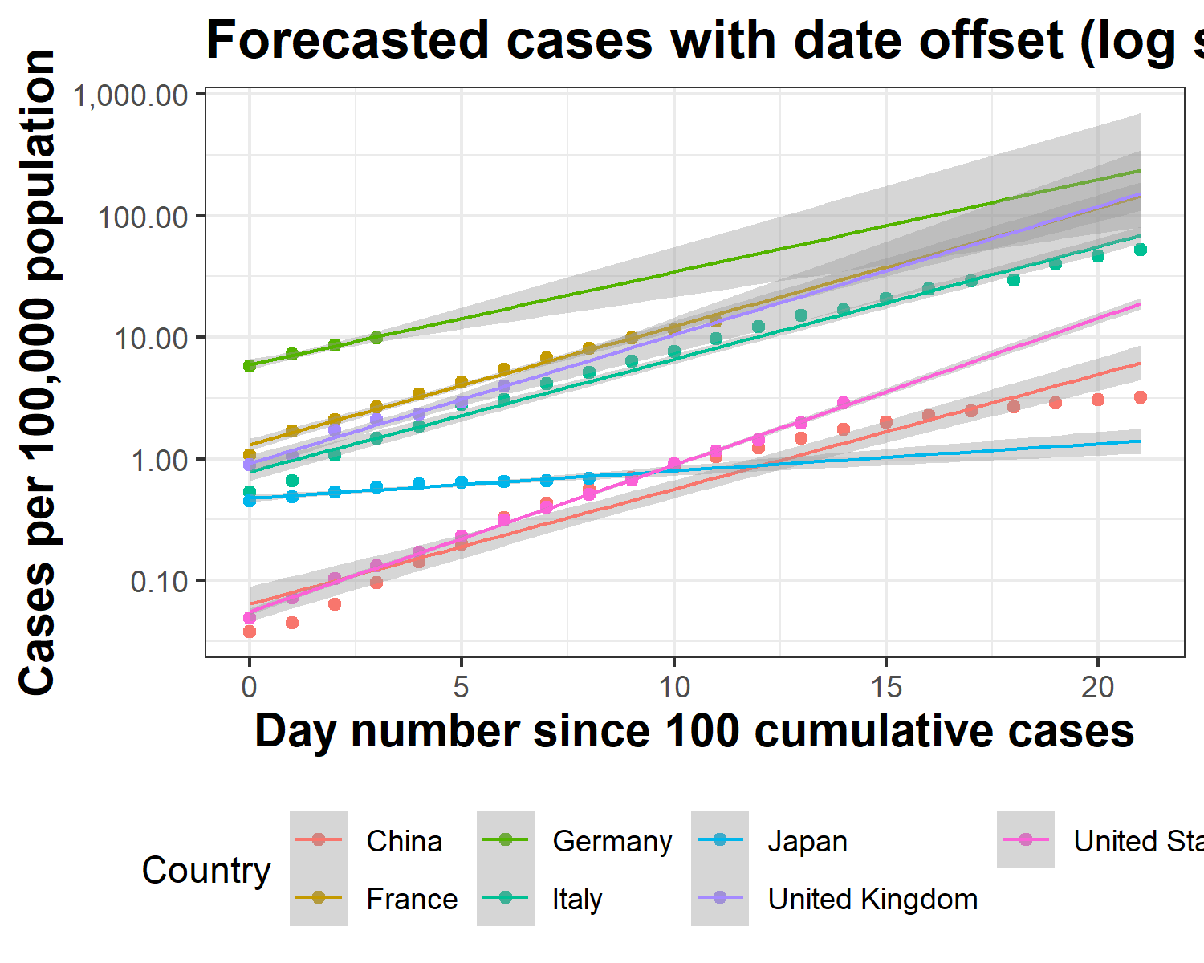

### Deaths per capita UK, Italy and China

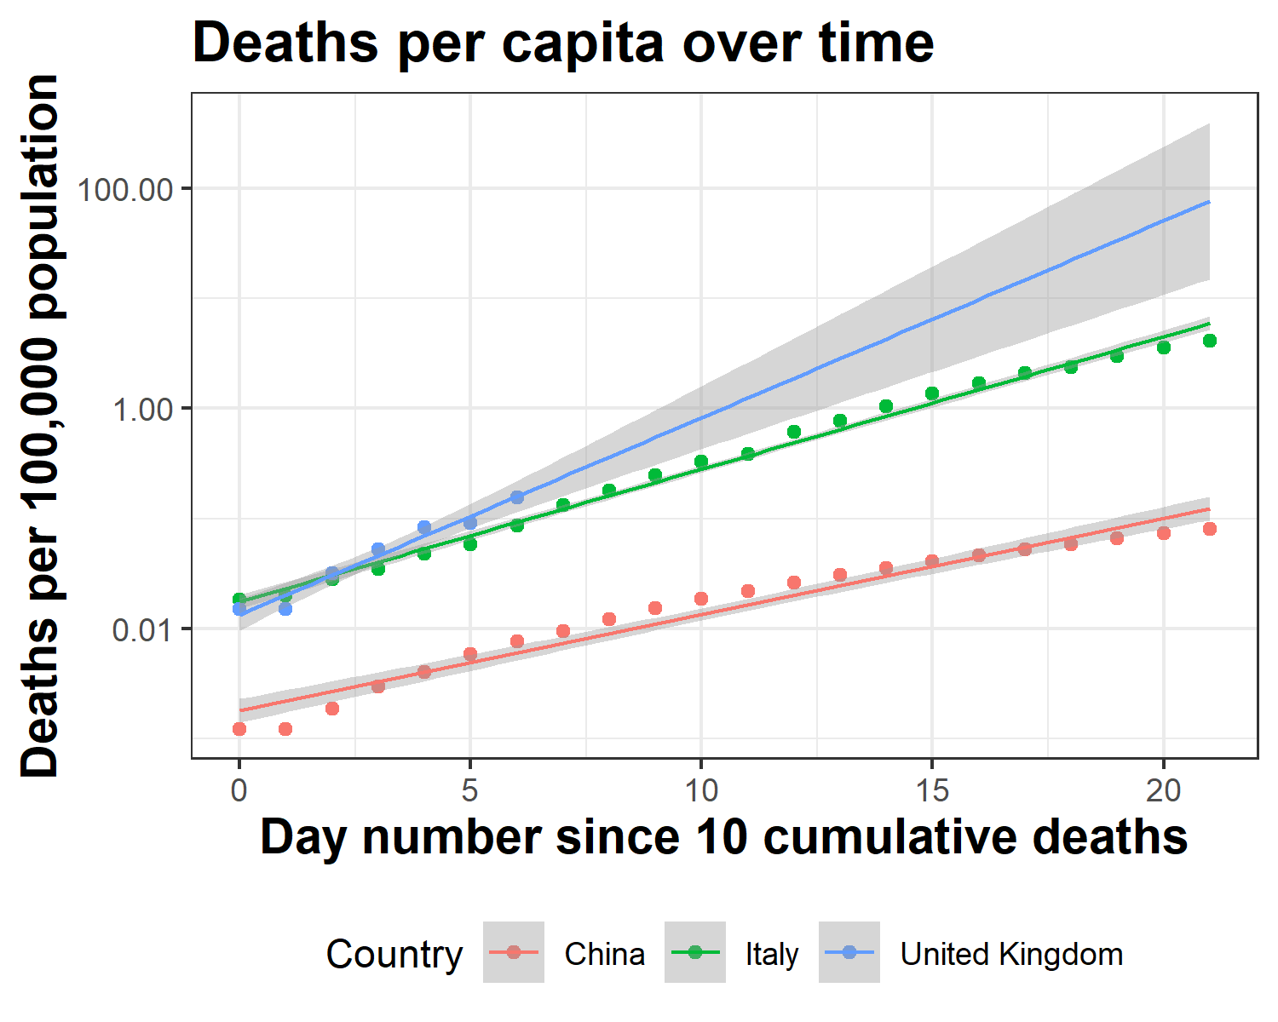

### Result Table

Results Table 1: Daily rate of increase of deaths and cases per capita for each country analysed. The United Kingdom shows a daily rate of increase in the number of deaths per 100,000 population of 51.0199071487831%, based on our model.

|  |  |  |  |  |
| --- | --- | --- | --- | --- |
| Country.Region | Daily increases in Deaths per 100,000 population (%) | Deaths (95% CI) | Daily increases in Cases per 100,000 population (%) | Cases (95% CI) |
| United Kingdom | 51.02 | 40.95-61.8 | 27.56 | 23.23-32.04 |
| Italy | 31.96 | 30.53-33.41 | 23.78 | 22.2-25.37 |
| France | 30.08 | 26.69-33.56 | 25.08 | 23.23-26.97 |
| China | 22.36 | 20.04-24.72 | 24.31 | 21.21-27.48 |
| United States | 19.82 | 18.64-21.01 | 32.06 | 31.16-32.97 |
| Japan | 11.09 | 8.49-13.76 | 5.292 | 4.09-6.51 |
| Germany | 2.43 | -0.32-5.25 | 19.2 | 16.23-22.24 |