Case Study 4: Linear 1D Transport Equation

Daniel Jauregui University of California, Davis Mechanical & Aerospace Department [danjau@ucdavis.edu](mailto:danjau@ucdavis.edu) November 18, 2015

*The solution to the 1D transport equation was solved numerically using four distinct schemes. Each scheme was solved with different space and time steps and compared to their respective analytical solution. It was found that the Upwind scheme is the scheme that least resembles the analytical solution, while the QUICK scheme is the method that best describes the actual solution. These results are due to the order of accuracy of the schemes. The Upwind scheme was treated as a 1st order scheme while the QUICK scheme was treated as a combination of 2nd and 3rd order methods.*

**Nomenclature**

u Convection velocity.

D Diffusion coefficient.

$ϕ$ Transported scalar (species mass fraction or temperature).

t Time.

x Space direction.

**Introduction**

As in Case Study 1, Case Study 4 consisted of solving the one dimensional transport equation. However, as we learn more intricate methods and techniques to solve differential equations numerically, we could now add the convection term to the equation, which makes the equation much more complex. The 1D transport equation with the convective term included is shown below.

$$\frac{∂ϕ}{∂t}+u\frac{∂ϕ}{∂x}=D\frac{∂^{2}ϕ}{∂x^{2}}$$

$$u=0.2\frac{m}{s} D=0.005\frac{m^{2}}{s}$$

Where u is the convection velocity, D the diffusion coefficient and $ϕ$ the transported scalar. The domain in which the equation is solved is the following.

$$0≤x≤L$$

$$0≤t≤τ$$

$$where L=1m, k=\frac{2π}{L}, τ=\frac{1}{k^{2}D}$$

The analytical solution to this 1D transport equation is

$$ϕ\left(x,t\right)=e^{-k^{2}Dt}\sin\left(k\left(x-ut\right)\right),$$

which has the following periodic boundary condition at t = 0.

$$ϕ\left(x,0\right)=\sin\left(kx\right).$$

The 1D equation was solved using four distinct numerical schemes. The first scheme was the trapezoidal method, also known as the Crank-Nicolson method. This scheme treated both the convective flux as well as the diffusion flux using central differencing. The second scheme was the Central Differencing method which used an ODE solver to time integration using central differences for both fluxes. The third scheme was Upwind which also utilized an ODE solver for time integration. This scheme treated the convective flux using the basic upwind method and central differencing for the diffusive flux. The final scheme was QUICK (Quadratic Upstream Interpolation for Convective Kinematics). This scheme also used an ODE solver and treated the convective flux using the QUICK method and the diffusive flux with central differencing.

Each scheme was solved five times using distinct $Δt$ ad $Δx$ values. The five different cases are listed below.

$$\left(C,s\right)∈\{\left(0.1, 0.25\right), \left(0.5, 0.25\right), \left(2, 0.25\right), \left(0.5, 0.5\right), \left(0.5, 1\right)\}$$

$$where C=\frac{uΔt}{Δx} and s=\frac{DΔt}{Δx^{2}}$$

**Solver Setup**

In this section each of the four methods will discussed. Their discretization as well as the solver method are covered in this section.

*Trapezoidal Method*

The trapezoidal scheme, also known as the Crank-Nicolson scheme was discretized using central differencing on both the convective and the diffusive terms of the 1D transport equation, however, taking into account the trapezoidal method. The main idea under this method is that the backward and forward methods are summed up and divided by two. Below is the discretization using this scheme.

$$\frac{ϕ_{i}^{n+1}-ϕ_{i}^{n}}{Δt}+\frac{u}{2} \left[\frac{ϕ_{i+1}^{n+1}-ϕ_{i-1}^{n+1}}{2Δt}+\frac{ϕ_{i+1}^{n}-ϕ_{i-1}^{n}}{2Δt}\right]=\frac{D}{2Δx^{2}}\left[\left(ϕ_{i+1}^{n+1}-2ϕ_{i}^{n+1}+ϕ_{i-1}^{n+1}\right)+\left(ϕ_{i+1}^{n}-2ϕ_{i}^{n}+ϕ_{i-1}^{n}\right)\right]$$

The equation above can be further simplified into an equation of two tridiagonal systems.

$$a1=-\frac{u}{4Δx}-\frac{D}{2Δx^{2}}$$

$$b2=\frac{1}{Δt}+\frac{D}{Δx^{2}}$$

$$c1=\frac{u}{4Δx}-\frac{D}{2Δx^{2}}$$

$$a2=\frac{D}{2Δx^{2}}+\frac{u}{4Δx}$$

$$b2=\frac{1}{Δt}-\frac{D}{Δx^{2}}$$

$$c2=\frac{D}{2Δx^{2}}-\frac{u}{4Δx}$$

$$\left[\begin{matrix}b1 & c1 & 0 & a1 & 0 \\ a1 & b1 & c1 & 0 & 0 \\ 0 & a1 & b1 & c1 & 0 \\ 0 & 0 & a1 & b1 & c1 \\ 0 & c1 & 0 & a1 & b1\end{matrix}\right]\left[\begin{aligned}\begin{matrix}ϕ_{0}^{n+1} \\ \\ ϕ_{i}^{n+1}\end{matrix} \\ \\ ϕ_{N-1}^{n+1}\end{aligned}\right]=\left[\begin{matrix}b2 & c2 & 0 & a2 & 0 \\ a2 & b2 & c2 & 0 & 0 \\ 0 & a2 & b2 & c2 & 0 \\ 0 & 0 & a2 & b2 & c2 \\ 0 & c2 & 0 & a2 & b2\end{matrix}\right]\left[\begin{aligned}\begin{matrix}ϕ_{0}^{n} \\ \\ ϕ_{i}^{n}\end{matrix} \\ \\ ϕ_{N-1}^{n}\end{aligned}\right]$$

$$\left[A\right]\left[ϕ_{new}\right]=\left[B\right][ϕ_{old}]$$

Since the problem has a periodic boundary condition at t = 0, the rows 0 and N-1 were modified accordingly to impose periodic boundary condition.

To solve the tridiagonal systems, since we know the initial condition or $ϕ_{old}$, it can be multiplied times vector B. Then A can be inverted and multiplied by the product of B and $ϕ_{old}$ to solve for $ϕ_{new}$. To solve for the solution for the new time step, $ϕ_{new}$ becomes $ϕ_{old}$.

*Central Differencing*

For the following schemes, an ODE solver was utilized to do the time integration. However the diffusion term was done using 2nd order central differencing for the central differencing, upwind and QUICK schemes.

In the central differencing scheme both the diffusive and convection terms were treated with central differences. Below is the discretization of the scheme.

$$\frac{∂ϕ_{i}^{n+1}}{∂t}+u\frac{ϕ_{i+1}^{n}-ϕ_{i-1}^{n}}{2Δx}=D\frac{ϕ_{i+1}^{n}-2ϕ_{i}^{n}+ϕ_{i-1}^{n}}{Δx^{2}}$$

This equation can be simplified to a single tridiagonal system.

$$a=\frac{D}{Δx^{2}}+\frac{u}{2Δx}$$

$$b=-\frac{2d}{Δx^{2}}$$

$$c=\frac{D}{Δx^{2}}-\frac{u}{2Δx}$$

$$\frac{∂ϕ_{i}^{n+1}}{∂t}=a ϕ_{i-1}^{n}+b ϕ_{i}^{n}+c ϕ_{i+1}^{n}$$

This ordinary differential equation can now be solved an ODE solver from Python. For this case and the other two (upwind and QUICK) the ODE solver, ‘vode’ with bdf (backward difference functions) was utilized to solve the system of ode’s. Below is the ODE setup. Note that the periodic boundary conditions was implemented the same method as the trapezoidal scheme.

$$\left[\begin{matrix}b & c & 0 & a & 0 \\ a & b & c & 0 & 0 \\ 0 & a & b & c & 0 \\ 0 & 0 & a & b & c \\ 0 & c & 0 & a & b\end{matrix}\right]\left[\begin{matrix}ϕ_{0}^{n} \\ \\ ϕ_{i}^{n} \\ \\ ϕ_{N}^{n}\end{matrix}\right]=\left[\begin{matrix}\frac{∂ϕ_{0}^{n+1}}{∂t} \\ \\ \frac{∂ϕ_{i}^{n+1}}{∂t} \\ \\ \frac{∂ϕ_{N}^{n+1}}{∂t}\end{matrix}\right]$$

$$\left[A\right]\left[ϕ_{i}^{n}\right]=[\frac{∂ϕ_{i}^{n+1}}{∂t}]$$

*Upwind*

The upwind scheme which is a finite volume scheme was discretized using the basic upwind method (1st order) on the convective term while using the central differencing on the diffusive term. Below is the set up and discretization of the scheme.

$$\frac{∂ϕ_{i}^{n+1}}{∂t}+u\frac{ϕ_{i}^{n}-ϕ_{i-1}^{n}}{Δx}=D\frac{ϕ_{i+1}^{n}-2ϕ_{i}^{n}+ϕ_{i-1}^{n}}{Δx^{2}}$$

$$a=\frac{D}{Δx^{2}}+\frac{u}{Δx}$$

$$b=-\frac{2d}{Δx^{2}}-\frac{u}{Δx}$$

$$c=\frac{D}{Δx^{2}}$$

$$\frac{∂ϕ_{i}^{n+1}}{∂t}=a ϕ_{i-1}^{n}+b ϕ_{i}^{n}+c ϕ_{i+1}^{n}$$

$$\left[\begin{matrix}b & c & 0 & a & 0 \\ a & b & c & 0 & 0 \\ 0 & a & b & c & 0 \\ 0 & 0 & a & b & c \\ 0 & c & 0 & a & b\end{matrix}\right]\left[\begin{matrix}ϕ_{0}^{n} \\ \\ ϕ_{i}^{n} \\ \\ ϕ_{N}^{n}\end{matrix}\right]=\left[\begin{matrix}\frac{∂ϕ_{0}^{n+1}}{∂t} \\ \\ \frac{∂ϕ_{i}^{n+1}}{∂t} \\ \\ \frac{∂ϕ_{N}^{n+1}}{∂t}\end{matrix}\right]$$

$$\left[A\right]\left[ϕ_{i}^{n}\right]=[\frac{∂ϕ_{i}^{n+1}}{∂t}]$$

*QUICK (Quadratic Upstream Interpolation for Convective Kinematics)*

Similarly as the Upwind scheme, the QUICK scheme is also a finite volume method. This scheme was discretized using the QUICK method, which is a 3rd order scheme. The QUICK method was implemented on the convective term of the 1D transport equation. The diffusive term was done using 2nd order central differencing just like the rest of the schemes. The discretization is shown below.

$$a1=\frac{3}{8} a2=\frac{1}{8} for a uniform mesh$$

$$ϕ_{e}=a1 ϕ_{i+1}^{n}-a2 ϕ_{i-1}^{n}+\left(1-a1+a2\right){ ϕ}_{i}^{n}$$

$$ϕ_{w}=a1 ϕ_{i}^{n}-a2 ϕ_{i-2}^{n}+\left(1-a1+a2\right)ϕ_{i-1}^{n}$$

The convective term can now be calculated the following way.

$$\frac{∂ϕ}{∂x}=\frac{ϕ_{e}-ϕ_{w}}{Δx}$$

After plugging back in the expression of $\frac{∂ϕ}{∂x}$ into the 1D equation and central differencing to the diffusive term, a tridiagonal system can be obtained and solved for similarly to how it was done in Upwind scheme. There is a major difference in this scheme compared to the rest. In this scheme instead of obtaining three diagonals, there are now four diagonals due to the i-2 term that shows up in the equation. Due to this extra term in the equation, the periodic boundary conditions in the A matrix needed to be modified. Note the matrix indexes (0,N-3), (0,N-2) are equal to ‘d’ for this specific case.

$$\frac{∂ϕ}{∂t}=d ϕ_{i-2}^{n}+a ϕ_{i-1}^{n}+b ϕ_{i}^{n}+c ϕ_{i+1}^{n}$$

$$d= -\frac{ua2}{Δx}$$

$$a=-\frac{u}{Δx} \left(-1+a1-2a2+\frac{D}{Δx}\right)$$

$$b=-\frac{2D}{Δx^{2}}-u\frac{1-2a1+a2}{Δx}$$

$$c=\frac{D}{Δx^{2}}-\frac{ua1}{Δx}$$

$$\left[\begin{matrix}b & c & 0 & d & a & 0 \\ a & b & c & 0 & d & 0 \\ d & a & b & c & 0 & 0 \\ 0 & d & a & b & c & 0 \\ 0 & 0 & d & a & b & c \\ 0 & c & 0 & d & a & b\end{matrix}\right]\left[\begin{matrix}ϕ_{0}^{n} \\ \\ ϕ_{i}^{n} \\ \\ ϕ_{N}^{n}\end{matrix}\right]=\left[\begin{matrix}\frac{∂ϕ_{0}^{n+1}}{∂t} \\ \\ \frac{∂ϕ_{i}^{n+1}}{∂t} \\ \\ \frac{∂ϕ_{N}^{n+1}}{∂t}\end{matrix}\right]$$

$$\left[A\right]\left[ϕ_{i}^{n}\right]=[\frac{∂ϕ_{i}^{n+1}}{∂t}]$$

**Results**

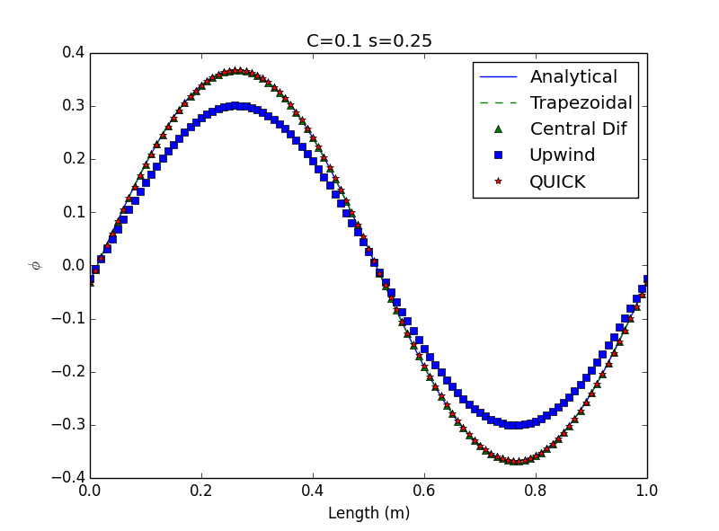

Figure 1. 1D Transport Equation solution at $t=τ$ with C=0.1 and s=0.25. The plot shows the analytical solution as well as the solution of each of the methods studied.

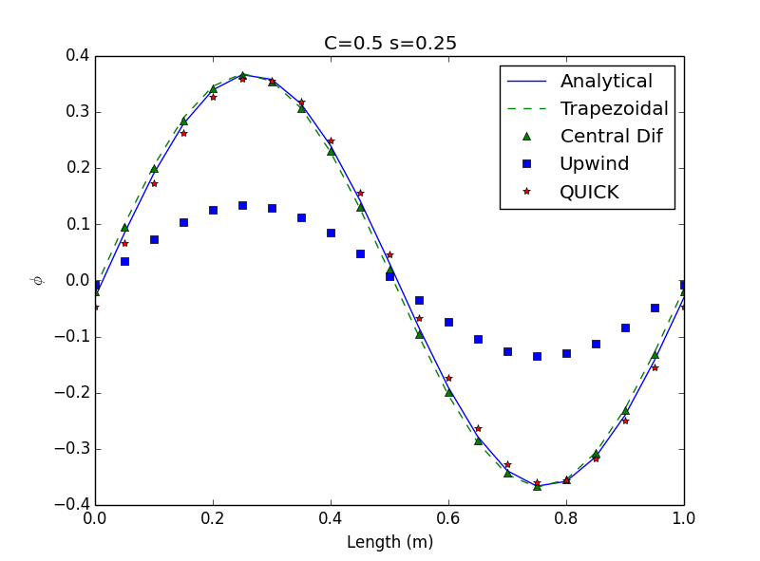

Figure 2. 1D Transport Equation solution at $t=τ$ with C=0.5 and s=0.25. The plot shows the analytical solution as well as the solution of each of the methods studied.

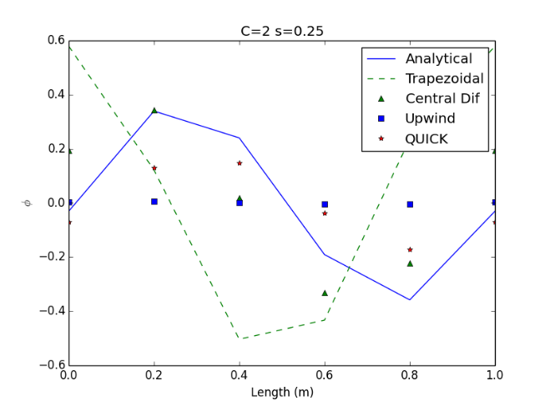

Figure 3. 1D Transport Equation solution at $t=τ$ with C=2.0 and s=0.25. The plot shows the analytical solution as well as the solution of each of the methods studied.

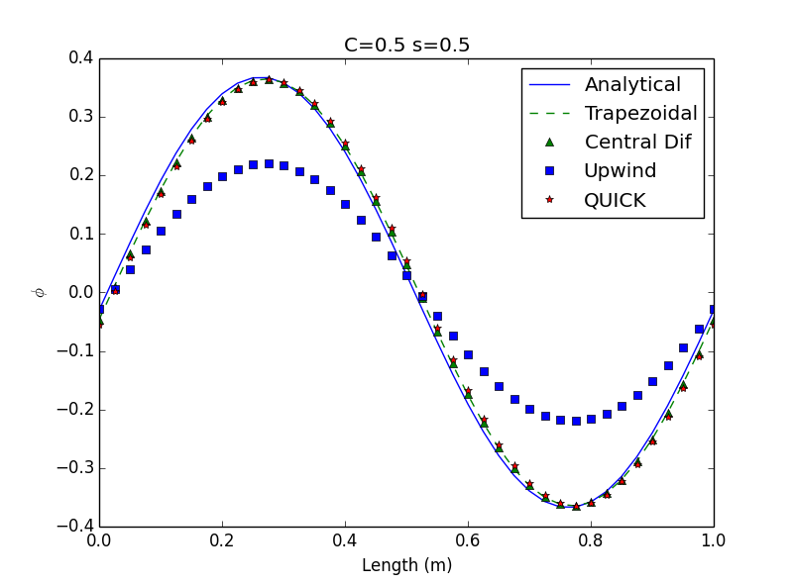

Figure 4. 1D Transport Equation solution at $t=τ$ with C=0.5 and s=0.55. The plot shows the analytical solution as well as the solution of each of the methods studied.

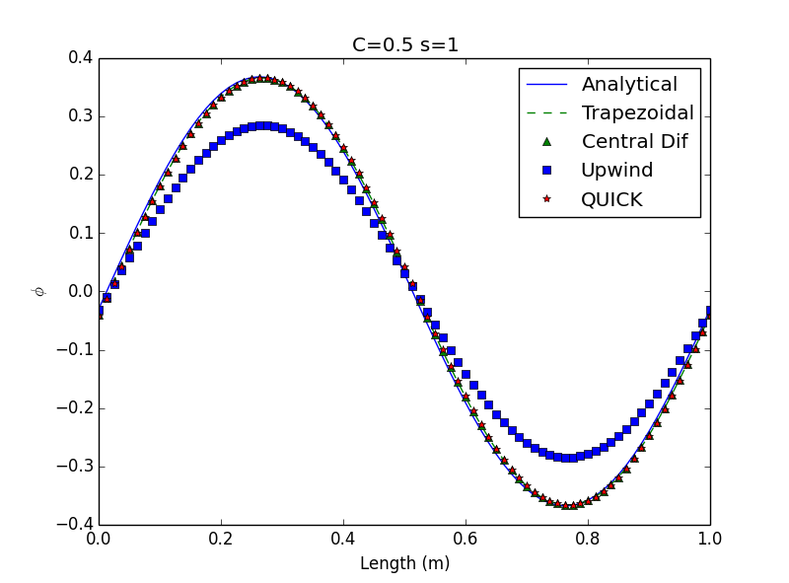

Figure 5. 1D Transport Equation solution at $t=τ$ with C=0.5 and s=1. The plot shows the analytical solution as well as the solution of each of the methods studied.

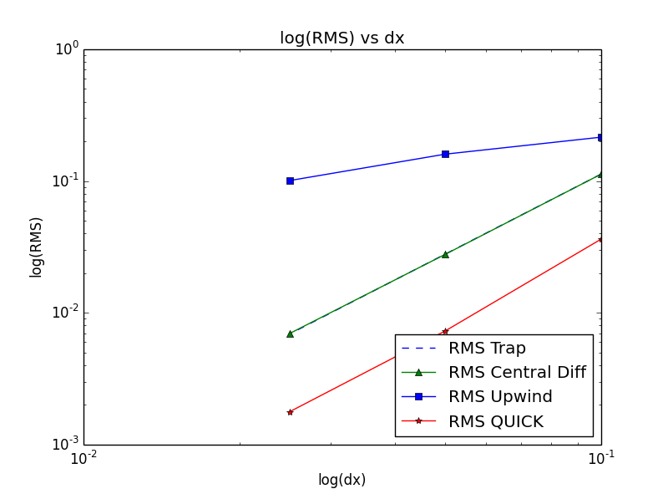

Figure 5. Logarithmic RMS error with decreasing logarithmic $Δx$ at a fixed $Δt$ ($Δt=0.00005, Δx=0.1, 0.05, 0.025).$

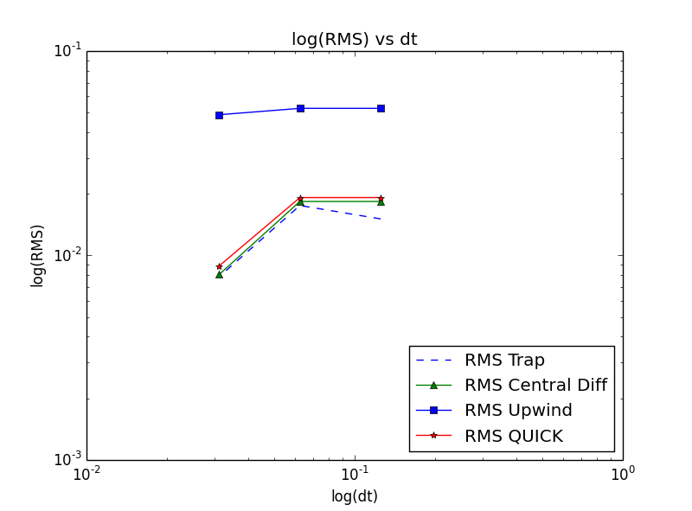

Figure 7. Logarithmic RMS error with decreasing logarithmic $Δt$ at a fixed $Δx$ ($Δx=0.01, Δt=0.125, 0.0625, 0.03125).$

|  |  |  |  |  |  |
| --- | --- | --- | --- | --- | --- |
|  | C1 | C2 | C3 | C4 | C5 |
| Trap. | 0.00022448 | 0.01146727 | 0.54069505 | 0.01185782 | 0.00726289 |
| Central | 0.00021472 | 0.0082841 | 0.17670847 | 0.01272206 | 0.00744639 |
| Upwind | 0.04703197 | 0.16123311 | 0.23502038 | 0.10369407 | 0.05876568 |
| QUICK | 0.001016 | 0.01287051 | 0.13720902 | 0.01770573 | 0.00872629 |

Table 1. RMS error values for each scheme at each of the five cases. The cases are shown at the end of the Introduction section.

|  |  |  |
| --- | --- | --- |
| Scheme | Variable dt | Variable dx |
| Trapezoidal | 0.468 | 2.016 |
| Central Diff. | 0.593 | 2.019 |
| Upwind | 0.051 | 0.547 |
| QUICK | 0.554 | 2.176 |

Table 2. Tabulated slopes for each of the four schemes for both variable dx at a fixed dt and variable dt at a fixed dx $(Δt=0.00005, Δx=0.1, 0.05, 0.025$ and $Δx=0.01, Δt=0.125, 0.0625, 0.03125)$.

**Discussion**

The main objective of this case study was to explore different schemes to solve a partial differential equation, in this case, the 1D transport equation. In the first analysis, each scheme was solved using five different space and time steps. In the Introduction, the five cases are listed. Using their relationship between C, dx, s and dt, the values of dx and dt can be obtained and those are listed below.

$$\left(Δx,Δt\right)∈\left\{\begin{aligned}\left(0.01, 0.005\right),\left(0.05, 0.125\right),\left(0.2, 2\right),\left(0.025, 0.0625\right) \\ ,\left(0.0125, 0.03125\right)\end{aligned}\right\}$$

Once each scheme was solved for each case, the results were compared to the corresponding analytical solutions. Figures 1 through 5, show plots of each case for the four different schemes.

The first scheme was the Trapezoidal method. This method is a combination of backward and forward differencing. It was solved using central differencing on both diffusive and convective terms. This resulted in a double tridiagonal system. The case study did not require an ODE solver for this specific scheme. Hence, it was solved implicitly marching in time. The rest of the four schemes, Central Differencing, Upwind and QUICK were all solved using an ODE solver. The utilized solver was a stiff solver, ‘vode’ based on backward differentiation formulas (BDF).

To qualitatively analyze the results from every solver, it is necessary to look at three various categories: accuracy, stability and effective order. Accuracy refers to the how close the solution of the scheme is to the analytical solution. By inspecting Figures 1 through 5, it can be observed which schemes are the closest to the analytical solution for each case. Figure 1 shows the results for Case 1. Case 1 is the case that has the smallest time step while having a relatively small $Δx$. The plots shows that all of the schemes match the analytical solutions closely, except for the Upwind scheme. Table 1 shows the RMS error values for each case for every scheme. For Case 1, the Upwind RMS value is one order of magnitude greater than the rest of the schemes, which is what the plot shows. Case 2 consists of greater $Δx$ and $Δt$ values. Figure 2 shows that due to the increase in $Δx$ and $Δt$, now the solutions get further away from the analytical solution, hence increasing the RMS error values. It should be noted that the Upwind solution is now two orders of magnitude above all the other RMS values. The Upwind maximum amplitude was halved from Case 1 due to the change in input. Case 3 is the case that holds the highest $Δx$ and $Δt$ values. Hence the quality of the solutions is not high. Table 1 shows the magnitude of the RMS error values. Due to the relatively high $Δx$ and $Δt$ values, the schemes do not produce qualitatively solutions. In addition to the poor solutions, the boundary conditions do not match, hence it seems as if they solutions represented other phenomena. Case 4 and 5 has $Δx$ values close the value of Case 1, but with a slightly greater time step. Despite the difference in time steps, the solutions of Case 4 and 5 resemble the solutions of Case 2 and 1 respectively.

The next analysis category is the effective order analysis. To carry this analysis through, it was necessary to run the first analysis, however, at a fixed $Δx$ or $Δt$. To further explain this analysis, a $Δx$ was chosen and kept fixed while $Δt$ varied. This also done fixing a $Δt$ and varying $Δx$. When $Δt$ was fixed at a value of 0.00005 through $Δx$ values of 0.1, 0.05 and 0.025, the slope of the schemes in a logarithm scale were approximately 2.016, 2.009, 0.547 and 2.175 for the Trapezoidal, Central Differencing, Upwind and QUICK schemes respectively. To obtain these effective order slopes, it was necessary to obtain the RMS error value. These values were plotted versus $Δx$, both on a logarithmic scale. A line a best fit was drawn through the results and it slope gives the value of the effective order. Table 2 shows the list of the effective order for each scheme. As expected these values do depict the actual order of each scheme, except for the Upwind scheme. All trapezoidal, central differencing and QUCK schemes are 2nd order. The Trapezoidal method by nature is 2nd order. The Central Differencing method was treated with a 1st order and 2nd order differences on the convective and diffusive terms respectively. This makes the whole scheme second order. The Upwind scheme treated the convective term as 1st order while keeping the diffusive term 2nd order, which turns the whole scheme into a 1st order scheme. The last scheme, QUICK, treated the convective term as 3rd order, also keeping the diffusive term as 2nd order, making the whole scheme 2nd order. Having a notion of the effective order for each scheme before actually calculating the value was essential to know whether the results were accurate. By inspecting Table 2, it ca be observed that all the schemes match their respective effective order. However, the Upwind scheme is the one was shows the greatest discrepancy among solutions. Going back to Figures 1 through 5, it was seen that the Upwind scheme had higher RMS values, or lower accuracy. It also worth mentioning that, as the value of the fixed $Δt$ is decreased, the effective orders converged closer to their respective or expected values. The second part of the effective order analysis was to fix a $Δx$ value while varying $Δt$. In this case, the fixed $Δx$ value was 0.01 and the varying $Δt$ were 0.125, 0.0625 and 0.03125. Table 2 shows the effective order results for this case. All of the effective order values are below one which do not coincide with what was expected. This discrepancy is due to the adaptive time step that occurs in the ODE solvers. In order to obtain descent effective order values, it would be necessary to determine a region where the $Δt$ is constant as the ODE adaptively modifies the time step.

The very final analysis category is stability. A stiff ODE solver (vode, bdf) was selected for these analyses. This specific solver is a stiff solver. It is known non-stiff solvers can solve stiff problems, however, they take much longer than what a stiff solver would. On the other hand, using a stiff solver to solve a non-stiff problem would not guarantee stability. Hence, in this specific case study a stiffness ratio or a condition number were not computed to find out whether the problem was stiff or not. However, based on the results and knowing that the difference between the solution of the partial differential equation and the finite difference equation does not grow, it can be said that the problem is somewhat stiff and therefore, using a stiff solver to solve this problem would guarantee stability.

**References**

[1] J. C. Tannehill, D. A. Anderson, and R. C. Letcher. Computational Fluid Mechanics and Heat Transfer. Computational and Physical Processes in Mechanics and Thermal Sciences. Taylor & Francis, 2nd edition, 1997.

**Appendix**

The code that was utilized in this case study is not included in this report. However, a separate zip file goes along with it with all the code scripts.