c)

We found that the optimal regularization parameter to be 8.5432 with a validation RMSE of 0.8340 and test RMSE of 0.862.

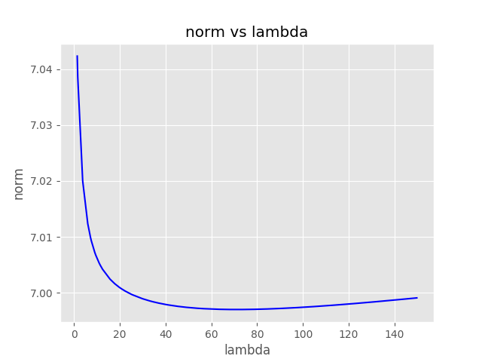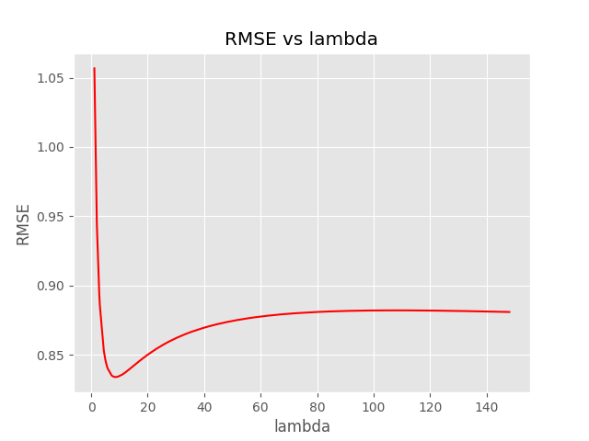

d)

Using the closed form solution with an explicit bias term gave us very similar results to solving it with the bias term already included. We note that the differences were

==> Difference in bias is 2.5360E-10

==> Difference in weights is 3.7975E-10

e)

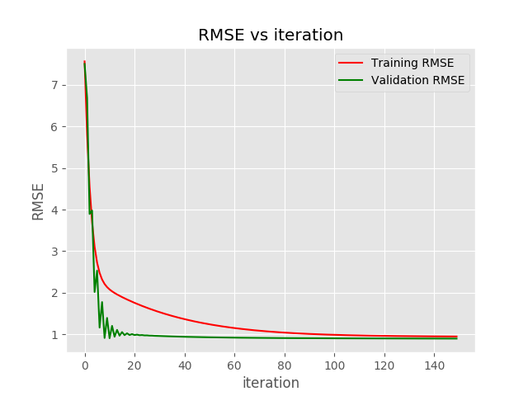

Solving the weights and bias using gradient descent also gave very similar to the closed form solutions as founds in parts c and d. Notably, the differences were

==> Difference in bias is 1.5387E-01

==> Difference in weights is 8.0099E-01