The plot of the Singular Value dropoff for the Clown Image is as bellows

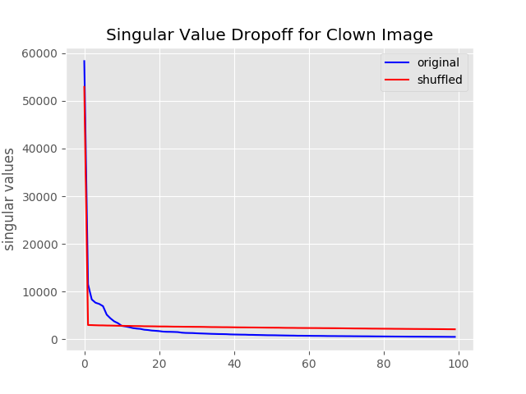

And the rank approximations below

