The convergence plot and regularization path are as below.

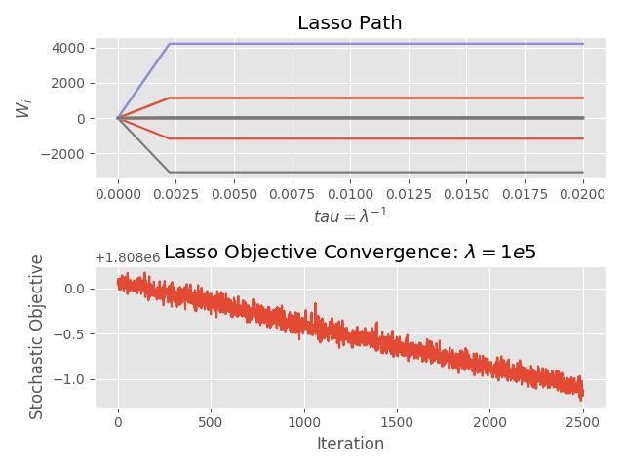

The most important features are

['timedelta' 'weekday_is_wednesday' 'weekday_is_thursday'

'weekday_is_friday' 'weekday_is_saturday']

From <https://archive.ics.uci.edu/ml/datasets/online+news+popularity> we can tell what the features actually represent. The features “weekday_is_XXX” tell us whether the news article was published on day XXX. Hence we can interpret this as shares of newspaper articles are dependent on which day it is published.