Data Set

Daniel Maclean

The question I asked was whether taller players have better finishing traits in FIFA. A player’s finishing rate is determined by their ability to finish goal scoring opportunities in real matches. Historically, taller players have been preferred as forwards for their ability to score when the ball is in the air above everyone else’s head. However, in the past couple decades some teams like Barcelona have adopted a style of play that emphasizes possession and skills while the ball is on the ground. Thus, more and more of the elite forwards of the world are relatively short. I hypothesize that there will be a negative correlation, as height increases, the finishing attribute will decrease.

To answer this research question, I collected a database of FIFA stats. FIFA ratings are computed by soccer analysts around the world and are typically considered representative of real player’s attributes. The finishing attribute is a score given to each player between 0-100 with 0 being no finishing abilities and 100 being perfect finishing abilities. See Table 1 for data taken from the FIFA database found on Kaggle, a website for data science applications. There are thousands of players in the FIFA database so for interpretability, I averaged all the players finishing abilities in 10cm intervals from the shortest players to the tallest.

**Table 1. Height and Average Finishing Attributes [1]**

|  |  |
| --- | --- |
| **Height (cm)** | **Finishing Attribute** |
| 155-165 | 59.01 |
| 165-175 | 62.46 |
| 175-185 | 55.78 |
| 185-195 | 53.78 |
| 195-205 | 52.39 |
| 205-215 | 58.21 |

For visualization, Figure 1 is a scatter plot of 50 random players taken from the database. As Figure 1 indicates, there was no significant correlation between the height of players and their ability to score. This result can be verified by repeatedly taking 50 sub samples and viewing the results. The best explanation for this result is that there are many other attributes that create a great scoring player and that the problem cannot be simplified to just height. I also conducted my experiment using all players in the entire game while it is possible a correlation can be found in certain subsets of the data. Soccer varies a lot from country to country and thus height could potentially be more important in one region as to another. Spain is known for very high possession, quick play where the ball is on the ground a lot where as England is known for getting the ball to the wing players on the sides and sending in crosses to tall forwards. Thus, shorter players could potentially be much more lethal in Spain and less so in England. In soccer any position can score so I did not omit any positions out from my data. The data collected in Figure 1 consists of forwards, midfielders, defenders and goalkeepers. The purpose of this was to account for tall defenders that frequently score headers on crosses. Thus, a correlation could be inferred in the subset of players that typically play forward.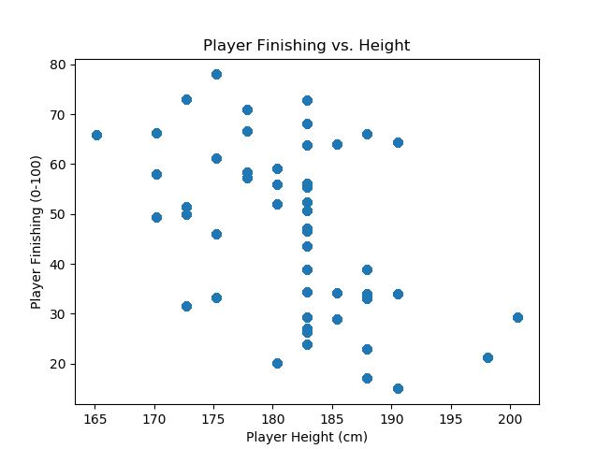

**Figure 1. Height and Average Finishing Attribute [1]**

**REFERENCES**

[1] K. Gadiya. (2018, December). *FIFA 19 Complete Player Dataset* [Online]. Available: https://www.kaggle.com/karangadiya/fifa19