Daniel Levine

Dr Dionisio

Screens Screens Everywhere(of Every Size)

Abstract: This paper is a comprehensive study of both the Oculus Rift and Microsofts RoomAlive project and their “immersiveness”. The paper explores a brief history of virtual reality and the potential for both devices. It also goes over the mental models and usability issues in of both the devices. The study determines that Oculus seems to be the future in regard to immersive technology.

Section 1 Intro:

Screens have seen major advancements in recent years with the technology of HD TVs to LED to 3D to most recently Ultra High Definition (or 4k). Through these changes it seems that the mental model of the creators has been to deliver a more immersive experience this can be demonstrated by the creation of the new curved TV by Samsung or the recent rise in the use of projectors in homes to make screens so big that it feels like you're in the room with what is going on in the screen. The goal of complete immersion seems to be leading eventually toward holograms(3D imagery not requiring a screen) and virtual reality(“a computer-generated simulation of a three-dimensional image or environment that can be interacted with in a seemingly real or physical way by a person using special electronic equipment, such as a helmet with a screen inside or gloves fitted with sensors.”) so that a TV isn’t even necessary anymore. Steps toward complete immersion are already being taken with the Oculus Rift and Sonys Morpheus Project both are virtual reality headsets that allow the user to feel as if they are in the game by cutting out all distractions like noise and peripheral vision. On the other side of the immersion spectrum is Microsoft’s response to virtual reality is their prototype called RoomAlive, they use kinect devices attached to projectors in order to turn the whole room into an interactive environment giving the user a different sense of immersion. These two examples show two very different ways that the researchers are trying reach the nearly graspable task of complete immersion. On one side of the spectrum with the Oculus Rift they are trying to achieve total immersion by cutting you off from the outside world hence limiting possible distractions from what is going on in the screen. Where as on the other side Microsofts RoomAlive project instead of taking you from the outside world it brings program to you making your entire room a holodeck of sorts.These examples highlight the differences in the mental models between these two up and coming technologies. This battle between virtual reality and holograms seems to be the future for screens however both are not without faults especially from a usability standpoint.

Section 2 Background/Prior Work/Literature Review:

Virtual Reality isn’t as new an idea as most people believe, the idea of a virtual reality headset can originate itself to the 1930s book "Pygmalion's Spectacles" by Stanley G. Weinbaum(Bib1). In the 1990s sega came out with virtual reality headsets however, Virtual Reality technology at the time suffered from a myriad of usability issues at the forefront of which was motion sickness as “the onscreen graphics didn’t keep pace with the gamer’s head movements”(Bib2).The Oculus Rift has be able to eventually overcome these issues that had previously being the demise of its predecessors by “reducing the lag between head movement and the headset response to just 2 milliseconds”(Bib2). Although there will most likely always be a small subset of people where the issue of motion sickness remain, this innovation has made virtual reality on a more widespread scale possible.

The creator of the Oculus Rift(Palmer Lucky) made it as a way to “bring games to the next level” by as he called it “plugging into the matrix” he achieved this by using “immersive stereoscopic 3d rendering, a massive field of view and ultra low latency head tracking”(Bib 3). When using most stereoscopic headsets you see “ a really small image way off into the distance” whereas with the Oculus Rift you get a view of 110 degrees making it seem as if you are in the environment(Bib3). This was Palmer Lucky’s way of sharing his vision of a new completely immersive technology with possible developers and consumers . In a recent study a youth research and digital entertainment firm gave 12 children(ages 7 to 12) the Oculus Rift to use. The study had extremely positive results. They found that “while the children had some trouble getting the headset on, the kids did not have any ill effects from wearing it for too long, but noted that the head movements could be a strain on younger players”(Bib4), however, the study goes on to note that with lighter headsets on the way they don’t see many usability issues with the Oculus Rift especially in children. Another study conducted in 2013 by Adam Halley-Prinable ,a graduate student at Bournemouth University, studied the immersiveness of an Oculus Rift device as opposed to a standard computer monitor. In order to do this he created “an original horror game created by the author” and measured “the immersiveness through fear that the Oculus Rift caused” and compared “it to the immersiveness that the screen caused”(Bib 7). The study measured fear by using a heart rate test and found that increased immersion leads to increased fear as highlighted by the graph below, “ This means that in a controlled environment, a measurement of fear is a measurement of immersion”(Bib 7).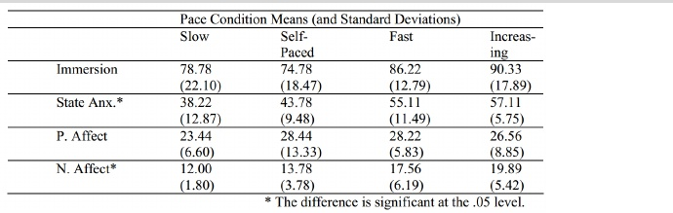

Each test subject was booked into a 30 minute timeslot, “altogether 56 of the total 60+ people who participated in this experiment were able to contribute their data”(Bib 7). Of the subjects that were unable to finish the game because “overwhelming psychological anguish and terror, while others still were unable to complete theOculus Rift section because of induced headaches, nausea, and dizziness”(Bib 7). The study found that of the “56 people who completed the questionnaire fully, 2 people found the screen more immersive, 3 people found both options equally immersive, and the remaining 51 people found the Oculus Rift to be the most immersive.” (Bib 7)

Creators of RoomAlive call the technology “projection mapping”, it is meant to turn a room into “an immersive, augmented entertainment experience through the use of video projectors”(Bib 6).The RoomAlive project was built mainly off of one of Microsoft's previous projects, “IllumiRoom, which explored interactive projection mapping surrounding a television screen”(Bib 6). The place where RoomAlive differs from IllumiRoom is that IllumiRoom “ was largely focused on *display*, extending traditional gaming experiences out of the TV”(Bib 6) and RoomAlive focuses more on “*interaction*, and the new kinds of games that we can create with interactive projection mapping”(Bib6). In order to do all this they use what they call a “procam” which is essentially a projector connected to a kinect sensor, the kinect is used for tracking while the projector is for display. For the IllumiRoom project they used one procam and for the RoomAlive project they will use 6 procams.

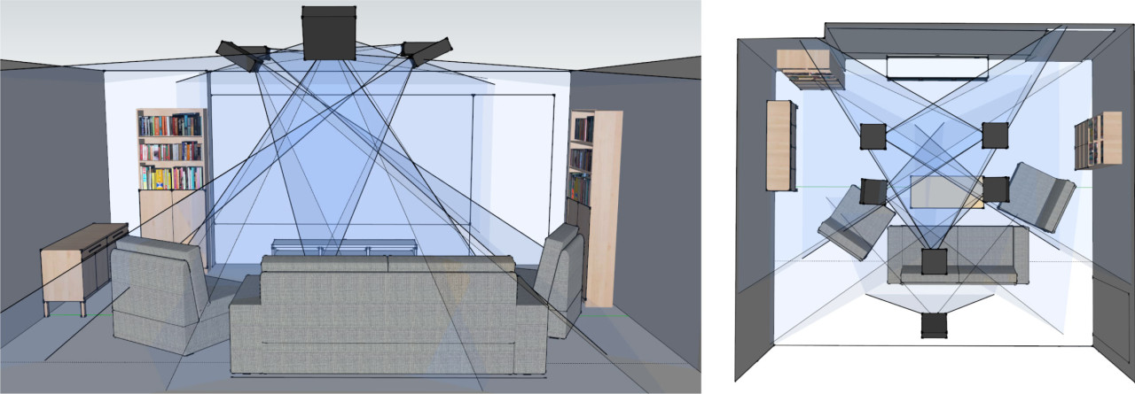

Section 3 Methods:

Technological information for both Oculus and RoomAlive were collected from numerous studies,articles and forums. For this study I tried to obtain the data from a recently conducted survey(Bib 8) by a student at the University of Glasgow, however, he was unable to release the results until the paper is published. The information that I found that seems to hold the most relevance is the study of that pits the Oculus Rift against the standard monitor as a way to determine which is ultimately more immersive. This study seems to hold weight due to its large sample size and extremely positive results based on the data collected.

Section 4 Discussion:

The technology of Virtual Reality has grown leaps and bounds leading to the creation multiple new devices the most prevalent one recently has been the Oculus Rift. Public support for virtual reality technology was made evident during the original kickstarter campaign for the Oculus Rift, initially requesting funding of 250,000 dollars the project received close to 10 times that amount before it was bought by Facebook for 2 billion dollars. The clear mental model that the creator of the Oculus Rift, Palmer Lucky, was to change the way that people play games by creating a truly immersive experience, a mental model he hoped to translate to users through the medium of his device the Oculus Rift . One of the usability issues that had made this difficult in the past with other stereoscopic headsets had been the weight of the screen making it hard to move around and the sensors that track your head moving have gotten much better. The results found in the study by Dubit Limited where the children tested the Oculus Rift were in overwhelming support of the Oculus Rift’s usability particularly in children the study came to a few interesting conclusions for example, the games that were grounded in reality performed much better that the games that we based on abstract concepts. The research done by Adam Halley-Prinable interestingly found that fear and immersion didn’t correlate when using the Oculus Rift even though the users found the Oculus Rift both more “scary and immersive”(Bib 8). The experiment did find usability issues with the Oculus Rift with some users being unable to finish the because of dizziness nausea or headaches.Other usability issues that still plague the Oculus Rift are mainly revolving around interaction with reality, for example finding your keyboard or controller with the headset on could potentially lead to problems if you the space near your keyboard or controller is not kept clean or if you have other objects in the area. Another potential problem could be if you are in the room with someone else the headset effectively limits all interaction with the people in your immediate vicinity.Students at the University of Glasgow have recognized usability issues and have even gone as far as prototyping possible solutions for them (see video:Bib5). However it seems these usability issues are simply a byproduct of Palmers initial mental model and perhaps may be a necessary evil to provide a “truly immersive virtual reality” experience(Bib3).

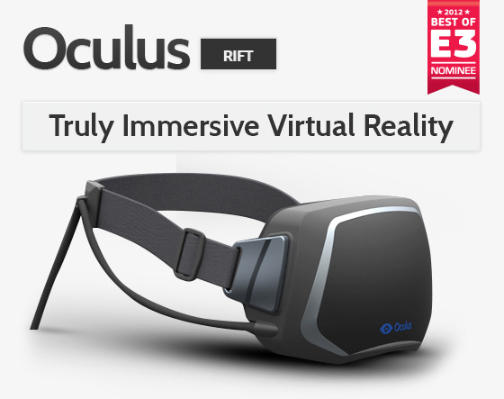

The competition to the new age of virtual reality headsets coming out is one that takes a different stance on how virtual reality should be displayed with the introduction holographic environments. The mental model the creators of RoomAlive have in mind is the creation of an “Immersive augmented experience” that “transforms the room into a new (Interactive)environment”(Bib 6). Microsoft’s RoomAlive project, still in developmental stages, represents the alternative to stereoscopic headsets while being very reminiscent to Star Trek’s holodeck. While RoomAlive is still in its early developmental stages I can see a multitude of usability problems arising with this initial concept. One of which would be the possibility of running into objects while using the RoomAlive because the RoomAlive could potentially obstruct your view of other objects around the room. Another problem that could potentially doom the RoomAlive project is cost, the IllumiRoom project was initially ended because it was deemed “too expensive for consumers”(Bib 6), so it seems that the RoomAlive may also fall to the same fate of its predecessor. While the concept might be on the right track it seems to be a while till the RoomAlive projects mental model will be able to connect to the user.

Section 5 Conclusion

While it seems that virtual reality is the future it remains to be seen which mental model will win out in the end however, the technology currently heavily favors stereoscopic headsets.

Bibliography

1 http://en.wikipedia.org/wiki/Virtual_reality#Timeline

2 http://www.bbc.com/future/story/20140327-virtual-realitys-puke-problem

3 https://www.kickstarter.com/projects/1523379957/oculus-rift-step-into-the-game

4 http://www.dubitlimited.com/blog/2014/06/24/what-they-really-think-of-virtual-reality/

5 <https://www.youtube.com/watch?v=fEiyzJDFiJI>

6 <http://projection-mapping.org/roomalive-uist/>

7 <http://www.academia.edu/5387318/The_Oculus_Rift_and_Immersion_through_Fear>

8 https://developer.oculusvr.com/forums/viewtopic.php?f=26&t=13692