Danny Mulick, Database Management, Fall 2016

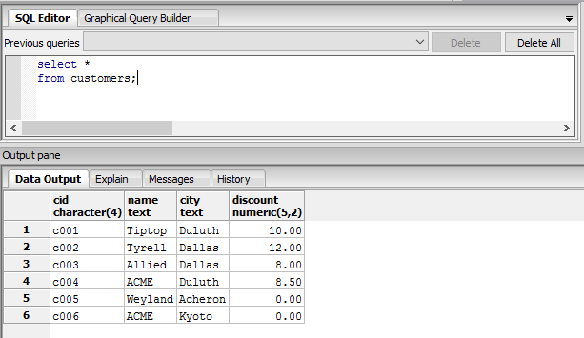

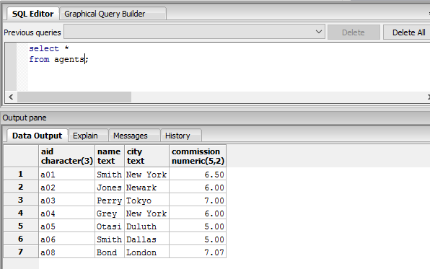

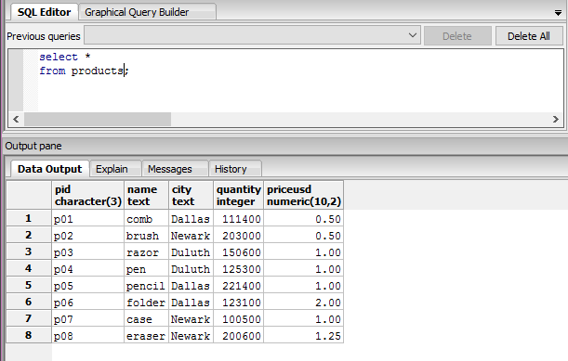

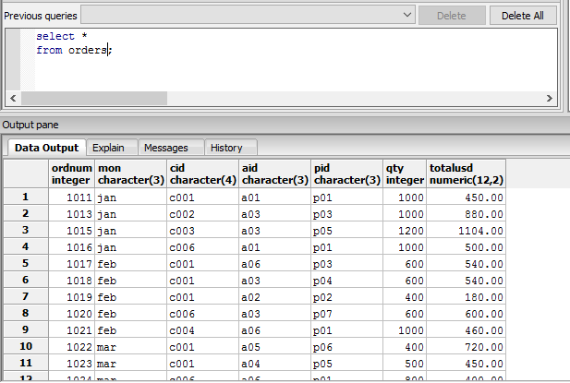

Above are images taken from the four queries for the CAP database

2. Primary key – a value in a table that exists to uniquely identify all records in a table  
candidate key – a value that can be used to uniquely identify any database record without referring to any other data  
superkey – a value that uniquely identifies any row within a relational database table

The distinctions between these three keys is that the primary key is limited to only finding records within a table, while the other two are used to find a record anywhere in the database. The distinction between a candidate key and a superkey is that while both the keys can use multiple columns to find one record, the candidate key uses the list of columns within the superkey, and is built from the least amount of columns, making it an optimized version of a superkey.

3. Write a short essay on data types. Select a topic for which you might create a table. Name the table and list its fields (columns). For each Wield, give its data type and whether or not it is nullable.

Data types are the categories that we can give to the columns or fields within our data tables to help maintain data regularity, whether the values will all be text, integer, or otherwise. An example that would best display the different data types would just be an example table, such as one built for a Magic: The Gathering card database. Some fields that we could find in this table could be the mana cost, which would be a character field to house values such as “B” to represent a single Blue mana, all the way up to “7RRR” to represent 7 generic mana and three Red mana. Along with the mana cost, we could see the name of the card, a regular text field because Wizards of the Coast recently removed certain special characters which could mess with the data records. A third field could even be the card’s converted mana cost, which would be typed as integers because cards in most sets that could be listed would have integers as their converted mana costs. Ultimately, it comes down to whether or not these fields could contain null values, and the answer to that would be no. Each card in Magic’s history must have a name, mana cost, and due to it having a mana cost, a converted mana cost. There is currently no Magic card that cannot have one of those attributes.

4. Explain the following relational “rules” with examples and reasons why they are important.   
a. The “first normal form” rule

I. The “first normal form” rule is meant to signify that each field must be atomic, meaning that it is indivisible. Say you have a table with a field labelled “superpowers.” That field could contain data such as “Flight, intangibility, and psychic powers”, which would be a violation of the first rule. We would break down this field into three separate fields, superpower1, superpower2, and superpower3, and put the three pieces of data into the respective fields. This rule is important because it helps us to maintain data that is unique and easily identifiable.

b. The “access rows by content only” rule

II. The second rule, “access rows by content only”, is used to show that we should only be referencing the data itself when we are looking within the database, not the order of the data. This rule is important because the actual order of the database is always able to change, either by our command of sorting or when new records are introduced. The data in row 3 when you build the database on Tuesday may not be the data in row 3 when you build it on Wednesday.  
c. The “all rows must be unique” rule

III. The third rule, that “all rows must be unique”, is important because it helps to keep the duplicity of data low, and the accuracy of information high. This rule means that you can never have two rows in the same database that contain the same data in the same fields. Each row must be unique to allow the user to easily find it with a query.