Danny Mulick, Database Management, Fall 2016

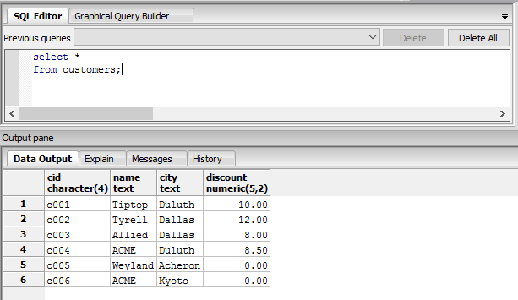

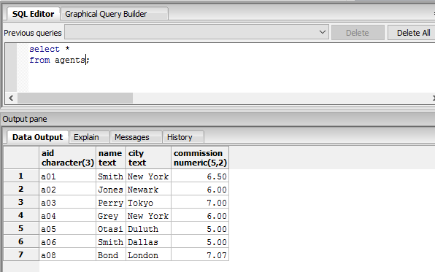

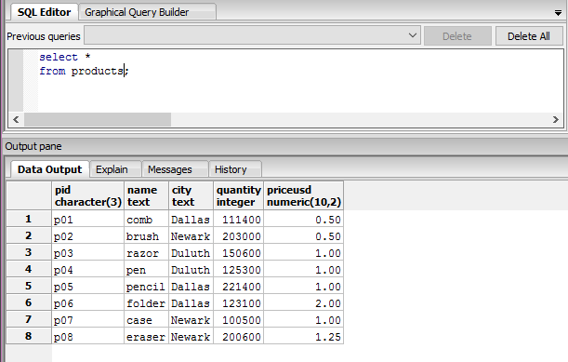

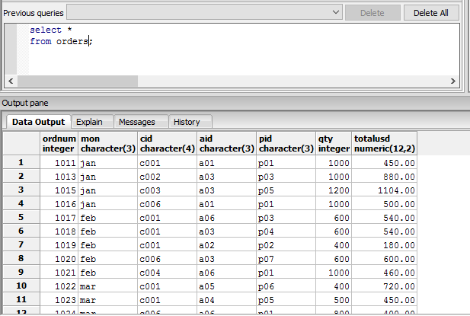

Above are images taken from the four queries for the CAP database

2. Primary key – a value in a table that exists to uniquely identify all records in a table  
candidate key – a value that can be used to uniquely identify any database record without referring to any other data  
superkey – a value that uniquely identifies any row within a relational database table

The distinctions between these three keys is that the primary key is limited to only finding records within a table, while the other two are used to find a record anywhere in the database. The distinction between a candidate key and a superkey is that while both the keys can use multiple columns to find one record, the superkey uses the least amount of columns between the two.

3. Write a short essay on data types. Select a topic for which you might create a table. Name the table and list its fields (columns). For each Wield, give its data type and whether or not it is nullable.

Data types are the categories that we can give to the columns or fields within our data tables to help maintain data regularity, whether the values will all be text, integer, or otherwise. An example that would best display the different data types would just be an example table, such as one built for a Magic: The Gathering card database. Some fields that we could find in this table could be the mana cost, which would be a character field to house values such as “B” to represent a single Blue mana, all the way up to “7RRR” to represent 7 generic mana and three Red mana,