Danny Mulick

Lab 9 Database Management

1. Functional dependencies
   1. pID 🡪fName, lName, age
   2. pID 🡪 chairPref, preferredDrink, recommHangoverCure
   3. pID 🡪 academicDegree, favVideoGame
   4. pID 🡪 yearsFlying, golfHandicap, spouseFName, spouseLName
   5. pID, scID 🡪
   6. scID 🡪 name, tailNumber, weightInTons, fuelType, crewCapacity
   7. scID, sysID 🡪
   8. sysID 🡪 name, desc, costUSD
   9. sysID, partID 🡪
   10. partID 🡪 name, desc, costUSD
   11. partID, supID 🡪
   12. supID 🡪 name, address, paymentTerms
2. E/R Diagram
   1. 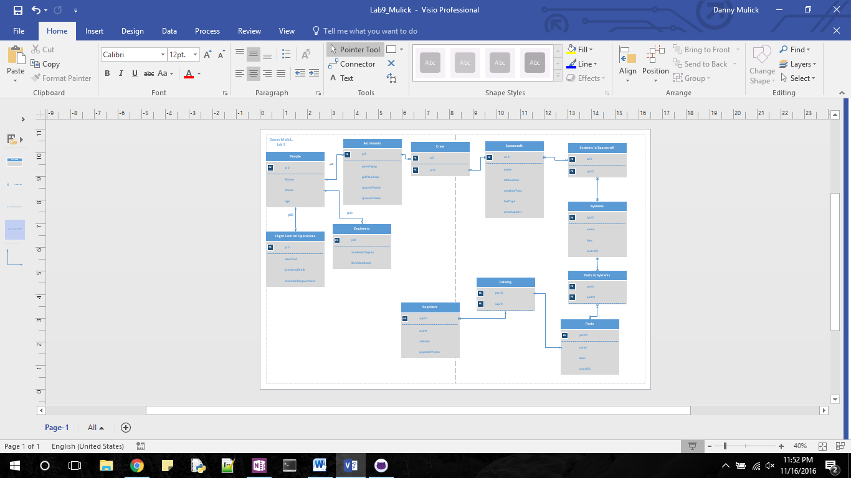
3. Normal Forms
   1. 1NF
      1. First normal form states that all fields in a database must be indivisible, and therefore atomic
      2. All fields in my database are atomic
   2. 2NF
      1. Second normal form requires that the database is in first normal form and states that there are no partial key dependencies in your database
      2. Every field that is not a primary key in my database is dependent on the entire primary key for the table
   3. 3NF
      1. Third normal form requires second normal form and states that there are no multi-key dependencies
      2. This means that every field is dependent on the primary key, and no other field, and my database meets that standard.
   4. BCNF
      1. Boyce Codd normal form states that your database must be in third normal form, and that there are no transitive dependencies
      2. My database meets these requirements