Metode Local Binary Pattern Histogram (LBPH) Pengenalan Wajah Pada Sistem Absensi Online Karyawan Radar Cirebon

Danny Fachrul Aliansyah Nurdin

STIKOM Poltek Cirebon

Jl. Pusri, Cirebon 45153

email: dannyfachrul@gmail.com

|  |  |  |
| --- | --- | --- |
| ARTICLE INFO |  | ABSTRACT |
| **Article history:**  Received July 28, 2021  Revised August 28, 2021  Accepted September 28, 2021 |  | Covid-19 merupakan virus yang penyebarannya sangat cepat, tanpa penanganan yang baik maka kita semua akan sulit keluar dari pandemi. Pemerintah indonesia mengeluarkan kebijakan PPKM dan *work from home* yang bertujuan untuk mengurangi penyebaran virus covid-19. Radar Cirebon merupakan perusahaan yang bergerak dibidang berita yang memiliki banyak karyawan yang memiliki mobilitas tinggi. Untuk mendukung upaya pemerintah melaksanakan *Work from home* maka perlu dibuat sistem untuk pengawasan, salah satunya dengan sistem absensi *online*. Dari masalah tersebut penulis melakukan penelitian *computer vision* tentang pengenalan wajah. Absensi *online* yang dibuat akan menggunakan wajah sebagai media verifikasinya. Metode pengenalan wajah yang digunakan pada penelitian ini adalah Local Binary Pattern Histogram (LBPH). LBPH merupakan pengembangan dari metode Local Binary Pattern (LBP). Dalam metode LBPH gambar wajah akan dipecah menjadi beberapa sel dan dilakukan perhitungan LBP sehingga menghasilkan sebuah Histogram. Penelitian ini menghasilkan model yang dibuat menggunakan metode LBPH yang mampu mengenali wajah dengan akurasi antara 74,10% - 78,22%. Model tersebut diaplikasikan pada *website* sehingga dapat digunakan pengguna dimanapun secara *online*. |
| **Keywords:**  Pengenalan Wajah;  Covid-19;  LBPH |
| This work is licensed under a [Creative Commons Attribution-Share Alike 4.0](https://creativecommons.org/licenses/by-sa/4.0/deed.id) |
| **Danny Fachrul Aliansyah Nurdin**,  Affiliation, Address, City and Postcode, Country  Email: [dannyfachrul@gmail.com](mailto:dannyfachrul@gmail.com) | | |

# PENDAHULUAN

Dengan merebaknya kasus covid-19 di Indonesia, Pemerintah Indonesia melakukan bebagai hal agar virus covid-19 tidak semakin menyebar. Salah satu upaya yang dilakukan pemerintah adalah mengeluarkan kebijakan WFH (*work from home*), kebijakan ini bertujuan agar membatasi kegiatan sosian antar karyawan. Namun kebijakan WFH dapat berjalan dengan lancar harus dibarengi dengan pengawasan, salah satu cara pengawasannya adalah dengan sistem absensi.

Authors are suggested to present their articles in the section structure: **(1)** **Introduction, (2) Method, (3) Results and Discussion, (4) Conclusion**. Margins, column widths, line spacing, and type styles are built-in; examples of the type styles are provided throughout this document and are identified in italic type, within parentheses, following the example. Some components, such as multi-leveled equations, graphics, and tables, are not prescribed, although the various table text styles are provided. The author will need to create these components, incorporating the applicable criteria that follow.

**The research background is**

**The related work from the past research is as follow**

**The main research contribution is**

# METHOD

In this section, you should explain how the research was conducted, including research design, research procedure (in the form of algorithms, Pseudocode, or other), how to acquire the data, and how to perform any test. The description of the course of research should be supported by references, so the explanation can be accepted scientifically.

## Subsection 1

This is how to start a subsection

# Subsection 2

This is how to start another subsection

# RESULTS AND DISCUSSION

In this section, the results of the research are explained and, at the same time is given a comprehensive discussion. Results can be presented in figures, graphs, tables, and others that make the reader understand easily. The discussion can be made in several sub-chapters. It is strongly suggested that comparison wih results from other published articles are provided to give more context and to strengthen the claim of novelty.

## Figures and Tables

Positioning Figures and Tables: Place figures and tables at the top and bottom of columns. Avoid placing them in the middle of columns. Large figures and tables may span across both columns. Figure captions should be below the figures; table heads should appear above the tables. Insert figures and tables after they are cited in the text. Use the abbreviation “**Fig. 1**,” “**Table 1**,” even at the beginning of a sentence.

**Table 1.** Table Styles

|  |  |  |  |
| --- | --- | --- | --- |
| **Table Head** | Table Column Head | | |
| **Table column subhead** | **Subhead** | **Subhead** |
| copy | More table copy |  |  |
| copy | More table copy |  |  |

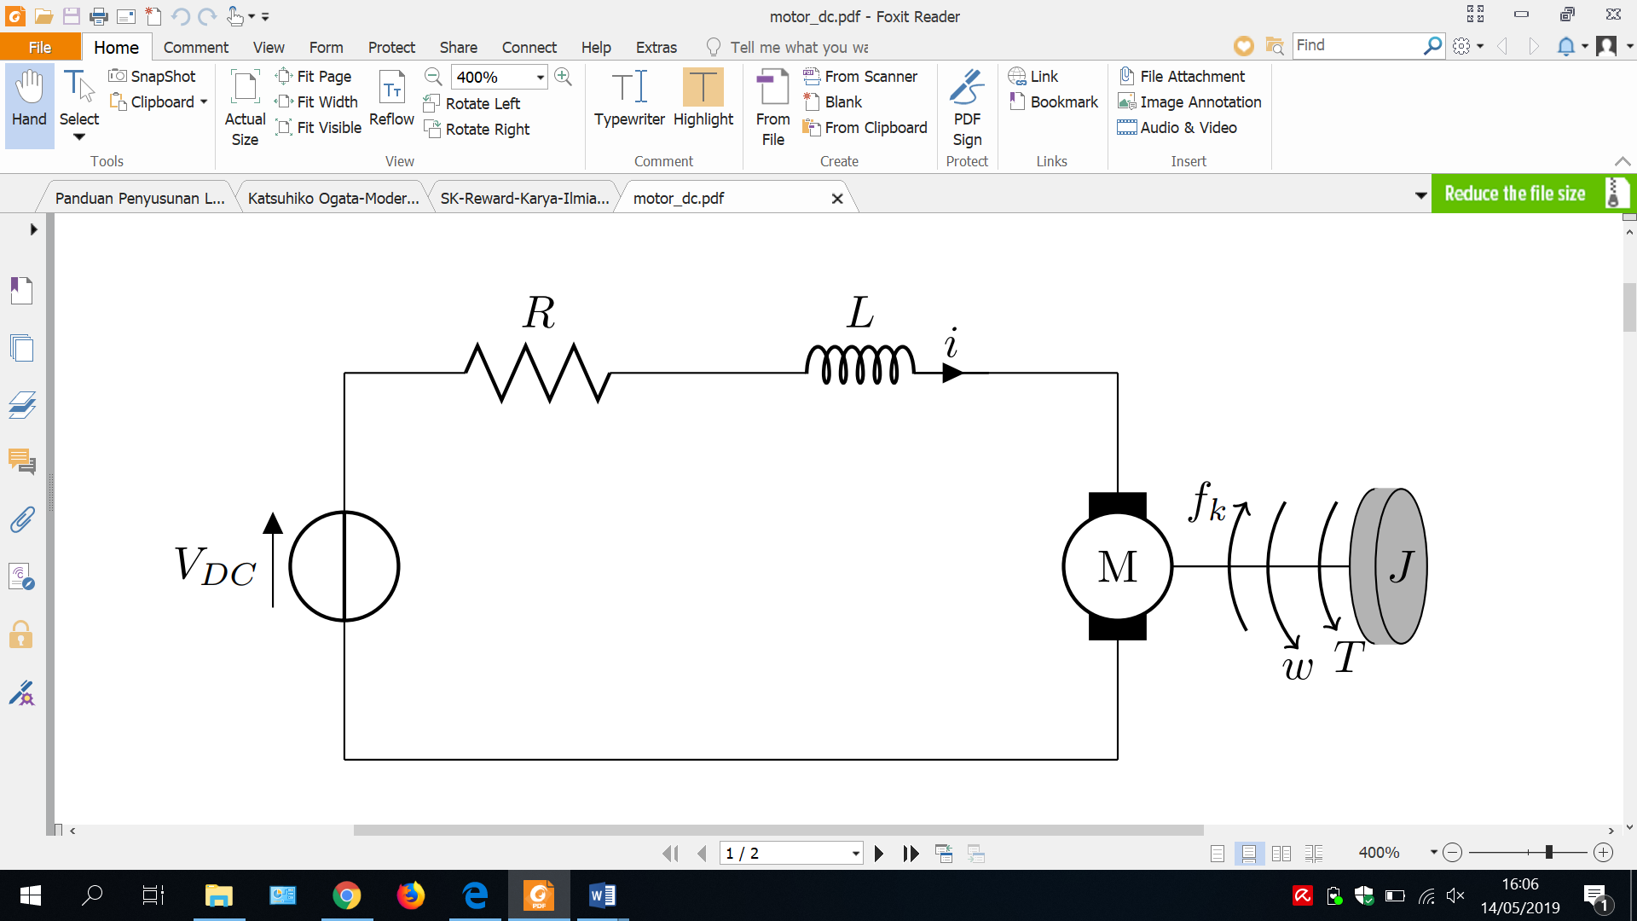

**Fig.** **1.** Example of a figure caption

Figure Labels: Use 10 point Times New Roman for Figure labels. Use words rather than symbols or abbreviations when writing Figure axis labels to avoid confusing the reader. As an example, write the quantity “Magnetization,” or “Magnetization, M,” not just “M.” If including units in the label, present them within parentheses. Do not label axes only with units. In the example, write “Magnetization (A/m)” or “Magnetization (A ( m(1),” not just “A/m.” Do not label axes with a ratio of quantities and units. For example, write “Temperature (K),” not “Temperature/K.”

## Equations

Equations should be written using native MS Word Equation (Insert equation). Do not use an image for any equation, as the quality will be degraded during the production of the pdf version. The equation should be numbered consecutively. The number is put on the right side. Do not forget to explain any variables or parameters in the first use, especially under the equation. The sample of the equation is as follow:

|  |  |  |
| --- | --- | --- |
|  | $$a+b=c$$ | (1) |

Note that the equation is centered using a center tab stop. Be sure that the symbols in your equation have been defined before or immediately following the equation. Use “(1),” not “Eq. (1)” or “equation (1),” except at the beginning of a sentence: “Equation (1) is ...”.

## Bibliography and citation in text

The organization and citation of the bibliography should use IEEE style in numbers, just like [1, 2] or [3-7]. The use of any reference manager tools (e.g., EndNote, Mendeley, Zotero etc.), is allowed. Each citation should be written in the order of appearance in the text. The reference style should follow the template, as shown in the Reference section at the end of this file. The main references are international journals. All references should be to the most pertinent and up-to-date sources. All references should appear in the text. Avoid unreliable internet websites (Wikipedia/blogs/news) as a reference at all. Please use a consistent format for references.

# CONCLUSION

Provide a statement that what is expected as stated in the "Introduction" chapter can ultimately result in the "Results and Discussion" chapter, so there is compatibility. Moreover, the authors can elaborate on the prospect of the development of research results and inspire further studies (based on results and discussion).

##### Acknowledgments

You may want to thank your funding source (but do not thank any of the authors!).

# REFERENCES

**The minimal references must be 30 from a journal that was published 5 years ago. It must be from the Science Direct database** [**https://www.sciencedirect.com/**](https://www.sciencedirect.com/)

1. J. Zhou, M. Abdel-Mottaleb, “A content-based system for human identification based on bitewing dental X-ray images,” *Pattern Recognition*., vol. 38, pp. 2132–2142, 2005. DOI URL **(Sample for a journal paper)**

**The minimal references are 30 from a journal that was published 5 years ago from the ScienceDirect database.**

**BIOGRAPHY OF AUTHORS (10 PT)**

|  |  |
| --- | --- |
| first author photo | **First Author Name**  (first author biography and email) |
| second author photo | **Second Author Name**  (second author biography and email) |