1. The SDES would be taking a Raw Key as input in order for it to run

Define it inside the rawkeys byte array.

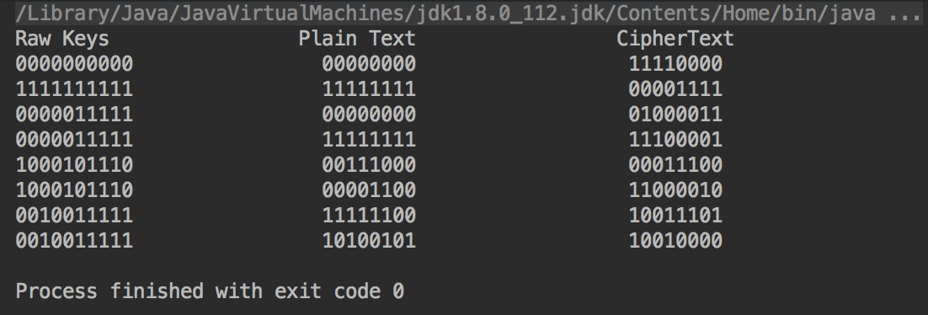

1. Triple SDES would need both raw keys to work.

3. For the Cracking SDES #1 we would need the String in order for it to encrypt into bytes. Also need CASCII.java that is included

4. the last two problems in 3, we would need to take in the bytes for it to find out the output.