**Challenge 1 - Customer Views**

Store Products

By selecting **View Products in Stock**, this view will be displayed showing the customer which products are available for purchase.

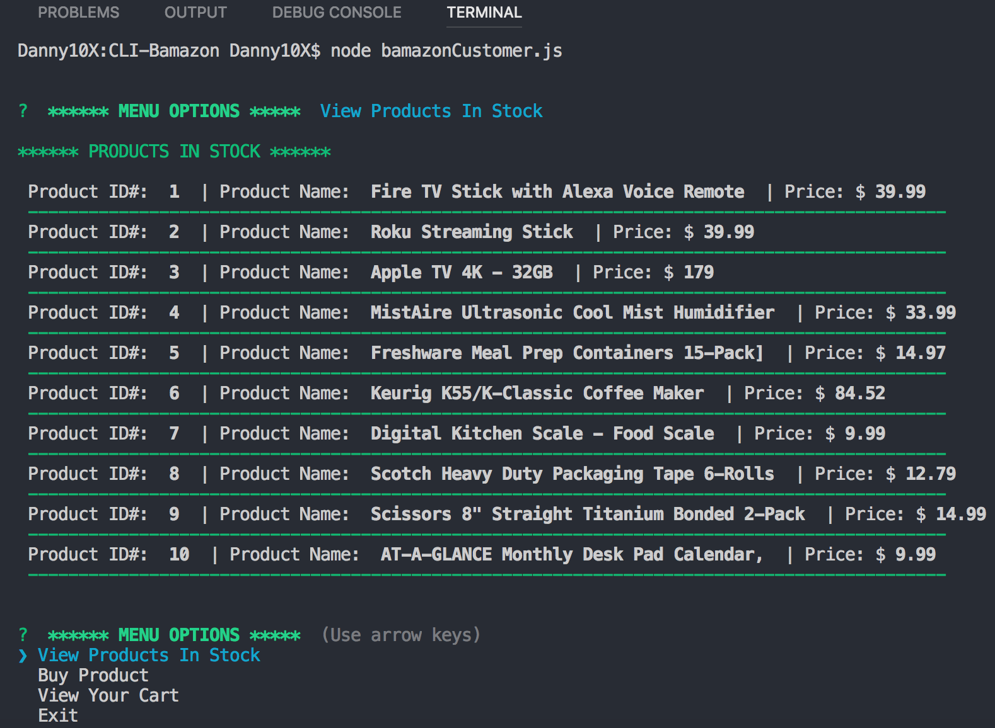

Out-of-Stock Items

When user selects a quantity that is greater than what’s available, a warning message is displayed “**Quantity in stock not available**” and the total quantity of items available are displayed as well.

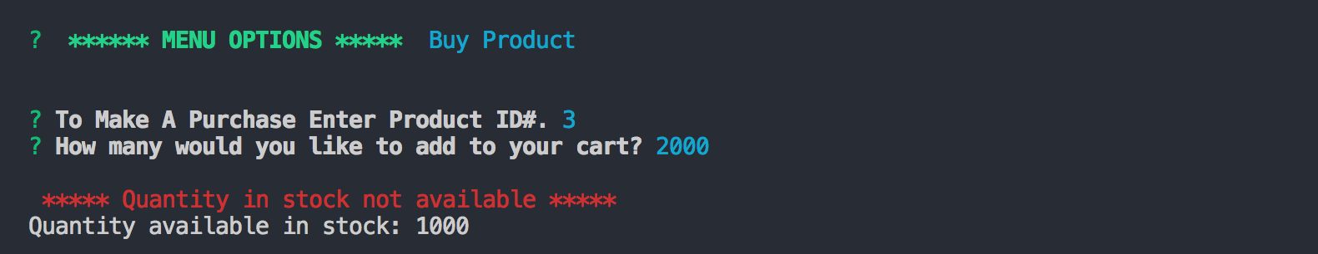

Buy Product

When selecting **Buy Product**, this view shows when a selection is made (Product ID# **10**) and the quantity added to the cart (**5**). After selection is completed, customer will get a message “It Has Been Added to Your Cart!”.

Also, when selecting **View Your Cart** a total amount will show that is equal to **Price** * **Quantity**.

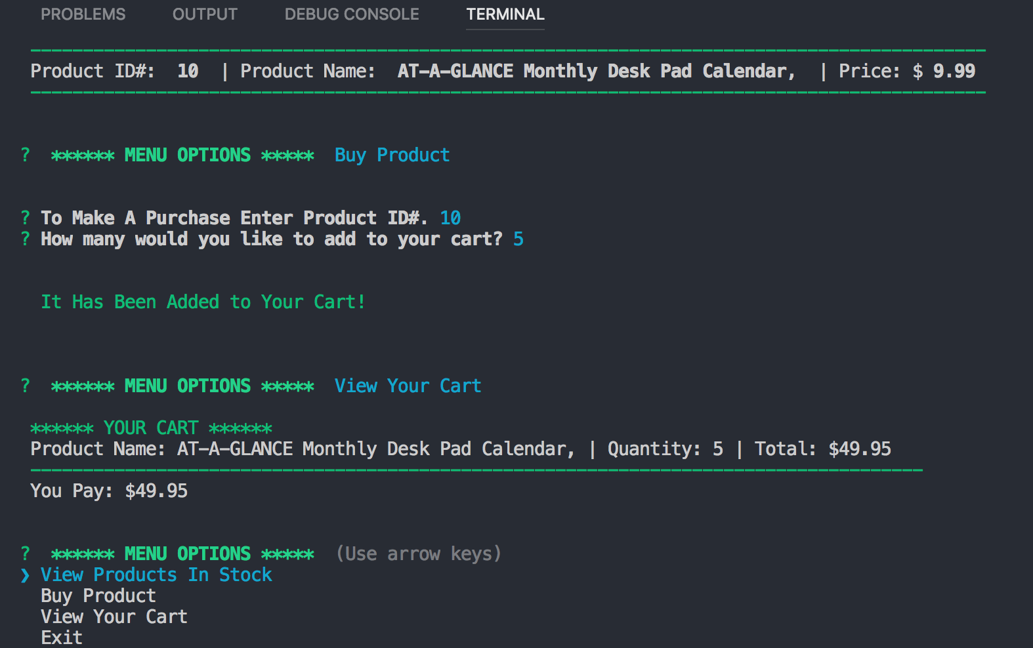

Not Providing an Input

If an entry is missing, the customer will receive a message regarding what would they like to do. The options are to **Continue Shopping** or **Exit Program**.



